# ASSIGNMENT 2 REPORT

# *1. Introduction*

This report examines vegetation dynamics in the Mount Kenya rangelands a semi‑arid, pastoral landscape characterized by bimodal rainfall (long rains Mar–May, short rains Oct–Dec) and significant altitudinal gradients. I compare two consecutive annual periods (Period A: 1 Mar 2022–28 Feb 2023; Period B: 1 Mar 2023–29 Feb 2024) using Sentinel‑2 surface reflectance composites to derive key vegetation structure and moisture indices.

# *2. Study Area and Period*

The Mount Kenya rangelands span elevations from 1,500 to 3,000 m, supporting grasses, shrubs, and scattered trees. Pastoral livelihoods depend on seasonal forage availability. Variability in rainfall can lead to drought stress or forage abundance. My analysis covers two full hydrological cycles to capture interannual variability in phenology and moisture.

# *3. Choice of Vegetation Indices*

I selected three indices tailored to rangeland monitoring:  
-EVI (Enhanced Vegetation Index):Sensitive to canopy greenness and optimized under low‐leaf‐area conditions in sparse rangelands.  
- NDMI (Normalized Difference Moisture Index): Captures water content in vegetation and soils, essential for assessing forage moisture during dry and wet seasons.  
- MSAVI (Modified Soil‑Adjusted Vegetation Index): Mitigates soil brightness effects, improving vegetation signal detection where ground cover is sparse.

# *4. Results*

4.1 Summary Statistics by Index and Period

|  |  |  |  |  |  |  |
| --- | --- | --- | --- | --- | --- | --- |
| Period | Index | Mean | Median | Std Dev | 10th %ile | 90th %ile |
| A | EVI | 0.1556 | 0.1338 | 0.0765 | 0.0833 | 0.2641 |
| B | EVI | 0.2597 | 0.2268 | 0.2067 | 0.0974 | 0.4755 |
| A | NDMI | -0.1543 | -0.1798 | 0.1016 | -0.2522 | -0.0168 |
| B | NDMI | -0.0221 | -0.0574 | 0.1566 | -0.2004 | 0.2102 |
| A | MSAVI | 0.1363 | 0.1199 | 0.0650 | 0.0714 | 0.2255 |
| B | MSAVI | 0.2260 | 0.1969 | 0.1259 | 0.0886 | 0.4111 |

4.2 Change Analysis (Period A → Period B)

|  |  |  |  |  |  |  |  |
| --- | --- | --- | --- | --- | --- | --- | --- |
| Index | Mean_A | Mean_B | Δ Mean | % Δ Mean | Median_A | Median_B | Δ Median |
| EVI | 0.1556 | 0.2597 | +0.1040 | +66.8% | 0.1338 | 0.2268 | +0.0931 |
| NDMI | -0.1543 | -0.0221 | +0.1322 | –85.7% | -0.1798 | -0.0574 | +0.1224 |
| MSAVI | 0.1363 | 0.2260 | +0.0897 | +65.8% | 0.1199 | 0.1969 | +0.0770 |

# *5. Interpretation and Discussion*

In the Mount Kenya rangelands, vegetation response is tightly coupled to bimodal rainfall patterns. Period B shows a pronounced increase in EVI (Mean: +0.1040, +66.8%), indicating a greener canopy likely due to above-average long rains in early 2023 and adequate short rains in late 2023. Higher peak EVI during March–May supports better forage during the primary growing season.  
NDMI’s shift from –0.1543 to –0.0221 (Δ +0.1322) reflects increased water content in both vegetation and soils, aligned with reports of above‑normal precipitation in October–December 2023. Improved moisture is critical for pastoralists, reducing drought stress and sustaining grazing.  
MSAVI’s rise (+0.0897, +65.8%) corroborates enhanced vegetation cover while accounting for exposed soils common in dry rangelands. The consistent direction of change across indices confirms a broad-scale positive ecosystem response.  
However, the doubling of EVI standard deviation (0.0765 → 0.2067) and similar increases in NDMI and MSAVI variability indicate greater spatial heterogeneity. This suggests localized management interventions such as water point development, rotational grazing fences, or supplemental feed zones creating patches of high vigor amid drier areas. Detailed maps (see Attachments) will help identify these hotspots and guide rangeland management.  
Overall, the metrics demonstrate that 2023 hydrological conditions favored vegetation recovery and moisture retention in the Mount Kenya rangelands, with implications for herd health, biodiversity, and sustainable grazing.

# 6. Attachments

-Monthly EVI, NDMI, and MSAVI time-series plots.

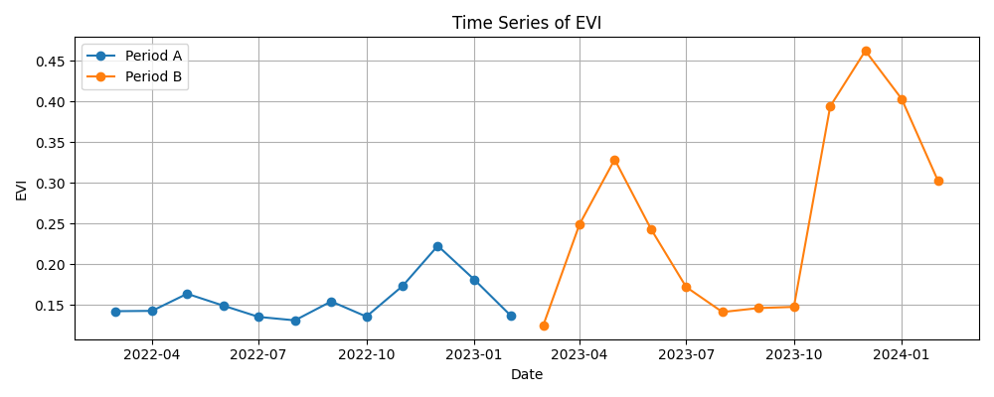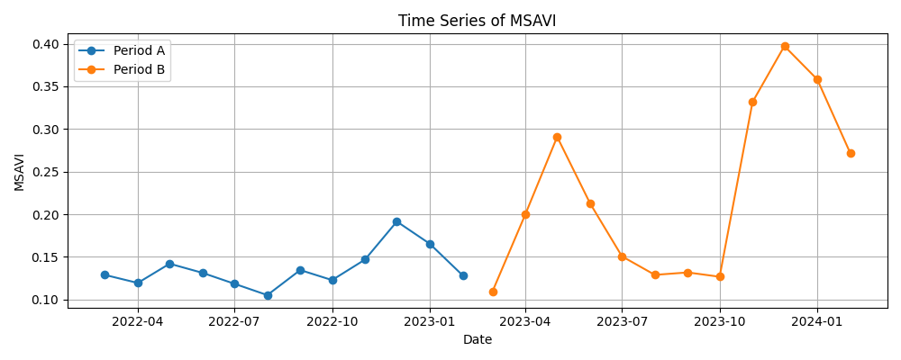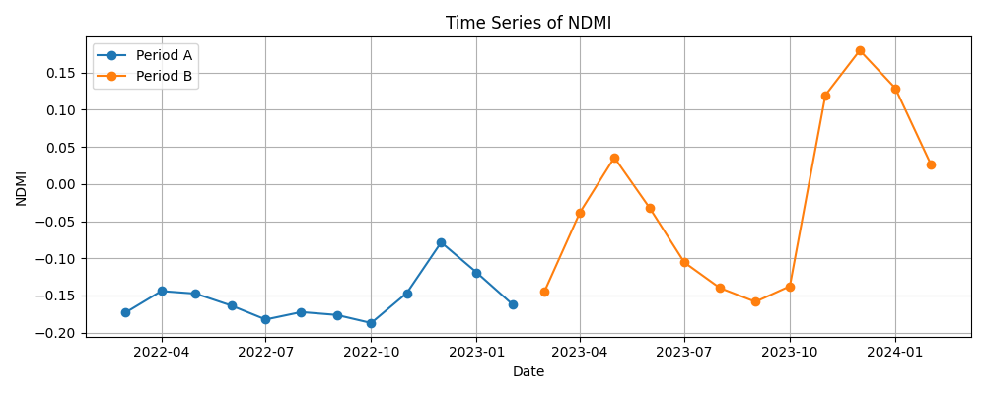

- Composite index maps for March 2022 vs. March 2023.

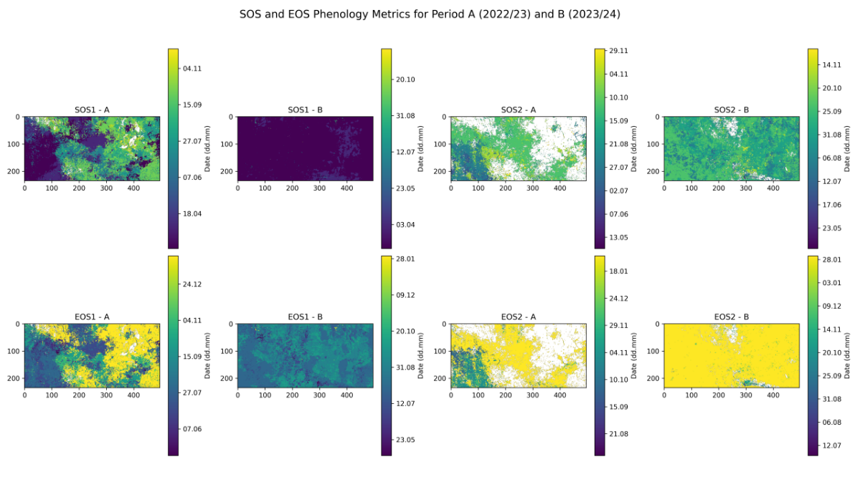  
- EVI Time series with Phenology Markers

