Improved Imaging of Aquifer Systems in Southern Alberta Using Airborne Electromagnetic (AEM) Data
Final Technical Report on Reprocessing, Inversion Framework, Field-Scale Rock Physics, and Hydrogeological Delineation
Report Author | Dr. Hyeon-Woo Kang (Postdoctoral Fellow, Dept. of Earth Sciences, University of Manitoba)
Principal Investigator (PI) | Dr. Seogi Kang (Assistant Professor, Dept. of Earth Sciences, University of Manitoba)
Partner Organization | Alberta Geological Survey, Alberta Energy Regulator (AGS-AER)
Project Period | 1st April 2026 – 31st May 2027
Survey Dataset | Calgary-Lethbridge Corridor AeroTEM III AEM Survey (Originally acquired under PGIP)
Primary Deliverable | Digitized Resistivity Profiles, Field-Scale Rock Physics Relationships, Technical Report
Report Date | October 2026

Executive Summary
This technical report presents the advanced reprocessing, multidimensional spatial inversion, and field-scale rock physics modeling of approximately 27,000 line-kilometers of helicopter-borne time-domain electromagnetic (AeroTEM III) data over the Calgary-Lethbridge Corridor in Southern Alberta. Commissioned and supported by the Alberta Geological Survey, Alberta Energy Regulator (AGS-AER), and undertaken by the University of Manitoba, this project re-evaluates legacy airborne geophysical data originally acquired under Alberta's Provincial Groundwater Inventory Program (PGIP). The primary objective is to resolve regional sediment and bedrock aquifer geometries, delineate depths to Cretaceous bedrock, and establish a quantitative field-scale link between electrical resistivity and lithological categories.
Data preprocessing utilizing spatial binning and stacking (50 m interval) successfully suppressed ambient electromagnetic fluctuations without destructive cultural noise masking, as correlation analysis confirmed powerline interference was largely uncoupled from subsurface target responses. Inversion was conducted using an unreferenced spatial regularization framework (smallness weight $α_{s}$ = 0) to prevent artificial model bias, combined with a normalized data misfit metric ($C_{\%}$ = 0.04 and noise floor $ε_{floor}$ = 5% of reported survey noise). The resulting resistivity cross-sections reveal a pronounced regional structural contrast between the resistive western fluvial sandstones (Scollard Formation) and the conductive eastern marine and deltaic mudstone/shale aquitards (Horseshoe Canyon and Bearpaw Formations).
To transform inverted electrical resistivity profiles into hydrogeological sediment classes, a non-negative least squares (NNLS) equation-based bootstrapping calibration was implemented against co-located lithological logs (Knight et al., 2018; Kang, 2025). The unsegmented All-Depths calibration is adopted as the primary operational baseline for regional 3D lithological mapping, yielding representative bulk resistivities of 16.2 ohm-m for coarse-grained aquifers (sg), 14.3 ohm-m for mixed facies (others), and 13.2 ohm-m for confining aquitards (shale). While evaluating data across the regional water table shows slightly higher sand resistivity below the water table (17.0 vs. 15.0 ohm-m), regional AEM depth slices (1.00 m vs. 49.59 m) and earlier survey records (Davis & Groom, 2018) confirm this reflects the regional transition from conductive surficial till into resistive bedrock sandstones and basal channel gravels. Consequently, the All-Depths integrated calibration provides the most stable and practical standard for regional hydrogeological mapping.
Project Milestone Summary: Key Deliverable Milestones Achieved: (1) Robust AEM 1D inversion profiles across major survey lines; (2) Quantitative descriptive statistics for sensor terrain clearance; (3) Regional hydrogeological cross-sections mapping Scollard, Horseshoe Canyon, and Bearpaw stratigraphic units; and (4) Field-scale rock physics bootstrapping calibration establishing representative resistivity bounds for aquifer-aquitard differentiation.

1. Project Background and Regional Geological Setting
1.1 Scope of Work and Project Objectives
Under the Scope of Work (SOW) established between the Alberta Geological Survey (AGS-AER) and the University of Manitoba, the project re-evaluates legacy airborne electromagnetic data to address critical data gaps in regional groundwater management across the Calgary-Lethbridge Corridor. While historical AeroTEM III surveys originally flown under Alberta's Provincial Groundwater Inventory Program (PGIP) provided extensive regional airborne coverage, earlier inversion efforts (Davis and Groom, 2018; AER/AGS Special Report 110) noted persistent challenges in resolving intra-formational lithologies within Upper Cretaceous strata due to narrow electrical resistivity contrasts. The present investigation deploys tailored spatial regularization, improved misfit balancing, and rigorous statistical bootstrapping with driller's logs to transform AEM conductivity volumes into hydrogeologically actionable sediment models.
1.2 Regional Stratigraphy and Hydrogeological Framework
The survey domain spans the Western Canada Sedimentary Basin foreland eastward across Vulcan and Wheatland counties. The stratigraphic sequence transitions from Paleocene continental deposits in the west to Upper Cretaceous marine and deltaic successions in the east:
• Paskapoo Formation (Paleocene): Buff-colored fluvial sandstones interbedded with siltstone and mudstone, forming prime regional bedrock aquifers.
• Scollard Formation (Maastrichtian-Danian): Fluvial sandstone channels, siltstones, and prominent coal seams (including the Ardley coal zone), exhibiting elevated bulk resistivity.
• Horseshoe Canyon Formation (Edmonton Group, Campanian-Maastrichtian): Deltaic to fluvial sandstones, siltstones, carbonaceous shales, and coal beds, characterized by low to moderate resistivity.
• Bearpaw Formation (Campanian): Extensive marine shales, silty clays, and bentonite beds acting as a thick, regional aquitard with exceptionally low electrical resistivity (< 10 ohm-m).
• Quaternary Glacial Drift: Discontinuous till veneers, glaciolacustrine clays, and buried paleochannel (thalweg) gravel aquifers incised into the bedrock surface.
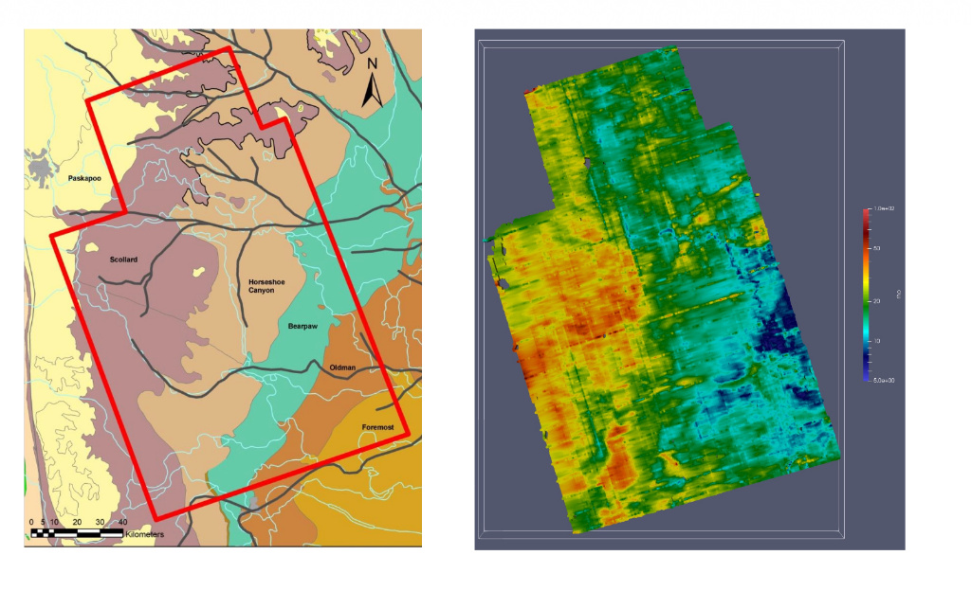
Figure 1.1: Regional Geological Map of Southern Alberta (left) overlaid with survey outline (red boundary) and corresponding AEM Inversion Resistivity Depth Slice (right) displaying pronounced resistivity contrast between the resistive western Scollard formation (orange-red, 30-60 ohm-m) and the conductive eastern Horseshoe Canyon/Bearpaw shales (blue, 5-20 ohm-m).
2. AEM Survey Data, Flight Characteristics, and Preprocessing
2.1 AeroTEM III Instrumentation and Flight Parameters
The geophysical survey was executed using Aeroquest's AeroTEM III helicopter-borne time-domain electromagnetic system. The transmitter loop (10 m diameter) operated at a base frequency of 90 Hz with a peak current of 455 A and peak dipole moment of 178,600 NIA. Receiver coils recorded dB/dt in both coaxial Z and coplanar X orientations across 30 off-time gates (spanning 104 $μs$ to 3.03 $ms$). Nominal survey design called for an aircraft terrain clearance of 82 m (275 ft) and an EM bird clearance of 30 (Aeroquest, 2011).
2.2 Flight Altitude Statistics and Terrain Tracking
Laser and radar altimeter records from the smooth inversion dataset were analyzed to extract rigorous descriptive statistics of the EM bird clearance (bheight). While the survey maintained close terrain conformity over flat agricultural plateaus, altitude climbed markedly over major river valleys (Bow, Highwood, and Oldman rivers), steep coulees, and powerline corridors.
Flight Altitude Parameter | Calculated Statistical Value
Mean Bird Clearance (bheight) | 36.52 m
Standard Deviation | 10.61 m
Median Bird Clearance | 35.29 m
5th Percentile | 25.21 m
95th Percentile | 50.03 m
Minimum Recorded Clearance | 2.47 m
Maximum Recorded Clearance | 391.68 m (River gorges / infrastructure pull-ups)
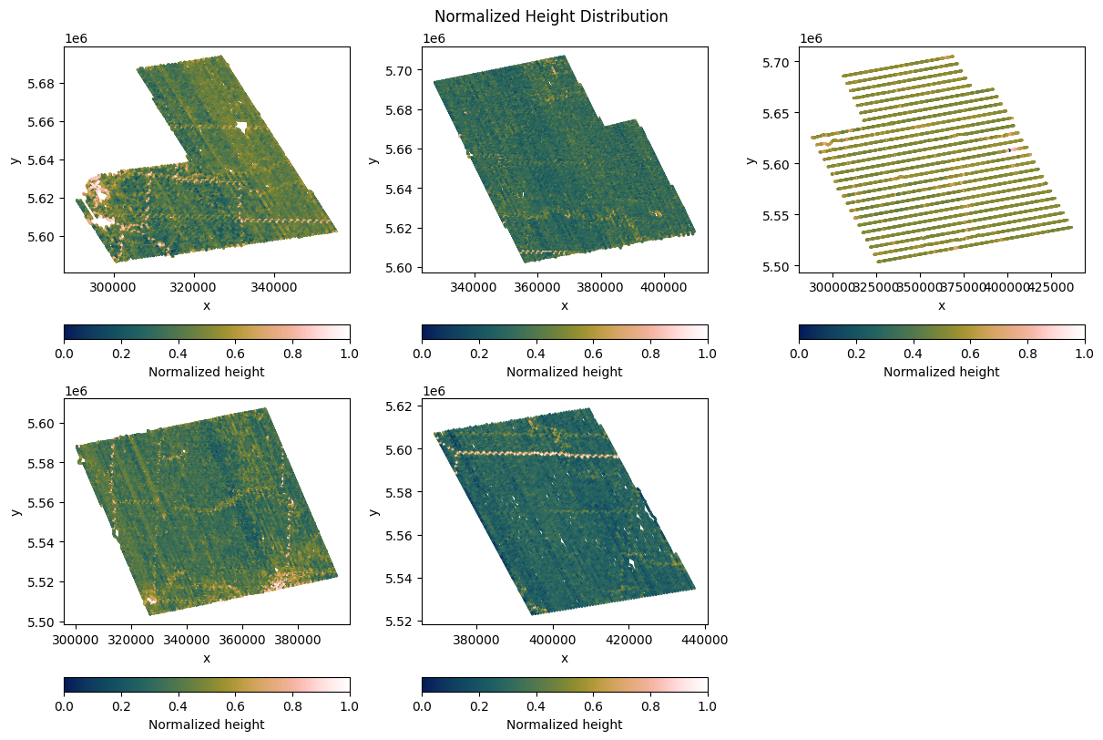
Figure 2.1: Spatial distribution of AEM sensor terrain clearance (bheight). Median altitude is 35.29 m, with 90% of soundings bounded between 25.21 m and 50.03 m.
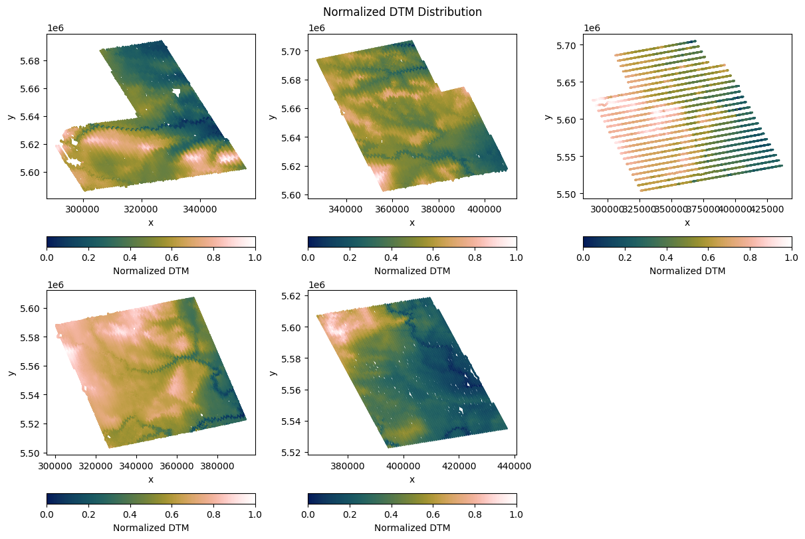
Figure 2.2: Digital Elevation Model (DEM) distribution across the survey corridor, showing regional eastward slope.
2.3 Cultural Noise Assessment and Data Preprocessing Pipeline
High-voltage AC transmission lines, pipelines, and metallic railway corridors represent significant cultural noise sources in Southern Alberta. Comparative cross-correlation between mapped powerline corridors and raw EM sounding decays revealed that powerline effects are localized and do not exhibit broad regional coupling into late-time channels across open rural flight paths. Consequently, rather than applying aggressive spatial masking that would sever continuous aquifer geometry, a spatial binning and stacking protocol (~40 m window) was executed. This approach effectively suppressed random instrument noise and high-frequency cultural spikes while retaining the integrity of continuous subsurface conductivity boundaries.
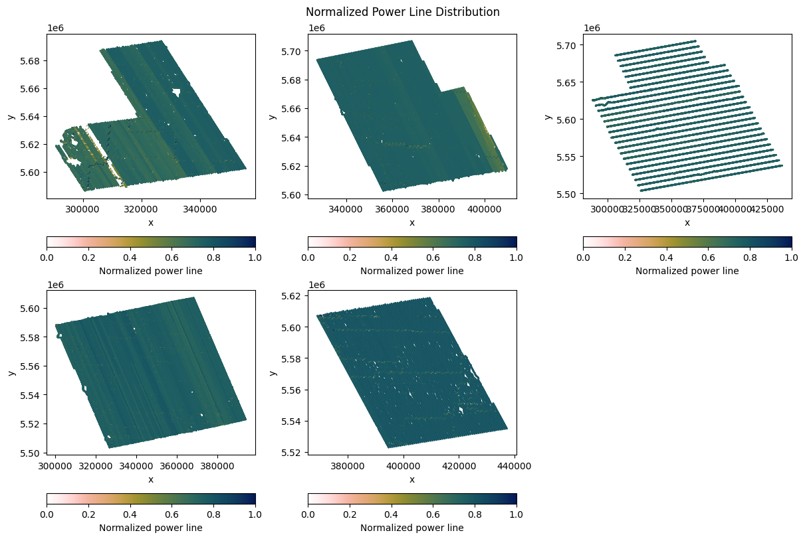
Figure 2.3: Cultural noise distribution map indicating locations of mapped transmission powerlines across the survey lines.
3. Inversion Methodology and Spatial Regularization Framework
3.1 Data Misfit Formulation and Noise Weighting
To achieve robust, multi-channel 1D inversion across the wide dynamic range of time-domain electromagnetic decays, the data misfit objective function $ϕ_{d}(m)$ is formulated using an adaptive uncertainty weighting scheme. The discrete misfit quantifies the cumulative normalized discrepancy between forward-modelled responses and field observations across all active time gates:
$$ϕ_{d}\left(m\right)=\sum_{i=1}^{N}{ϕ_{d,i}}=\sum_{i=1}^{N}{{\left(\frac{f_{i}\left[m\right]-d_{i}^{obs}}{ε_{i}}\right)}^{2}}$$ | (Eq. 3.1)

In compact matrix-vector notation, this objective function is expressed as the squared L2-norm of the uncertainty-weighted data residual vector:
$$ϕ_{d}\left(m\right)={\left\|W_{d}\left(f\left[m\right]-d^{obs}\right)\right\|}_{2}^{2}=e^{T}W_{d}^{T}W_{d}e$$ | (Eq. 3.2)

where N denotes the total number of active time channels (gates) per sounding, $f_{i}[⋅]$ is the forward electromagnetic operator response computed for the layered 1D conductivity model m at time channel i, $d_{i}^{obs}$ is the corresponding observed secondary magnetic field time-derivative (dB/dt, in nT/s), and $e$ is indicating data misfit vector.
Because AEM transient decays span several decades of amplitude—ranging from thousands of nT/s in the earliest off-time gates to less than 1 nT/s in the latest gates—an unweighted least-squares formulation would be overwhelmingly dominated by high-amplitude early times, causing the inversion to ignore deep-probing late times. To ensure an even fitting across all decay stages, the standard deviation uncertainty threshold $ε_{i}$ assigned to each time channel is defined as:
$$ε_{i}=C_{\%}⋅\left|d_{i}^{obs}\right|+ε_{floor}$$ | (Eq. 3.3)

The corresponding data weighting matrix $W_{d}$ is constructed as a diagonal matrix whose non-zero entries are the inverse channel uncertainties:
$$W_{d}=diag[ ε_{1}^{-1}, ε_{2}^{-1},⋯,ε_{N}^{-1} ]$$ | (Eq. 3.4)

The mathematical parameters and physical rationale governing this data weighting scheme are defined as follows:
- Fractional Relative Uncertainty ($C_{\%}$ = 0.04 / 4%): The fractional relative error parameter $C_{\%}$ is assigned as 0.04 (4%). This term scales the assigned data uncertainty proportionally to the magnitude of the measured signal, ensuring that early, intermediate, and late channels contribute symmetrically to the objective function. This operates analogously to field normalization (which represents the specific limiting case where $C_{\%}$= 1), preventing high-amplitude near-surface responses from overshadowing deep electrical targets.
- Absolute Noise Floor ($ε_{floor}$ = 0.25 nT/s): The noise floor parameter $ε_{floor}$ is set to 5% of the nominal survey noise level reported in the SkyTEM contractor technical specifications (5.0 nT/s peak-to-peak), yielding an absolute floor of ε_floor = 0.05 × 5.0 nT/s = 0.25 nT/s. This positive constant prevents late-time channels—where signal decay approaches or dips below the instrumental and atmospheric noise floor—from acquiring artificially inflated weights ($ε$→ 0, $W_{d}$ → ∞). It guarantees numerical stability and prevents the inversion algorithm from over-fitting noise artifacts.
- Data Weighting Matrix ($W_{d}$): By mapping each residual through $W_{d}$, data points with high signal-to-noise ratio (SNR) exert primary influence on the model update, while noisy or sub-floor late channels are stabilized without destabilizing the global optimization.
3.2 Spatial Regularization and Model Constraints
Because 1D electromagnetic soundings are inherently ill-posed and non-unique, spatial regularization is incorporated into the global objective function to couple adjacent soundings into laterally continuous, geologically coherent profiles. In continuous functional form, the model objective function $ϕ_{m}(m)$ is defined as:
$$ϕ_{m}\left(m\right)=α_{s}\int_{V}{{\left\|W_{m}\left(m-m_{ref}\right)\right\|}^{2}dV}+α_{r}\int_{V}{{\left\|\frac{∂m}{∂r}\right\|}^{p_{r}}dV}+α_{z}\int_{V}{{\left\|\frac{∂m}{∂z}\right\|}^{p_{z}}dV}$$ | (Eq. 3.5)

A foundational design constraint in this study is the strict elimination of the smallness regularization term ($α_{s}=0$).
The mathematical formulation and physical rationale of each component in this spatial constraint framework are detailed below:
- Reference-Free Inversion Philosophy ($α_{s}=0$): In standard Tikhonov regularized inversion, the smallness term penalizes deviation from an a priori reference model $m_{ref}$ , prescribing an arbitrary homogeneous or layered reference model inevitably introduces subjective bias—artificially pulling recovered resistivities toward the assumed background. By enforcing $α_{s}$ = 0, the inversion operates in a purely data-driven mode, ensuring that all resolved resistivity variations arise exclusively from the AEM observations and spatial continuity.
- Lateral Spatial Continuity ($α_{r}$): The lateral roughness term applies a finite-difference differential operator ($\frac{∂m}{∂r}$) between adjacent 1D soundings along the flight line (r-direction). This term enforces lateral continuity of continuous sedimentary formations, regional confining shales, and buried paleochannel aquifer ribbons, suppressing spurious station-to-station noise variations.
- Vertical Stratigraphic Smoothness ($α_{z}$): The vertical roughness term controls the vertical derivative ($\frac{∂m}{∂z}$) between consecutive 1D depth layers at each station. This penalizes unphysical, highly oscillatory vertical conductivity variations while allowing genuine stratigraphic layering to develop.
- Smooth vs. Sharp Regularization Configurations: The balance between $α_{r}$ and $α_{z}$ and the mathematical norm definition ($p_{r}$ and $p_{z}$) were tailored between Smooth and Sharp inversion configurations: Smooth inversions (standard L2 norm) provide continuous, gradational imaging suitable for weathered zones, diffusive clay transitions, and regional groundwater salinity gradients; Sharp inversions (iteratively reweighted compact norms) focus gradient penalties to recover crisp, step-like boundaries with zero norm, resolving abrupt geological contacts such as the incised bedrock unconformity beneath Quaternary drift.
4. Inversion Results and Regional Profile Analysis
4.1 East-West Regional Contrast: Scollard Sandstones vs. Horseshoe/Bearpaw Shales
A primary finding from the 1D inversion sections is the dramatic regional structural dichotomy between the western and eastern sectors of the Calgary-Lethbridge Corridor. Along East-West tie lines, the western sector is dominated by the resistive Scollard Formation (40–100 ohm-m), where permeable fluvial sandstones persist from shallow depths down to several hundred meters.
Approaching the central and eastern sectors, resistivity drops precipitously into the conductive Horseshoe Canyon and Bearpaw Formations (5–20 ohm-m). In these eastern lowland sections, the near-surface profile exhibits a distinctive three-part stratigraphy: a thin resistive surface sand veneer, underlain by conductive Quaternary glacial till, resting unconformably atop marine Bearpaw shale aquitards.
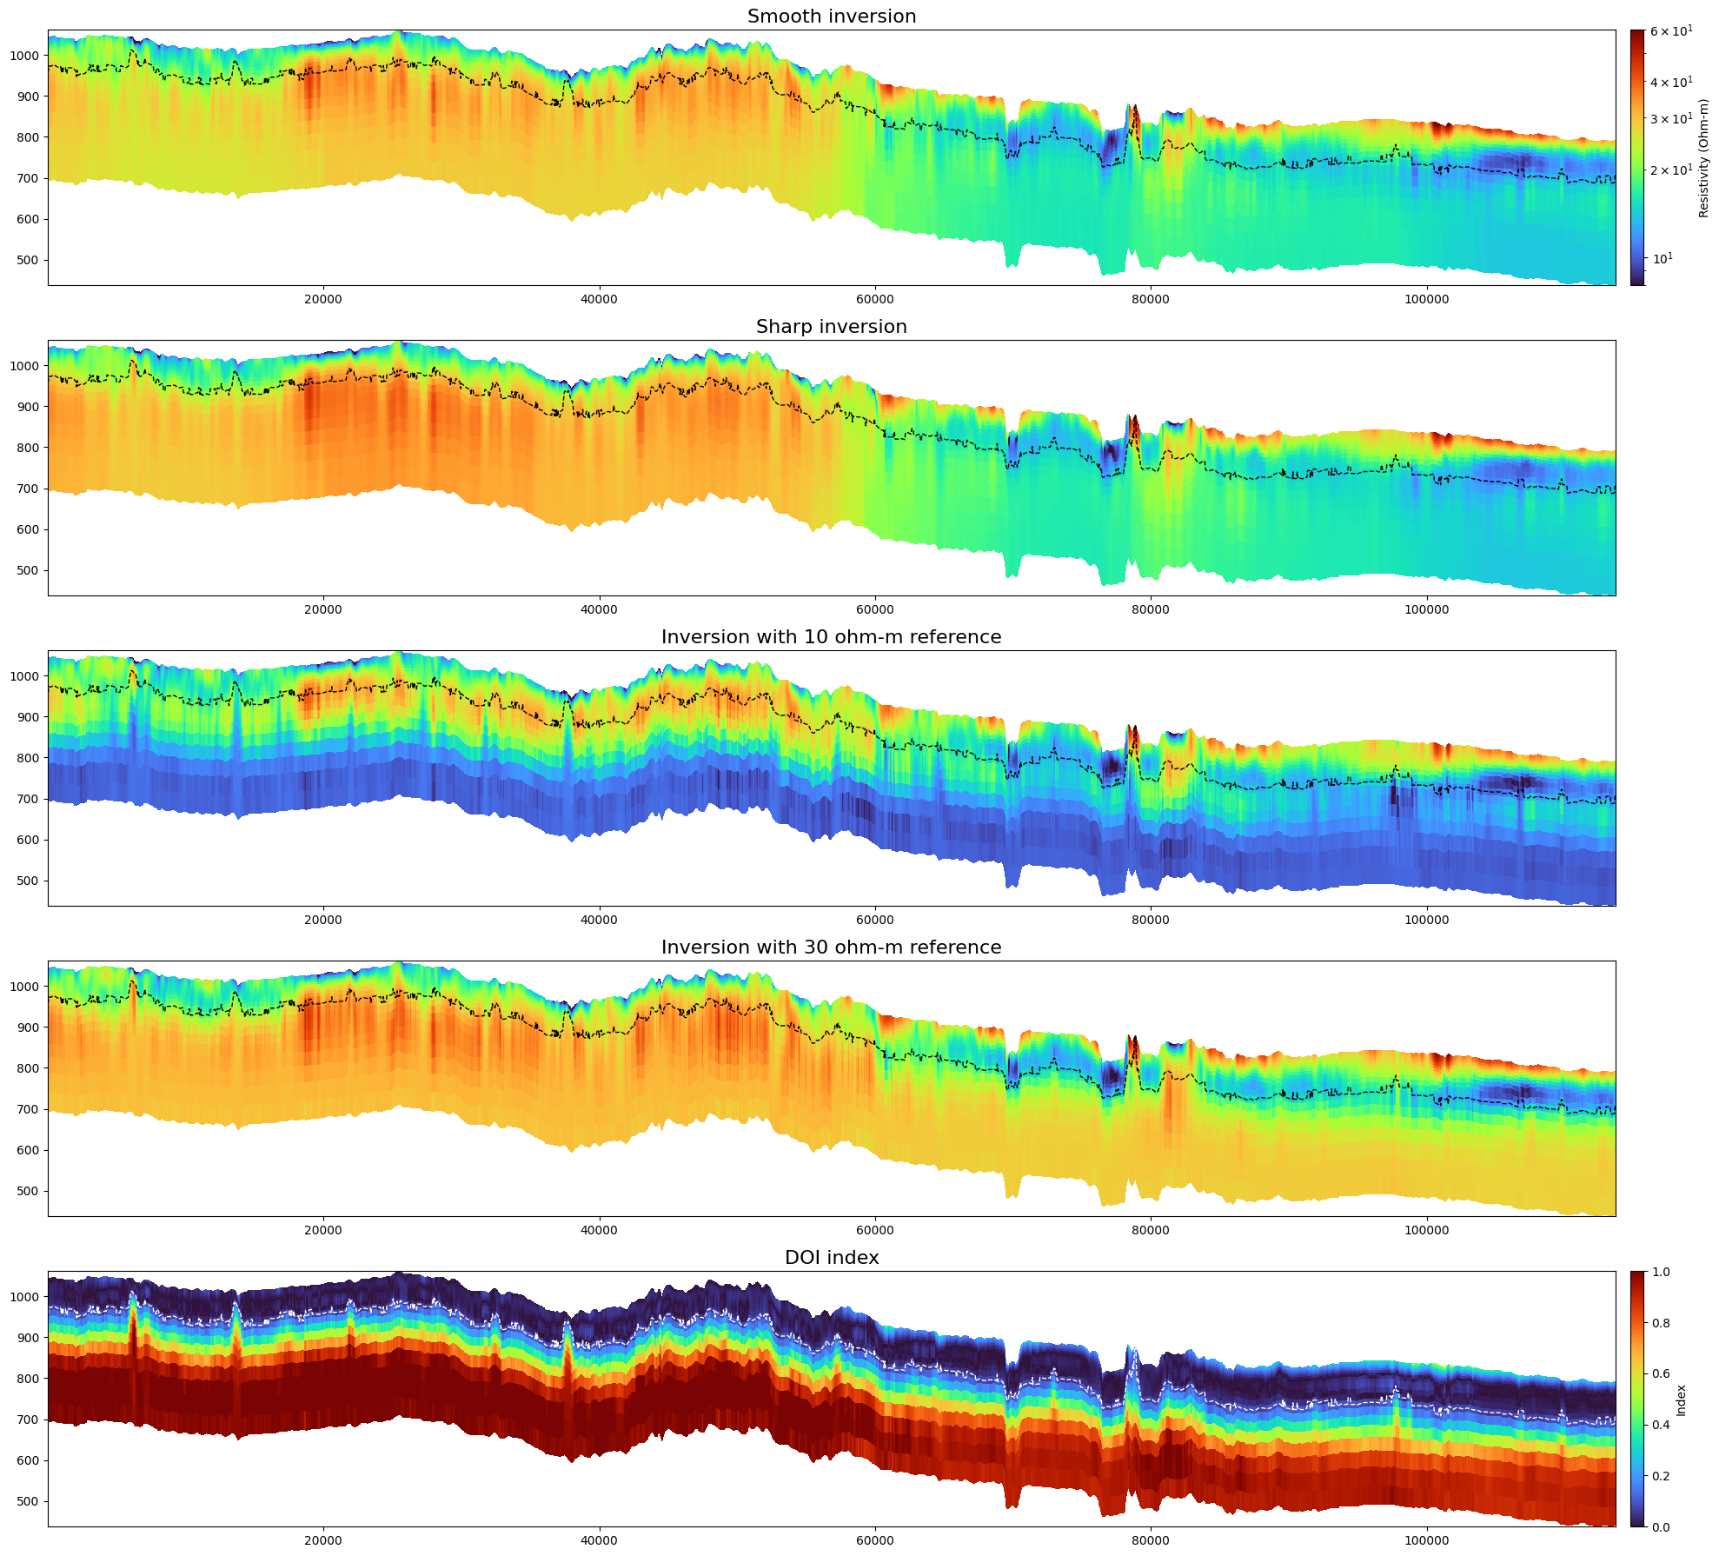
Figure 4.1: Terrain-following XZ resistivity section along East-West Tie Line T19110 (Iteration 14). Note the pronounced contrast between resistive Scollard sandstones (30-60 ohm-m) on the west and conductive Horseshoe Canyon / Bearpaw shales (10-20 ohm-m) on the east.
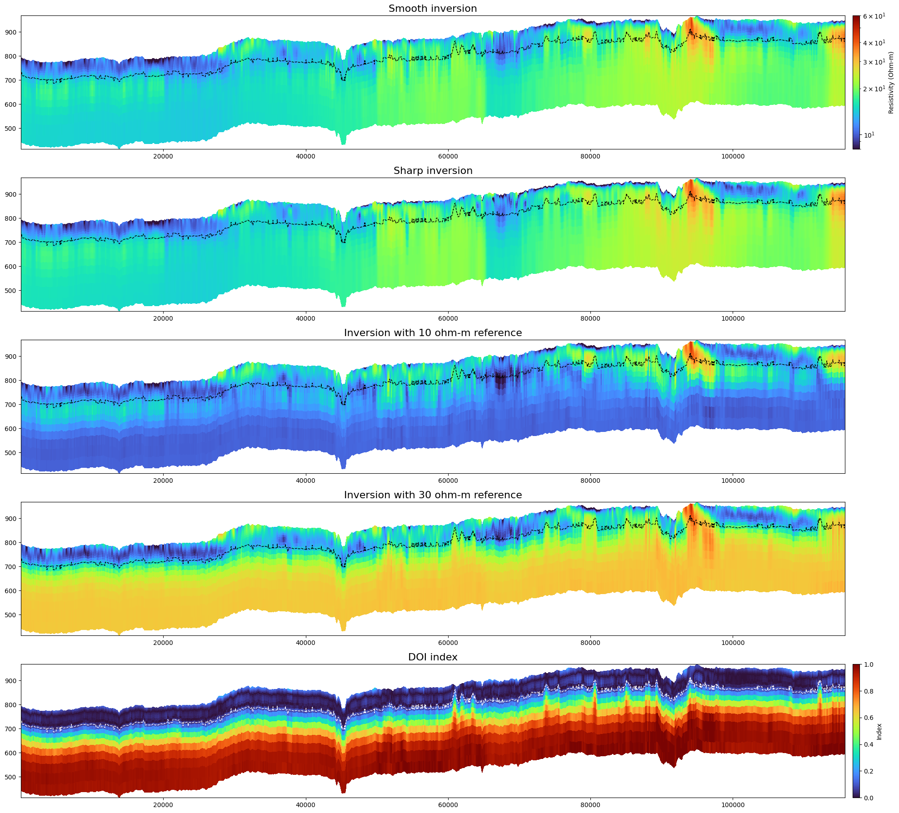
Figure 4.2: Terrain-following XZ resistivity section along southern East-West Tie Line T29240 / T19240, demonstrating lateral continuity of western resistive bedrock vs eastern conductive aquitards.
4.2 North-South Stratigraphic Transition: Line L10051
Traverse Line L10051 illustrates the north-south lithological transition across Vulcan County. In the southern portion, the profile intersects the subcropping Bearpaw Formation marine shale, manifested as an intense low-resistivity conductor (< 10 ohm-m, deep blue). Progressing northward, resistivity increases progressively as the survey crosses into the deltaic sandstones of the Horseshoe Canyon Formation.
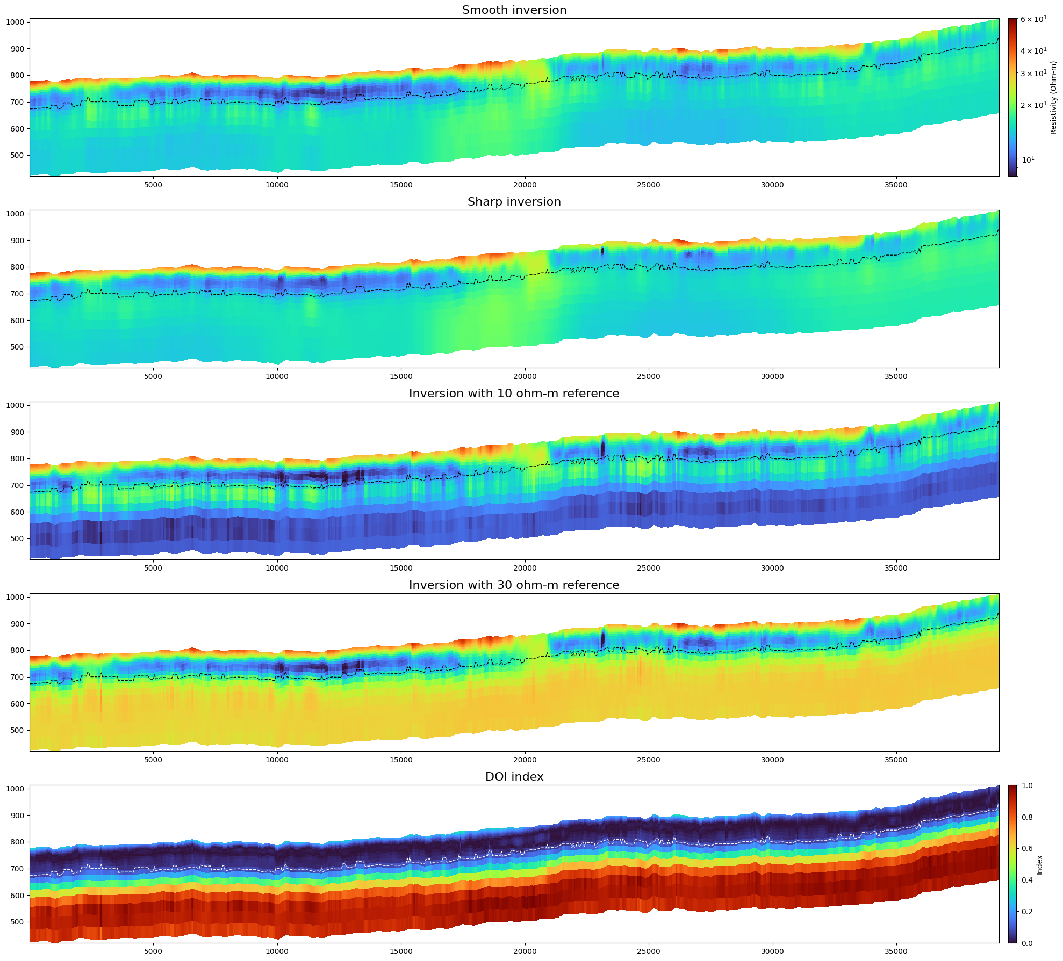
Figure 4.3: Terrain-following XZ resistivity section along North-South Traverse Line L10051, showing transition from conductive Bearpaw marine shale in the south to resistive Horseshoe Canyon sandstones in the north.

5. Field-Scale Rock Physics Inversion and Lithological Classification
5.1 Driller's Log Synchronization and Linear Mixing Model
To quantitatively link AEM electrical resistivity to physical sediment types, driller's lithological logs from co-located Water Wells and Coal Holes were harmonized into three primary hydrostratigraphic classes:
1. Sand / Sandstone / Gravel (sg): Clean aquifer-forming coarse-grained clastics (sand, sandstone, gravel, boulders, alluvial drift).
2. Shale / Clay / Till (shale): Low-permeability confining aquitards and matrix-supported diamictons (shale, clay, bentonite, till, silt).
3. Others (others): Secondary and organic-rich facies, including coal seams, ironstone, and carbonaceous transitional beds.
At each well location, lithological layer boundaries were geometrically intersected with the discrete 1D AEM inversion layer thicknesses. Under the parallel electrical conduction model, the bulk layer conductivity s$σ_{aem}$ is related to lithological end-member conductivities via the linear mixing system: $σ_{aem}=\sum_{k=1}^{3}{A_{j,k}⋅σ_{k}}$, where $A_{j,k}$ represents the volume fraction of lithology k in AEM layer j (Kight et al., 2018, Kang, 2025).
5.2 Non-Negative Least Squares Equation Bootstrapping
To rigorously quantify uncertainty without imposing ad-hoc regularization, an equation-level bootstrapping inversion (1,000 iterations) was implemented using Non-Negative Least Squares (NNLS). Three segmentation scenarios were evaluated: (1) All Depths combined, (2) Above Modelled Water Table (Vadose Zone), and (3) Below Modelled Water Table (Saturated Zone).
Depth Segmentation Scenario | sg (Aquifer) | shale (Aquitard) | others (Coal/Mixed)
All Depths Combined | 16.2 ohm-m (0.062 S/m) | 13.2 ohm-m (0.076 S/m) | 14.3 ohm-m (0.070 S/m)
Above Modelled Water Table (Vadose) | 15.0 ohm-m (0.067 S/m) | 13.6 ohm-m (0.074 S/m) | 14.8 ohm-m (0.068 S/m)
Below Modelled Water Table (Saturated) | 17.0 ohm-m (0.059 S/m) | 13.1 ohm-m (0.076 S/m) | 13.9 ohm-m (0.072 S/m)
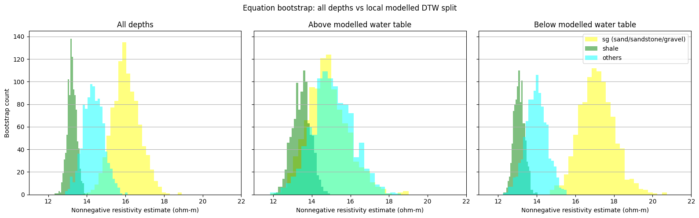
Figure 5.1: Non-negative least squares bootstrapping resistivity distributions across: (Left) All depths combined; (Center) Above modelled water table; and (Right) Below modelled water table. Sandstone/gravel (yellow) exhibits robust, distinct separation from shale (green) and others (cyan).
5.3 Discussion: Evaluation of the All-Depths Baseline and Considerations on Depth Partitioning
To establish an objective rock-physics transformation for regional 3D hydrogeological modeling, the comparative performance of the unsegmented (All Depths) and depth-partitioned (Above vs. Below Water Table) bootstrapping calibrations was evaluated. As illustrated in Figure 5.1, the All-Depths integrated calibration (left) yields clean, well-separated unimodal distributions across all three classes (sg: 16.2 ohm-m, others: 14.3 ohm-m, shale: 13.2 ohm-m), and is adopted as the primary operational baseline for production 3D lithological mapping.
When evaluating the dataset split by the regional modeled water table (DTW), the coarse clastic category (sg) exhibits slightly higher bulk resistivity below the water table (17.0 ohm-m) than above it (15.0 ohm-m), while sg and others heavily overlap in the shallow zone (Figure 5.1, center). While this pattern could initially appear counter to simple pore-saturation assumptions, interpreting results split by the water table across the entire corridor involves several practical data and geological considerations:
- 1. Resolution Limitations of the Regional Water Table Model: The regional depth-to-water-table (DTW) surface is an interpolated model derived from historical water well records with variable measurement dates and sparse spatial coverage across an 18,600 km² basin. The spatial and vertical resolution of this interpolated surface is relatively coarse compared to the scale of individual AEM soundings. Consequently, using this surface as a strict boundary introduces classification uncertainty, as the true local water table varies dynamically with topography and local hydrogeology.
- 2. Regional East-West Transition and Limits of Uniform Corridor Analysis: The Calgary-Lethbridge Corridor spans a profound regional geological transition—from resistive fluvial sandstones of the Scollard Formation in the west to conductive marine shales of the Bearpaw Formation in the east. Analyzing the entire survey corridor with a single, uniform calibration has inherent limitations. In the western sector, water wells frequently penetrate into bedrock sandstones below the water table, potentially contributing higher resistivities to the deeper dataset, whereas shallow soundings capture a higher proportion of eastern and surficial clay-rich materials. This regional geological asymmetry can naturally influence depth-partitioned statistics.
- 3. Near-Surface AEM Constraints and Overburden Characteristics: In the upper 10–15 m, AEM soundings are subject to wider diffusive footprints, altimeter variations, and fewer independent early-time gates. The surficial Laurentide till and glaciolacustrine clays are clay-rich and subject to semi-arid weathering and soil salinization. Thin, discontinuous sand lenses embedded within this conductive matrix cannot be easily resolved independently by AEM, which likely contributes to the heavy overlap observed between sg and others in the shallow zone.
- 4. Empirical Validation from AEM Depth Slices and Earlier Observations (Davis & Groom, 2018, p. 58): A general increase in resistivity with depth across the regional basin is visually confirmed by the AEM smooth inversion depth slices (Figure 5.2). At 1.00 m depth (Figure 5.2, left), the survey corridor is dominated by pervasive conductive overburden (< 12–15 ohm-m, dark purple/blue) associated with surficial tills and clays. At 49.59 m depth (Figure 5.2, right), the regional resistivity noticeably increases (20–60 ohm-m), delineating western Scollard bedrock sandstones (30–60 ohm-m) and basal paleochannels. This general progression is consistent with earlier AEM observations by Davis & Groom (2018; AER/AGS Special Report 110, p. 58), who noted that shallow river areas appeared conductive while deeper paleochannels were relatively resistive. This confirms that the transition from conductive surficial overburden to more resistive underlying bedrock and channel units is a genuine regional feature.
- 5. Rationale for Adopting the All-Depths Integrated Baseline: Given the resolution limits of the regional water table model, the pronounced East-West geological transition, and near-surface AEM constraints, attempting to segment the calibration by water table introduces more ambiguity than clarity. In contrast, the All-Depths integrated calibration (sg: 16.2 ohm-m, others: 14.3 ohm-m, shale: 13.2 ohm-m) integrates the full volumetric distribution of soundings, providing a stable, uncorrupted baseline for regional 3D lithological transformation, while regional domain partitioning remains an important avenue for future sub-regional modeling.
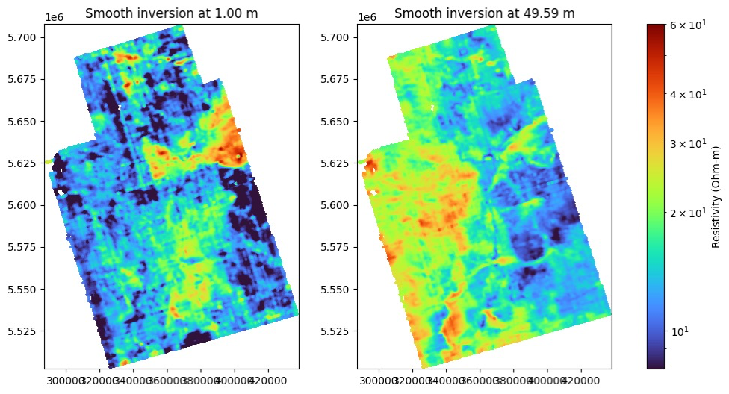
Figure 5.2: Regional AEM smooth inversion resistivity depth slices at 1.00 m (left) and 49.59 m (right) across the Calgary-Lethbridge Corridor. The 1.00 m slice displays pervasive conductive overburden (< 12–15 Ω·m, dark purple/blue) across the regional basin, whereas the 49.59 m slice reveals extensive resistive bedrock sandstones and buried paleochannels (20–60 Ω·m, yellow/orange/red), directly verifying that subsurface resistivity systematically increases with depth.
6. Conclusions and Recommendations
The advanced reprocessing and inversion of the 2011 Calgary-Lethbridge Corridor AeroTEM III dataset has successfully yielded a continuous, field-scale hydrogeological framework. The primary conclusions include:
1. Inversion Regularization: Implementing unreferenced spatial regularization ($α_{s}$ = 0) with 4% relative uncertainty and a 5% noise floor stabilized decay fitting across 30 time channels without generating spurious artifacts or suppressing resistive channel targets.
2. Regional Structural Mapping: Resistivity depth slices and cross-sections definitively map the regional transition from western resistive sandstone aquifers (Scollard Formation, 30–60 ohm-m) to eastern conductive shale aquitards (Bearpaw Formation, < 10 ohm-m).
3. Rock Physics Calibration and Baseline Adoption: The All-Depths integrated bootstrapping calibration is adopted as the primary operational baseline (sg: 16.2 ohm-m, others: 14.3 ohm-m, shale: 13.2 ohm-m). While depth partitioning was examined, it is constrained by the coarse resolution of regional water-table data, near-surface AEM limits, and the pronounced East-West geological transition. Regional AEM depth slices (1.00 m vs. 49.59 m) and earlier survey observations (Davis & Groom, 2018, p. 58) confirm a general increase in resistivity with depth, supporting the all-depth model as the most reliable regional standard.
References
Aeroquest Airborne (2011): Report on a Helicopter-Borne AeroTEM System Electromagnetic & Magnetic Survey, Aeroquest Job # 11024, Southern Alberta; prepared for Government of Alberta, Environment, March 2011, Mississauga, ON, 19 pp.
Davis, L. and Groom, R.W. (2018): Calgary-Lethbridge Corridor Geophysical Survey: Interpretation of AeroTEM Airborne Data; Alberta Energy Regulator / Alberta Geological Survey, AER/AGS Special Report 110, 123 pp. (ISBN 978-1-4601-2216-7).
Hamilton, W.N., Langenberg, C.W., Price, M.C. and Chao, D.K. (1998): Geological map of Alberta; Alberta Geological Survey, AGS Map 236, scale 1:1,000,000.
Kang, S. (2025): Targeted inversion of airborne electromagnetic data for improved imaging of large-scale hydrogeologic structures; The Leading Edge.
Kang, S. (2026): Improved Imaging of Aquifer Systems in Southern Alberta using Airborne Electromagnetic Data; Statement of Work (SOW), University of Manitoba and Alberta Geological Survey, 4 pp.
Knight, R., R. Smith, T. Asch, J. Abraham, J. Cannia, A. Viezzoli, and G. Fogg (2018): Mapping aquifer Systems with Airborne Electromagnetics in the Central Valley of California; Groundwater, 56(6), 893–908.
Pawlowicz, J.G., Fenton, M.M. and Andriashek, L.D. (2007): Bedrock thalwegs, 1:2 000 000 scale (GIS data, line features); Alberta Energy and Utilities Board, EUB/AGS Earth Sciences Report 2007-06.

