**Supporting information S1: Map of sampled weather stations**

*E. M. Grooss, N. Eisenhauer, Y. Huang, J. Quosh, M. Wendisch, R. Beugnon  
10 April, 2025*

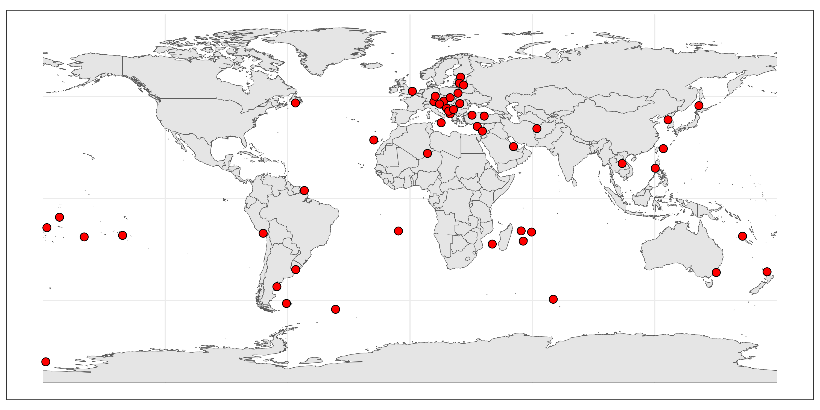Weather stations from which data were retrieved through the National Oceanic and Atmospheric Administration (NOAA). Stations were randomly selected from all 50 countries that had station with hourly temperature data available in 2020.