**Supporting information S6: Structure of the microclimate simulation**

*E. M. Grooss, N. Eisenhauer, Y. Huang, J. Quosh, M. Wendisch, R. Beugnon*  
*10 April, 2025*

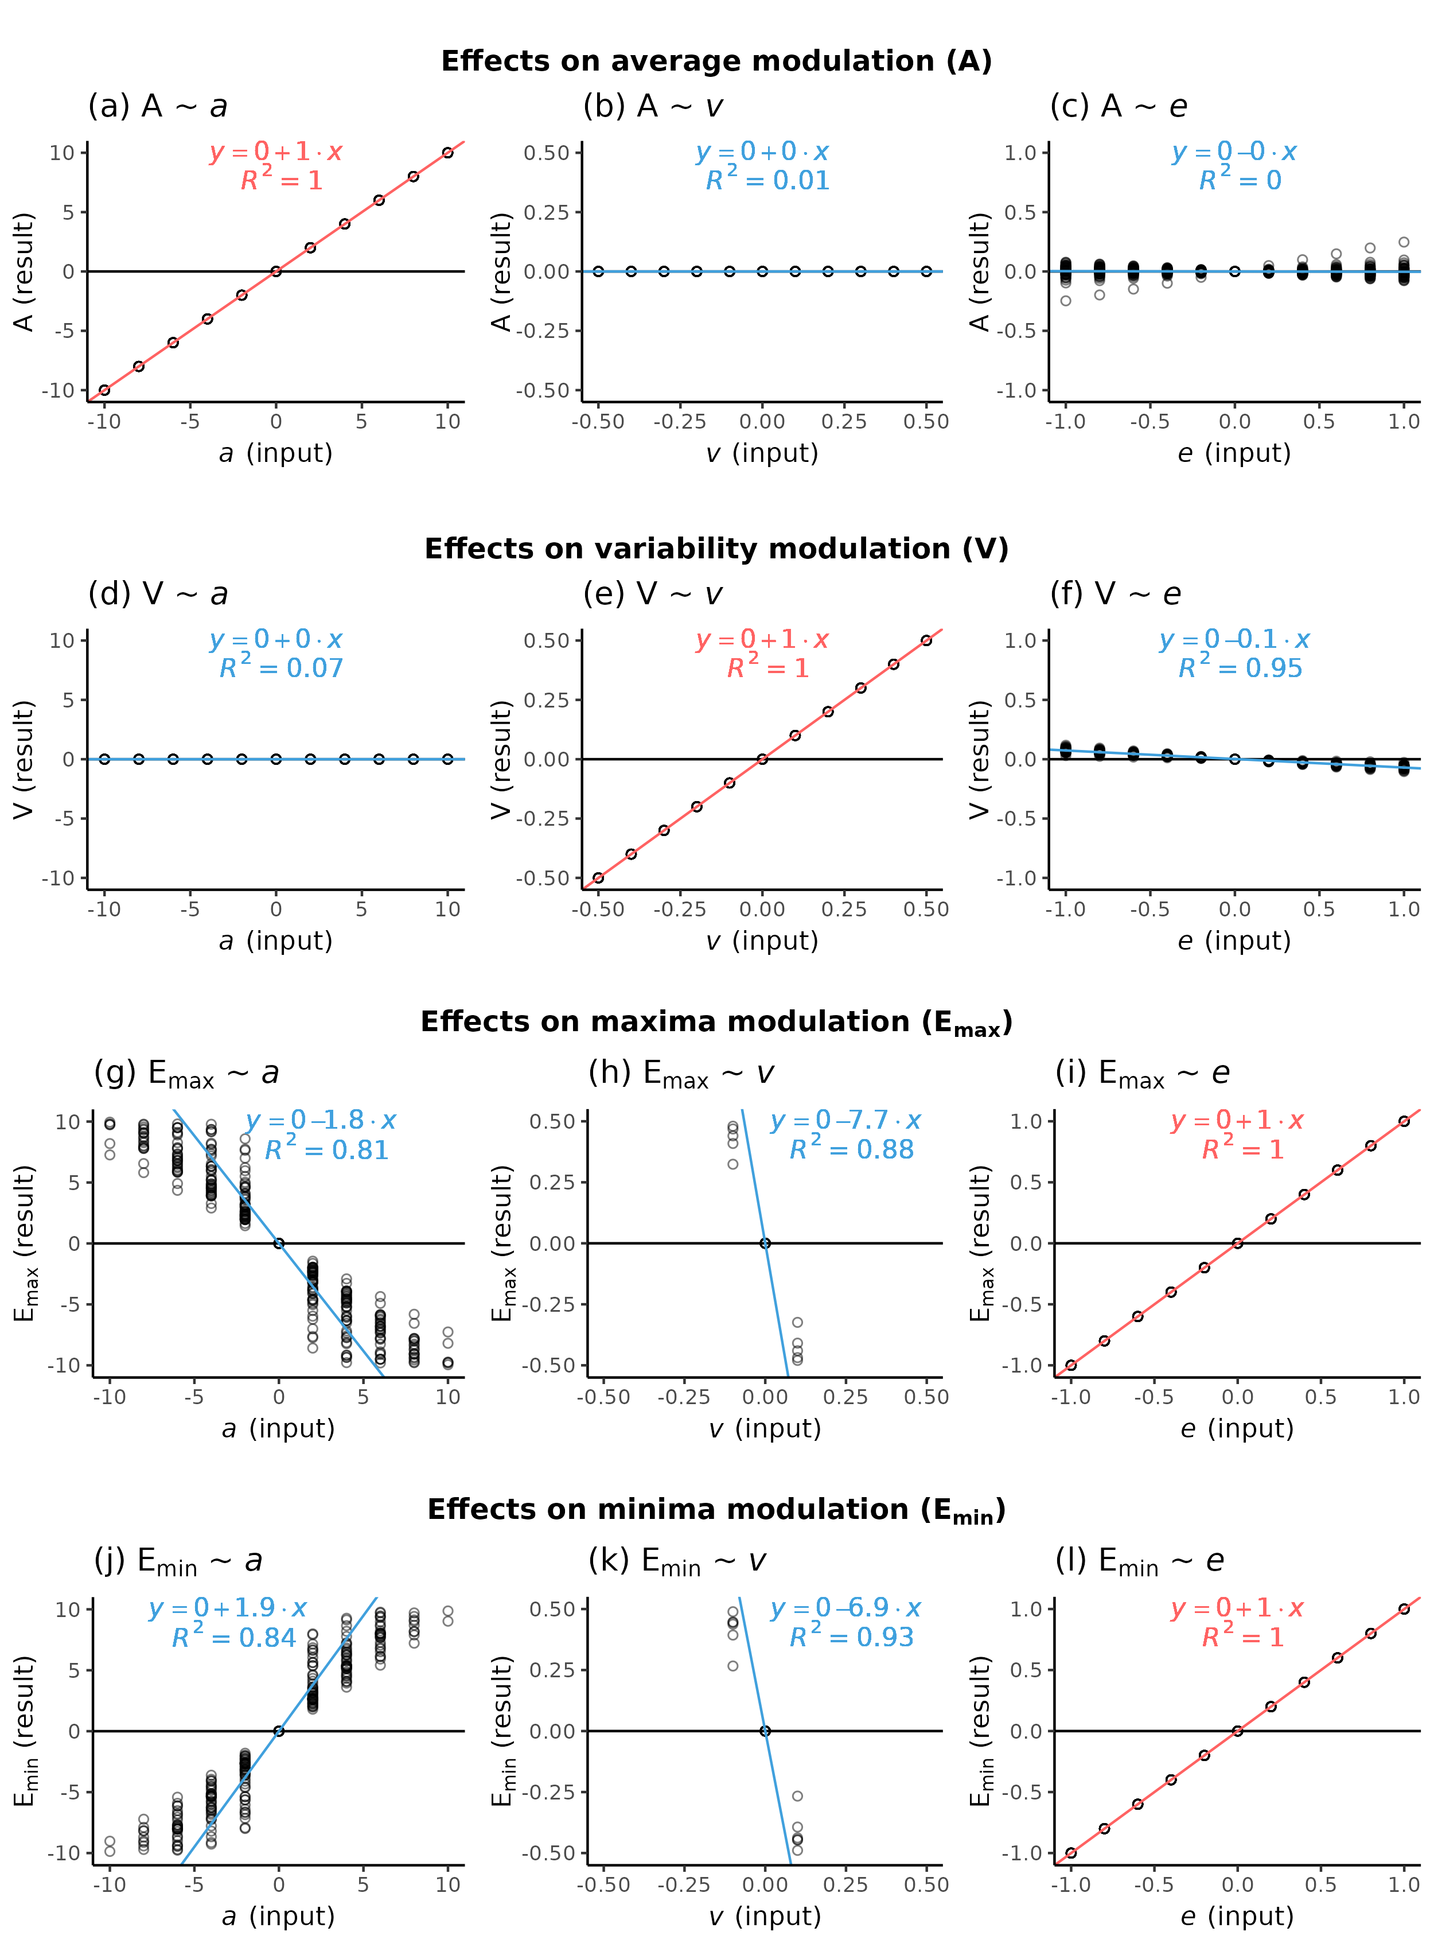

Effects of simulated microclimate modulation on the aspects average (A, a-c), variability (V, d-f), maxima (E max , g-i) and minima (E min , j-l). Regression lines where the

targeted modulation aspect corresponds to the input parameter are depicted in red.