**Supporting information S7: Performance of quantile-dependent indices at different quantiles**

*E. M. Grooss, N. Eisenhauer, Y. Huang, J. Quosh, M. Wendisch, R. Beugnon*  
*10 April, 2025*

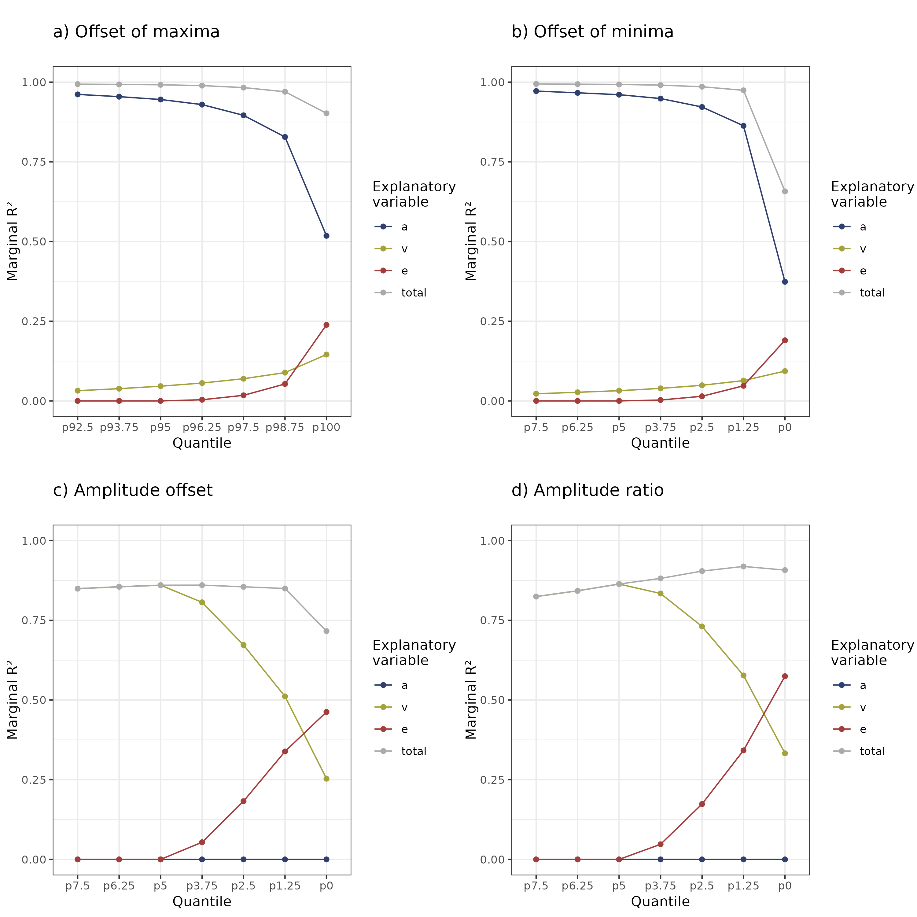

Effect of quantiles on the performance of the indices “offset of maxima”, “offset of minima”, “amplitude offset”, and “amplitude ratio”. For all indices, extreme modulation has no effect below the 95th or above the 5th percentile, i.e. the cut-off values for the simulation of extreme modulation. The variance explained by e increases towards the absolute maximum/minimum, while the variance explained by a decreases for offset of maxima and minima, and the variance explained by v decreases for amplitude offset and ratio. For all indices except amplitude ratio, the total marginal R² is decreased when the absolute maximum/minimum are used, indicating higher unexplained variance in the index.