**CSE 212 – Programming with Data Structures**

**W01 Prove – Response Document**

|  |  |
| --- | --- |
| **Name:** | Eli Hansen |
| **Date:** | 8/27/2024 |
| **Teacher:** | Zachariah Alvey |

*It is a violation of BYU-Idaho Honor Code to post or share this document with others or to post it online. Storage into a personal and private repository (e.g. private GitHub repository, unshared Google Drive folder) is acceptable.*

**Question 1: For the rotate right problem, provide a description of how you solved the problem.**

We have to first determine the count or how much data there is in the list, in this case it is the length of the list, so a list of { 1, 2, 3, 4, 5, 6, 7, 8, 9 } has a count of 9 and the amount is how much we need to rotate. So, if the amount is 1 then essentially, we just get the last value in the list and insert it at the front of the list. If the amount to move were 3, then we would get the last 3 values in the list and insert them at the front of the list. This rotates the list the given amount.

**Question 2: For the rotate right problem, draw a picture of how you solved the problem.**

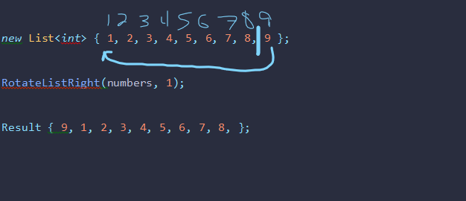

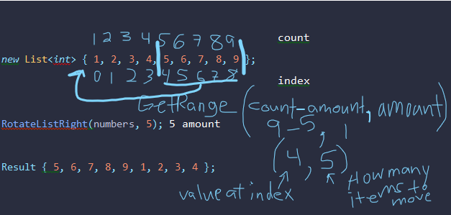

Remember: You need to commit all the changes to the prove-01-<username> repository along with this document. Then submit a link to the repository in I-Learn.