[College Result]

[A Python based Result analyser and visualizer]

MOHIT BANSAL

[05414802715]

Abstract

[Draw your reader in with an engaging abstract. It is typically a short summary of the document.   
When you’re ready to add your content, just click here and start typing.]

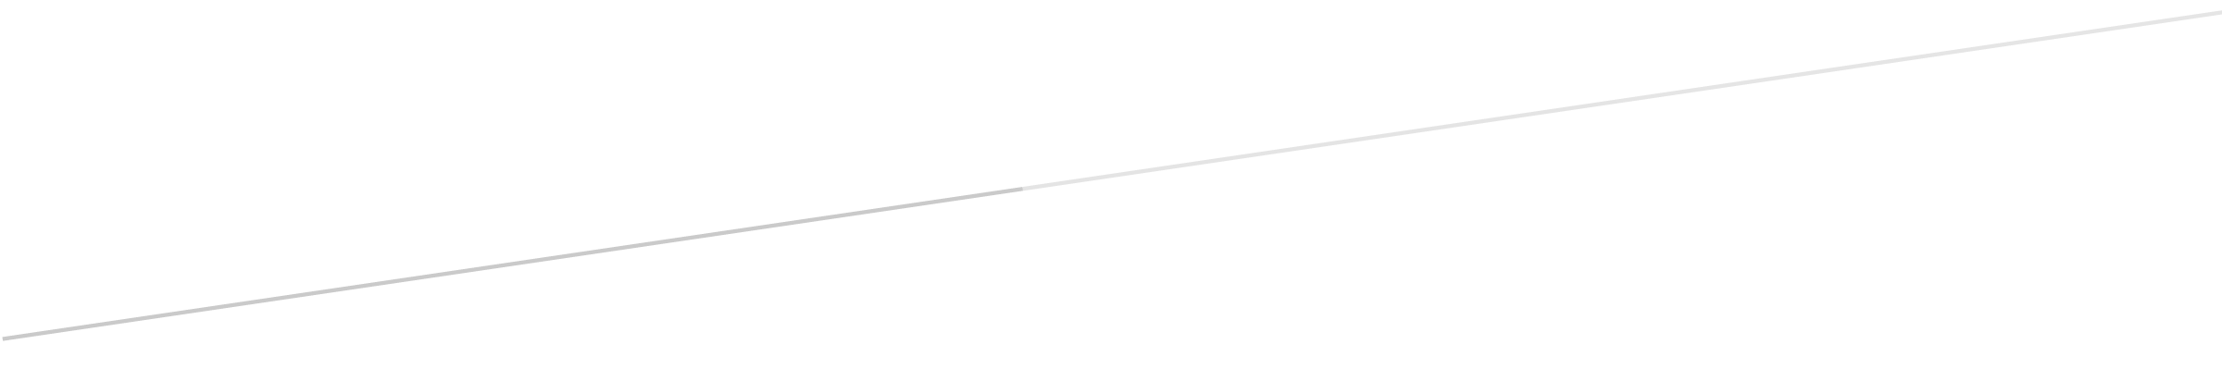

**Acknowledgement**

**Certificate**

**Declaration**

**Preface**

**Organization Introduction**

**List of Tables**

**List of Figures**

**Project Details**

**Contents**

**Screenshots**

**Conclusion**

**Reference/Bibliography**

**Abbreviations Used**

**Thanks for Coming!**