Design Example: CMOS Differential-pair with Constant-gm Biasing, FREEPDK45

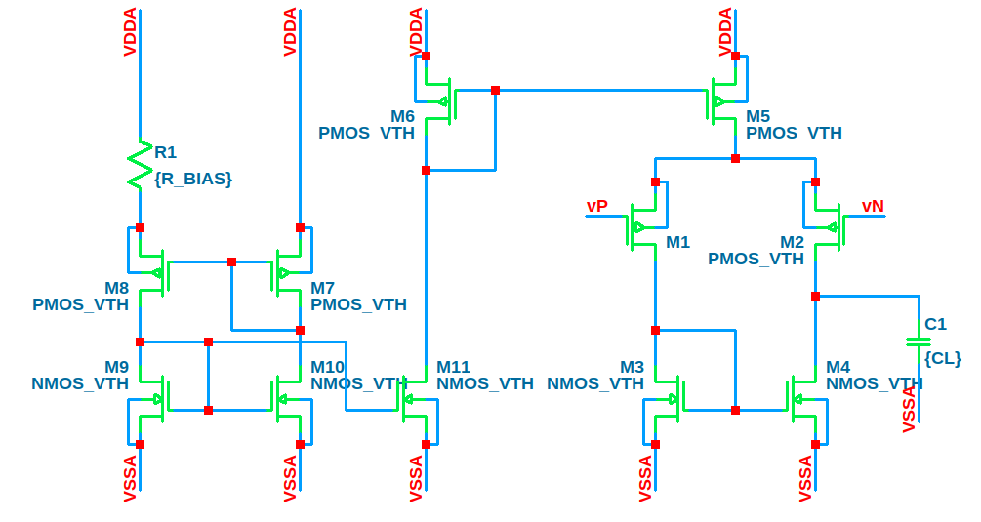Figure 1: Diff-pair with Constant-gm Biasing
Specifications:
VDD = 1.8V, GBW = 120e6 Hz, C_{L} = 10 pF, with freePDK45 process node technology

→ Start with M1 (and M2)
- From C_{L} and GBW: , where the factor 0.2 is to capture some parasitic capacitance
- Since we don’t have a specific power consumption spec here, we pick (MI) for M1 since it is a gain stage

- From of PMOS, we determine (there could be some other different candidates)
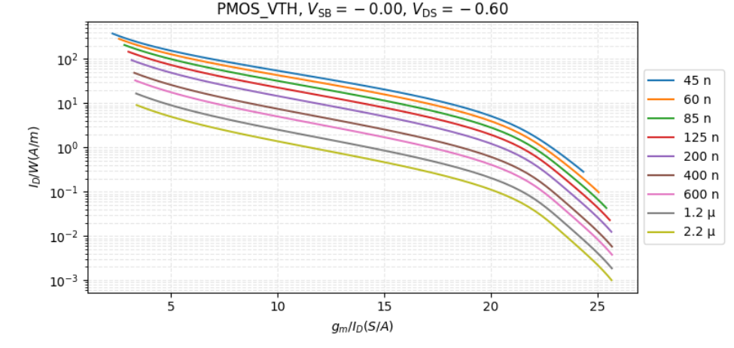Figure 2:

(If you have any DC gain requirement, you can increase L_{M1} by looking at , which will give you a new W_{M1}.)
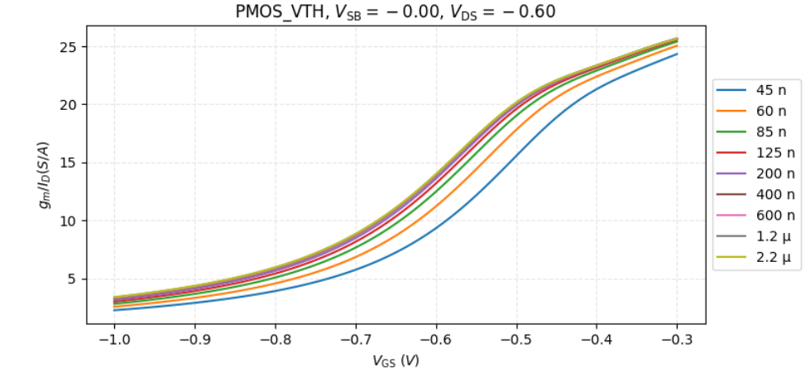Figure 3:

→ Second, we design M3 (and M4)
- Since we don’t have a specific power consumption spec here, we pick for M3 since it is an active load (source), so it should be smaller
- Since we know already from the calculation of M1, from , we determine (there could be some other candidates)
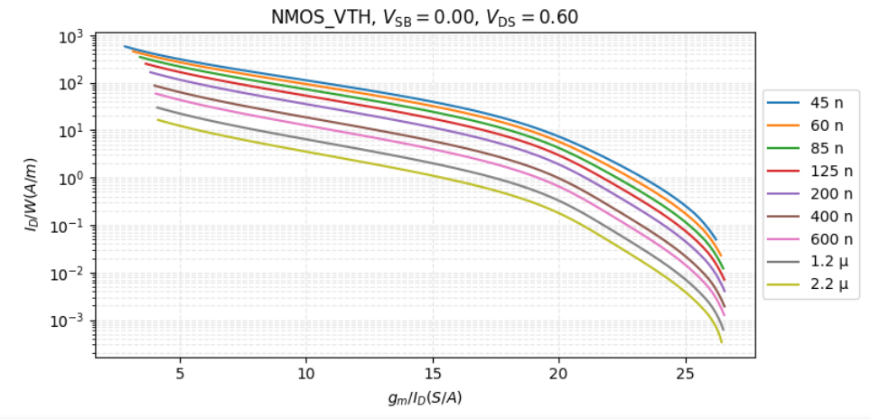Figure 4:

The active load and current source should have larger output impedance, therefore L is intentionally picked larger value.
→ Third, we design current mirror M5 (and M6)
- For simplicity here, we assume M5 and M6 have the same dimension (can be scaled down later for reducing power consumption(
- Since we don’t have a specific power consumption here, we pick M5 since it is active load (source), a device whose g_{m} does not contribute to gain and should have a good matching we pick the transonductance effficeiency in SI (The mismatch is independent of transistor width in strong inversion. The only way to improve the matching is to employ a longer channel.)
Theis even smaller than M3’s since here, , smaller can give larger L values, which is desirable for current mirror design
- Since we know , already from the calculation of M1, from Figure 2 we determine (there could be some other different candidates)

Now, we can start designing the constant-gm biasing block
Analysis:

→NMOS implementation of constant-g_{m} biasing circuit
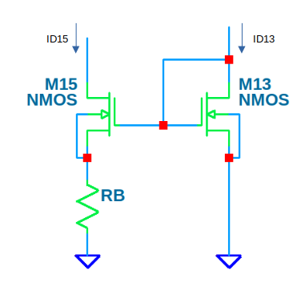Figure 5: NMOS implementation

→ PMOS implementation of constant-g_{m} biasing

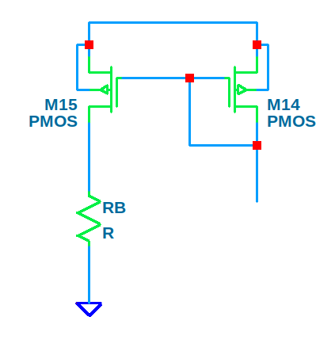Figure 6: PMOS implentation

Analysis:

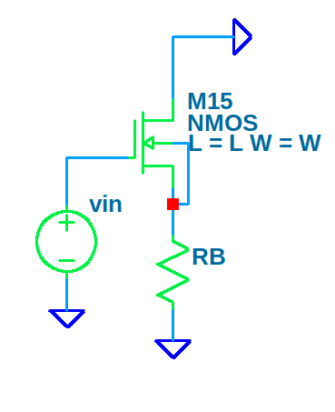Figure 7: G_{m} of NMOS with R_{B} in source
→ an analysis of the M15 and R_{B} subcircuit from Figure 5, shown in Figure 7 will show that G_{m} of this circuit is equal to 1/R_{B}

→ to keep gm constant in Figure 5 we need , this way if we can select gm through , we can set R_{B} to give us a specific current for biasing our amplifier
Now we will analyse Figure 5, to get the needed aspect ratios to have:

We arrive at,, where this were calculated as with long channels and strong-inversion equations.
If we let M1 and M7 have the same size, and if we can somehow let M1 and M7 have the same g_{m}, then their I_{D} will also be the same.
Design R_{BIAS}:
Letting

→ Design M7 (and M8)
- Simply copying M1 to M7:
- Rather than making , we can let and use multiplier (you can aproximate its value by SPICE simulations, as the equations used for this example are not accurate)
→ Design M9 (M10 and M11)
- Simply copying M3 to M9, M10
- For M11 we simply double the width of M9
- If necessary you can increase L of M9, M10 and M11 to increase the output resistance of current mirror, ensuring you are always operating them in saturation region.

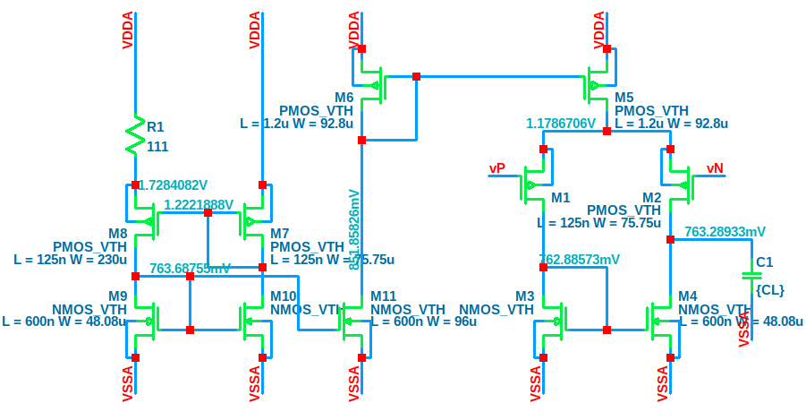Figure 8: Diff-Amp with Aspect Ratios for GBW ~120 MHz with freePDK45

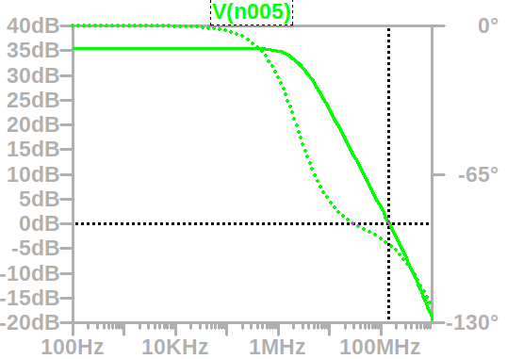Figure 9: GBW representation ~ 120 MHz

Appendix
Note: If you are designing by Av0 as a specification parameter, then L and will play a significant role as seen in Figure 10, where

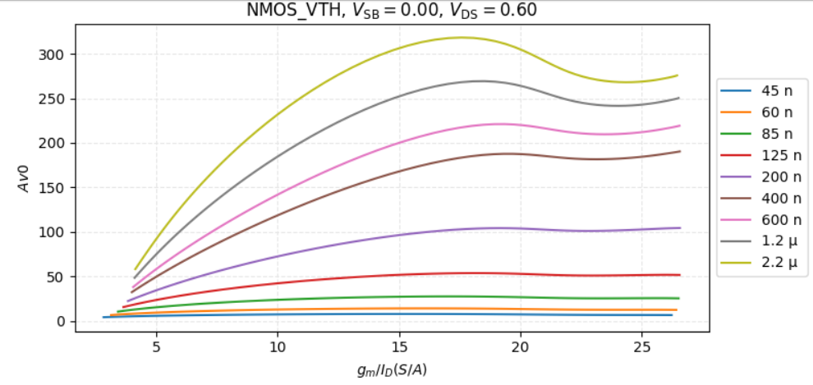Figure 10:
Av0 will also tradeoff with ft Figure 11, and implicitly fu of the circuit:
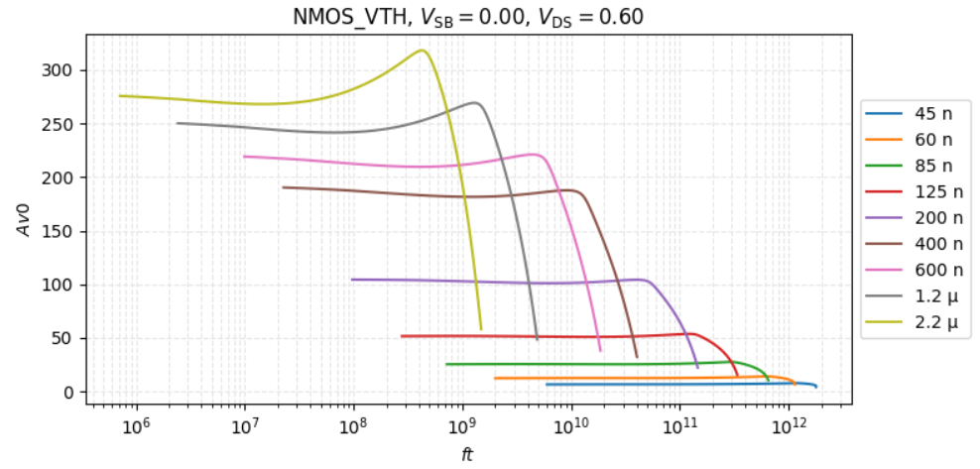Figure 11:

