SAPIENTIA
Enterprise Understanding Architecture Specification
Version 1.1

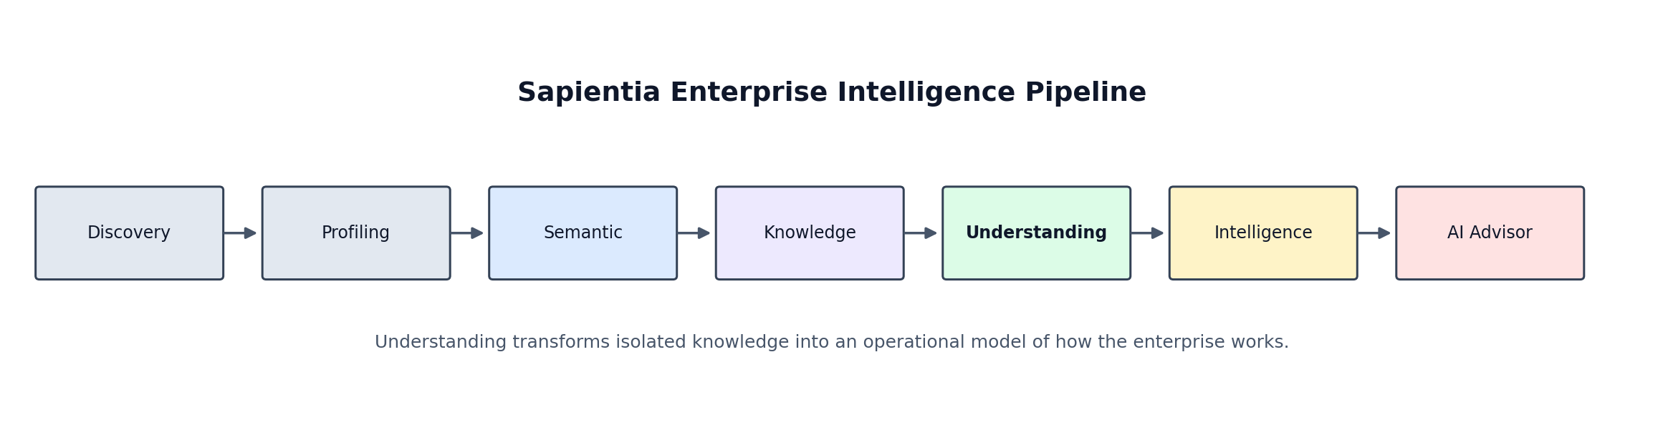
  - Architecture baseline for the Enterprise Understanding Layer within “The Enterprise Intelligence Platform.”

Document control | Value
Document owner | Sapientia Product and Architecture
Version | 1.1
Status | Revised department-agnostic architecture baseline
Scope | Enterprise Understanding Layer
Primary consumers | Knowledge Engine, Intelligence Engine, AI Advisor, product UI
Target MVP | Sapientia post-UI MVP capability build

1. Executive Summary
The Enterprise Understanding Layer converts isolated enterprise knowledge into an operational, explainable model of how a business works. It sits between the Knowledge and Intelligence layers and provides the missing context required for root-cause analysis, impact analysis, evidence-backed recommendations, and enterprise-grounded AI reasoning.
Core definition
The Enterprise Understanding Layer answers “How does this business work?” by connecting business concepts, processes, rules, events, evidence, systems, and dependencies into a governed Enterprise Understanding Model.

The layer does not replace discovery, profiling, semantic classification, or knowledge generation. It consumes their outputs and organises them into a coherent operational model. Intelligence and AI Advisor then use this model rather than attempting to infer the business from raw metadata at question time.

1.1 Business outcome
- Sapientia can explain how concepts are produced, used, and affected across the enterprise.
- Intelligence findings can be traced through processes, dependencies, rules, and source evidence.
- AI Advisor can reason over validated enterprise context rather than acting as a generic chatbot.
- Business understanding can evolve incrementally as new data, documents, rules, and user validations are added.
- Uncertain inferences remain explicit through confidence scoring, provenance, and validation status.

1.2 MVP boundary
Version 1.1 focuses on a department-agnostic operational model. The first implementation should infer and persist concept relationships, simple process structures, operational context, and bounded impact paths using existing Sapientia knowledge and evidence. Finance remains the first validation scenario because the current MVP already contains suitable Finance data and documents, but no core schema, relationship type, engine rule, repository contract, or API may depend on Finance-specific semantics. The implementation should not attempt full business process mining, enterprise-wide workflow automation, or autonomous decision execution.

1.3 Alignment with the Current Sapientia Codebase
The current Sapientia repository already contains an enterprise_understanding package. Its existing role is orchestration: it loads evidence, invokes Semantic, Knowledge Fusion and Enterprise Concept capabilities, and returns a consolidated understanding result for datasets within a common project and business-domain scope. Version 1.1 preserves that working pipeline but distinguishes it from the new persistent Enterprise Understanding Model described in this specification.
The implementation should evolve incrementally. Existing orchestration remains operational while a dedicated ekr_understanding persistence boundary, relationship inference services, snapshots and query contracts are introduced. Business-domain values may continue to constrain a run or filter context, but they are metadata scopes rather than hard-coded engine behaviour.
Compatibility rule: existing Enterprise Understanding service and engine entry points should be adapted or wrapped rather than duplicated. New components must follow Sapientia’s current service, repository, SQLAlchemy connection and dependency-injection conventions.

2. Goals and Non-Goals

2.1 Goals
- Define a canonical Enterprise Understanding Model (EUM).
- Create a dedicated ekr_understanding schema and ownership boundary.
- Infer business relationships from existing concepts, assets, metadata, rules, documents, and AI reasoning.
- Assemble relationships into understandable business processes and flows.
- Generate traversable impact paths for root-cause and downstream-impact analysis.
- Preserve evidence, provenance, confidence, temporal validity, and human validation for every inferred object.
- Expose stable read APIs to Enterprise Intelligence and AI Advisor.

2.2 Non-goals for v1.0
- Replacing the existing semantic or knowledge layers.
- Implementing a general-purpose graph database as a prerequisite.
- Automatically executing business actions or modifying source systems.
- Performing full event-log process mining across all enterprise systems.
- Guaranteeing that AI-inferred relationships are correct without supporting evidence or validation.
- Modelling every possible industry or departmental process before the generic model is proven through one primary and one secondary validation scenario.

3. Architecture Context

Figure 1. The Understanding Layer sits between Knowledge and Intelligence.
Layer | Primary question | Primary output
Discovery | What assets exist? | Datasets, documents, source systems, tables, columns and files
Profiling | What is the shape and quality of the data? | Profiles, quality indicators, distributions and samples
Semantic | What does the data represent? | Semantic types, candidate mappings and classifications
Knowledge | What business concepts and rules exist? | Concepts, definitions, rules, evidence and confidence
Understanding | How does the business operate? | Processes, relationships, operational context and impact paths
Intelligence | What is happening and why? | Findings, insights, recommendations and reports
AI Advisor | What does this mean and what should we do? | Evidence-grounded answers and actions for consideration

4. Design Principles
Principle | Implication
Business-first | Concepts and processes are first-class. Technical assets support them as evidence rather than defining the model.
Evidence-backed | Every inferred relationship, process, and impact path must retain evidence and provenance.
Confidence-aware | Inference uncertainty is explicit and machine-readable.
Explainable | Every output must be traceable back to relationships, rules, source assets, and generation runs.
Incremental | The model is enriched over time; it is not rebuilt as a disconnected snapshot for every question.
Temporal | Relationships and process structures may change. Effective dates and supersession must be supported.
Human-governed | Users can confirm, reject, or amend inferred understanding.
Storage-agnostic at the service boundary | PostgreSQL can support v1.0 while APIs preserve a path to a future graph projection if required.

5. Enterprise Understanding Model
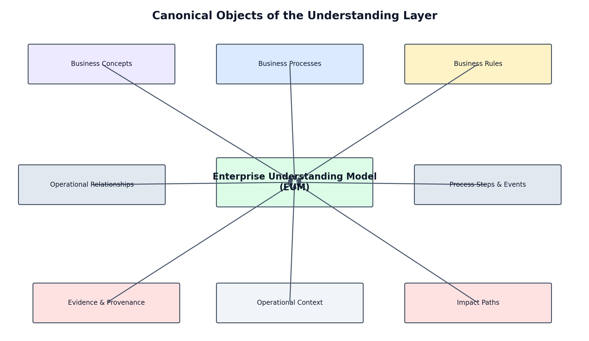
Figure 2. Canonical objects that together represent enterprise understanding.

5.1 Canonical entities
Entity | Purpose | Produced by
business_process | A coherent enterprise outcome or end-to-end process, such as fulfil demand, acquire goods, onboard a worker, or resolve a service request. | Knowledge concepts, rules and relationships
process_step | An ordered activity within a business process. | Process inference and validation
business_event | A meaningful occurrence that starts, changes, or completes a process step. | Source data, documents or AI inference
operational_relationship | A directed, typed relationship between two canonical objects. | Relationship Engine
business_dependency | A specialised relationship describing operational reliance or prerequisite. | Relationship and Impact Engines
business_flow | An ordered traversal that represents how value, information, or control moves. | Process Engine
operational_context | A consolidated view of where and how a concept operates. | Context Engine
impact_path | A scored, directional path describing upstream causes or downstream effects. | Impact Engine
understanding_evidence | A link between an inferred object and supporting evidence. | All engines
validation_decision | A human or automated decision that confirms, rejects, or amends an inferred object. | Validation service
understanding_snapshot | A versioned published model for repeatable intelligence and AI reasoning. | Publication service

5.2 Relationship taxonomy
Relationships are typed and directional. Generic “related to” edges may be stored during early inference, but they should not be treated as published enterprise understanding until a meaningful relationship type is assigned.
Type | Direction | Example
produces | Process/step -> concept or event | Invoice generation produces an Invoice
consumes | Process/step -> concept or asset | Revenue recognition consumes Invoice and Shipment evidence
depends_on | Concept/process -> concept/process | Revenue depends on recognised invoices
precedes | Step/event -> step/event | Shipment precedes invoice recognition
triggers | Event -> step/process | Approved purchase order triggers goods receipt
generates | Concept/event -> concept/event | Invoice generates an accounts receivable obligation
derived_from | Concept -> concept/asset | Gross Margin is derived from Revenue and Cost of Goods Sold
governed_by | Concept/process -> rule/policy | Revenue is governed by recognition rules
measured_by | Concept/process -> KPI/metric | A process is measured by its relevant cycle-time, quality, cost, risk, or outcome metrics
owned_by | Concept/process -> organisational role | Cash Management is owned by Treasury
executed_in | Process/step -> source system | Invoice posting is executed in ERP
impacts | Concept/event/process -> concept/KPI | Late payment impacts Cash Flow
mitigates | Action/rule -> risk/impact | Credit control mitigates overdue receivables
evidenced_by | Any understanding object -> evidence | A relationship is evidenced by a policy paragraph and data pattern

6. Logical Architecture
Component | Responsibility
Understanding Orchestrator | Coordinates an understanding run, loads context, invokes engines, handles idempotency, and publishes results.
Relationship Engine | Infers candidate relationships between concepts, processes, rules, assets, events, and KPIs.
Process Engine | Groups validated or high-confidence relationships into processes, steps, events, and ordered flows.
Operational Context Engine | Builds the consolidated context for each concept and process: owners, systems, rules, evidence, producers, consumers, and metrics.
Impact Engine | Traverses dependencies and impact relationships to create upstream cause paths and downstream effect paths.
Evidence and Confidence Service | Normalises evidence, calculates confidence, records provenance, and prevents unsupported publication.
Validation Service | Supports confirm, reject, amend, and supersede decisions from users or governance rules.
Understanding Repository | Persists versioned EUM entities in ekr_understanding.
Understanding Query Service | Exposes stable APIs for UI, Intelligence Engine, and AI Advisor.
Snapshot Publisher | Creates immutable published snapshots so intelligence and AI answers can reference a specific model version.

7. Runtime Processing Flow
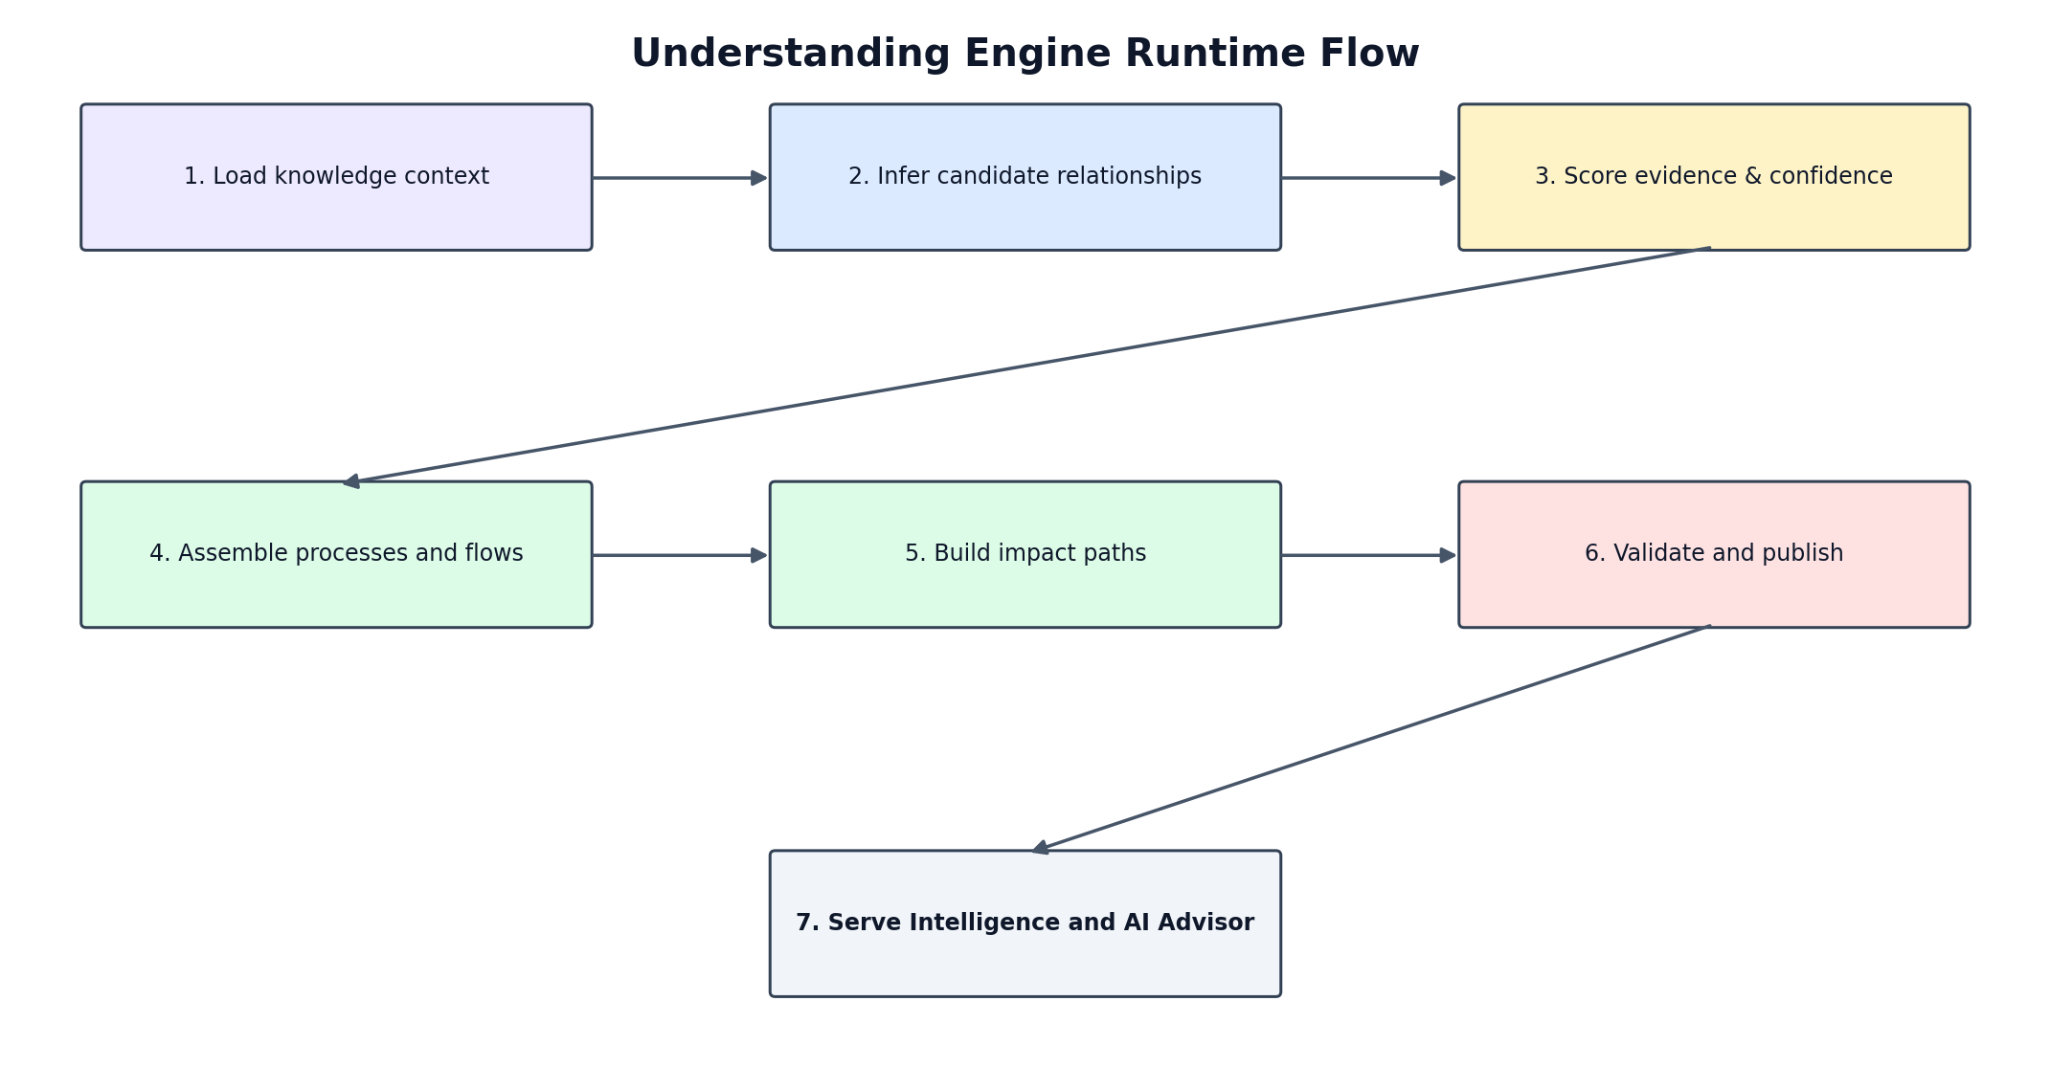
Figure 3. Proposed understanding generation and publication flow.
- Create an understanding run for a project or enterprise with an optional scope such as capability, process, business area, dataset, or document set.
- Load active concepts, definitions, rules, semantic mappings, profiles, assets, evidence, previous understanding, and relevant documents.
- Generate candidate relationships using deterministic rules first, then AI-assisted inference for unresolved cases.
- Attach evidence and calculate a confidence score for each candidate.
- Persist candidates as proposed objects; do not overwrite previously published understanding.
- Assemble compatible relationships into candidate processes, steps, flows, and impact paths.
- Apply validation thresholds and route low-confidence or conflicting candidates for review.
- Publish an immutable understanding snapshot containing approved and auto-published objects.
- Make the snapshot available to Intelligence and AI Advisor through read APIs.
- Record all generation, validation, supersession, and consumption events for auditability.

8. Inference Strategy

8.1 Evidence hierarchy
Evidence class | Examples | Default reliability
Explicit enterprise rule | Approved policy, procedure, glossary, configuration or user validation | Very high
Structural metadata | Foreign key, lineage, model constraint, ERP mapping | High
Observed data pattern | Repeated keys, temporal sequence, reconciled measures, co-occurrence | Medium to high
Naming and semantic convention | Column names, schema names, enterprise terminology, and recognised domain vocabulary | Medium
AI inference | LLM reasoning from supplied context | Variable; never sufficient alone for high-risk publication
External reference model | Industry process template or accounting convention | Supporting only until aligned to enterprise evidence

8.2 Deterministic inference rules for MVP
Rule | Candidate inference | Required evidence
Foreign-key relationship | A references/depends_on relationship between mapped business concepts | Validated key metadata plus concept mappings
Measure derivation | A derived_from relationship between KPI concepts | Expression, transformation logic, or approved business rule
Temporal sequence | A precedes or triggers relationship | Consistent event timestamps across sufficient records
Shared business identifier | Concepts participate in the same process context | Stable shared key and semantic compatibility
Documented verb phrase | Typed relationship from policy or procedure text | Document extract and concept/entity grounding
Source-system action | Process step executed_in a system | System metadata, API operation, or documentation
Metric ownership | Process measured_by a KPI | Report metadata, glossary, or approved mapping

8.3 AI-assisted inference
AI may propose relationship types, process names, missing process steps, and operational explanations when deterministic evidence is incomplete. The AI prompt must include only bounded enterprise context and require structured output containing subject, predicate, object, rationale, supporting evidence identifiers, counter-evidence, and confidence. AI outputs enter the model as proposed candidates and remain distinguishable from validated enterprise facts.

9. Confidence and Publication Model
Confidence should be calculated from evidence rather than copied directly from an LLM response. The exact weighting may evolve, but v1.0 should use a transparent weighted score.
Dimension | Suggested weight | Description
Evidence authority | 30% | Reliability of policy, metadata, user validation, data pattern, or AI source
Evidence agreement | 20% | Degree to which independent sources support the same inference
Semantic compatibility | 15% | Compatibility of source and target object types with the relationship
Observed consistency | 15% | Frequency and stability of the pattern across available records or documents
Temporal validity | 10% | Whether evidence is current and applies to the effective period
Contradiction penalty | Up to -30% | Reduction for conflicting rules, patterns, or validation decisions
Human validation bonus | Up to +20% | Increase for authorised confirmation, capped at 100%

Score | Default status | Publication behaviour
0.90-1.00 | high_confidence | Eligible for automatic publication when no contradiction exists
0.70-0.89 | review_recommended | May be used in exploratory analysis; clearly marked as inferred
0.50-0.69 | proposed | Requires review before publication
< 0.50 | insufficient | Retained for diagnostics but excluded from published understanding

10. Physical Storage Model
A dedicated PostgreSQL schema named ekr_understanding is recommended. The initial design uses relational tables with adjacency-style relationships. This is sufficient for the MVP and keeps deployment aligned with Sapientia’s current architecture. A graph projection can be added later without changing the canonical service contract.
Table | Purpose
understanding_run | Run-level status, scope, timing, model version, and errors.
business_process | Canonical process identity, name, description, owner, scope, status, confidence, and validity.
process_step | Ordered step linked to a process, with inputs, outputs, systems, and conditions.
business_event | Event identity, event type, triggering conditions, source, and temporal semantics.
operational_relationship | Subject, predicate, object, direction, confidence, status, generation method, and validity.
business_flow | Named ordered flow representing value, information, control, or causal movement.
business_flow_step | Ordered membership of process steps, events, concepts, or relationships in a flow.
operational_context | Materialised concept/process context for efficient UI and AI retrieval.
impact_path | Path header with direction, scenario, total confidence, and model snapshot.
impact_path_step | Ordered relationship membership with cumulative confidence and explanatory text.
understanding_evidence | Evidence links for any process, step, relationship, context, or path.
validation_decision | Reviewer, decision, reason, amendments, timestamp, and authority.
understanding_snapshot | Immutable publication identifier, scope, version, status, and effective timestamp.
snapshot_object | Objects included in each published snapshot.
understanding_audit_event | Append-only lifecycle and consumption events.

10.1 Key design rules
- Use UUID or bigint surrogate identifiers consistently with the existing Sapientia repository conventions.
- Every business object must include project_id and, where available, enterprise_id. Business domain, business area, capability, process, dataset, or document scope is optional classification context and must not determine the canonical model.
- Relationship subjects and objects must reference canonical object identifiers and object types.
- Published records are not destructively updated; corrections create a new version and supersede the prior version.
- Every generated record must retain created_by_run_id and generation_method.
- Every evidence-bearing record must support one-to-many evidence links.
- All confidence values use the numeric range 0.0 to 1.0.
- Effective_from and effective_to support temporal changes in business operations.
- JSONB may be used for bounded extensibility, but core query fields must remain typed columns.

11. Service and API Contracts
Endpoint | Purpose
POST /understanding/build | Create an understanding run for the selected project or enterprise and optional scope.
GET /understanding/runs/{run_id} | Return status, stage, counts, warnings, and errors.
GET /understanding/summary | Return coverage, confidence, processes, relationship counts, and latest snapshot.
GET /understanding/processes | List processes and high-level flows.
GET /understanding/processes/{process_id} | Return steps, events, systems, concepts, rules, evidence, and confidence.
GET /understanding/concepts/{concept_id}/context | Return operational context for a concept.
GET /understanding/concepts/{concept_id}/impact | Return upstream or downstream impact paths.
GET /understanding/relationships | Search/filter relationships by subject, predicate, object, status, and confidence.
POST /understanding/objects/{type}/{id}/validate | Confirm, reject, or amend an inferred object.
GET /understanding/snapshots/{snapshot_id} | Return the immutable model version used by intelligence or AI.
POST /understanding/query | Return a bounded subgraph/context package for Intelligence or AI Advisor.

11.1 AI context package
The query endpoint should not expose an unbounded graph. It should return a compact, evidence-backed context package suitable for a specific question or intelligence task:
- Request scope and selected project or enterprise, including optional capability, process, business-area, dataset, or document filters.
- Relevant concepts and definitions.
- Operational relationships and process membership.
- Applicable business rules.
- Upstream and downstream impact paths.
- Evidence references and extracts.
- Confidence, validation status, and model snapshot identifier.
- Known contradictions or unresolved gaps.

12. Integration with Existing Sapientia Engines
Existing engine | Information supplied to Understanding | Information consumed from Understanding
Discovery | Assets, systems, datasets, documents and locations | None for v1.0
Profiling | Keys, distributions, timestamps, quality and statistical patterns | Potential future process-quality context
Semantic | Semantic types, candidate concept mappings and entity roles | Validated relationship context may improve future classification
Knowledge | Concepts, definitions, rules, evidence and confidence | Operational context and process membership
Intelligence | Findings, measures and analysis requirements | Processes, impact paths, dependencies and explanations
AI Advisor | Questions, intent and requested scope | Bounded model context, evidence, rules and impact paths
UI | Selected project or enterprise, optional scope, and validation actions | Processes, context, confidence, gaps and evidence

13. Department-Agnostic MVP Validation Examples
The first demonstrable scenario may use an Order-to-Cash or Procure-to-Pay flow because the existing Sapientia MVP already supports relevant data, documents, concepts, intelligence, and AI Advisor. This is a validation scenario, not a Finance-specific architecture. A smaller second scenario from another business area should prove that the same model and engine operate without schema or code changes.

13.1 Primary validation example: Order to Cash
Sequence | Object | Type | Key relationships
1 | Customer order received | Business event | triggers Order Validation
2 | Order Validation | Process step | consumes Customer and Order; governed_by credit rules
3 | Shipment completed | Business event | precedes Invoice Generation
4 | Invoice Generation | Process step | produces Invoice; executed_in ERP
5 | Revenue Recognition | Process step | consumes Invoice and Shipment; produces Revenue
6 | Accounts Receivable | Business concept | generated by Invoice; impacts Cash Flow
7 | Payment received | Business event | reduces Accounts Receivable; improves Cash Flow

13.2 Example reasoning path
Question
Why has cash flow deteriorated despite stable revenue?

- AI Advisor resolves Cash Flow and Revenue to validated business concepts.
- Understanding Query Service retrieves the relevant process and its downstream and upstream dependencies.
- The impact path shows Cash Flow depends on payment timing and Accounts Receivable, while Revenue is produced earlier at recognition.
- Intelligence provides evidence that overdue receivables and average payment days increased.
- Business rules provide standard payment terms and collection thresholds.
- AI Advisor explains that revenue remained stable but conversion of receivables into cash slowed, cites evidence, states confidence, and recommends investigation of late-paying customer segments.

13.3 Secondary cross-domain validation
Run the same canonical model and inference pipeline against a small non-Finance scenario, such as employee onboarding, customer support resolution, or inventory replenishment. The test passes only when no schema, repository, engine class, endpoint or relationship taxonomy change is required; only source evidence and optional configuration vocabulary may differ.

14. Product Experience
The Understanding Layer should be visible through existing product areas rather than introduced as another disconnected technical page. Enterprise Knowledge remains the main place to explore concepts, while process and operational context enrich each concept. Enterprise Intelligence uses the model to explain findings. AI Advisor uses it to answer questions.
Product area | Understanding experience
Enterprise Overview | Coverage summary: processes inferred, validated relationships, confidence, unresolved gaps.
Enterprise Knowledge | Concept detail includes produced by, consumed by, depends on, impacts, process membership, rules and evidence.
Enterprise Intelligence | Insights display causal and impact paths rather than isolated narratives.
AI Advisor | Answers include the reasoning path, evidence, confidence and model snapshot.
Data Sources | Shows which assets and documents contribute to enterprise understanding.
Validation workflow | Allows a business user to confirm, reject or amend candidate relationships and processes.

15. Governance, Security and Audit
- Apply enterprise and business-area access controls to every query and object.
- Do not expose evidence extracts from a source the requesting user cannot access.
- Record who generated, validated, amended, published, and consumed each object.
- Preserve the model snapshot used for every published intelligence report and AI answer.
- Classify AI-generated objects separately from deterministic and human-validated objects.
- Support retention and deletion policies for source-derived evidence.
- Prevent prompt inputs from bypassing repository-level authorisation filters.

16. Non-Functional Requirements
Area | v1.0 requirement
Explainability | All published objects trace to evidence and generation method.
Repeatability | A published snapshot reproduces the context used by an insight or answer.
Idempotency | Re-running the same scope must not create uncontrolled duplicates.
Performance | Concept context should return within 2 seconds for normal MVP scope; bounded impact traversal within 5 seconds.
Scalability | Repository and APIs support multiple enterprises, capabilities, business areas, datasets, documents, processes, and snapshots.
Observability | Runs expose stage, duration, object counts, confidence distribution, warnings and failure details.
Resilience | Partial inference failures do not invalidate previously published snapshots.
Extensibility | New object and relationship types can be introduced through controlled reference data and versioned contracts.

17. Implementation Plan
Increment | Deliverable | Acceptance outcome
U1 - Foundation | DDL, repositories, reference data, run orchestration and snapshot model | An empty but operational understanding run can be created and published.
U2 - Relationship Engine | Deterministic generic relationships, evidence links, and confidence scoring | Concepts show typed, evidence-backed relationships.
U3 - Process Engine | Generic process and step assembly with process APIs | At least one evidence-backed business flow is represented as a navigable process.
U4 - Context Engine | Materialised operational context and concept APIs | Knowledge pages can display how each concept operates.
U5 - Impact Engine | Upstream/downstream traversal and impact APIs | Sapientia can return explainable cause and effect paths.
U6 - Validation | Confirm/reject/amend workflow and audit events | A business user can govern inferred understanding.
U7 - Intelligence and AI integration | Bounded context package and snapshot references | Intelligence and AI Advisor use published understanding.
U8 - Demo hardening | Primary and secondary cross-domain test data, evaluation cases, observability, and regression tests | A repeatable end-to-end demonstration succeeds without manual database changes.

17.1 Recommended immediate build order
- Create ekr_understanding DDL and reference data.
- Implement the Understanding Repository and run lifecycle.
- Build deterministic relationship inference from existing concepts, foreign keys, semantic mappings, rules, and evidence.
- Expose concept operational-context and relationship read APIs.
- Add optional domain-pack process templates only as weak priors. They must be configuration-driven and must never substitute for enterprise evidence.
- Assemble the first evidence-backed process flow and verify that the same assembly logic can support a second business-area scenario.
- Add impact traversal and integrate it into one Intelligence report and one AI Advisor question.
- Add validation only after the initial candidate model can be inspected end to end.

18. MVP Acceptance Criteria
- An understanding run can be started for a project or scoped subset and completes with auditable stage status.
- At least ten typed relationships are generated from real Sapientia concepts and evidence.
- Every published relationship includes confidence, evidence, provenance, generation method, and validity dates.
- At least one business process contains ordered steps, inputs, outputs, systems, concepts, and rules, using only generic canonical object and relationship types.
- A concept context endpoint explains where a concept is produced, used, governed, measured, and impacted.
- An impact endpoint returns at least one explainable upstream and downstream path.
- A low-confidence or conflicting relationship can be reviewed and confirmed, rejected, or amended.
- One Intelligence output references an understanding snapshot and displays its causal path.
- One AI Advisor answer uses a bounded understanding context package and cites evidence.
- Re-running the same source scope does not create uncontrolled duplicate published objects.

19. Key Risks and Mitigations
Risk | Mitigation
AI invents plausible but unsupported business relationships | Require evidence identifiers, apply confidence thresholds, retain proposed status, and support validation.
Model becomes too generic or abstract | Start with one concrete business scenario and bounded process outputs, not an unlimited ontology.
Graph traversal becomes expensive | Use bounded depth, typed predicates, indexed adjacency tables, and materialised operational context.
Duplicate concepts create fragmented understanding | Use canonical concept identity and synonym resolution before relationship publication.
Process templates override enterprise reality | Treat templates only as priors and require enterprise evidence for publication.
Users cannot understand confidence | Expose plain-language confidence reasons and supporting/contradicting evidence.
Version changes break reproducibility | Use immutable snapshots and store snapshot IDs on reports and AI responses.
Scope expands beyond MVP | Limit v1.1 to one primary process, one lightweight cross-domain validation case, and the APIs required by Intelligence and AI Advisor.

20. Architecture Decisions
Decision | v1.0 position | Reason
Dedicated schema | Use ekr_understanding | Separates “what we know” from “how the business operates”.
Database technology | Use existing PostgreSQL/Aurora storage | Avoids premature graph-platform complexity and accelerates MVP delivery.
Graph representation | Typed adjacency relationships plus materialised context | Supports traversals while remaining compatible with current repositories.
Publication | Immutable snapshots | Enables repeatable intelligence and AI explanations.
AI role | Candidate generator and summariser, not source of truth | Protects explainability and trust.
Validation | First-class lifecycle state | Allows enterprise users to govern inferred understanding.
Initial validation scope | Finance-led example plus one non-Finance validation case | Aligns with existing test data, documents, concepts, reports and AI flows.

21. Target End-State
When implemented, Sapientia will no longer answer business questions by searching disconnected metadata and generated text. It will retrieve a versioned operational model of the enterprise, traverse the relevant processes and dependencies, apply business rules, assess current intelligence, and present a traceable explanation.
Illustrative end-state
A user asks why an enterprise outcome has deteriorated. Sapientia resolves the relevant concepts, traverses the applicable process and dependencies, combines current intelligence with documented rules and source evidence, explains the impact chain, reports confidence, and recommends a targeted investigation. The same generic understanding remains reusable by reports, future questions, and new intelligence runs. A Finance working-capital question is one possible demonstration, not a limitation of the model.

This is the role of the Enterprise Understanding Layer: to make enterprise data, knowledge, and AI collectively explain how the business works.

Appendix A - Suggested Status Values
Object lifecycle | Values
Inference status | proposed, review_recommended, approved, rejected, superseded
Publication status | draft, published, retired
Validation decision | confirmed, rejected, amended
Generation method | deterministic_rule, data_pattern, document_extraction, ai_inference, human_authored
Evidence role | supporting, contradicting, contextual
Path direction | upstream_cause, downstream_impact

Appendix B - Example Relationship Record
Subject: Business Object A
Predicate: generates
Object: Business Object B
Scope: Example enterprise process
Confidence: 0.94
Status: approved
Generation method: deterministic_rule
Evidence: structural mapping, approved procedure extract, observed data pattern
Effective from: 2026-07-01
Created by run: U-RUN-00042
Published snapshot: U-SNAP-00007

