Comparing Neighborhoods of two Major Cities in North America

Michael Obi

March 20, 2020

## 1.0 Introduction

1.1 Background

The strength and vitality of the many neighbourhoods that make up Toronto, Ontario, Canada has earned the city its unofficial nickname of "the city of neighbourhoods."[[1]](https://en.wikipedia.org/wiki/List_of_neighbourhoods_in_Toronto#cite_note-1) There are 140 neighbourhoods officially recognized by the City of Toronto[[2]](https://en.wikipedia.org/wiki/List_of_neighbourhoods_in_Toronto#cite_note-2) and upwards of 240 official and unofficial neighbourhoods within the city's boundaries.[[3]](https://en.wikipedia.org/wiki/List_of_neighbourhoods_in_Toronto#cite_note-3) Before 1998, Toronto was a much smaller municipality and formed part of [Metropolitan Toronto](https://en.wikipedia.org/wiki/Metropolitan_Toronto). When the [city amalgamated that year](https://en.wikipedia.org/wiki/Amalgamation_of_Toronto), Toronto grew to encompass the former municipalities of [York](https://en.wikipedia.org/wiki/York,_Toronto), [East York](https://en.wikipedia.org/wiki/East_York), [North York](https://en.wikipedia.org/wiki/North_York), [Etobicoke](https://en.wikipedia.org/wiki/Etobicoke), and [Scarborough](https://en.wikipedia.org/wiki/Scarborough,_Toronto). Each of these former municipalities still maintains, to a certain degree, its own distinct identity, and the names of these municipalities are still used by their residents, sometimes for disambiguation purposes as amalgamation resulted in duplicated street names. The area known as Toronto before the amalgamation is sometimes called the "old" City of Toronto, the Central District or simply "Downtown".

The neighborhoods in New York City are located within the five [boroughs](https://en.wikipedia.org/wiki/Boroughs_of_New_York_City) of the [City of New York](https://en.wikipedia.org/wiki/New_York_City). Their names and borders are not officially defined, and they change from time to time.[[4]](https://en.wikipedia.org/wiki/Neighborhoods_in_New_York_City#cite_note-1) New York City is split up into five boroughs: [the Bronx](https://en.wikipedia.org/wiki/The_Bronx), [Brooklyn](https://en.wikipedia.org/wiki/Brooklyn), [Manhattan](https://en.wikipedia.org/wiki/Manhattan), [Queens](https://en.wikipedia.org/wiki/Queens), and [Staten Island](https://en.wikipedia.org/wiki/Staten_Island). Each [borough](https://en.wikipedia.org/wiki/Borough_(New_York_City)) has the same boundaries as a [county](https://en.wikipedia.org/wiki/County_(United_States)) of the state. The county governments were dissolved when the city consolidated in 1898, along with all city, town, and village governments within each county. The term borough was adopted to describe a unique form of governmental administration for each of the five fundamental constituent parts of the newly [consolidated city](https://en.wikipedia.org/wiki/History_of_New_York_City_(1898-1945)).

In this project, I explored, a Downtown neighborhood in the city of Toronto in Canada and compare it to the downtown neighborhood in the city of New York in the United States of America.

1.2 Interest

Visitors and tourists across the cities would be very interested in knowing what similarities or differences exist and what to expect as they plan their travel for adaptability and cost control.

2. Data acquisition and cleaning

2.1 Data Sources

New York Neighborhood has a total of 5 boroughs and 306 neighborhoods. In order to segment the neighborhoods and explore them, I essentially used a dataset that contains the 5 boroughs and the neighborhoods that exist in each borough as well as the latitude and longitude coordinates of each neighborhood. The dataset was taken from the website at <https://geo.nyu.edu/catalog/nyu_2451_34572>

For the Toronto neighborhood data, a Wikipedia page exists that has all the information we need to explore the neighborhood of interest in Toronto. I scraped the Wikipedia page and wrangle the data, clean it, and then read it into a pandas dataframe so that it is in a structured format like the New York dataset.

2.2 Data Cleaning

Addresses were converted into their equivalent latitude and longitude values. Also, I used the Foursquare API to explore neighborhoods in both Cities. Also, the explore function was used to get the most common venue categories in each neighborhood, and then use this feature to compare the categories

3.0 Methodology

Once the data was in a structured format, I performed the analysis of the two city (Toronto and New York) datasets to explore and compare a downtown neighborhood in the cities.

3.1 Load and explore the datasets

The data for the New York neighborhood is gotten using the !wget to retrieve the data from a saved server directory and the then read with the json.load

3.2 Get Geo-Coordinates

Use geopy library to get the latitude and longitude values of the Cities. In order to define an instance of the geocoder, we need to define a user_agent. I named the agents NY_explorer and ON_explorer, as shown below.

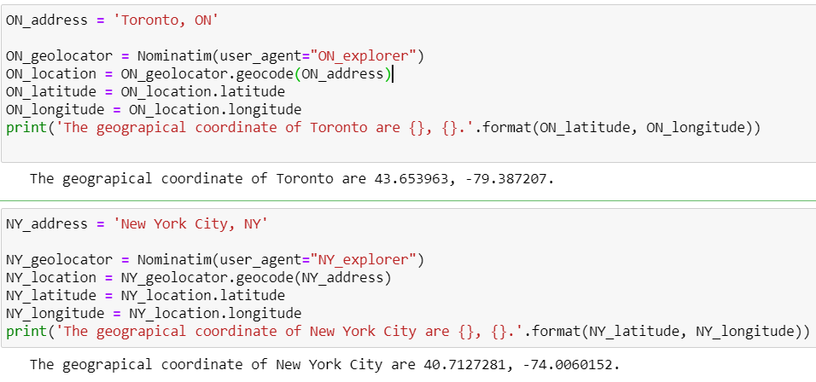

3.3 Transform the data into panda

Transform the data into a pandas dataframe. The next task is essentially transforming this data of nested Python dictionaries into a pandas dataframe. So, let's start by creating an empty dataframe. Then the neighborhoods in the new dataframe is explored. For New York, I selected the Downtown index, while I randomly selected a neighborhood based on the fact that the entire neighborhood makes up the Downtown of Toronto

3.4 Utilizing the Foursquare API

To explore the neighborhoods and segment them, first the original dataset is sliced to create a new dataset for the neighborhoods of interest. Then the I Defined Foursquare Credentials (CLIENT_ID, CLIENT_SECRET) and Version.

4.0 Results

# The results show that of the 100 venues returned in China town of downtown Toronto, there are 71 unique Categories. While the results show that of the 100 venues returned in China town of downtown Toronto, there are 55 unique Categories

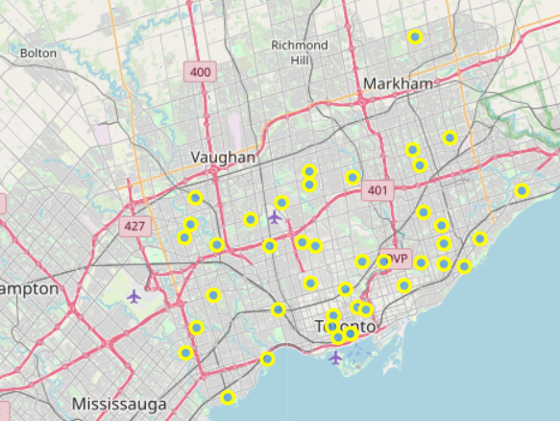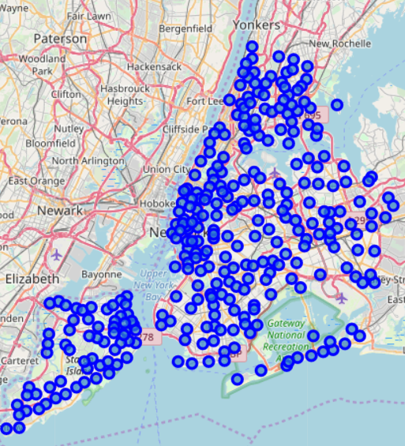

4.0 Discussion

We can see that New York downtown's Borough has more neighborhoods than that of Toronto Also notice that the Downtown area of New York is a neighborhood inside of Brooklyn, while the downtown of Toronto is an entire Borough.

5.0 Conclusion

The main aim of this work was to practice the use of the data science tools in python and employ the use of Four Square API with python to get useful information like geo coordinates and city profiles. Although this report does not give details as to the clusters of venues in these two cities, we can see a pattern or similarity in the places and categories of neighborhoods. Also, it is obvious from the data analysis that New York city is more neighborhoods segmented into few Boroughs, while Toronto has more Boroughs with less neighborhoods.

References

1. "The Globe's Insider's City Guides: Toronto" John Allemang, Tralee Pearce. *The Globe and Mail.* Jun 11, 2003. pg. T.1
2. [**^**](https://en.wikipedia.org/wiki/List_of_neighbourhoods_in_Toronto#cite_ref-2) *Toronto, City of (14 July 2017).*[*"Data, Research & Maps"*](http://www.toronto.ca/demographics/profiles_map_and_index.htm)*. toronto.ca.*
3. [**^**](https://en.wikipedia.org/wiki/List_of_neighbourhoods_in_Toronto#cite_ref-3) [*"City of Toronto Residential Communities and Business Improvement Areas Map"*](https://web.archive.org/web/20060103041741/http:/www.toronto.ca/pdf/hoods.pdf)*(PDF). toronto.ca. Archived from*[*the original*](http://www.toronto.ca/pdf/hoods.pdf)*(PDF) on 2006-01-03. Retrieved 2009-05-21.*
4. MICHAEL M. GRYNBAUM (September 9, 2012). [*"Amateur Mapmakers Reshape Neighborhoods"*](https://www.nytimes.com/2012/09/10/nyregion/amateur-mapmakers-reshape-new-york-neighborhoods-online.html?_r=0). New York Times.

<https://en.wikipedia.org/wiki/List_of_neighbourhoods_in_Toronto>

<https://en.wikipedia.org/wiki/Neighborhoods_in_New_York_City>