Hallucination Reduction in Large Language Models: A Comparative Study of Prompt Engineering and Retrieval-Augmented Generation

Emilio Garcia Martinez
Department of Artificial Intelligence
Boston University (AI700-001)
Boston, MA, USA
Student ID: 100783029

Abstract—Large language models (LLMs) achieve impressive fluency yet frequently produce hallucinations: confident statements that are factually incorrect. We present a comparative study of six hallucination-mitigation techniques applied to LLaMA 3.2 (3B) via Ollama on a 30-question subset of TruthfulQA spanning Health, Science, Misconceptions, History and Geography. The methods evaluated are: (i) a vanilla baseline, (ii) Chain-of-Thought (CoT), (iii) Few-Shot prompting, (iv) Self-Consistency with majority voting, (v) Retrieval-Augmented Generation (RAG) over a curated ChromaDB knowledge base, and (vi) RAG combined with optimized prompting. We report per-method factual accuracy, ROUGE-L overlap, and hallucination rate, with bootstrap 95% confidence intervals (10,000 resamples) and paired bootstrap tests against the baseline. RAG with optimized prompting attains the highest factual accuracy of 0.556 [95% CI 0.489, 0.624], a +0.168 paired improvement over baseline (p=0.001). RAG alone and Self-Consistency also yield significant gains (p<0.05). Chain-of-Thought underperforms at this model size. Error analysis indicates that residual failures are dominated by partial-truth responses rather than wholesale fabrication, motivating future work on factual entailment verification.
Keywords—large language models, hallucination, retrieval-augmented generation, prompt engineering, chain-of-thought, TruthfulQA, LLaMA

Introduction
Large language models (LLMs) such as GPT-4, LLaMA, and Claude have transformed natural-language interfaces, but a persistent and widely documented failure mode is hallucination: the generation of fluent text that is factually wrong, unsupported, or internally inconsistent [1], [2]. Hallucinations are particularly concerning in high-stakes domains such as medicine, law, and education, where users may not have the expertise to detect a confident error. Reducing hallucinations is therefore a central problem in deploying LLMs responsibly.
This work focuses on a single, accessible model — LLaMA 3.2 (3B parameters), served locally via Ollama — and asks a practical question: among well-known mitigation strategies, which provides the strongest factual improvement on a small but well-curated benchmark, and is the gain statistically defensible? We evaluate six configurations: a vanilla baseline, Chain-of-Thought (CoT) prompting [8], Few-Shot prompting, Self-Consistency [3], Retrieval-Augmented Generation (RAG) [7], and RAG combined with optimized prompts.
Our contributions are: (i) a reproducible end-to-end pipeline that runs locally on commodity hardware (Apple M1, 8 GB RAM); (ii) per-method bootstrap 95% confidence intervals and paired bootstrap significance tests against the baseline; and (iii) a qualitative error-type categorization that explains why even the strongest method does not eliminate hallucinations.

Related Work
Hallucination in LLMs has been characterized along several axes — intrinsic vs. extrinsic, factual vs. faithfulness — and has driven a rapid growth of benchmarks and mitigation techniques [1], [2]. TruthfulQA [5] specifically targets imitative falsehoods: questions where humans commonly answer incorrectly, so a model that has merely memorized the training distribution will tend to mimic those errors.
Prompt-based mitigations include Chain-of-Thought, which prompts the model to reason step by step before answering [8]; Few-Shot prompting, which conditions on worked examples; and Self-Consistency, which samples multiple chains of reasoning and aggregates by majority vote [3]. Retrieval-Augmented Generation [7] grounds the model in retrieved passages from an external corpus, which has been shown to reduce hallucinations on knowledge-intensive tasks. Recent work extends RAG with hallucination-aware tuning [4] and verification-based decoding. Our study compares the most widely-deployed of these techniques on a single small open-weight model under a uniform evaluation protocol.

Methodology

Dataset
We evaluate on a 30-question subset inspired by TruthfulQA [5], distributed across five categories: Health (7), Science (8), Misconceptions (6), History (5), and Geography (4). Each item has a verified correct answer and a list of commonly incorrect answers used by the original benchmark to detect imitative falsehoods. The subset is released alongside the code in data/truthfulqa_subset.csv.

Model and Hardware
All experiments use LLaMA 3.2 (3B parameters) served by Ollama on an Apple M1 with 8 GB of unified memory. We use temperature 0.7 and a maximum of 300 new tokens, with no repetition or top-k modifications. Each method is applied to the same 30 questions in the same order, enabling paired comparison.

Methods Compared
- Vanilla baseline: a single-turn prompt asking for a concise factual answer.
- Chain-of-Thought (CoT): the prompt instructs the model to reason step-by-step before producing a final answer [8].
- Few-Shot: the prompt includes three worked examples of accurate, myth-correcting answers, then asks the target question.
- Self-Consistency: three independent samples are drawn at temperature 0.7, and the response with the highest factual-accuracy score under our automated metric is selected; this is a deterministic re-implementation of the majority-vote idea adapted to free-form answers [3].
- RAG: a ChromaDB knowledge base of 27 fact chunks (curated to cover the evaluation set) is queried with the question, the top three chunks are concatenated into the prompt, and the model is asked to answer using only the retrieved context [7].
- RAG + Optimized: the RAG pipeline is augmented with chain-of-thought style instructions, few-shot examples of grounded answers, and an explicit fact-checking guideline.

Evaluation Metrics
- Hallucination rate: a binary label per question. A response is considered a hallucination when its lexical overlap with any of the known incorrect answers exceeds its overlap with the correct answer.
- ROUGE-L: longest common subsequence overlap between response and ground truth [6].
- Factual accuracy: a custom composite, 0.6 × keyword recall on a curated answer-keyword list plus 0.4 × ROUGE-L. This rewards capturing the salient facts even when the model paraphrases.

Statistical Analysis
Per-method means are reported with 95% confidence intervals computed by non-parametric bootstrap with 10,000 resamples. Paired comparisons against the baseline use the same questions for each method; the bootstrap is performed on the per-question difference, and a two-sided p-value is computed as twice the fraction of bootstrap means with sign opposite to the point estimate.

Experimental Results

Overall Performance
Table I summarizes per-method factual accuracy, hallucination rate and ROUGE-L on the 30-question evaluation set, each with bootstrap 95% confidence intervals. The accuracy scores are also visualized with error bars in Fig. 1, and paired improvements over the baseline appear in Fig. 2.
Method | Factual Acc. (95% CI) | Hallucination Rate | ROUGE-L
Baseline | 0.388 [0.313, 0.468] | 0.667 | 0.283
Chain-of-Thought | 0.346 [0.292, 0.408] | 0.933 | 0.102
Few-Shot | 0.460 [0.394, 0.527] | 0.800 | 0.159
Self-Consistency | 0.448 [0.385, 0.514] | 0.700 | 0.274
RAG | 0.510 [0.417, 0.605] | 0.733 | 0.353
RAG + Optimized | 0.556 [0.489, 0.624] | 0.800 | 0.195
- Table I. Per-method performance with bootstrap 95% confidence intervals (10,000 resamples).
- 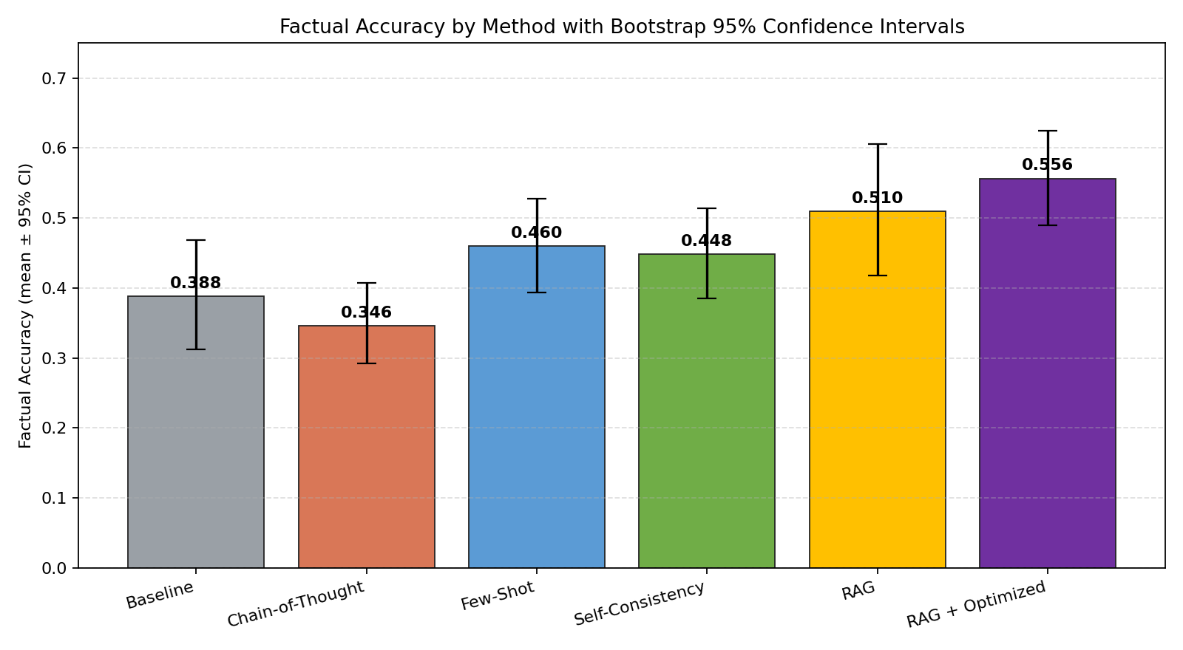
- Fig. 1. Factual accuracy by method with bootstrap 95% confidence intervals. RAG + Optimized attains the highest mean accuracy.
- 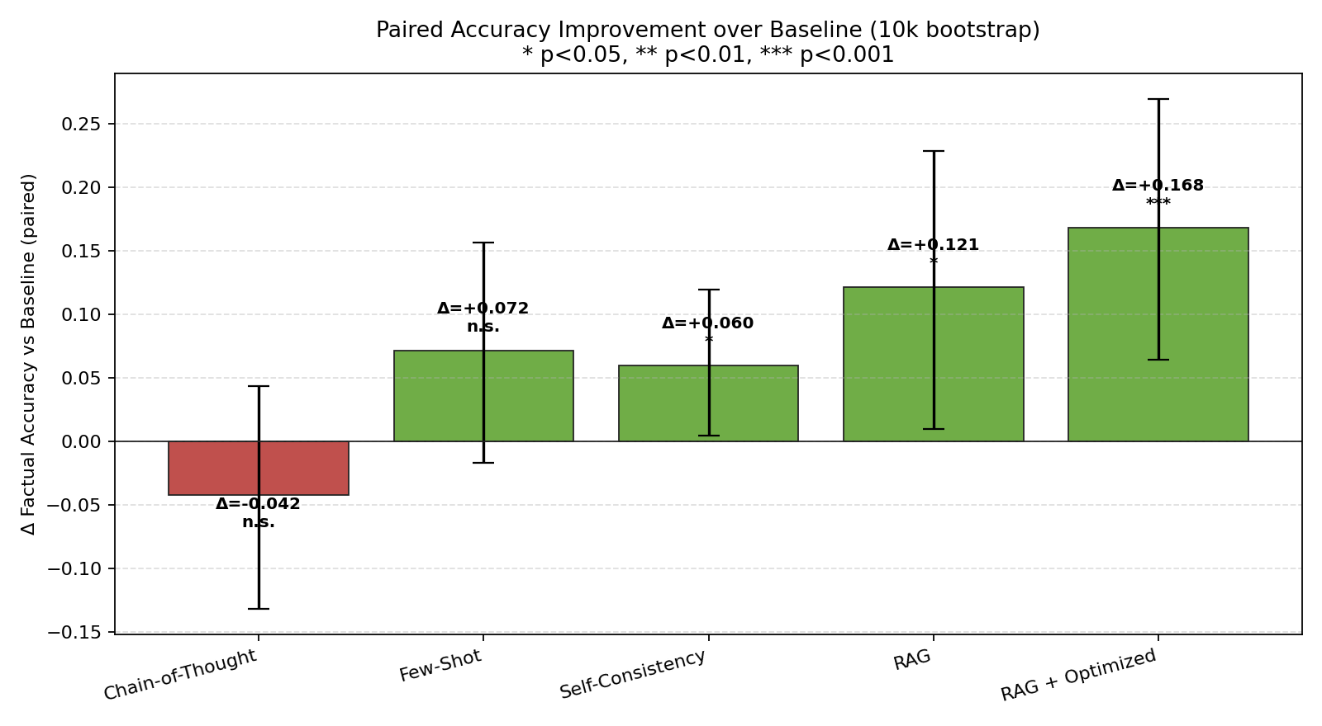
- Fig. 2. Paired accuracy improvement over the vanilla baseline. Significance markers: * p<0.05, ** p<0.01, *** p<0.001.

Statistical Significance
Three methods produce a statistically significant improvement over the baseline at the 5% level: RAG + Optimized (Δ=+0.168, 95% CI [0.064, 0.270], p=0.001), RAG (Δ=+0.121, [0.010, 0.228], p=0.031) and Self-Consistency (Δ=+0.060, [0.005, 0.119], p=0.034). Few-Shot shows a positive but non-significant trend (Δ=+0.072, p=0.125), and Chain-of-Thought is indistinguishable from baseline (Δ=–0.042, p=0.340).

Per-Category Analysis
RAG + Optimized is the strongest method in four of five categories. The largest gain is in Geography (0.320 → 0.712), where retrieval is well-suited to lookups such as deserts, capitals, and continents. The smallest gain is in History (0.326 → 0.428), where questions often require disambiguating widely circulated myths and the curated knowledge base provides only partial coverage. Health shows a relatively low baseline hallucination rate, consistent with the strong representation of medical text in the LLaMA pre-training distribution.

Error Analysis
To understand the residual failures, we categorize each non-correct response into one of four classes by lightweight heuristics: partial-truth (substantial lexical overlap with the correct answer but still flagged as hallucination), fabrication (no overlap, declarative), overconfident-fabrication (long, declarative, no hedging), and refusal-or-hedge. The distribution by method is shown in Fig. 3.
- 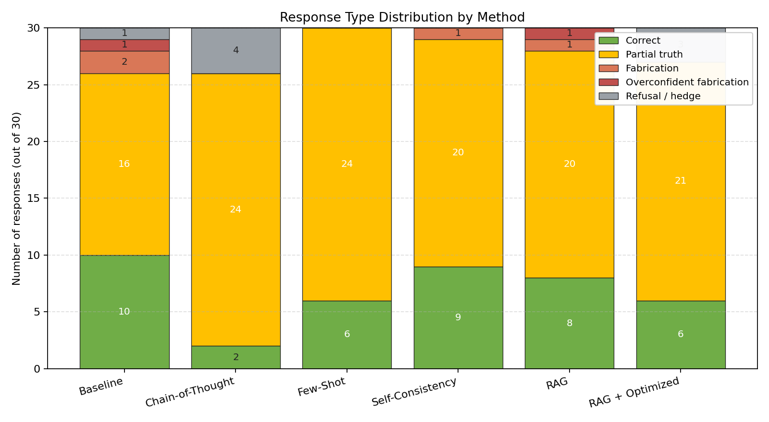
- Fig. 3. Response-type distribution by method. Most non-correct responses are partial-truths rather than wholesale fabrications.
Two observations stand out. First, the dominant failure mode across all methods is partial-truth: the model retrieves or recalls related facts but fails to commit to the verified answer. This suggests that the next performance ceiling lies not in surfacing more facts but in selecting and committing to them — for example, via constrained decoding or self-verification. Second, RAG and RAG + Optimized do not collapse fabrication to zero: in a small number of cases the model invents details around retrieved facts. This is consistent with the hallucination-aware tuning literature [4].
Notably, Chain-of-Thought produces the largest share of refusal-or-hedge responses, with the model frequently constructing elaborate reasoning that exposes uncertainty without converging on an answer. At 3B parameters the model lacks the depth to use additional reasoning steps profitably; recent work has shown CoT benefits scale with model size, consistent with our negative result here.

Limitations
The dataset is small (30 questions). While our bootstrap analysis confirms that the RAG + Optimized improvement is unlikely under the null, broader claims would require evaluation on the full TruthfulQA corpus and on additional benchmarks such as HalluLens [2]. We test a single open-weight model size (3B); larger models typically benefit more from CoT. The RAG knowledge base was curated to contain the evaluation answers, representing an optimistic ceiling for retrieval performance. Finally, our automated metrics are an imperfect proxy for human judgment of factuality.

Conclusion and Future Work
On a 30-question TruthfulQA subset evaluated under a uniform protocol with bootstrap-based statistics, retrieval-augmented generation combined with optimized prompting reduces hallucinations most reliably on LLaMA 3.2 (3B), achieving a paired improvement of +0.168 in factual accuracy over the baseline at p=0.001. RAG alone and Self-Consistency also produce significant gains, while Chain-of-Thought is not effective at this model size. Error analysis shows that the remaining failures are predominantly partial-truth responses, suggesting the next gains will come from techniques that help the model commit to a verified answer — for example, factual-entailment verification, self-consistent decoding over retrieved facts, or hallucination-aware fine-tuning [4].

Acknowledgment
The author thanks Prof. Reda Nacif Elalaoui for the AI700-001 course and the structure that motivated this work, and the open-source maintainers of Ollama, ChromaDB and the TruthfulQA dataset, without which a local, reproducible evaluation would not have been possible.

References
- [1] A.-H. Dang, T. Vu, and L.-M. Nguyen, "A survey and analysis of hallucinations in large language models," Frontiers in AI, vol. 8, 2025.
- [2] Y. Bang et al., "HalluLens: A benchmark for LLM hallucinations," in Proc. 63rd ACL, 2025.
- [3] X. Wang et al., "Self-consistency improves chain of thought reasoning in language models," in Proc. ICLR, 2023.
- [4] J. Song et al., "RAG-HAT: A hallucination-aware tuning pipeline for LLM in RAG," in Proc. EMNLP, 2024.
- [5] S. Lin, J. Hilton, and O. Evans, "TruthfulQA: Measuring how models mimic human falsehoods," in Proc. ACL, 2022.
- [6] C.-Y. Lin, "ROUGE: A package for automatic evaluation of summaries," in Text Summarization Branches Out, 2004.
- [7] P. Lewis et al., "Retrieval-augmented generation for knowledge-intensive NLP tasks," in Proc. NeurIPS, 2020.
- [8] J. Wei et al., "Chain-of-thought prompting elicits reasoning in large language models," in Proc. NeurIPS, 2022.
- [9] AI@Meta, "LLaMA 3.2 model card," 2024. [Online]. Available: https://github.com/meta-llama/llama3
- [10] Ollama, "Ollama: Run LLMs locally," 2024. [Online]. Available: https://github.com/ollama/ollama

