Currency Exchange Office System
Network Application Development – Final Project Documentation
Author: Emil

1. Overview
This project is a network-based application that simulates an online currency exchange office (kantor). It is built on the .NET platform using Windows Communication Foundation (WCF). The system retrieves live exchange rates from the National Bank of Poland (NBP) public API, lets a client application perform currency operations, and persists user accounts and transactions in a SQL database.
The application follows a three-tier architecture: a WCF web service holding the business logic, a WPF desktop client for the user interface, and a SQL Server LocalDB database for persistent storage.
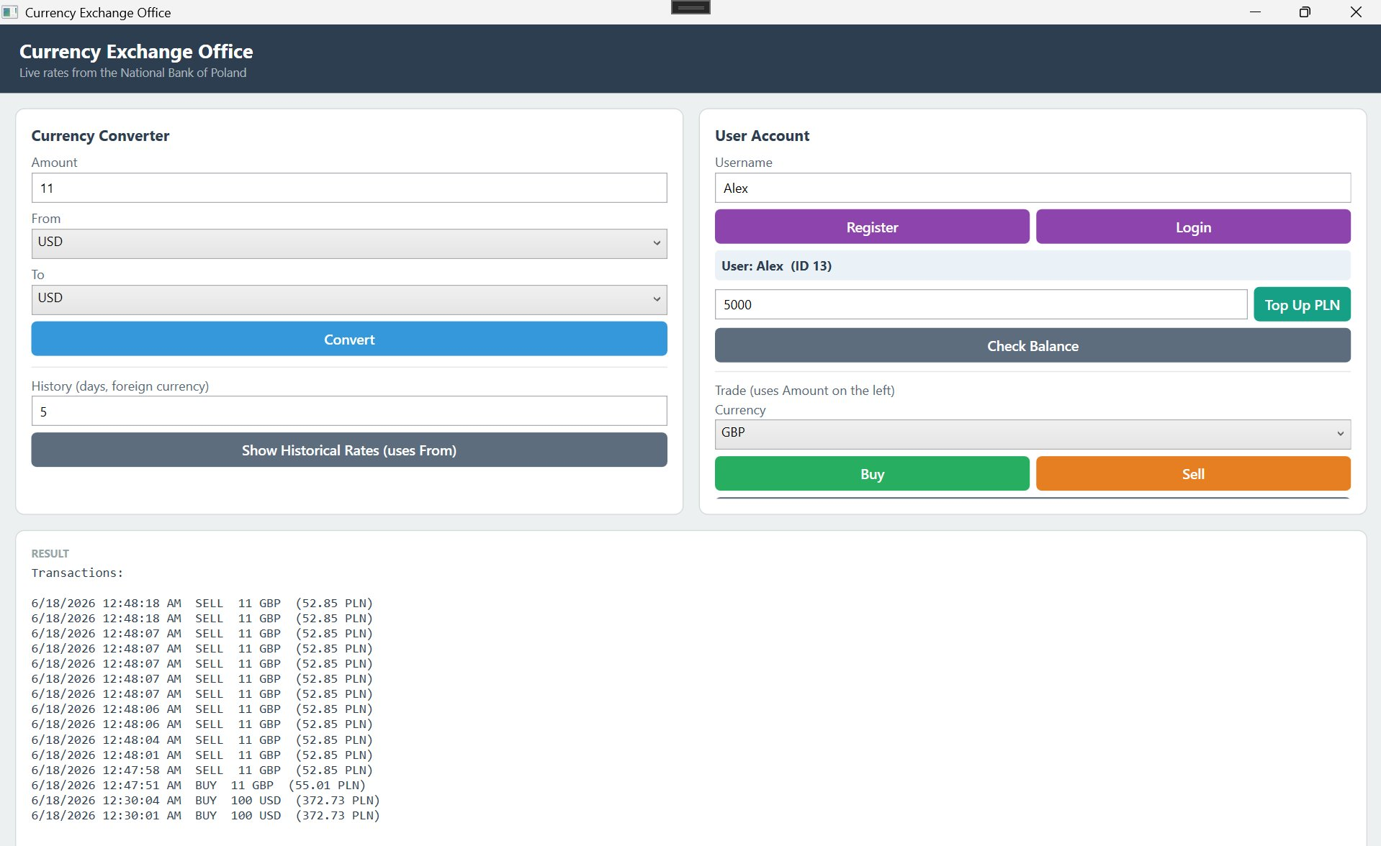
Figure 1: The WPF client application – currency converter, user account, and results panel.

2. System Architecture
The system is divided into three independent components that communicate over the network:
- WCF Web Service (ExchangeService) – hosts all business logic. It calls the NBP API for exchange rates, performs buy/sell and conversion calculations, and reads from / writes to the database. The service exposes its operations through a service contract (IService1) and is consumed over HTTP.
- WPF Client Application (ExchangeClient) – the desktop user interface. It communicates with the web service through a generated service reference, so all calculations and data access happen on the service side, not in the client.
- SQL Database (ExchangeDB) – a SQL Server LocalDB database that stores users, their PLN balances, and a log of all currency transactions.
Data flow: the WPF client calls a method on the WCF service; the service contacts the NBP API and/or the database as needed; the result is returned to the client and displayed to the user.

3. Technologies Used
- .NET Framework (C#)
- Windows Communication Foundation (WCF) – web service layer
- Windows Presentation Foundation (WPF) – client interface
- SQL Server LocalDB with ADO.NET – data persistence
- NBP public API (api.nbp.pl) – live exchange-rate data source (no authorization required, HTTPS)

4. Web Service Functionality
The WCF service exposes the following operations. Exchange rates come from NBP table A; buy and sell operations apply a 2% office margin (the exchange office buys below and sells above the official rate).
Method | What it does
GetExchangeRate | Returns today's NBP rate for a currency (value in PLN).
Convert | Converts an amount between any two currencies, with PLN allowed on either side, at the official rate.
BuyCurrency | Calculates the PLN cost to buy a given amount of a foreign currency (with margin).
SellCurrency | Calculates the PLN received when selling a foreign currency (with margin).
GetHistoricalRates | Returns the last N daily rates for a currency from NBP.
RegisterUser | Creates a new user account with a zero balance and returns its ID.
LoginUser | Looks up an existing user by name and returns their ID.
TopUp | Adds PLN to a user's balance (simulated deposit).
GetBalance | Returns a user's current PLN balance.
BuyForUser | Buys currency for a user: checks balance, deducts PLN, logs the transaction.
SellForUser | Sells currency for a user: adds PLN to balance, logs the transaction.
GetUserTransactions | Returns the user's transaction history.

5. Client Application Functionality
The WPF client provides a single window with two areas plus a results panel:

Currency Converter
- Enter an amount and choose From / To currencies (PLN selectable on either side).
- Check live exchange rates and view historical rates for a chosen currency.

User Account
- Register a new user or log in to an existing one.
- Top up a PLN balance and check the current balance.
- Buy and sell foreign currencies through the account; each operation updates the balance and is recorded.
- View the full transaction history for the logged-in user.
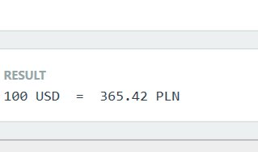
Figure 2: A live currency conversion result returned by the service.
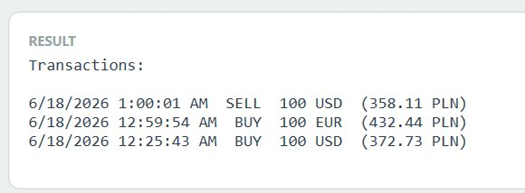
Figure 3: A user's transaction history shown in the client.

6. Database Design
The database (ExchangeDB) contains two tables:
Table | Stored information
Users | Id, Username, BalancePLN – one row per registered user and their current PLN balance.
Transactions | Id, UserId, Operation (BUY/SELL), CurrencyCode, Amount, ValuePLN, Date – a log of every currency operation a user performs.
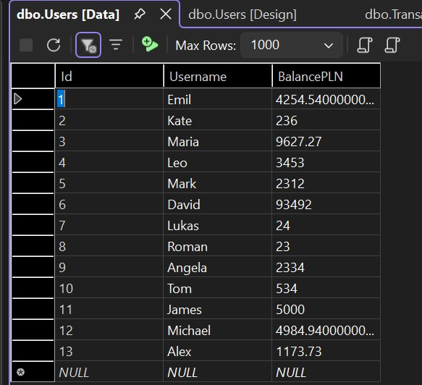
Figure 4: The Users table – registered users and their PLN balances.
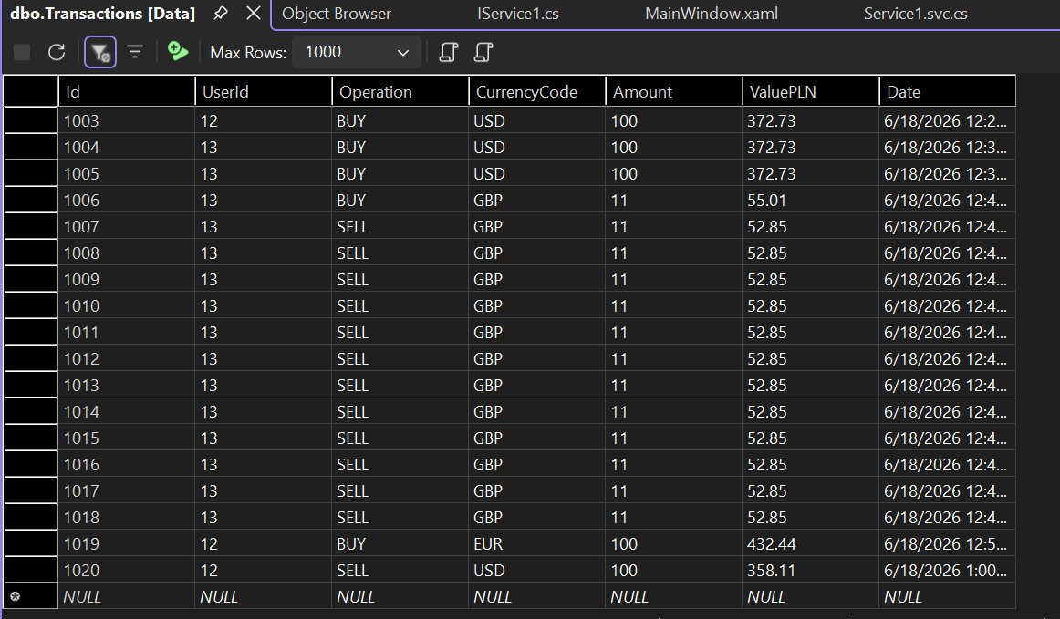
Figure 5: The Transactions table – a persistent log of all buy/sell operations.

7. Running the Project
1. Open the solution in Visual Studio (with the .NET desktop and WCF components installed).
2. The database uses SQL Server LocalDB. The connection string in Service1.svc.cs targets (localdb)\ProjectModels. On another machine, change it to (localdb)\MSSQLLocalDB if needed.
3. Run the included database_setup.sql once to create the Users and Transactions tables.
4. Set both projects to start (service first, then client) and run. The client window opens and communicates with the service.
Exchange rates are provided by the National Bank of Poland public API (api.nbp.pl).

