MeterIt Pro
Electricity Meter Management — Application Sheet
Document MIP-AS-001 · Rev A · © 2026 MeterIt Pro
www.meteritpro.com | info@meteritpro.com
Electricity Meter Management  Application Sheet | MeterIt Pro  CLOUD PLATFORM

MeterIt Pro — Cloud Electricity Meter Management
MeterIt Pro is a cloud-based electricity meter data management platform for meter manufacturers, resellers, utilities and facility teams. Automate readings, validate data, generate reports and query your portfolio with AI — across a single site or hundreds of locations, from any browser.
At a Glance
Metric | Meaning
24/7 | Real-time access to all meter data
100% | Cloud-hosted — no on-prem setup
100s | Locations from one dashboard
RBAC | Role-based access per tenant

◉ ◉ ◉ meteritpro.com/home
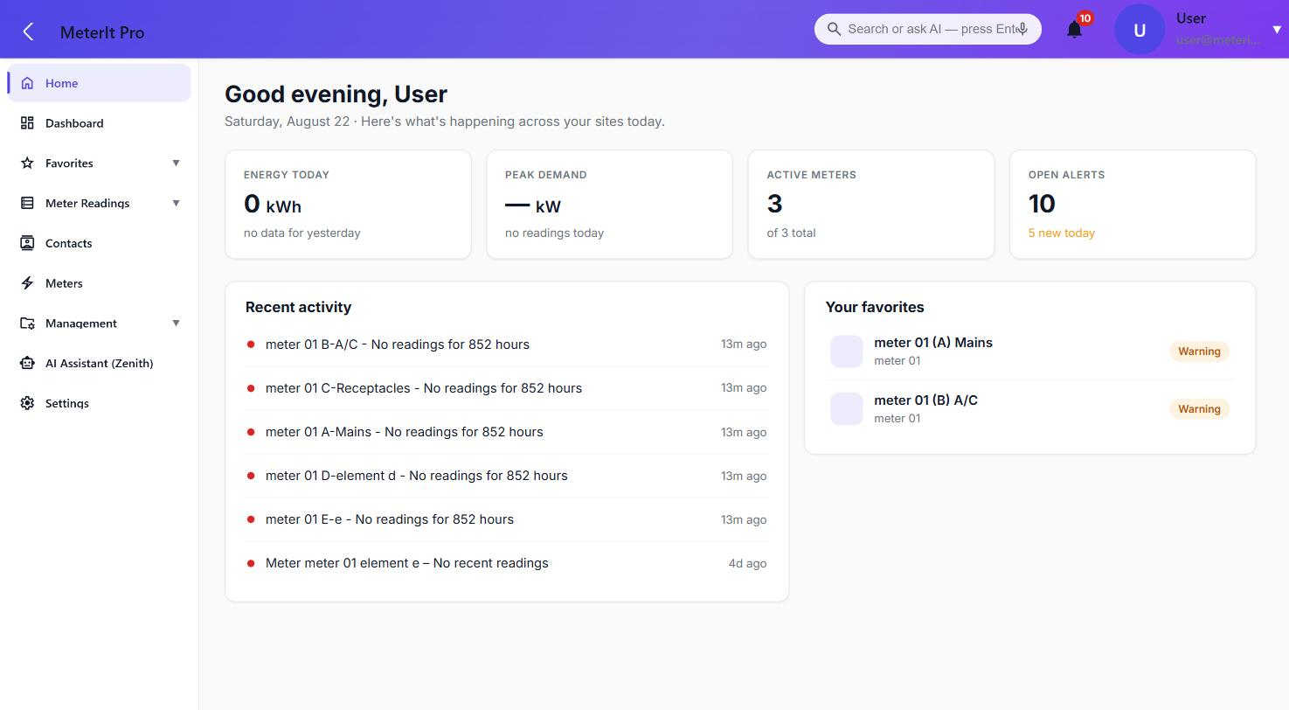
Portfolio home dashboard — energy, peak demand, active meters and open alerts at a glance.
MIP-AS-001 · Rev A · © 2026 MeterIt Pro page 1 of 9 www.meteritpro.com | info@meteritpro.com

Electricity Meter Management  Application Sheet | MeterIt Pro  CLOUD PLATFORM

Core Capabilities
Purpose-built electricity metering software that keeps every reading accurate, traceable and easy to analyze — one platform for capture, validation, analytics, alerting and reporting.
- Smart Meter Capture — Mobile-friendly workflows guide technicians through every reading. Physical and virtual electricity meters, captured at the register and circuit level.
- Validation & Anomaly Detection — Automatic quality checks flag anomalies and missing data before reports go out, so your data stays audit-ready.
- Energy Analytics & Reporting — Track usage trends, peak demand and cost efficiency across all meters. Export to PDF or CSV for billing, audits and analysis.
- Multi-Site Portfolio — Manage readings across hundreds of locations from a single dashboard — ideal for ESCOs, property managers and facility teams.
- Alerts & Notifications — Set threshold-based rules on any register and get notified instantly when readings fall outside expected ranges.
- AI-Ready Data Platform — Query your meter data in plain language with the built-in Zenith assistant. Built for AI integration from day one.
Full Visibility, Access Anywhere
- Live dashboard updates — no manual refresh or exports
- Desktop, tablet or mobile on any modern browser
- Role-based access — field, manager and client views
- Secure, encrypted connections (HTTPS/TLS)
- Tenant-level data isolation across every account
- Share read-only portfolio views with stakeholders
MIP-AS-001 · Rev A · © 2026 MeterIt Pro page 2 of 9 www.meteritpro.com | info@meteritpro.com

Electricity Meter Management  Application Sheet | MeterIt Pro  CLOUD PLATFORM

Meters & Registers
Every meter is modelled with its own registers (elements) — Mains, A/C, Receptacles and more — so consumption is tracked at the circuit level, not just the building level.
Setup Steps
- Name the meter & assign its location
- Choose physical or virtual meter
- Assign device model & sync server
- Map registers / elements
- Set alert rules on any register
- Assign role-based user access
Meter Types
- Physical meters — Bound to a device on a sync server; MeterIt Pro polls it for live readings.
- Virtual meters — Derived from other meters (e.g. "mains less lighting") — no hardware required.
Per-Meter Registers
- Multiple registers / elements per meter
- Named channels: Mains, A/C, Receptacles…
- Per-register readings, graphs & alerts
- Serial, IP, sync server & live status
◉ ◉ ◉ meteritpro.com/meters
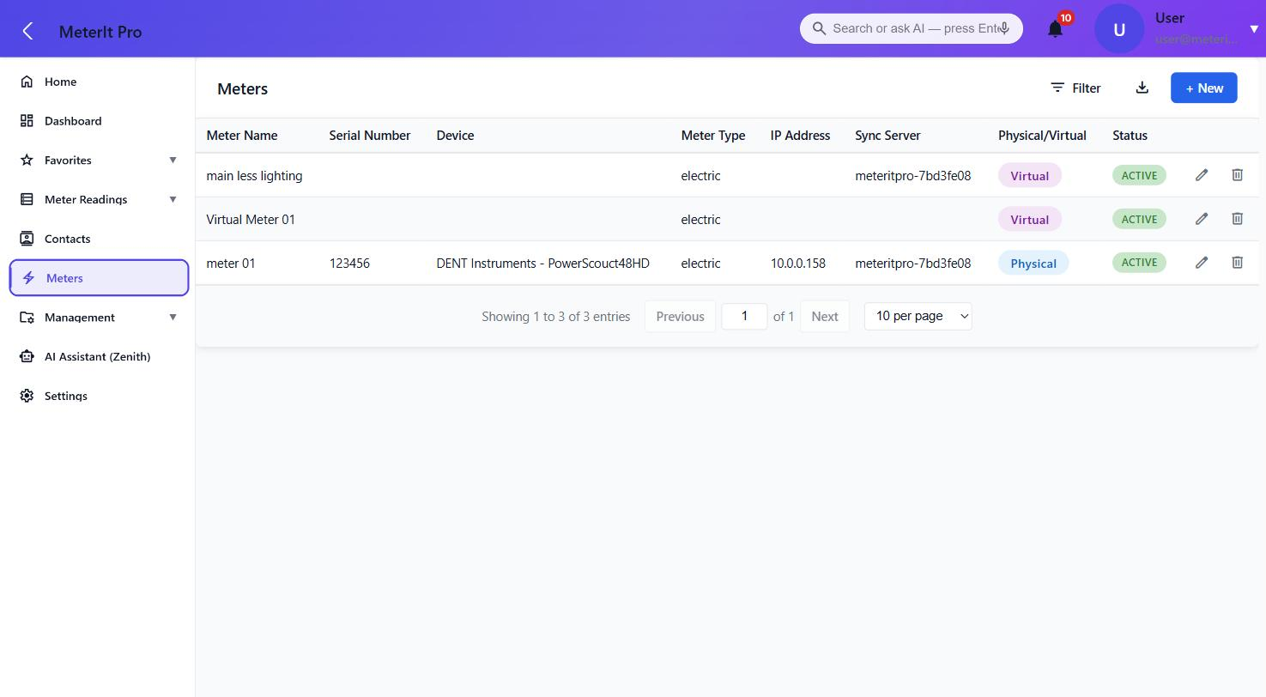
Meter list — physical and virtual meters, each tied to a device, IP, sync server and status.
MIP-AS-001 · Rev A · © 2026 MeterIt Pro page 3 of 9 www.meteritpro.com | info@meteritpro.com

Electricity Meter Management  Application Sheet | MeterIt Pro  CLOUD PLATFORM

Metering Data Captured
Per register, per interval — the full electrical picture, retained and queryable. Readings are timestamped and export-ready as CSV or PDF, or emailed on a schedule.
Parameter | Unit | Resolution | Notes
Energy | kWh | 15-min interval | Cumulative & calculated consumption
Apparent power | kVA | 15-min interval | Total load
Apparent power, per phase | kVA | 15-min interval | Phase A / B / C
Current | A | 15-min interval | Total current draw
Current, per phase | A | 15-min interval | Phase A / B / C
Timestamp | ISO | Per reading | Local site time, audit-retained

◉ ◉ ◉ meteritpro.com/meter-readings
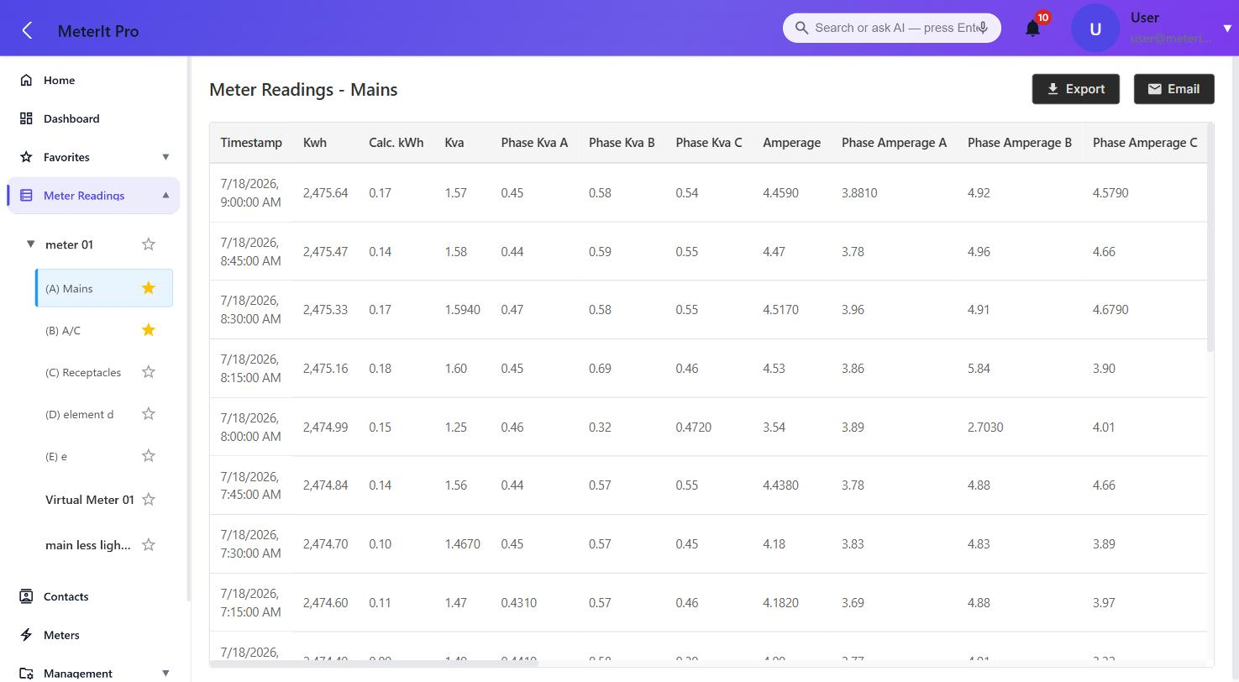
Detailed register readings — kWh, kVA, per-phase kVA & amperage at 15-min intervals.
MIP-AS-001 · Rev A · © 2026 MeterIt Pro page 4 of 9 www.meteritpro.com | info@meteritpro.com

Electricity Meter Management  Application Sheet | MeterIt Pro  CLOUD PLATFORM

Dashboards & Analytics
Compose custom dashboards from configurable chart widgets. Set the time range, chart type, granularity and aggregation on each widget — then refresh, export or email it.
- Multiple dashboards per user
- Drag-and-drop widget layout
- Range: since install, daily or custom
- Granularity down to 15-minute intervals
- Aggregation: max, min, average, sum
- Per-widget refresh, export & email
Chart types: Bar · Line · Area · Pie / Ring · Tabular
◉ ◉ ◉ meteritpro.com/dashboard
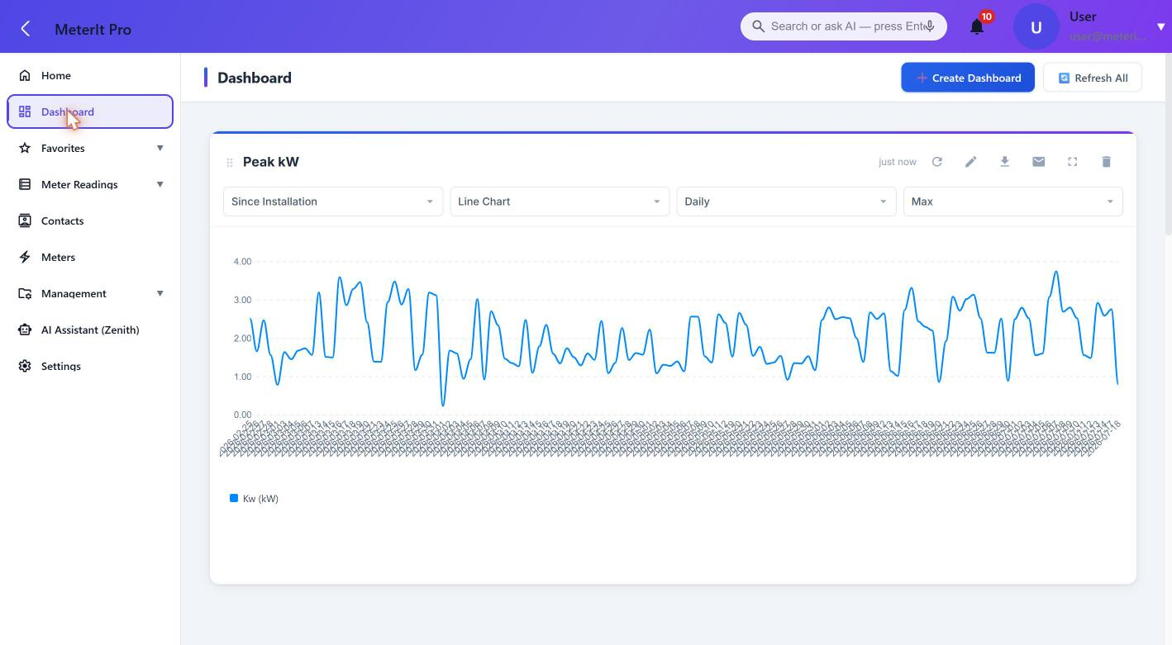
Custom dashboard — a Peak kW widget with configurable range, chart type & aggregation.
MIP-AS-001 · Rev A · © 2026 MeterIt Pro page 5 of 9 www.meteritpro.com | info@meteritpro.com

Electricity Meter Management  Application Sheet | MeterIt Pro  CLOUD PLATFORM

Alerts & Notifications
Define alert rules once and let the platform watch every register around the clock. Catch a stalled meter or a runaway load before your clients do.
Rule Types
- Custom — threshold rules on any parameter
- No Reading — when a meter goes silent
- Zero Reading — for dead or stalled channels
- Active / inactive per rule, with full history
Notification Channels
- In-app banner on the platform
- Email alerts with a link to the meter in alarm
- Threshold breach, over-interval & over-time
- Scheduled scans clear stale notifications
◉ ◉ ◉ meteritpro.com/notification-rules
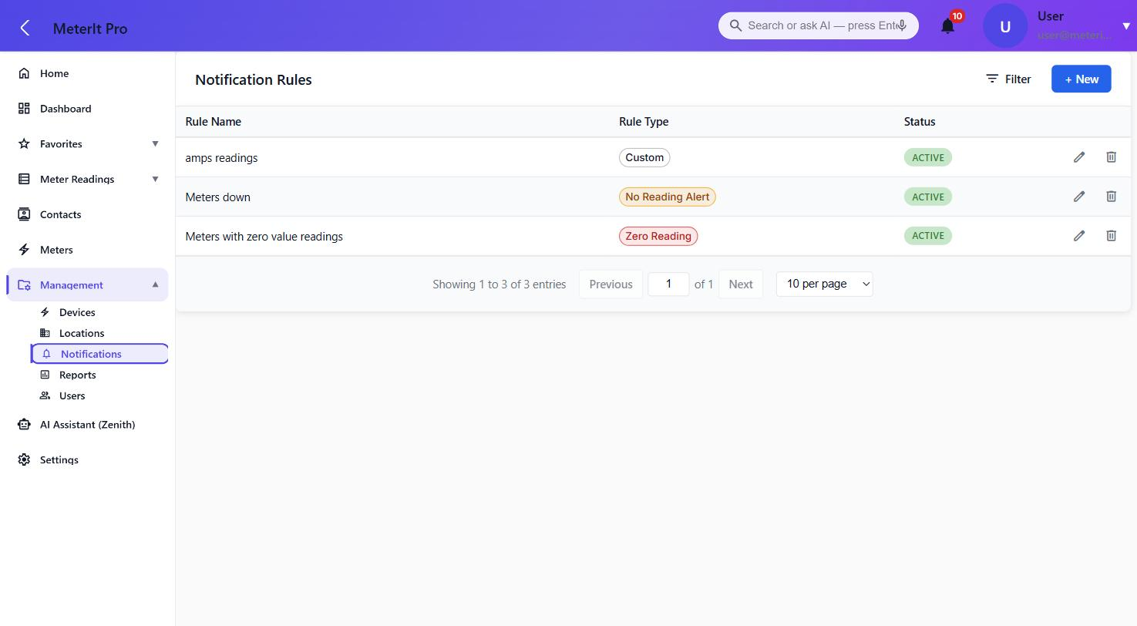
Notification rules — custom, no-reading and zero-reading rule types, toggled per register.
MIP-AS-001 · Rev A · © 2026 MeterIt Pro page 6 of 9 www.meteritpro.com | info@meteritpro.com

Electricity Meter Management  Application Sheet | MeterIt Pro  CLOUD PLATFORM

Zenith AI Assistant
Query meters, readings and alerts in plain language — no reports to build, no filters to configure. Zenith reads across your whole portfolio and answers in seconds.
Ask Questions Like
- "Which meters haven’t reported in 48 hours?"
- "What is my total consumption today?"
- "Which alert rules triggered this week?"
- "Summarize peak demand across all sites."
◉ ◉ ◉ meteritpro.com/ai-chat
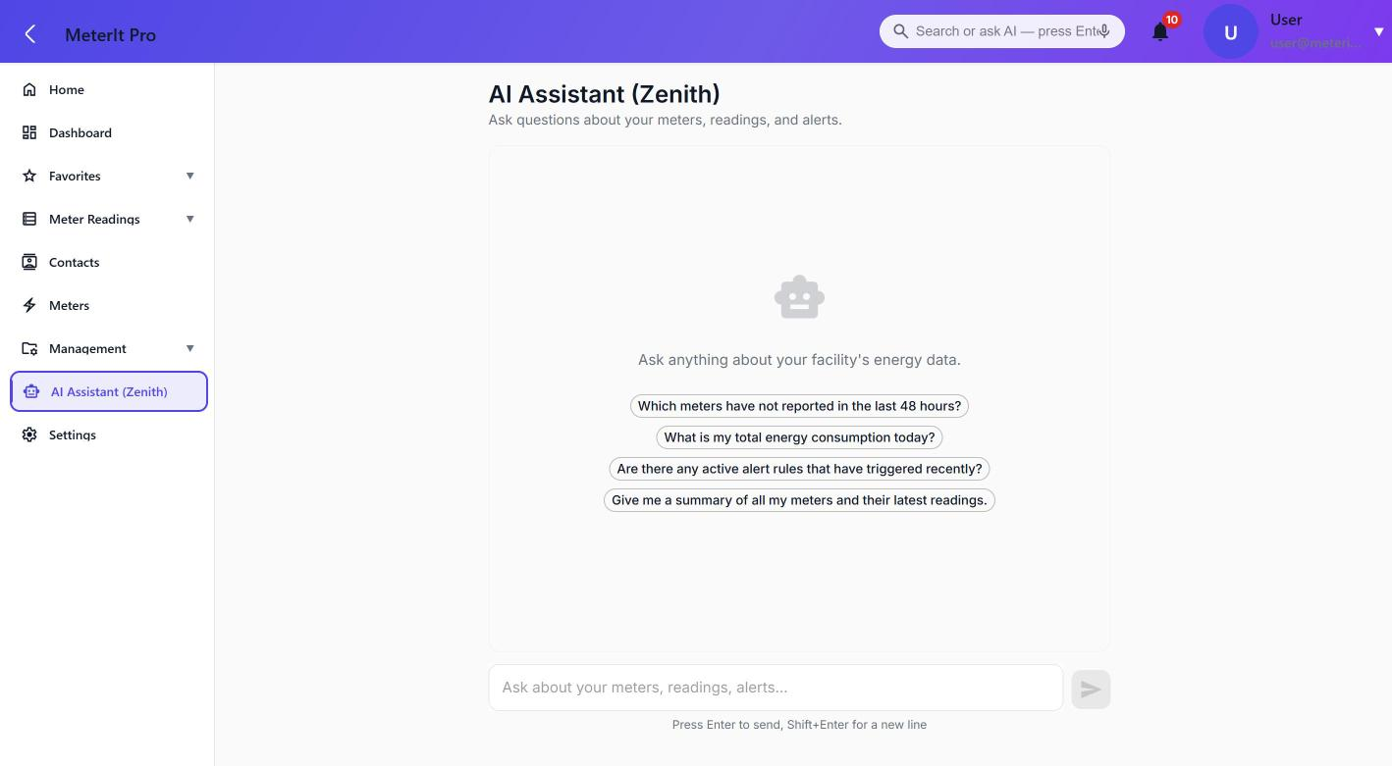
Zenith assistant — a plain-language front door to your meter data, with suggested prompts.
MIP-AS-001 · Rev A · © 2026 MeterIt Pro page 7 of 9 www.meteritpro.com | info@meteritpro.com

Electricity Meter Management  Application Sheet | MeterIt Pro  CLOUD PLATFORM

On-Site Sync Server
The MeterIt Pro Sync Server is a compact, sealed, Linux-based appliance installed on-site. It talks directly to your meters over BACnet and IP and, critically, keeps metering even when the internet goes down — then catches the cloud up automatically once the connection returns.
Resilient by Design — No Data Gaps
- Online · Normal — Meter & stream live — Polls every meter on the local network at 15-minute intervals and streams readings to the MeterIt Pro cloud in real time.
- Internet Outage — Keeps metering offline — If the site loses internet, the Sync Server keeps polling and buffers every reading to local storage. Nothing is lost.
- Reconnected — Auto-uploads & back-fills — When the connection returns, buffered readings upload automatically and back-fill the timeline — no gaps, no manual steps.
Hardware
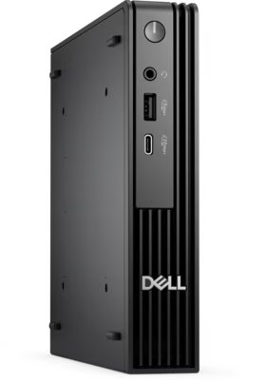  Dell Micro — Front I/O | 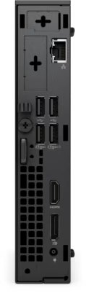  Rear I/O | 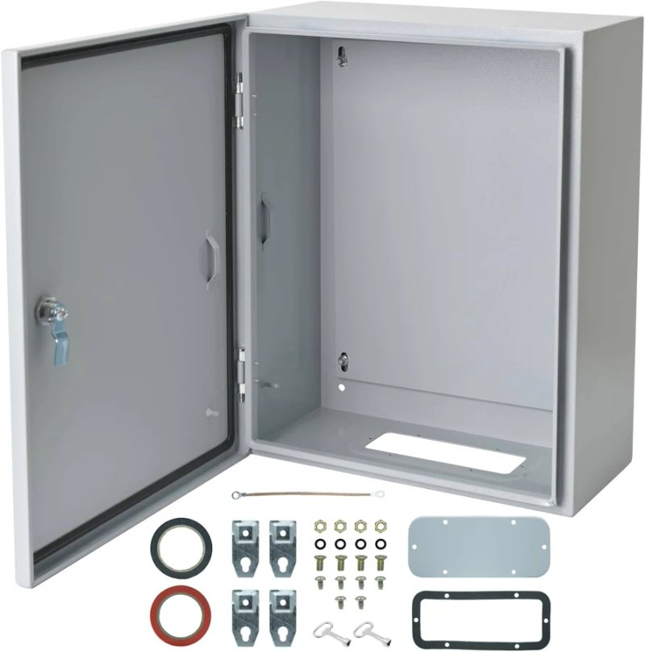  Sealed Wall Enclosure

Sync Server Specifications
Spec | Value
Processor | Intel Core i5-8400T
Cores / clock | 6C · up to 3.3 GHz · 35 W
Memory | 16 GB DDR4
Storage | 512 GB SSD
Operating system | Linux-based (hardened)
Graphics | Intel UHD 630
Networking | Gigabit Ethernet (RJ-45)
Ports | USB 3.1 · USB-C · 2× DP · HDMI
Form factor | Micro (≈1.2 L chassis)
Dimensions | 36 × 182 × 178 mm
Power | 65 W external adapter
Meter protocols | BACnet · IP
Local buffering | Full readings retained offline
Recovery | Fast reimage & redeploy
Uptime | 24/7 unattended operation

MIP-AS-001 · Rev A · © 2026 MeterIt Pro page 8 of 9 www.meteritpro.com | info@meteritpro.com

Electricity Meter Management  Application Sheet | MeterIt Pro  CLOUD PLATFORM

Enclosure — Altelix 14×11×5 Vented NEMA Weatherproof Box
Sealed, weatherproof, vented wall/pole-mount enclosure housing the Sync Server. Polycarbonate + ABS construction with a gasketed hinged door and dual latches; RF-transparent for on-site wireless, and ventilated for continuous 24/7 operation.
- Weatherproof, UV-stable PC + ABS enclosure — NEMA 3R / 3RX / IP24
- Gasketed hinged door with dual latches + tamper-proof locking screw (key & padlock provision)
- Two 3" vents with rain shields and cleanable screens for airflow
- RF-transparent for on-site wireless devices
Spec | Value
Model | Altelix 14×11×5 PC+ABS Weatherproof Vented Utility Box
Exterior dimensions | 13.4 × 11.6 × 6.3 in (340 × 294 × 161 mm)
Interior dimensions | 12.0 × 8.0 × 4.0 in (305 × 203 × 102 mm)
Material | Polycarbonate + ABS (UV-resistant, industrial grade)
Flame rating | Meets UL94-V0
Environmental rating | NEMA Type 3R, 3RX / IP24
Door / security | Gasketed hinged door, dual latches, tamper-proof locking screw (key & padlock)
Ventilation | Two (2) 3" vents with rain shields and cleanable screens
Mounting | Wall mount hardware included; optional pole-mount kits (poles up to 8" dia.)
Knockouts | 4× 0.62" (16 mm), 4× 0.78" (20 mm), 4× 1.30" (33 mm, top & bottom)
Weight | 3.2 lbs (1.4 kg)
Colors | Gray, Black, Light Ivory, OD Green
Included accessories | Cable grommets, zip ties, cable-management loops, ground plate, ground wire
RF | RF-transparent for wireless devices

Source: enclosurehub.com — Altelix 14x11x5 PC+ABS Weatherproof Vented Utility Box
MIP-AS-001 · Rev A · © 2026 MeterIt Pro page 8 of 9 www.meteritpro.com | info@meteritpro.com

Electricity Meter Management  Application Sheet | MeterIt Pro  CLOUD PLATFORM

Specifications
Device Compatibility
Manufacturer | Description | Model no. | Type | Elements
DENT Instruments | PowerScout 48HD | PowerScout48HD | Electric | 48
TBWC, Inc. | PS24 | DI-MMU8 | Electric | 24
TBWC, Inc. | PS48 | DI-MMU16 | Electric | 16
TBWC, Inc. | PS12 | DI-MMU4 | Electric | 12
TBWC, Inc. | PS3 | DI-SAKIT | Electric | 3

Technical Specifications
Spec | Value
Deployment | Fully cloud-hosted (SaaS)
On-premises servers | None required
Access | Any modern browser
Tenancy | Multi-tenant, isolated
Access control | Role-based (RBAC)
Transport security | HTTPS / TLS
Meter focus | Electricity only
Meter models | Physical & virtual
Reading interval | 15 min (typical)
Export formats | PDF · CSV · Email
Site sync | Edge sync-server agents
Meter protocols | BACnet · IP
Integrations | AI querying · CSV · REST API

Platform Capabilities
- Physical & virtual electricity meters
- Per-register readings, graphs & alerts
- Custom dashboards & analytics
- Multi-site portfolio management
- Threshold, no-reading & zero-reading alerts
- PDF / CSV export & scheduled email
- Zenith AI plain-language querying
- On-site Sync Server with offline resilience
MIP-AS-001 · Rev A · © 2026 MeterIt Pro page 9 of 9 www.meteritpro.com | info@meteritpro.com

