Electricity Meter Management
Application Sheet
MeterIt ProCloud Platform
MeterIt Pro — Cloud Electricity Meter Management
MeterIt Pro is a cloud-based electricity meter data management platform for meter manufacturers, resellers, utilities and facility teams. Automate readings, validate data, generate reports and query your portfolio with AI — across a single site or hundreds of locations, from any browser.
Electricity
Metering
kWh · kVA
Amps
Per-Phase
Detail
15-min
Intervals
24/7
Real-time access to all meter data
100%
Cloud-hosted — no on-prem setup
100s
Locations from one dashboard
RBAC
Role-based access per tenant
meteritpro.com/home
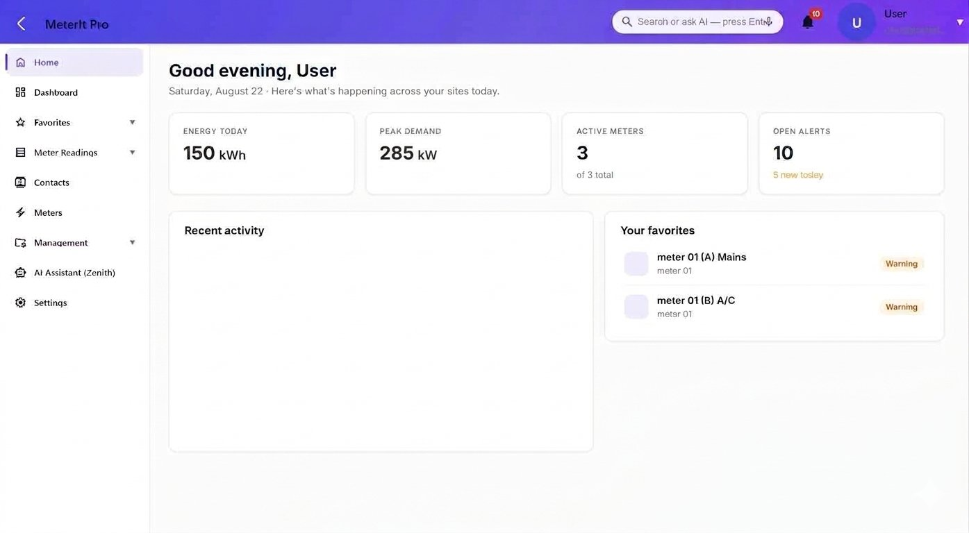
Portfolio home dashboard — energy, peak demand, active meters and open alerts at a glance, with live recent activity and favorite registers.
MIP-AS-001 · Rev B · © 2026 MeterIt Propage 1 of 9www.meteritpro.com | info@meteritpro.com
Electricity Meter Management
Application Sheet
MeterIt ProCloud Platform
Core Capabilities
Purpose-built electricity metering software that keeps every reading accurate, traceable and easy to analyze — one platform for capture, validation, analytics, alerting and reporting.

Smart Meter Capture
Mobile-friendly workflows guide technicians through every reading. Physical and virtual electricity meters, captured at the register and circuit level.

Validation & Anomaly Detection
Automatic quality checks flag anomalies and missing data before reports go out, so your data stays audit-ready.

Energy Analytics & Reporting
Track usage trends, peak demand and cost efficiency across all meters. Export to PDF or CSV for billing, audits and analysis.

Multi-Site Portfolio
Manage readings across hundreds of locations from a single dashboard — ideal for ESCOs, property managers and facility teams.

Alerts & Notifications
Set threshold-based rules on any register and get notified instantly when readings fall outside expected ranges.

AI-Ready Data Platform
Query your meter data in plain language with the built-in Zenith assistant. Built for AI integration from day one.
Full Visibility, Access Anywhere
- Live dashboard updates — no manual refresh or exports
- Desktop, tablet or mobile on any modern browser
- Role-based access — field, manager and client views
- Secure, encrypted connections (HTTPS/TLS)
- Tenant-level data isolation across every account
- Share read-only portfolio views with stakeholders
MIP-AS-001 · Rev B · © 2026 MeterIt Propage 2 of 9www.meteritpro.com | info@meteritpro.com
Electricity Meter Management
Application Sheet
MeterIt ProCloud Platform
Meters & Registers
Every meter is modelled with its own registers (elements) — Mains, A/C, Receptacles and more — so consumption is tracked at the circuit level, not just the building level.
Step 1Name the meter & assign its location
Step 2Choose physical or virtual meter
Step 3Assign device model & sync server
Step 4Map registers / elements
Step 5Set alert rules on any register
Step 6Assign role-based user access
Meter Types
Physical meters
Bound to a device on a sync server — MeterIt Pro polls it for live readings.
Virtual meters
Derived from other meters (e.g. “mains less lighting”) — no hardware required.
Per-Meter Registers
- Multiple registers / elements per meter
- Named channels
- Per-register readings, graphs & alerts
- Serial, IP, sync server & live status
meteritpro.com/meters
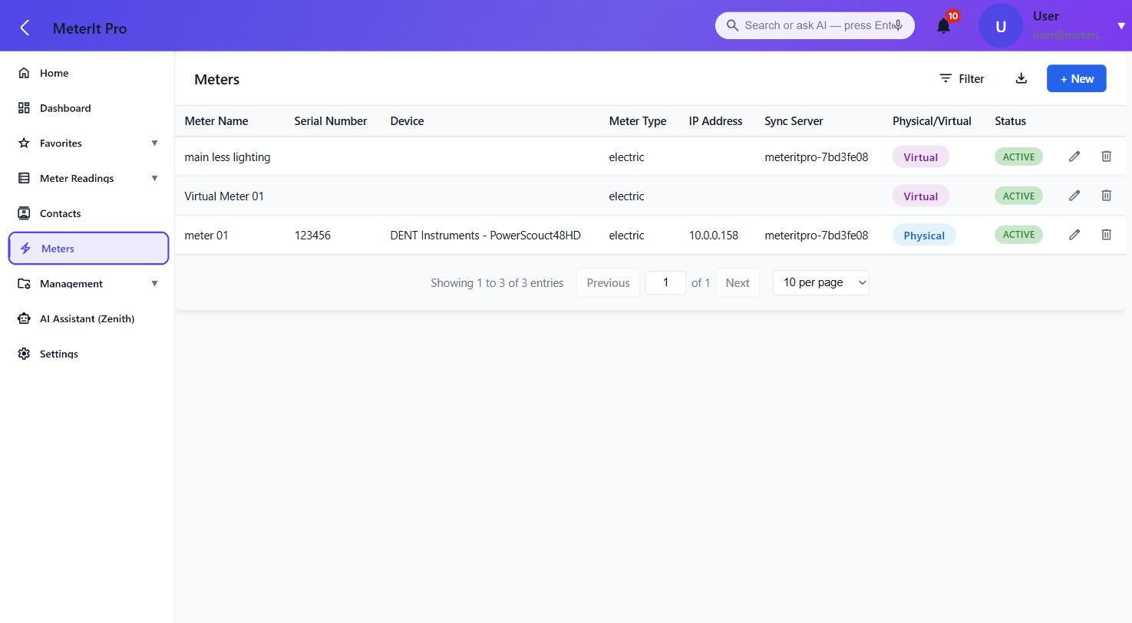
Meter list — physical and virtual meters, each tied to a device, IP address, sync server and live status.
MIP-AS-001 · Rev B · © 2026 MeterIt Propage 3 of 9www.meteritpro.com | info@meteritpro.com
Electricity Meter Management
Application Sheet
MeterIt ProCloud Platform
Metering Data Captured
Per register, per interval — the full electrical picture, retained and queryable. Readings are timestamped and export-ready as CSV or PDF, or emailed on a schedule.
Parameter | Unit | Resolution | Notes
Energy | kWh | 15-min interval | Cumulative & calculated consumption
Apparent power | kVA | 15-min interval | Total load
Apparent power, per phase | kVA | 15-min interval | Phase A / B / C
Current | A | 15-min interval | Total current draw
Current, per phase | A | 15-min interval | Phase A / B / C
Timestamp | ISO | Per reading | Local site time, audit-retained
meteritpro.com/meter-readings
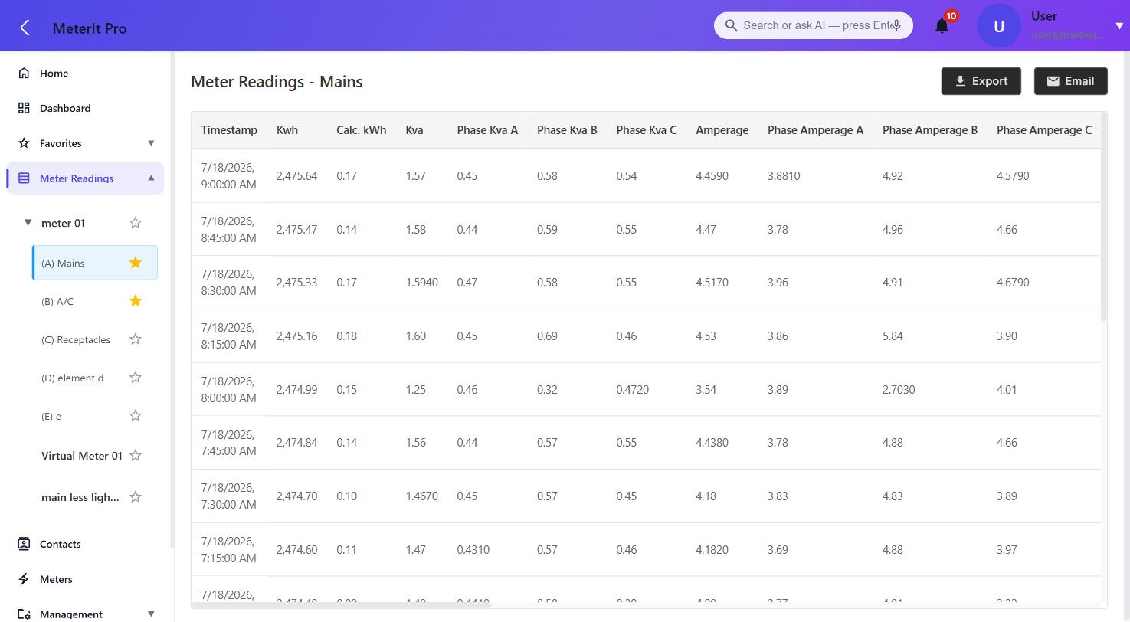
Detailed register readings — kWh, calculated kWh, kVA, per-phase kVA and per-phase amperage at 15-minute intervals, with one-click Export & Email.
MIP-AS-001 · Rev B · © 2026 MeterIt Propage 4 of 9www.meteritpro.com | info@meteritpro.com
Electricity Meter Management
Application Sheet
MeterIt ProCloud Platform
Dashboards & Analytics
Compose custom dashboards from configurable chart widgets. Set the time range, chart type, granularity and aggregation on each widget — then refresh, export or email it.
- Multiple dashboards per user
- Drag-and-drop widget layout
- Range: since install, daily or custom
- Granularity down to 15-minute intervals
- Aggregation: max, min, average, sum
- Per-widget refresh, export & email
Bar Line Area Pie / Ring Tabular
meteritpro.com/dashboard
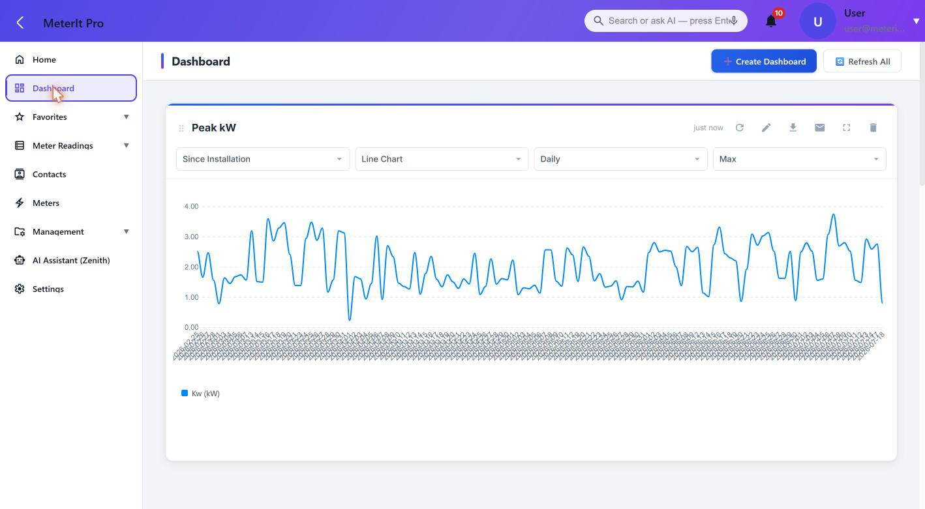
Custom dashboard — a Peak kW widget with configurable range, chart type, granularity and aggregation. Build the exact view each team needs.
MIP-AS-001 · Rev B · © 2026 MeterIt Propage 5 of 9www.meteritpro.com | info@meteritpro.com
Electricity Meter Management
Application Sheet
MeterIt ProCloud Platform
Alerts & Notifications
Define alert rules once and let the platform watch every register around the clock. Catch a stalled meter or a runaway load before your clients do.
Rule Types
- Custom threshold rules on any parameter
- No Reading when a meter goes silent
- Zero Reading for dead or stalled channels
- Active / inactive per rule, with full history
Notification Channels
- In-app banner on the platform
- Email alerts with a link to the meter in alarm
- Threshold breach, over-interval & over-time
- Scheduled scans clear stale notifications
meteritpro.com/notification-rules
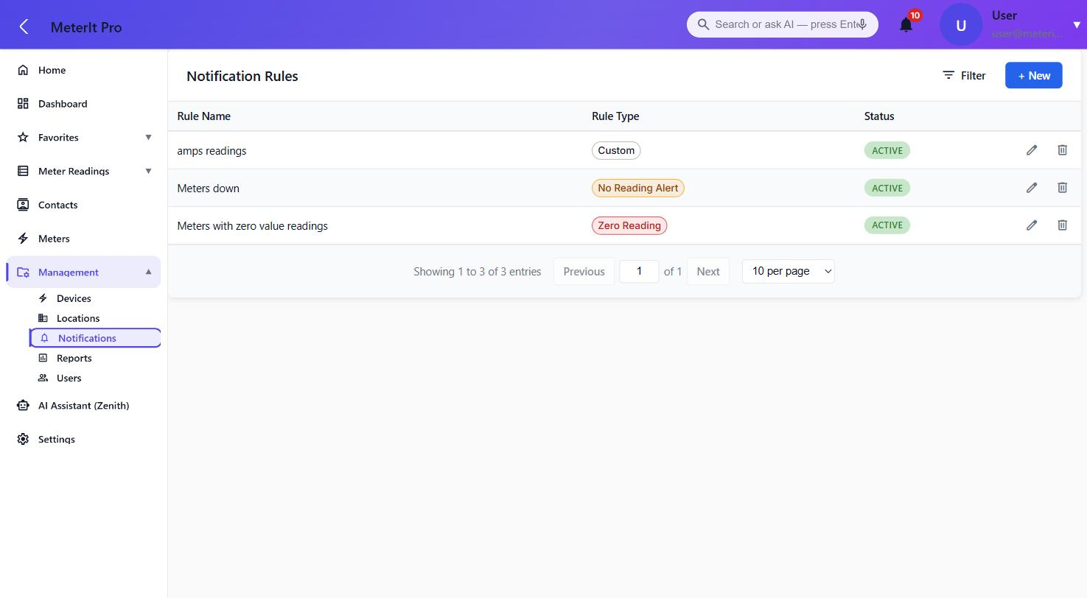
Notification rules — custom, no-reading and zero-reading rule types, each toggled active or inactive per register.
MIP-AS-001 · Rev B · © 2026 MeterIt Propage 6 of 9www.meteritpro.com | info@meteritpro.com
Electricity Meter Management
Application Sheet
MeterIt ProCloud Platform
Zenith AI Assistant
Query meters, readings and alerts in plain language — no reports to build, no filters to configure. Zenith reads across your whole portfolio and answers in seconds.
Ask questions like
- “Which meters haven't reported in 48 hours?”
- “What is my total consumption today?”
- “Which alert rules triggered this week?”
- “Summarize peak demand across all sites.”
meteritpro.com/ai-chat
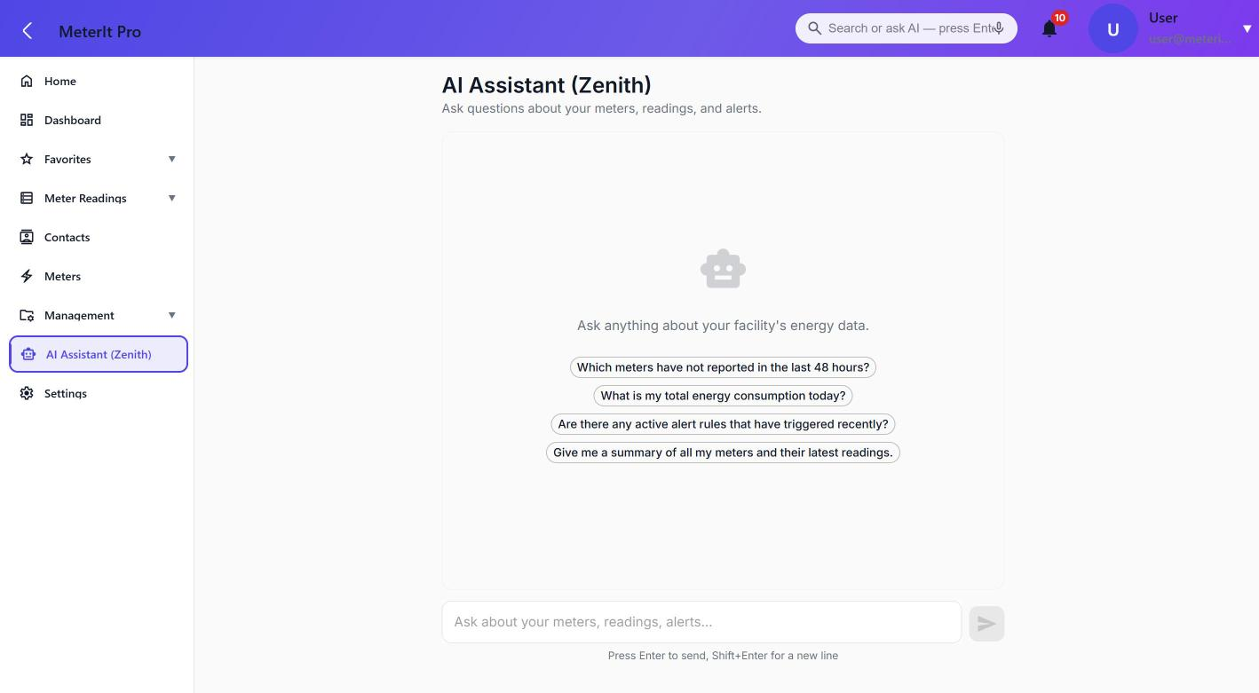
Zenith assistant — a plain-language front door to your meter data, with suggested prompts to get started. Built for AI integration from day one.
MIP-AS-001 · Rev B · © 2026 MeterIt Propage 7 of 9www.meteritpro.com | info@meteritpro.com
Electricity Meter Management
Application Sheet
MeterIt ProCloud Platform
On-Site Sync Server
The MeterIt Pro Sync Server is a compact, sealed, Linux-based appliance installed on-site. It talks directly to your meters over BACnet and IP and, critically, keeps metering even when the internet goes down — then catches the cloud up automatically once the connection returns. The hardened Linux image is fast to redeploy and built for optimal, unattended uptime.
Resilient by Design — No Data Gaps
Online · Normal

Meter & stream live
Polls every meter on the local network at 15-minute intervals and streams readings to the MeterIt Pro cloud in real time.
Internet Outage

Keeps metering offline
If the site loses internet, the Sync Server keeps polling and buffers every reading to local storage. Nothing is lost.
Reconnected

Auto-uploads & back-fills
When the connection returns, buffered readings upload automatically to the production site and back-fill the timeline — no gaps, no manual steps.
Hardware
Sync Server — Dell Micro Desktop
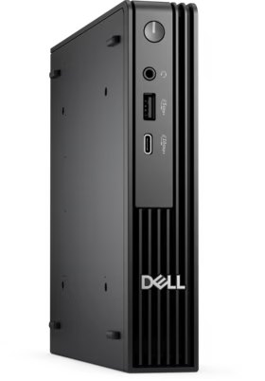Front I/O 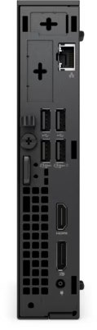Rear I/O
Sealed Wall Enclosure
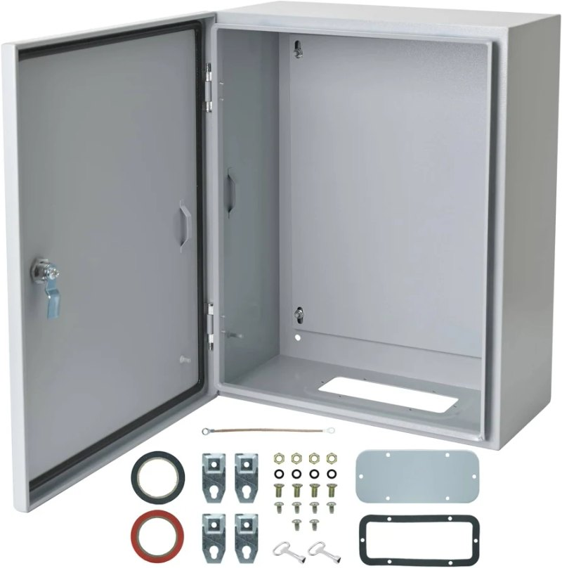
Sync Server Specifications
ProcessorIntel Core i5-8400T
Cores / clock6C · up to 3.3 GHz · 35 W
Memory16 GB DDR4
Storage512 GB SSD
Operating systemLinux-based (hardened)
GraphicsIntel UHD 630
NetworkingGigabit Ethernet (RJ-45)
PortsUSB 3.1 · USB-C · 2× DP · HDMI
Form factorMicro (≈1.2 L chassis)
Dimensions36 × 182 × 178 mm
Power65 W external adapter
Meter protocolsBACnet · IP
Local bufferingFull readings retained offline
RecoveryFast reimage & redeploy
Uptime24/7 unattended operation
Enclosure
- Lockable steel wall-mount enclosure
- Sealed, dust- & tamper-resistant
- Ventilated for continuous 24/7 operation
MIP-AS-001 · Rev B · © 2026 MeterIt Propage 8 of 9www.meteritpro.com | info@meteritpro.com
Electricity Meter Management
Application Sheet
MeterIt ProCloud Platform
Specifications
Device Compatibility
Manufacturer | Description | Model no. | Type | Elements
DENT Instruments | PowerScout 48HD | PowerScout48HD | Electric | 48
TBWC, Inc. | PS24 | DI-MMU8 | Electric | 24
TBWC, Inc. | PS48 | DI-MMU16 | Electric | 16
TBWC, Inc. | PS12 | DI-MMU4 | Electric | 12
TBWC, Inc. | PS3 | DI-SAKIT | Electric | 3
Technical Specifications
DeploymentFully cloud-hosted (SaaS)
On-premises serversNone required
AccessAny modern browser
TenancyMulti-tenant, isolated
Access controlRole-based (RBAC)
Transport securityHTTPS / TLS
Meter focusElectricity only
Meter modelsPhysical & virtual
Reading interval15 min (typical)
Export formatsPDF · CSV · Email
Site syncEdge sync-server agents
Meter protocolsBACnet · IP
IntegrationsAI querying · CSV · REST API
Platform Capabilities
- Physical & virtual electricity meters
- Per-register readings, graphs & alerts
- Custom dashboards & analytics
- Multi-site portfolio management
- Threshold, no-reading & zero-reading alerts
- PDF / CSV export & scheduled email
- Zenith AI plain-language querying
- On-site Sync Server with offline resilience
MIP-AS-001 · Rev B · © 2026 MeterIt Propage 9 of 9www.meteritpro.com | info@meteritpro.com

