|  |
| --- |
| Project Report |
| Project: GRE for Dummies |
| *CSE 2100: Software Development Project - 1* |

KHULNA UNIVERSITY OF ENGINEERING & TECHNOLOGY

*Project by*

*Ahmad Musa*

*(1207021)*

*&*

*Faisal Ahmed Amil*

*(1207044)*

Under Supervision of:

**Saifuddin Mahmud**

Lecturer

Department of Computer Science & Engineering

Khulna University of Engineering & Technology

Table of Contents

|  |  |  |
| --- | --- | --- |
| 1 | Introduction | 2 |
| 2 | Objective | 2 |
| 3 | The Deployments | 3 |
| 4 | Project Structure | 4 |
| 5 | Control Flow in the Project: The Web | 5 |
| 6 | A Brief Discussion on How GRE for Dummies Works | 6 |
| 7 | Explanation: A Dive into the Depth | 7-11 |
| 8 | Features & Usefulness Rendered | 11 |
| 9 | Limitations | 12 |
| 10 | Improvement | 12 |
| 11 | Conclusion | 12 |
| 12 | Reference | 13 |
| 13 | Acknowledgment | 13 |

1. **Introduction:**

GRE, which stands for Graduate Record Examination, is the general test for most grad schools. GRE test takers come from all walks of academic life and ultimately venture out into a wide variety of careers. If anyone is planning to attend graduate school in any field other than business, law, or medicine, they will need to take the GRE as part of the admission process.

To be prepared for the GRE exam, a lot of hard work needs to be done. For the math section, test taker needs to study geometry, quantitative comparisons, probability, number theory and a lot of other things. More often he needs to test himself. But, taking a test for own isn’t that easy. So, this software “GRE for dummies” will help a lot to study and take practice test at any time!

1. **Objective:**

To help users organise their computer files in terms of renaming in a very intuitive and efficient manner, even when large number of files is concerned. This application provides facilities not usually provided by the operating system, be it Microsoft’s Windows or Linux.

1. **The Deployments:**

This application is developed as a 3rd semester software development project, a course titled *“Software Development Project-1”*. As a requisite we used the Java programming language to develop the application. The development environment used was “Eclipse IDE*”, Version: Indigo Service Release 1.*

**3-1. Why use Java:**

***Simple*** - Java has thrown out many of the complex features of C++ and C resulting in a simpler language (no pointers, no unions, no enumerations)

***Object-oriented*** - Java is a single-root, single-inheritance object oriented language

***Multithreaded*** - Java has a built-in support for multithreading

***Distributed*** - Using Java RMI (remote method invocation) you can access objects on other machines almost as if they were local

***Portable*** - programs written in the Java language are platform independent

**3-2. About Eclipse IDE:**

The Integrated Development Environment most favoured by many Java application developers is *“Eclipse”.* It contains a base workspace and an extensible plug-in system for customizing the environment. Written mostly in Java, Eclipse can be used to develop applications. The initial codebase originated from IBM VisualAge.[2] The Eclipse software development kit (SDK), which includes the Java development tools, is meant for Java developers. Users can extend its abilities by installing plug-ins written for the Eclipse Platform, such as development toolkits for other programming languages, and can write and contribute their own plug-in modules.

Released under the terms of the Eclipse Public License, Eclipse SDK is free and open source software (although it is incompatible with the GNU General Public License [3]). It was one of the first IDEs to run under GNU Class path and it runs without problems under IcedTea.

1. **Project Structure:**

|  |  |
| --- | --- |
| Package name | Classes contained |
| Default Package | Main |
| Tutorial |
| Test |
| ChapterWiseTest |
| FullTest |
| AboutGre |
| HomeFrame |
| HomePanel |
| AboutPanel |
| CoordinateGeometry |
| Equation |
| Sequence_And_Series |
| EliminationStrategies |
| Fractions_And_Decimals |
| Exponenets_and_roots |
| Geometry |
| Graph |
| Hard_Quantitative_Comparisons |
| MyDomParser |
| Permutations_And_Combinations |
| Quantitative_comparisons |
| Probability_and_statistics |
| questionParser |
| Ratio_and_proportion |
| result |
| Sequence_And_Series |
| wordProblems |
| showCorrectAnswer |
| numberTheoryTest |
| equationTest |
| geometryTest |
| seqAndSeriesTest |
| quatitativeComparisonsTest |
| NumberTheory |

The project has one package, containing 33 classes. The package along with the classes it contains, are shown below:

Table 1: Packages and classes in the project

1. **Control Flow in the Project: The Web**

Home

Test

Tutorial

About GRE

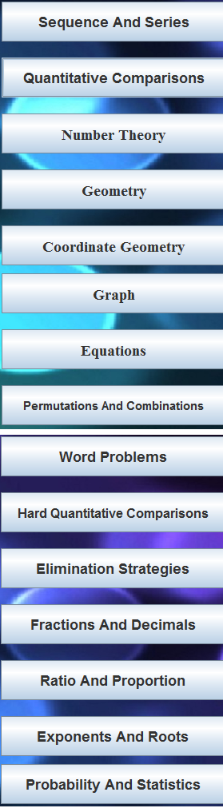

Full Test

Chapter Wise Test

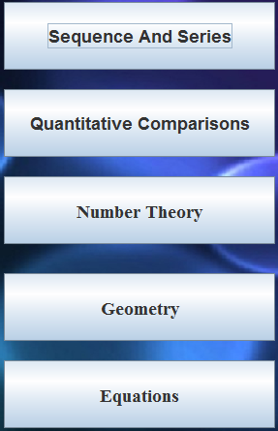

Figure1: A web showing how control flows inside the project.

1. **A brief Discussion on How GRE for Dummies Works:**

From user’s point of view, the application provides a very user-friendly interface.

Window of the application is shown below for easy reference.

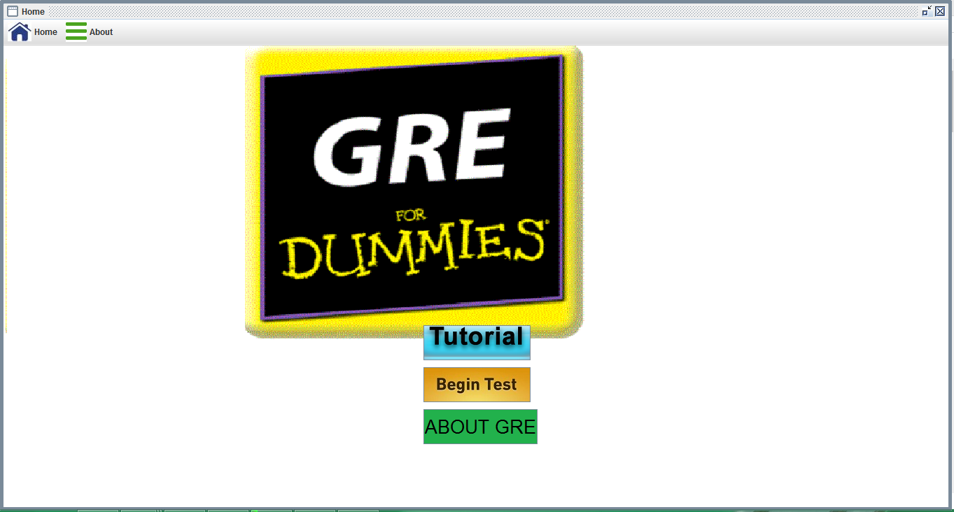

Figure2: The Main Window of GRE for Dummies

The application has buttons that speak for themselves, in the sense that their names show what they do. In the main home window, there are three buttons, “Tutorial” , “Test” and “About GRE” .

Tutorial has a vast collection of 15 different chapters and Test has two options – chapter wise test and full test. About GRE section contains information regarding GRE preparation and details.

1. **Explanation: A Dive into the Depth**

Program starts with “home.java”. This runs the whole program. HomeFrame and HomePanel helps it to draw the main window.

* Tutorial :

Tutorial class has all 15 chapters button and their action listener. All of the 15 classes work in the same way. They use MyDomParser class to parse data from an xml file.

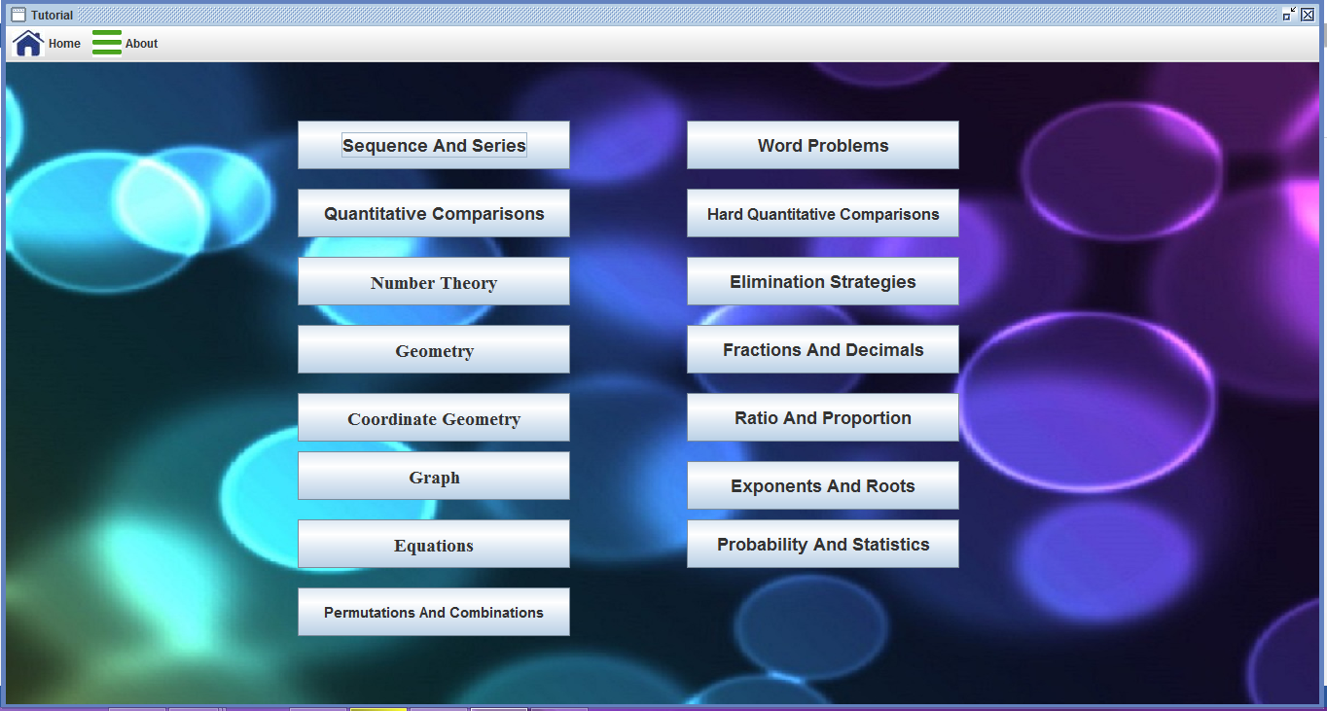

If “Sequence and Series” gets clicked, then this following window will pop up.

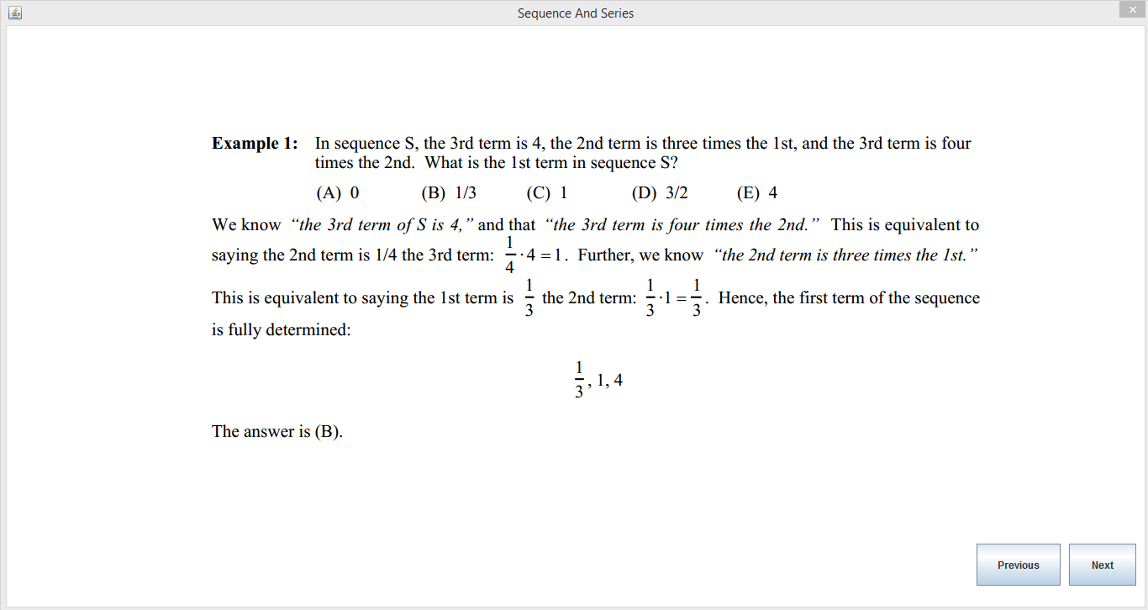

After clicking Next, it goes to next page.

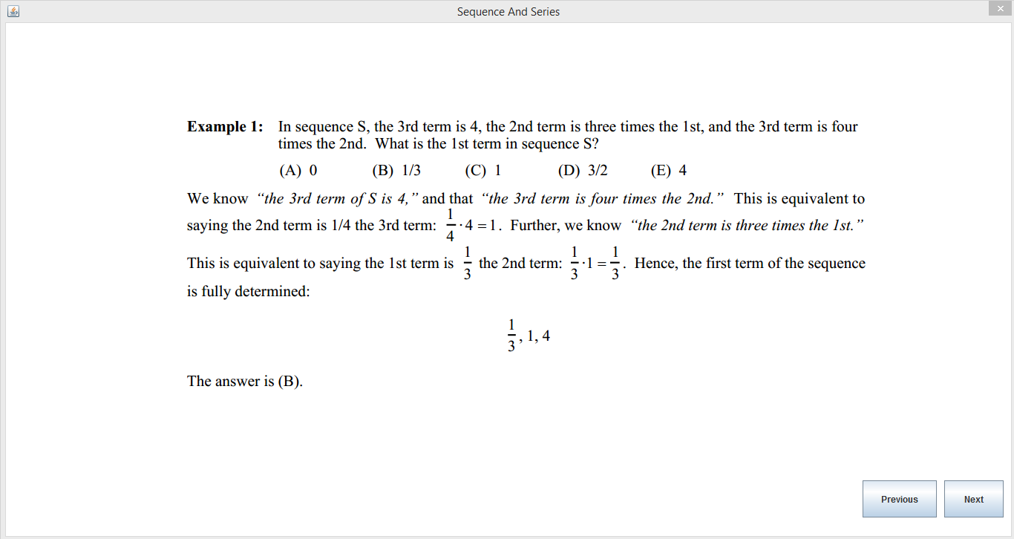

* Test :

Test works in a different way. The choice Set and answers are kept in the xml files. But the questions and answer explanation are kept in the .png format picture. So , the program just parse data from xml and set choice then compares answer and output result .

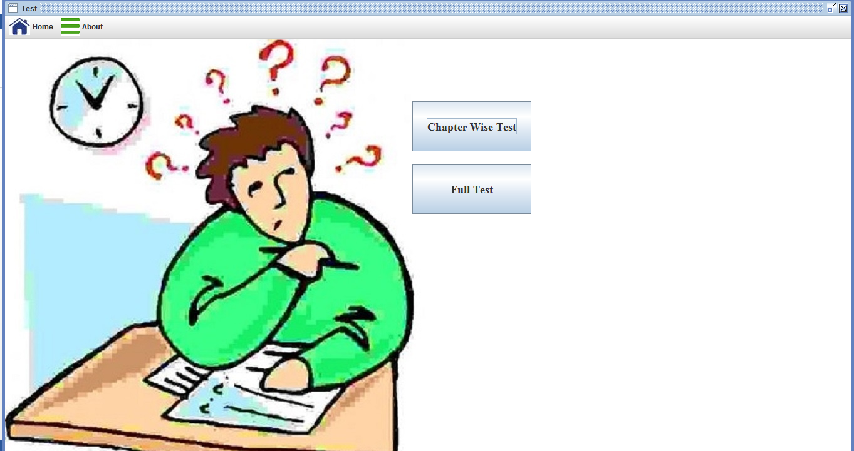

Chapter Wise Test looks as follows:

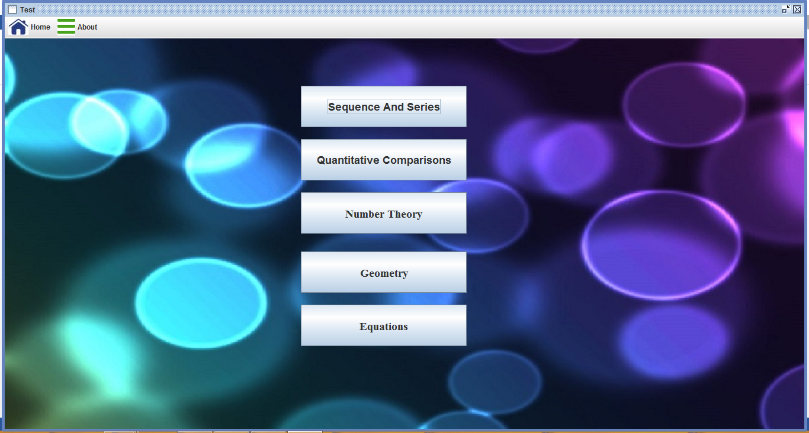

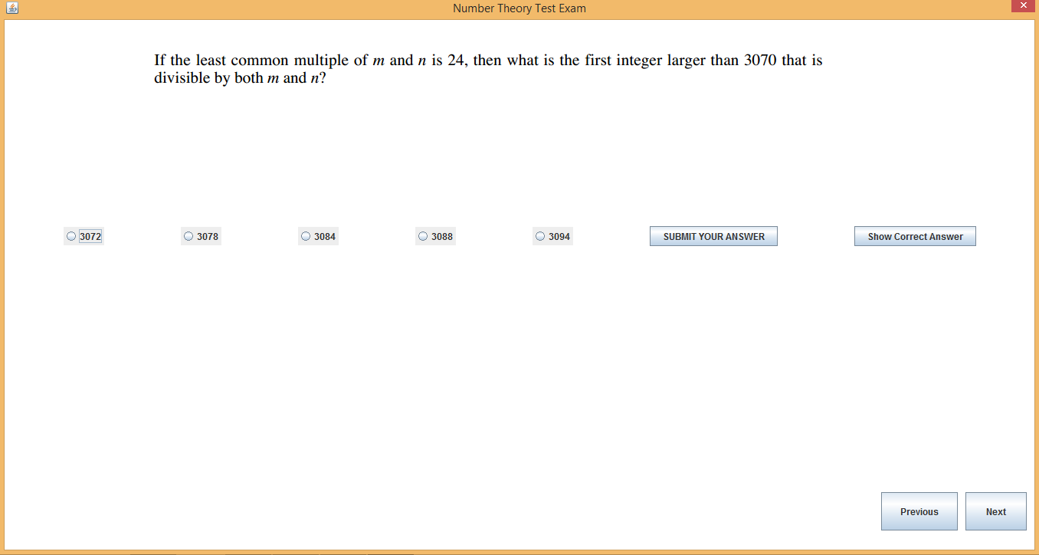

After the Test, the result will be given ,

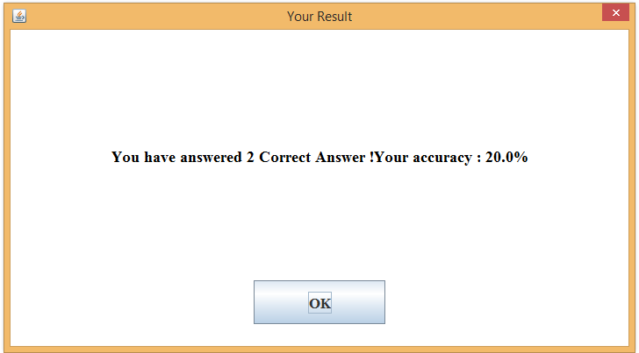

About GRE page looks like this:

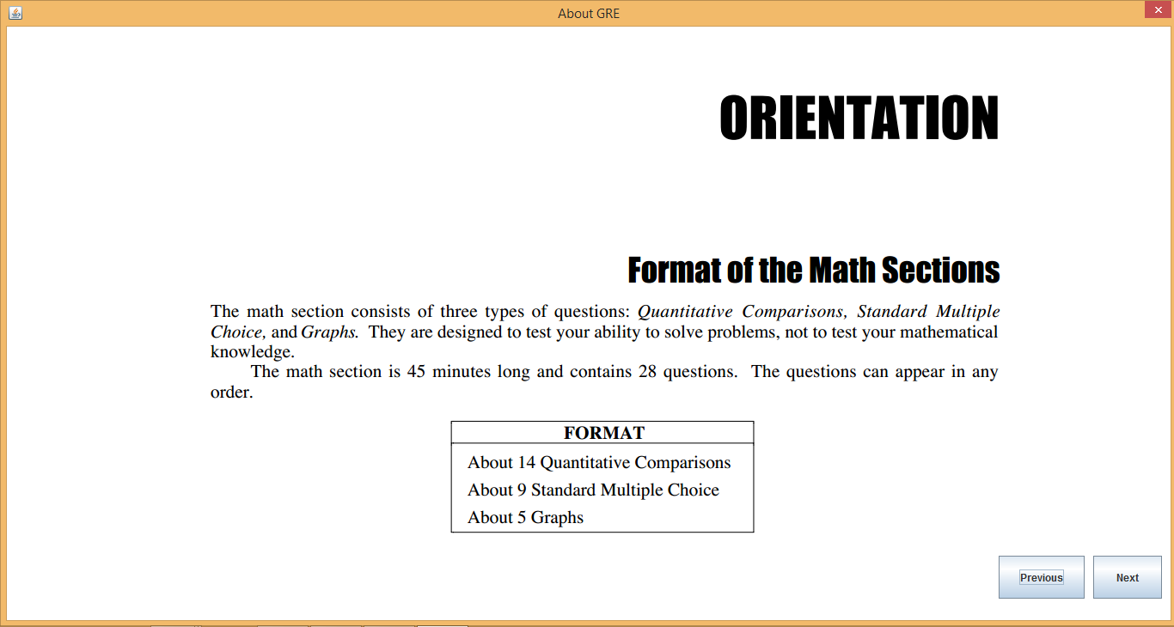

1. **Features and Usefulness**

The purpose of the application was to enable users to study various topics of GRE math and take a practice test. The usefulness rendered by this application is described in brief below.

1. Study: There are 15 chapters covered in the “tutorial” section of this software. By clicking on any chapter user can study the basic needs for GRE exam preparation.
2. Test: There are two options for Test. One is Chapter Wise Test and another is Full Book Test. Chapter Wise Test enables user to answer multiple choice questions on any selected topic. Randomly some questions will pop up and user have to choose an answer. He can also check the correct answer. After the test, he will be given a score. This score will justify his performance. Full Book Test has a lot of questions mixed on all topics and user can practice on full book anytime.
3. About GRE: About GRE covers the necessary information for GRE exam. All the details and updated information is provided here.
4. **Limitations**

As no single program can fulfil all requirements, our application GRE for dummies, hence, has some shortcomings. These, along with the improvements that can be made to this application (in Section-10), are discussed below:

1. Though this software has a collection of 15 chapters, but still some chapters are missing. Those could not be added for the lack of time.
2. In the test section, the GRE exam format has not been implemented. This software only covers a simple practice test, not the way GRE exam is taken.
3. **Improvement**

The following improvements could be made to the application against the limitations stated above:

1. More chapters could be added .
2. GRE exam format could be maintained in the Test section.
3. Level wise question sorting could be done .
4. **Conclusion**

GRE for Dummies as an application does what it is supposed and meant to do. A lot of students who are seeking admission in graduate program oversees can be benefited from GRE for Dummies.

1. **Reference**

* The Java SE 7 Documentation by Oracle Corporation
* The Java Tutorial by Oracle Corporation
* Java – How to Program, 9th Edition, Paul Deitel & Harvey Deitel

Acknowledgment

A word of special thanks must go to our highly esteemed teacher and this project’s supervisor, Saifuddin Mahmud, Lecturer, Department of computer Science & Engineering, KUET, for his excellent advices and right directions without which our project may not have reached a state it is in now.

Any constructive comments, suggestions, criticism from teachers as well as seniors will be highly appreciated and gratefully acknowledged.