INTRODUCE YOURSELF WITH BOOTSTRAP

Name: Lucky Christian Z. Eser
Section: UCOS 3-2

INSTRUCTIONS:

- Copy first the Bootstrap starter template from Bootstrap’s official website. You have the freedom to choose the version, but I strongly recommend using the version 4.6.

- Your goal for this activity is to utilize the Bootstrap concepts you learned from the last lecture. You must create a website where the viewers can get to know about you.

- You have to incorporate the NAVBAR COMPONENT as shown on the link below. Include at least 3-5 pages in the website.
  - https://getbootstrap.com/docs/4.6/components/navbar/

- Please DO NOT DOWNLOAD premade bootstrap templates, we’ll get there next week. We have to write the Bootstrap template FROM SCRATCH.

- Please DON’T INCLUDE your full name (your nickname is fine) or other PERSONAL DETAILS like birthday, address, location.

- The Bootstrap website you’ll create is instead more focused about your favorite music, dream places to live in, goals, aspirations, hobbies in life, items you may list on your bucket list, or anything else you can describe about yourself without specifying your personal details.

- Deploy the site using Github pages. Please MAKE SURE the link is working before submitting the document.
  - Here’s a guide on how to deploy:
    - https://docs.google.com/document/d/1IYSZFa4uhbNZPPlASRq5VwUzWFYayaG96o8uVSKQBa4/edit?usp=sharing

PROGRESS REPORT (AS OF FEBRUARY 3, 2026)
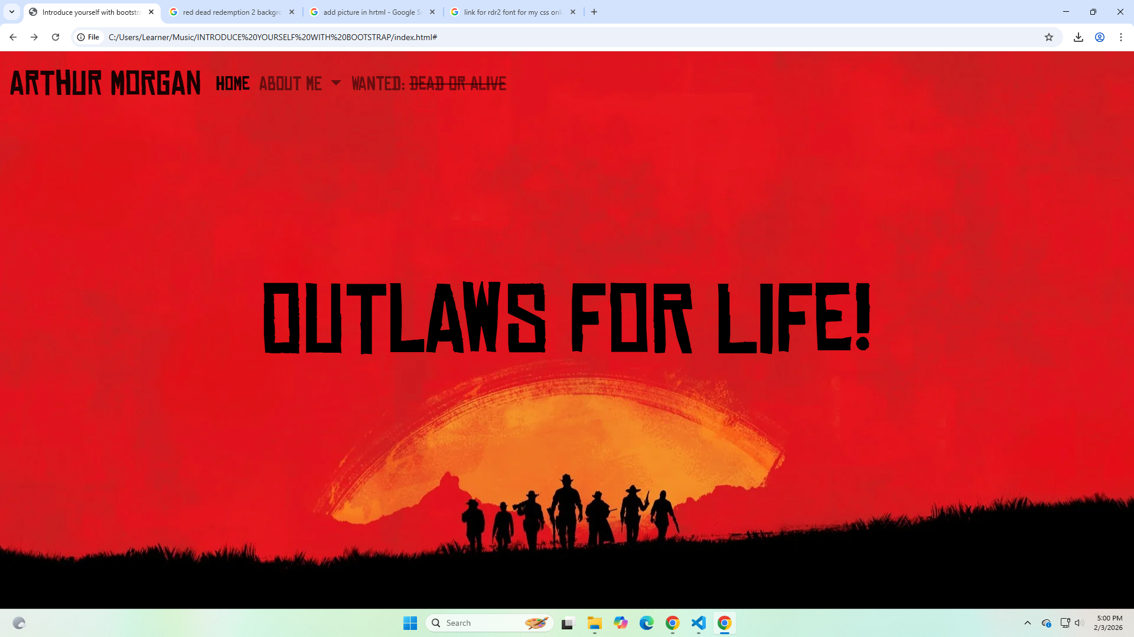
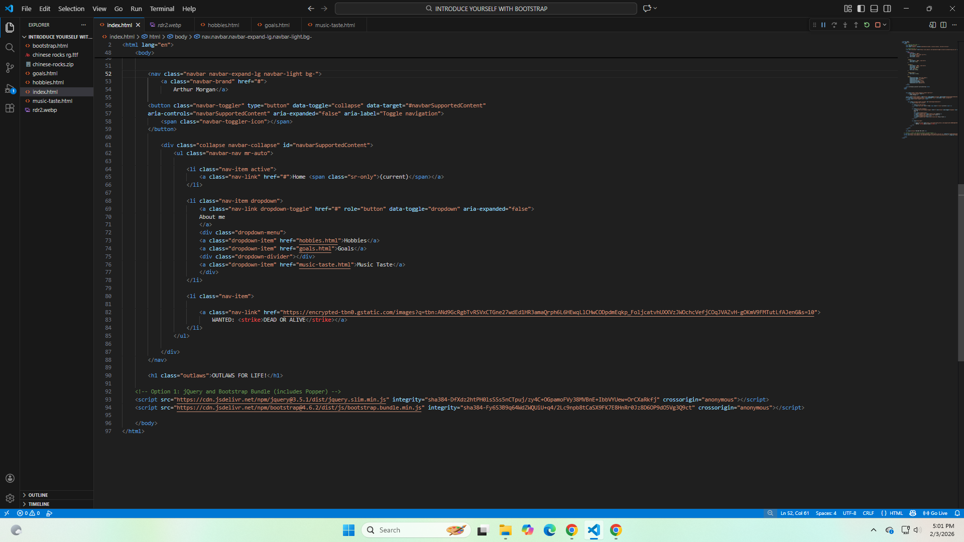
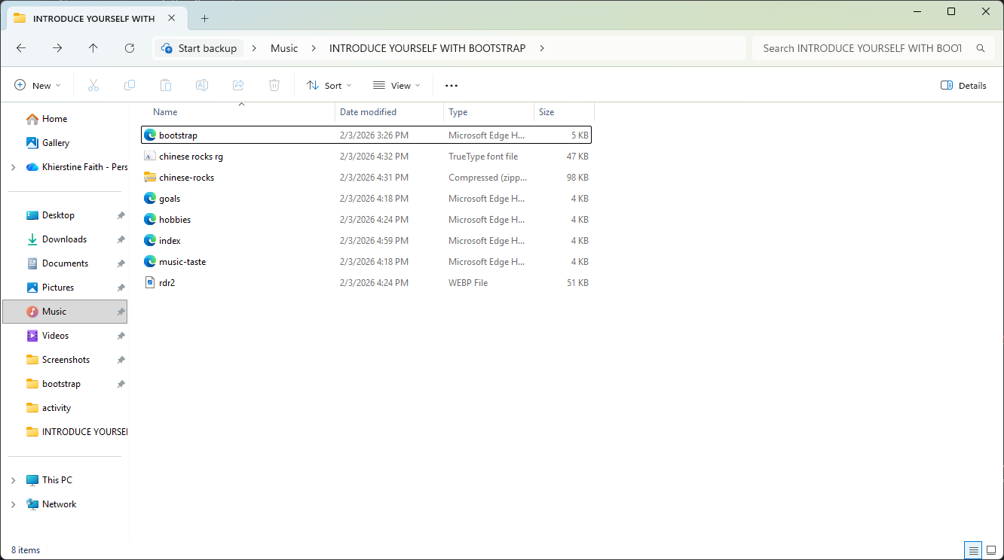

GITHUB PAGES LINK:
PASTE GITHUB PAGES LINK HERE

