Name: Emil Yong

Red Dragon : AI in production Run 2

Introduction

In this project, my primary objective was to design and develop a user-friendly chat interface empowered by Language Model technologies (LLMs). This interface was specifically engineered to facilitate seamless interaction and efficient information retrieval. The core functionality of the chat interface revolves around utilizing LLMs to extract relevant information from user queries. By harnessing the power of these advanced language models, the interface is able to interpret and comprehend user messages with a high degree of accuracy.
One of the key features of the chat interface is its ability to perform simple information extraction based on the nature of the query message. This involves parsing the user's input to identify keywords or intents that signal a request for specific information. Once these keywords or intents are identified, the interface dynamically interacts with a database containing police logs. Through this interaction, relevant data pertaining to the user's query is retrieved from the database in real-time.
By seamlessly integrating LLMs and database interactions, the chat interface provides users with a comprehensive platform for accessing pertinent information related to police logs. Whether users are seeking incident reports, crime statistics, or other relevant data, the interface streamlines the retrieval process, offering a convenient and intuitive user experience.

Data
Nevertheless, for this straightforward endeavor, I'll utilize an Excel spreadsheet as a repository for our data. Within this spreadsheet, you'll find entries detailing the date and time of each incident, along with the individual who reported it and a description of the event. This compiled data encompasses various types of assault incidents, including instances of molestation, theft, physical assault, altercations, domestic violence, and more.
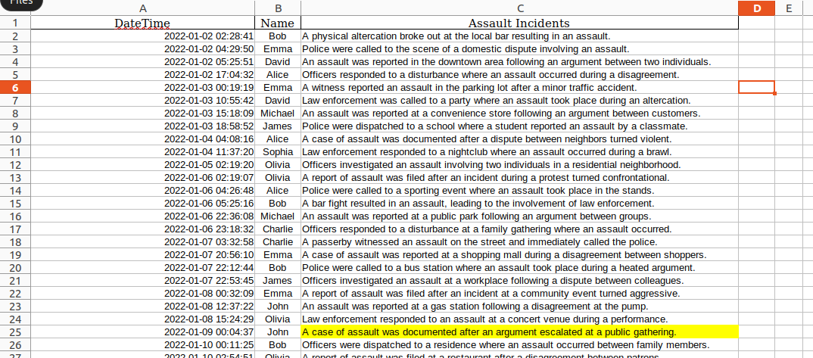
AI Model + Docker
Regarding the AI model selection, I've researched and opted to employ three primary services: Fast Chat, VLLM with Vicuna, and ultimately, the Fast Chat Server. Additionally, for the Vicuna Model, I've chosen the AWQ variant due to its lighter weight. These three services will be containerized using Docker. Furthermore, I've included a heartbeat mechanism in the Dockerization process. This health check feature enables me to promptly detect container failures without relying on a post request to assess the container's status.
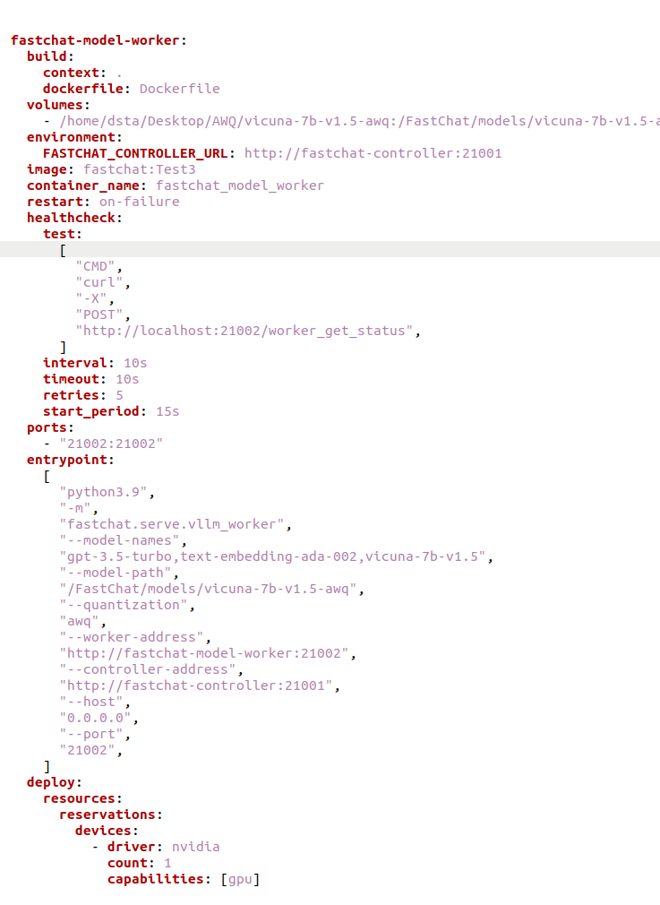

The repo name after building the docker file is fastchat with a tag named Test3 as shown in the image below
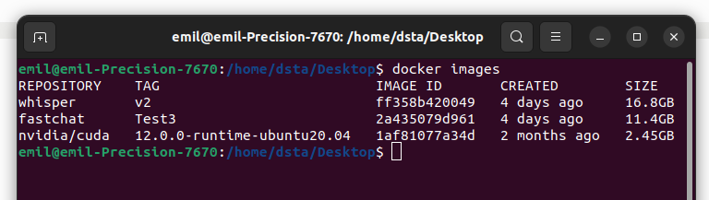

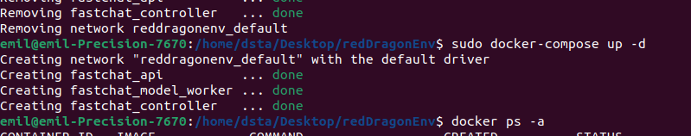
after docker compose up the image, based on the docker file specified , the port number to access the docker container is localhost:7862
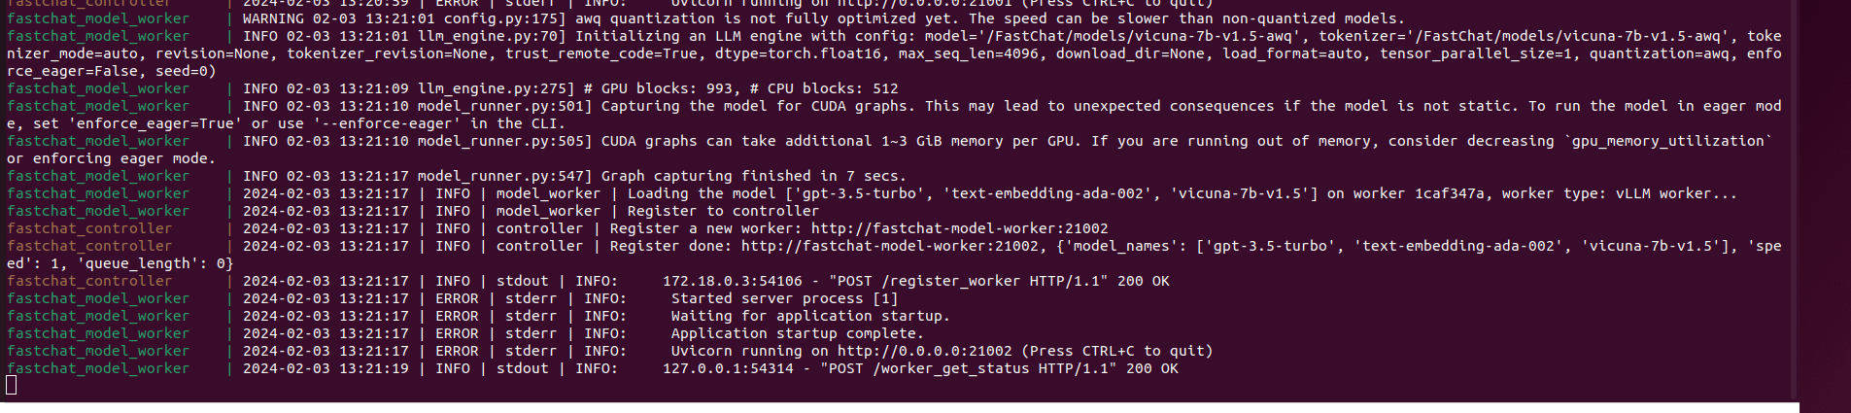
main.py Using FastAPI

Within this Python script, I've implemented FastAPI to handle incoming chat queries. The script facilitates the reception of these queries and subsequently forwards them to the Vicuna LLM model by issuing a POST request to the exposed FastChat endpoint located at "localhost:7862". Note that I am using fastAPI that calls the back end. Since fastchat handles the queuing of incoming request , I am able to run this main.py file at multiple instances to hit the backend.
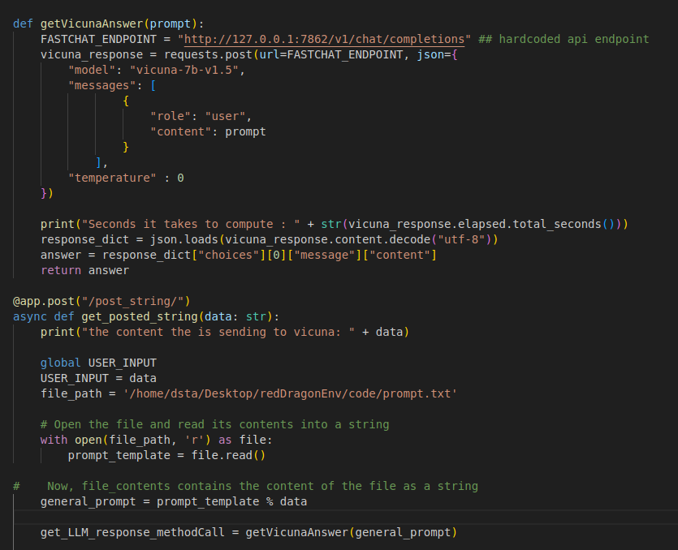

In this basic illustration, the primary concept revolves around utilizing a prompt template and the LLM to comprehend the query. The query could encompass various tasks such as retrieving assault type information, obtaining a range of police logs within a specific time frame, or retrieving the latest X number of police logs. The first prompt template will identify the tasks based on the query.
The following example demonstrates the prompt template used to recognize that the primary objective of the initial query is to retrieve the latest X number of police logs.
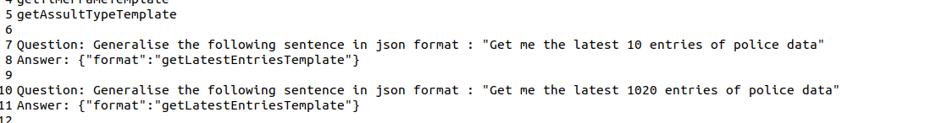
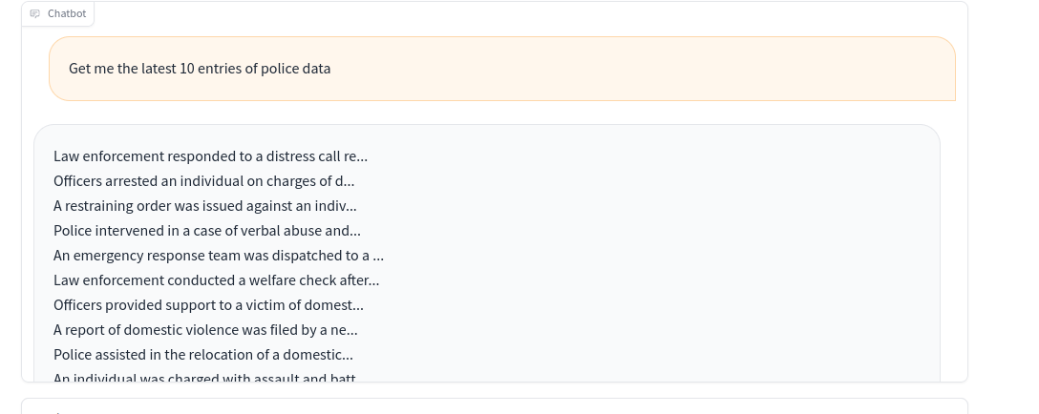
In this particular instance, upon identifying the query's intent to acquire the latest entries, the customized prompt template extracts the specified number of latest police logs, which in this case is 10. It will then extract the last 10 data entry and display it on the Gradio UI.

Conclusion
In conclusion, I've taken steps to productionize the Vicuna model, an advanced LLM, by containerizing it using Docker. This approach ensures portability and scalability, allowing for seamless deployment across various environments.
Furthermore, I've integrated VLLM to serve as the backbone of the model, enhancing its capabilities and performance. Moreover, to facilitate interaction with the Dockerized Vicuna AI model, I've leveraged both Gradio and FastAPI frameworks.
Gradio provides a user-friendly interface for real-time interaction with the model, while FastAPI offers a robust and efficient means of communication between the frontend and backend services. This integration streamlines the deployment process and enhances accessibility to the Vicuna AI model. By combining these technologies and methodologies, I've successfully created a scalable and efficient infrastructure for deploying the Vicuna AI model in production environments. This ensures reliability, scalability, and ease of use, making the model accessible to a wider audience and enabling seamless integration into various applications and workflows.

