1.1

CREATE TABLE SHOP

(

shopId INT PRIMARY KEY,

shopName VARCHAR(30)

)

INSERT INTO SHOP VALUES

(1, 'Amal Stores'),

(2, 'Jyothi Stores'),

(3, 'Indira Stores');

--DROP TABLE SHOP

CREATE TABLE unit

(

unitId INT PRIMARY KEY,

unitName VARCHAR(25)

)

INSERT INTO unit VALUES

(1, 'Piece'),

(2, 'Boxpack')

CREATE TABLE ITEMS

(

itemId INT PRIMARY KEY,

itemName VARCHAR(20)

)

INSERT INTO ITEMS VALUES(1,'Bar-one')

INSERT INTO ITEMS VALUES(2,'Kitkat')

INSERT INTO ITEMS VALUES(3,'Milky bar')

INSERT INTO ITEMS VALUES(4,'Munch')

--DROP TABLE ITEMS

CREATE TABLE Sales (

SaleID INT PRIMARY KEY,

ShopID INT,

ItemID INT,

Quantity INT,

unitId INT,

UnitPrice DECIMAL(10, 2),

SaleDate DATE,

FOREIGN KEY (unitId) REFERENCES unit (unitId),

FOREIGN KEY (ShopID) REFERENCES Shop (ShopID),

FOREIGN KEY (ItemID) REFERENCES Items (ItemID)

);

INSERT INTO Sales (SaleID, ShopID, ItemID, Quantity,Unitid, UnitPrice,SaleDate)

VALUES

(1, 1, 1, 100,1, 10.00,'2018-10-05'),

(2, 1, 2, 200,1, 15.00,'2018-10-05'),

(3, 1, 3, 50,1, 5.00,'2018-10-05'),

(4, 1, 4, 150,1, 10.00,'2018-10-05'),

(5, 2, 1, 10 ,2, 280.00,'2018-10-10'),

(6, 2, 2, 30 , 2,420.00,'2018-10-10'),

(7, 2, 3, 40 ,2, 140.00,'2018-10-10'),

(8, 2, 4, 20 ,2, 280.00,'2018-10-10'),

(9, 3, 1, 50,2, 280.00,'2018-09-15'),

(10,3, 2, 70,2, 420.00,'2018-09-15'),

(11,3, 3, 30,2, 140.00,'2018-10-10'),

(12, 1, 1, 150,1, 10.00,'2018-09-15'),

(13, 1, 2, 250,1, 15.00,'2018-09-15'),

(14, 1, 4, 200,1, 10.00,'2018-10-10');

--DROP TABLE SALES

SELECT \* FROM Sales

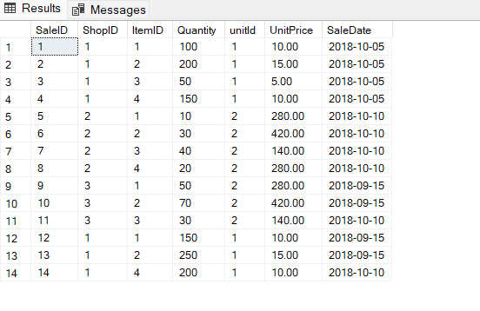

1.2

SELECT TOP 1 itemname,sum(s.quantity\*s.unitprice) AS Revenue

FROM Sales s

INNER JOIN ITEMS i

ON i.itemId=s.ItemID

WHERE MONTH(saledate)=10

GROUP BY itemname

ORDER BY revenue DESC

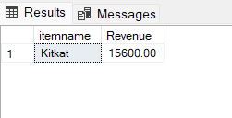

1.3

SELECT TOP 1 itemname,sum(s.quantity) AS quantity

FROM Sales s

INNER JOIN ITEMS i

ON i.itemId=s.ItemID

INNER JOIN shop sh

ON sh.shopId=s.ShopID

WHERE MONTH(s.saledate)=10 AND sh.shopName = 'Amal Stores'

GROUP BY itemname

ORDER BY quantity DESC

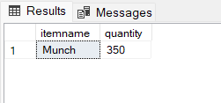

1.4

SELECT itemname,sum(s.quantity\*s.unitprice) AS Revenue

FROM Sales s

INNER JOIN ITEMS i

ON i.itemId=s.ItemID

WHERE MONTH(saledate)=10

GROUP BY itemname

HAVING sum(s.quantity\*s.unitprice) > 10000

ORDER BY revenue DESC

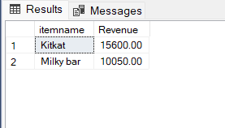

1.5

SELECT TOP 1 she.shopName,sum(s.quantity\*s.unitprice) AS Revenue

FROM Sales s

INNER JOIN ITEMS i

ON i.itemId=s.ItemID

INNER JOIN shop she

ON she.shopId=s.ShopID

WHERE MONTH(s.saledate)=10

GROUP BY she.shopName

ORDER BY Revenue DESC

