CREATE TABLE Employee(

EmployeeID INT PRIMARY KEY,

EmpName VARCHAR(30),

PHONE DECIMAL(15,2),

Email VARCHAR(20),

area_code INT

)

--DROP TABLE EMPLOYEE

CREATE TABLE MANUFACTURER(

MfName VARCHAR(20) PRIMARY KEY,

City VARCHAR(20),

State VARCHAR(20),

)

CREATE TABLE COMPUTER(

SerialNumber INT PRIMARY KEY,

MfName VARCHAR(20),

CONSTRAINT fk_001 FOREIGN KEY (MfName) REFERENCES MANUFACTURER(MfName),

Model VARCHAR(20),

Weight INT,

EmployeeID INT,

CONSTRAINT fk_002 FOREIGN KEY (EmployeeID) REFERENCES EMPLOYEE(EmployeeID),

STATUS VARCHAR(20)

)

INSERT INTO EMPLOYEE VALUES

(1, 'emil', 1234567890, 'emil@gmail.com',27),

(2, 'anto', 0987654321, 'anto@yahoo.com',10),

(3, 'will', 3456217809, 'will@gmail.com',25);

SELECT * FROM EMPLOYEE

INSERT INTO MANUFACTURER VALUES

('asd', 'india', 'ia'),

('qwe', 'newyork', 'nk'),

('zxc', 'south dakota', 'sd');

;

--DROP TABLE MANUFACTURER

SELECT * FROM MANUFACTURER

INSERT INTO COMPUTER VALUES

(101, 'asd', 'dell', 2, 1,'USE'),

(102, 'qwe', 'hp', 5, 2,'NOT USE'),

(103, 'zxc', 'leopad', 10, 1,'USE'),

(104, 'asd', 'asus', 8, 3,'NOT USE')

;

SELECT * FROM COMPUTER

1.

SELECT * FROM MANUFACTURER WHERE City = 'South Dakota'

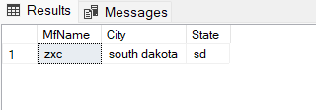

2.

SELECT AVG(Weight) AS AVG_Weight FROM COMPUTER WHERE STATUS = 'USE'

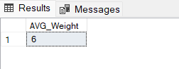

3.

SELECT EmpName FROM EMPLOYEE WHERE CAST(area_code AS varchar(20)) LIKE '2%'

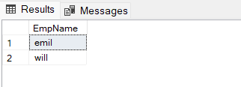

4.

SELECT SerialNumber FROM COMPUTER WHERE Weight< (SELECT AVG(Weight) FROM COMPUTER)

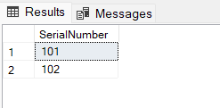

5.

SELECT MfName FROM MANUFACTURER WHERE MfName IN (

SELECT MfName FROM COMPUTER WHERE STATUS = 'NOT USE')

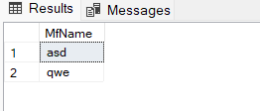

6.

SELECT e.EmpName,c.SerialNumber,m.City FROM EMPLOYEE e

INNER JOIN

COMPUTER c

ON e.EmployeeID = c.EmployeeID

INNER JOIN

MANUFACTURER m

ON c.MfName = m.MfName

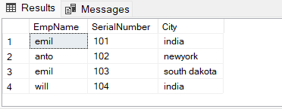

7.

CREATE PROCEDURE detail1

@employeeid INT

AS

BEGIN

SELECT c.SerialNumber,C.MfName,c.Model,c.Weight FROM COMPUTER c

WHERE @employeeid = c.EmployeeID

END

--DROP PROCEDURE detail

EXEC detail1 @employeeid=3

SELECT * FROM COMPUTER

