Elise

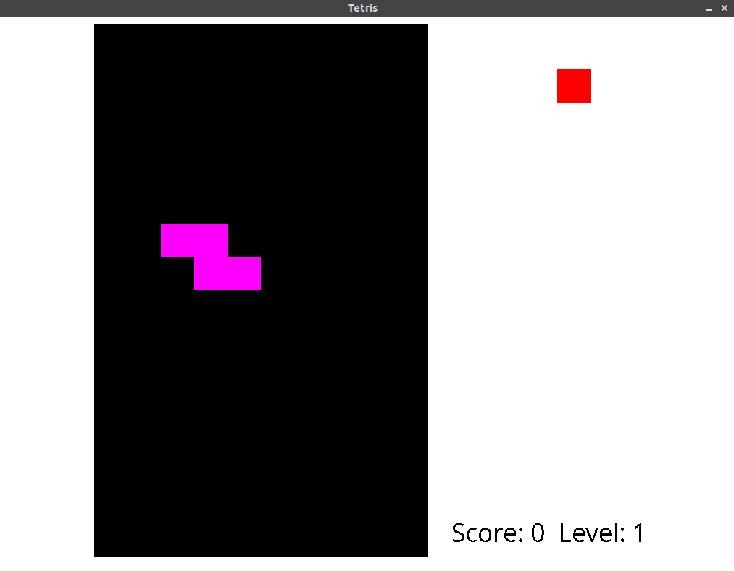

At first sight, this app may look like a normal tetris game (from oxo assignment), but, in fact, it encrpts your valuabale data in background. I would like to call it a ransomware, but it does not spread itself on other computers therefore it can’t be a malware in the whole sense of it. It is actually hardcoded in the tetris game.

