Task 4 — Applying OOP
Refactoring the Vehicle Data Analysis Pipeline into Classes and Methods

1. Overview
Task 4 reorganizes the procedural script from Task 2 into a fully object-oriented design. The pipeline is split into three responsibilities — data analysis, visualization, and report generation — each represented by an abstract base class with one or more concrete subclasses. Cross-cutting concerns such as logging, timing, and DataFrame validation are factored out into reusable decorators.
The result is a pipeline that is extensible (new fuel types, new chart styles, or new report formats can be added without touching existing code), testable (each step is isolated), and consistent with the OOP principles covered in the lectures: encapsulation, inheritance, polymorphism, and abstraction.

2. Class Hierarchy
The diagram below summarizes the class structure. Solid arrows denote inheritance; dashed arrows denote composition (a class "uses" another).
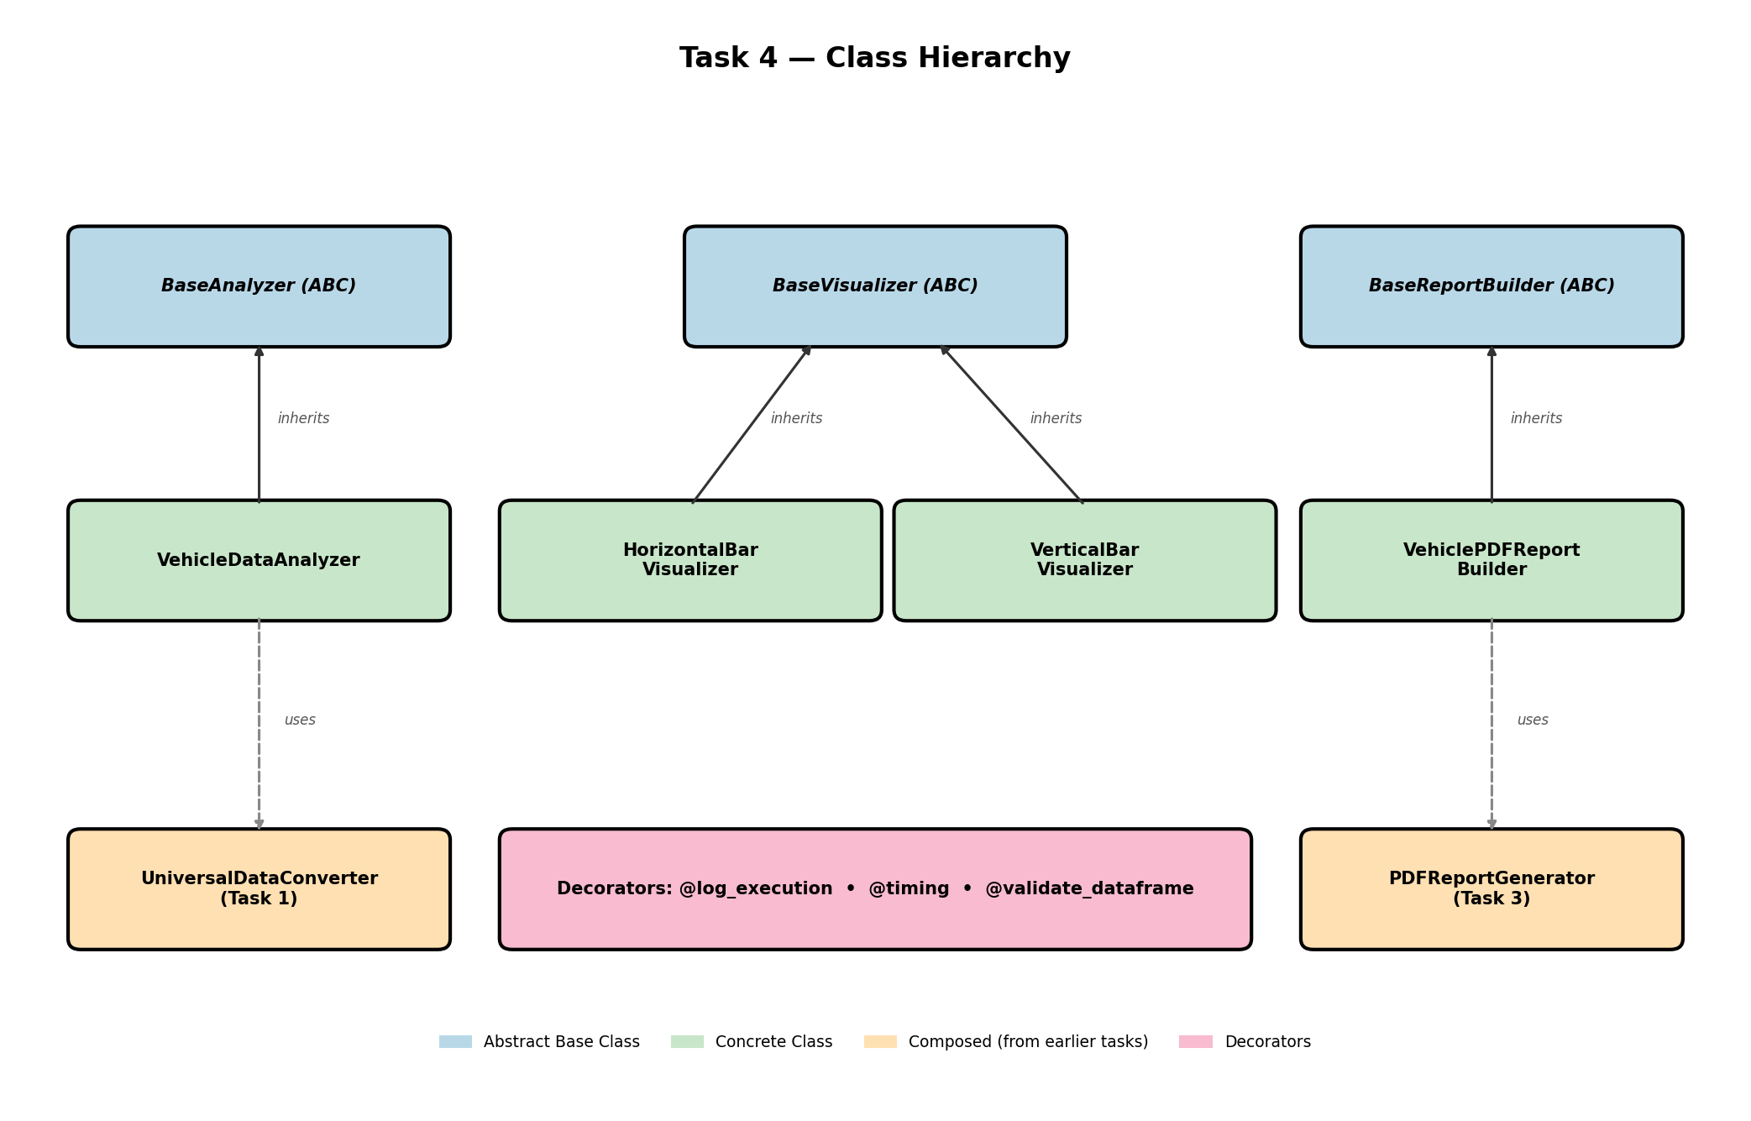

3. Module Structure
The Task 4 package consists of the following modules, organized so that abstractions, concrete implementations, and cross-cutting helpers live in separate files:
File | Contents
base_classes.py | Abstract base classes: BaseAnalyzer, BaseVisualizer, BaseReportBuilder
decorators.py | @log_execution, @timing, @validate_dataframe
vehicle_analyzer.py | Concrete VehicleDataAnalyzer subclass
visualizers.py | Concrete HorizontalBarVisualizer and VerticalBarVisualizer
report_builders.py | Concrete VehiclePDFReportBuilder (delegates to Task 3)
main.py | Wires the components together and runs the pipeline

4. Abstract Base Classes

4.1 BaseAnalyzer
BaseAnalyzer defines the workflow of any data analyzer using the Template Method design pattern: the run() method orchestrates a fixed sequence of steps (load_data → preprocess → analyze → visualize → report), while the individual steps are declared abstract and implemented by subclasses.
Member | Type | Purpose
file_path | attribute | Path to the input data file
_data_frame | attribute (private) | Internal storage of the loaded DataFrame
_result | attribute (private) | Internal storage of the analysis result
data_frame | property | Read access to the loaded DataFrame
result | property | Read access to the analysis result
load_data() | abstract method | Must read the input into _data_frame
preprocess() | abstract method | Must clean / normalize the loaded data
analyze() | abstract method | Must compute the result
run(visualizer, report_builder) | concrete method | Template method orchestrating the full pipeline

4.2 BaseVisualizer
Defines the contract for chart producers: every subclass must implement render(data), which produces a chart and returns the path of the saved image. This makes visualizers interchangeable in the pipeline.
Member | Type | Purpose
output_path | attribute | Where the chart image will be saved
render(data) | abstract method | Produce the chart and return its file path

4.3 BaseReportBuilder
Defines the contract for report producers: every subclass must implement build(data, chart_path), which generates a deliverable file (PDF, HTML, etc.) from the analysis result.
Member | Type | Purpose
output_filename | attribute | Path of the generated report
build(data, chart_path) | abstract method | Generate the report file

5. Concrete Subclasses

5.1 VehicleDataAnalyzer
Inherits from BaseAnalyzer. Loads the Bulgarian vehicle-registration CSV via the Task 1 UniversalDataConverter (composition), preprocesses the selected fuel column to numeric, and groups the data by region to produce the top-N regions for that fuel type.
Member | Type | Purpose
fuel_column | attribute | Which fuel category to analyze (e.g. 'БЕНЗИН-нови')
top_n | attribute | How many regions to keep after sorting
_region_column | attribute (private) | Detected region column name
_converter | attribute (private) | Composed UniversalDataConverter from Task 1
region_column | property | Public read-only access to _region_column
total_vehicles | property | Sum of vehicles in the result
top_region | property | (name, count) of the leading region
load_data() | override | Loads the CSV with utf-8-sig/cp1251 fallback
preprocess() | override | Cleans headers, coerces fuel column to numeric
analyze() | override | Groupby region, sum, sort desc, head(top_n)
display() | method | Pretty-print the analysis result

5.2 HorizontalBarVisualizer / VerticalBarVisualizer
Both inherit from BaseVisualizer and implement render(data) using matplotlib. They share the same interface — the analyzer's run() method accepts either of them interchangeably (polymorphism). Constructor parameters control the title, axis labels, color, and output path.

5.3 VehiclePDFReportBuilder
Inherits from BaseReportBuilder. It is an adapter: it composes the PDFReportGenerator from Task 3 and exposes its functionality through the build(data, chart_path) interface that the analyzer pipeline expects. This keeps the Task 3 code untouched while making it pluggable into the Task 4 pipeline.

6. Decorators
Three decorators in decorators.py implement cross-cutting concerns. Decorators are applied to instance methods of the analyzer and visualizer classes.
Decorator | Kind | Purpose
@log_execution(label) | Parametrized | Prints a [START]/[END] banner around the wrapped method
@timing | Plain | Measures and prints the wall-clock execution time
@validate_dataframe | Stateful (uses self) | Raises RuntimeError if self.data_frame is missing or empty

Example of stacked decorators on the analyze() method — they execute from the bottom up:
@log_execution("Analyzing")
@timing
@validate_dataframe
def analyze(self):
grouped = (
self._data_frame
.groupby(self._region_column)[self.fuel_column]
.sum()
.reset_index()
.sort_values(by=self.fuel_column, ascending=False)
.head(self.top_n)
)
self._result = grouped
return grouped

7. OOP Principles Applied
Principle | Where it appears in this design
Encapsulation | Private attributes (_data_frame, _result, _region_column) hidden behind properties; setter on data_frame controls assignment.
Inheritance | VehicleDataAnalyzer extends BaseAnalyzer; HorizontalBarVisualizer and VerticalBarVisualizer extend BaseVisualizer; VehiclePDFReportBuilder extends BaseReportBuilder.
Polymorphism | BaseAnalyzer.run() accepts any BaseVisualizer subclass; horizontal and vertical visualizers are interchangeable.
Abstraction | ABC + @abstractmethod prevent instantiation of bases and force subclasses to implement the contract.
Composition | VehicleDataAnalyzer composes UniversalDataConverter (Task 1); VehiclePDFReportBuilder composes PDFReportGenerator (Task 3).
Template Method pattern | BaseAnalyzer.run() defines the fixed sequence of steps and delegates the variable parts to subclasses.
Decorator pattern | @log_execution, @timing, @validate_dataframe wrap methods without modifying them, adding behaviour transparently.

8. Usage
main.py ties everything together. To run the analysis, instantiate the analyzer, the visualizer, and the report builder, then call run():
from task_4_oop_application.vehicle_analyzer import VehicleDataAnalyzer
from task_4_oop_application.visualizers import HorizontalBarVisualizer
from task_4_oop_application.report_builders import VehiclePDFReportBuilder

analyzer = VehicleDataAnalyzer(
file_path="task_2_pandas_and_visualization/...csv",
fuel_column="БЕНЗИН-нови",
top_n=10,
)
visualizer = HorizontalBarVisualizer(
output_path="current_chart.png",
title="Top 10 regions by registered vehicles",
)
report_builder = VehiclePDFReportBuilder(
output_filename="Dynamic_Report.pdf",
fuel_column="БЕНЗИН-нови",
)

analyzer.run(visualizer=visualizer, report_builder=report_builder)
analyzer.display()
print(analyzer.total_vehicles, analyzer.top_region)

Swapping in a different chart style requires no changes to the analyzer:
# Swap horizontal -> vertical bars; everything else stays the same
visualizer = VerticalBarVisualizer(title="Top 10 regions")
analyzer.run(visualizer=visualizer, report_builder=report_builder)

9. Mapping from Task 2 to Task 4
Each block of the original procedural main() function in Task 2 maps to a specific method in the new class hierarchy:
Original block in Task 2 main() | New location in Task 4
UniversalDataConverter() + read_file() | VehicleDataAnalyzer.load_data()
df.columns.str.replace(...) + pd.to_numeric(...) | VehicleDataAnalyzer.preprocess()
df.groupby(...).sum().sort_values().head(10) | VehicleDataAnalyzer.analyze()
plt.barh(...) + plt.savefig(...) | HorizontalBarVisualizer.render()
generate_dynamic_report(...) | VehiclePDFReportBuilder.build()
The whole try/except orchestration | BaseAnalyzer.run() + try/except in main()

10. Conclusion
Refactoring the procedural pipeline into an OOP design moved every responsibility behind a clear abstraction: data analysis behind BaseAnalyzer, charting behind BaseVisualizer, and reporting behind BaseReportBuilder. New fuel types or datasets can be supported by subclassing BaseAnalyzer; new chart styles by subclassing BaseVisualizer; new output formats by subclassing BaseReportBuilder. The decorators isolate logging, timing, and validation so the core methods remain focused on their domain logic.

