Transporting Structured Data
Today’s lab is all about transporting data from one system to another and from one format to another.

Other common terms for this process include:
- Data ingestion & conversion
- Data extraction and transformation

Exercise 1: Cost of Living Comparison

Cut and paste method

- Go to https://www.numbeo.com/cost-of-living/comparison.jsp select two Canadian cities that you would like to compare on the cost of living. Leave the browser window open.
- Create a new Google Sheet.
- Highlight the data in your cost-of-living report on Numbeo then copy and paste the data into the Google Sheet.
- Save the Google Sheet and leave it open.
- Create a new Excel workbook.
- Go back to your cost-of-living report on Numbeo.
- Highlight the data in your cost-of-living report on Numbeo then copy and paste the data into sheet 1 of your Excel workbook.
- Save the Excel workbook and leave it open.

Examine the data as displayed in Google and Excel. What is different? What is the same?

The data and values were the same in Google Sheets and Excel, but the formatting was different. In Excel, some of the columns were too narrow, which caused the text to wrap and made the data harder to read.

Connection Method (website to Excel)

Step 1  Choose a fresh sheet in your Excel workbook. Select the Data ribbon then Get Data then From Other Sources then From Web. | 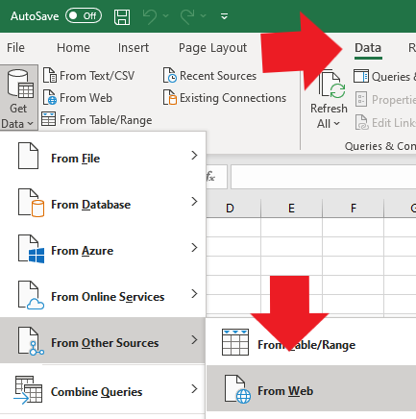

Step 2
Copy the Numbeo.com website address for the comparison you created and paste it into the box marked URL. Click OK.

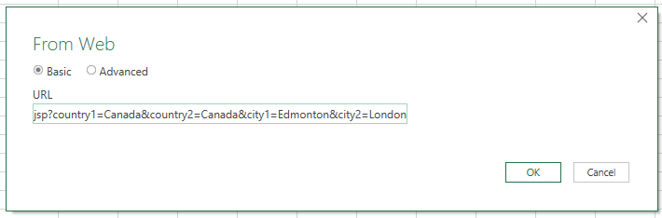

Step 3
Click on each table to find the one that contains your comparison data. Once you have found it, click Load. It might take a few minutes to load.

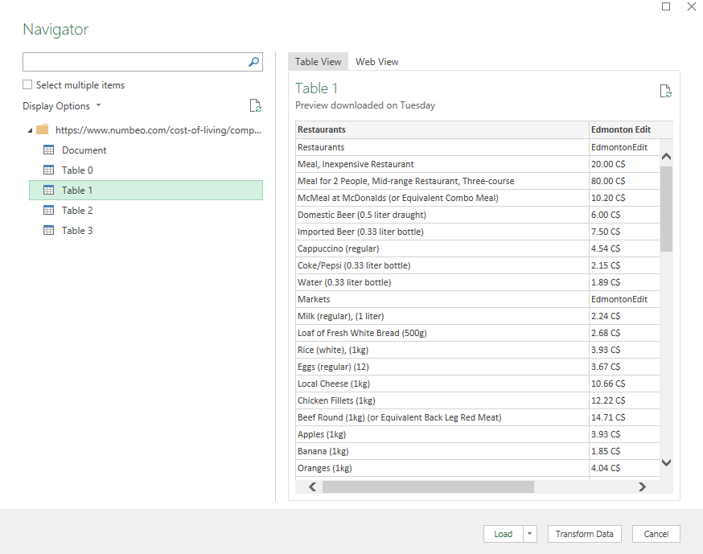

Your data looks quite different than it did when you cut and paste it into Excel. We will talk about some of the differences on another day.

Step 4
Save the Excel workbook and leave it open.

Connection Method (Google Sheet to Excel)
Step 1
Choose a fresh sheet in your Excel workbook. You will use this new sheet to connect to your Google Sheet containing Numbeo data.
- Click the ‘Share’ button in the upper right corner of your Google Sheet.
- Then change the permission to “Anyone with the link”.
- Copy the link.



Step 2
- Return to your Excel Workbook
- Select the Data ribbon then Get Data then From Other Sources then From Web.
- Paste in the copied link but do not click OK yet. We need to edit the link to connect to Google Sheets.
- Change the highlighted part of the link from this:
https://docs.google.com/spreadsheets/d/1IV8oIlzjWljgxQv8lilh2NgdjmBscpqlVFAZkSADDic/edit?usp=sharing
To this:
https://docs.google.com/spreadsheets/d/1IV8oIlzjWljgxQv8lilh2NgdjmBscpqlVFAZkSADDic/export?=csv
- Click Load

Step 3
- Once your Google Sheet data has loaded into Excel, go back to your original Google Sheet.  - Hold the Ctrl key while typing H.  - The search and replace menu will appear. Replace all mentions of the word ‘Taxi’ with ‘Spaceship’.  - Click ‘Replace all’ then ‘Done’. | 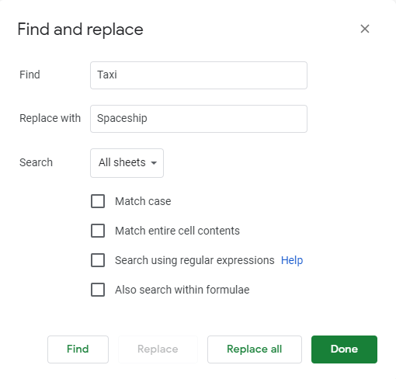

Step 4
- Return to the Excel worksheet containing your Google Numbeo data.  - Refresh the data by selecting the down arrow under Refresh and then select Refresh.  What happened?  After I refreshed the data in Excel, the word taxi was automatically replaced with spaceship. | 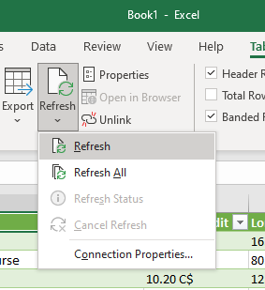

Step 5
Save and close your Excel workbook.

Exercise 2: Statistics Canada data

Create a new Google Sheet and Excel workbook. Transport the data using the methods you learned in exercise 1.

- Cut and paste from website to Google Sheet.
- Cut and paste from website to Excel.
- Connect Excel to website.
- Connect Google Sheet to Excel.

https://www150.statcan.gc.ca/t1/tbl1/en/tv.action?pid=1410001701

What worked? What didn’t work?

Some of the formatting did not transfer well. The columns were too narrow for some of the larger numbers, which caused them to display as ######. Connecting directly to the website worked better because the data was more organized and easier to read.

