SocultPaperV3

2024-05-19

# Introduction

### What is the adaptive cancer therapy

Worldwide, cancer is the cause of 1 out 6 deaths. Of these cancer deaths an estimated 90% are due to development of drug resistance (Bukowski, Kciuk, and Kontek 2020). While intial cancer treatment usually shows positive response in tumor burden, drug resistance develops due. To highlight the inefficincy of traditional approaches, (Staňková et al. 2019) models cancer treatment game theorict contest between a physician and a tumor, where physicians move on each round is to apply a certain treatment, and a tumor makes an adaption. While it is a “Stackelberg game”, a game where one player is the leader (the physician) and another player is a follower (the tumor), is assymerty is rarely exploited. Instead of using their advantage to steer the evolutionary pressures placed on tumors, the physician lets the tumor not only adapt to the current round of the game but also to future rounds of the game. The advantage of leading the game is thereby lost. The authors aptly analogize the current practice:

*“Consider cancer treatment as a rock-paper-scissors game in which almost all cells within the cancer play, for example, “paper.” It is clearly advantageous for the treating physician to play “scissors.” Yet, if the physician only plays “scissors,” the cancer cells can evolve to the unbeatable resistance strategy of “rock.”“* (Staňková et al. 2019)

*Adaptive Therapy* is a approach to cancer treatment based on controlling the intra-tumoral evolutionary dynamics. By leveraging that cancer cells can incur a fitness cost to evovling mechanisms that yield resistance to drugs. For example it has been shown that tumor cells can mutate to increased expression of PGP membrane pump, which uses ATP to move drugs out of the cell. While this makes cell more resistant to treatment, it also comes at metabolic cost. (Gatenby et al. 2009) found that PGP activity was the culprit of approximately 50% of cell metabolism. As a result, if resistant and non-resistant cells are competing for space and resources, drug-sensitive cells should over time outcompete resistant cells. Apative Therapy utilizes this darwinian competition to make cancer fight itself. Thus the dream-sceneario of this adaptive therapy is not to eradicate cancer, but instead make it a controllable chronic disease.

[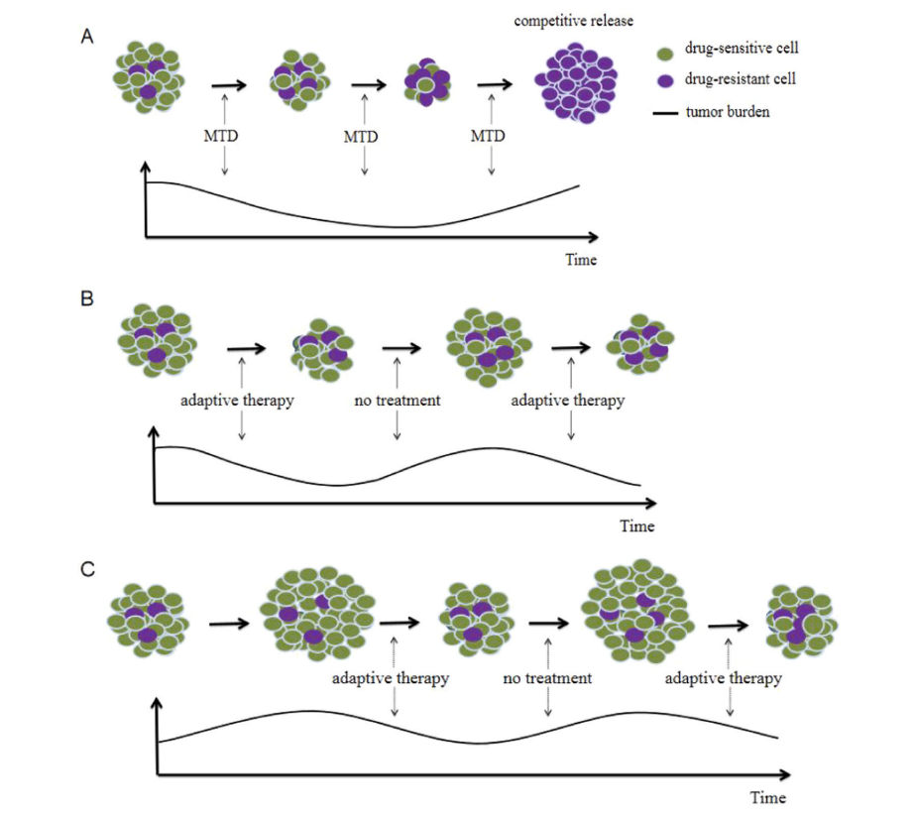](https://doi.org/10.1016/j.critrevonc.2023.104192)

Initial results from pilot clinical trial on metastatic castrate-resistant prostate cancer patients are promising. Intitial results showing both less cumuluative dosages and longer survival in comparison similiar group of patients recieving standard care. Firstly, patients were only involved if they showed a substainal positive response to treatment. The trial has then been utilizing a range-bounded treatment rule. If the bloodmarker *Prostate-specific Antigen* (PSA), a proxy of tumor burden, increases back to pre-trial levels, treatment is applied until PSA drops to 50% of pre–trial levels (Zhang et al. 2017). The trial is expected to run until december 2024 (Center and Research Institute 2024).

### Desired qualities of models

While the trial reported by (Zhang et al. 2017) only utilized a single drug, key researchers in researchers in Adapative Therapy has produced a review of the use of mathematical modelling in the field, and among other things, indentified that modelling multidrug treatments is a necessity of future models. Additionally, they argue that it is unlikely that any treatment approach can accomplish delaying the emergence of resistant cells, lower the tumor burden and minizmize the toxicity. Given that patients likely differ in their ability to tolerate tumor burden and the toxicity of drugs and the evolutioanry dynamics of the cancers that they carry differ, ,odels would ideally therefore have to trade-off each these factors given a specific patient. This will require fitting data on invidual patients. Lotke-volterra models have been fitted frequently.

#### biological factors

Another important aspect of modelling, is illumanitng the actual comppetive disadvantage that resistant cells are. While larger tumor sizes are thought to increase the suppresion of resistant cells, the dynamics are likely much more complex. Factors such as the spatial configuration of actual cells and the range of the molecular influence they yield of each other. It is also crucial that these actually incur a fitness cost, however other authiors argue that adaptive therapy might still be able to delay time-to-progression if this is not the case. Comptettion isn’t neccesarily strong if the tumor isn’t at carrying capacity.

** CONTROLLING THE RESPONSE TO TREATMENT IS PARAMOUNT. MOUNTAIN CAR PROBLEM**

Gene-expression has been shown to change in cells as a result of treatment, which further complicates modelling the adaptive therapy as case of resistant vs non resistant cells. Phenotypic plasticity should therefore also be accounted for. Another biological factor that should be accounted for is sourrind tissue. For example, prostate cancer cells in bone can utilzied such as the transforming growth factor $β$ can accelerate the proliferation of cancer cells.

** You can keep throwing layers at POMDPs**

The efficay adapative therapy depends strongly on initial resistance rates, and deciding to opt for control strategy such as adpative therapy would be beneficial if made early. THis however necessitates predicting what patients would respond better to adaptive therapy and who benefit better from the other treatment protocols, such as standard maximum tolerable dose protocol.

#### How to construct dosing protocols

High tumor burdens might also come with other costs, such as increasing the risk of new metastates or simply by the fact that more cells increase the chance total amount of mutations happening. Adapative therapy also depends on frequent monitoring, and could benefit from the use of different testing protocols.

Robustness to changes to in plans due to machine failure or tother practical constraints.

There is need to include multi-drug treatment protocols in adaptive therapy, but the number of possible permtuations at each point in time grows extremely fast when more treatment options are introduced. A potential solution to this problem is constructing a treatment protocol that steers the tumor in cycle, so that the conditions at the start of one treatment block is indentical to how conditions of the prior block. In principle only one block would have to be designed then. ** this is a non-steady-state equlibirum **

#### Constructing real time prediciton

Prediciting individual patient repsonses real-time would greatly enhance adaptive therapy since dose modulation could be indivdualized further and evolutionary dynamics controllable with more precision. Using relevant biomarkers would be crucial in this regard ** all observable consequences also generate information ** Any chosen model must be able to be calibrated and validated before hand. When to time the collection of biomarks also seems to be in issue, since the prostate trial found that treatment would at times overshoot, since biomarkers were collected too late, and the PSA levels were dropped well-below 50%. This likely leads to poorer clinical performance. The link between biomarkers and actual tumor progression is not certain neither, meaning that decidnig when to treat directly on the basis of a biomarker might not be optimal.

A key issue going forward is rethiking how data on patients is collected. It will be crucial to collect data not only to detect progression, but to collect data that will be usefull for future decisions too. ** this is EFE** Quantifying the unceartinty in the models belief and the consequences of its suggested actions is also paramount.

### What are POMDPs in general

Partially Observable Markov Decision Processes (POMPD) is class of controller models that model and underlying markovian process, that in disctrete time and state enviroment, the next step of the system only depends on the current step. Crucially for partial orbservability is crucial facet of these models, and refers to the fact that these models don’t directly observe the actual enviroment or markovian process, but instead only potentially noisy signals emitted by it while trying to manipulate the evivorment (Åström 1969). This allows these models to differiate an orbserved signal from what it “believes” about the enviorment and use a single reward function trade off unceartinty for achieveing a certain goal state (Kaelbling, Littman, and Cassandra 1998) while yielding bayes optimal beliefs. For example, if discretized a, POMDP could understand a PSA reading as noised signal of actual tumor state, and thus try to control to tumor state rather than the PSA reading. While POMDPs are typically difficult to solve analytically various approximate approaches exist.

### Using active inference to solve pompds

One approximate solutions, of these is born out of the field of neuroscience litterature. The field which has come to be know as active inference suggests that the brain could by using a varitional approach. By minimizing two objective functions. *Free Energy* (EFE) as measure of model and past sensory inputs, and *Expected Free Energy* (EFE) which evaluates future courses of actions against a set preferred observations. Active Inference has been used to model psychopathology (Da Costa et al. 2020) but also applied to control scenearious such as the mountain-car problem (Friston, Daunizeau, and Kiebel 2009) and, albeit augmented with deep-learning, robotics control @(Çatal et al. 2020). These have been implemneted in MATLAB and recently in Python with the python package pymdp [(Heins et al. 2022a) and (Heins et al. 2022b).

Typically POMDPs are modelled for discrete state spaces. Mathematically they are described as a joint probability:

$$p\left(o,s,u;ϕ\right)$$

where $o$ are observations, $s$ are hidden states, $u$ are “control states” (states that an agent can influence) and $ϕ$ are the hyperparameters of the model, such as $α$ typiccaly used as ‘inverse temperature’ i.e. how deterministicly the model selects actions. By conditioning on certain observations, the POMDP is solvable by various approximations schemes for the optimal posterior beliefs over what the underlying hidden states are and what the optimal course of action is given a set of preferences. For example, a POMPD could model the joint probability of observing a certain amount of tumor burden in a patient, given some hidden states, such as the how resistancy of the underlying tumors, and whether a certain treatment was applied. Disregarding computability this can be done for any time horizon. Due to considering time and states discrete, this joint probability can be made tractable for a time horizons by factorizing the joint probability into the following categorical probability distributions:

* A likelihood model $A$. Ususally modelled as a set of arrays where each array corresponds to an observation modality describes the how observations map to a particular state. For example how one modality could be PSA readings, and its likelihood array describes how likely different test results are under different tumor burdens. It can both be modelled as a perfect signal of the tumor burden, ie the same tumor burden always gives the same test result, but it could also be implemented as noised signal. If multiple states are modelled, each likelihood modality is an array with a dimension corresponding to the number of possible observations of that modality, and for each hidden state another dimension is added with the same length as the number of possible hidden states. In this way, every combination of state can be mapped to an observation.
* A transition model $B$. It describes the probability of state transitioning to another on any particular timestep. This also encodes how actions are expected to influence transition probabilites. It could describe how a tumor is likely to evolve from one timestep to next depending whether treatments is being applied. The transition model is usually coded as collection of three-dimensional arrays, a first dimension for the next state, a dimension for the current state, and a third dimension with the length of each action that would influence transition probabilities of the state. Modelling the transition probabilities would depend on whether treatment is being applied or not.
* A prior over preferred states $C$. A particularity of these models is that utility is specified in probabilities. This prior is set over certain observations, meaning that the model artificially expects to see certain observations. As a result, this drives the models behavior to act in ways that bring it close these expectations. At a first pass, describing a goal in terms of probabilities seems odd, but it could be considered a fundamental property of self-organizing systems. For example, to stay a live, I would have to spend time states where my tumor burden is low, even though in all likelihood, given enough time, I would come to develop cancer. Crucially, it allows for inferring what actions would bring about me spending time in states with low tumor burdens.
* A prior over initial states $D$. These are vectors of probabilities of intial beliefs. In continuation with example above, this component would specify how probable different levels of tumor burden before interacting with the patient.

The POMPD can be solved at any time step by minimizing two measures, *Variational Free Energy* (VFE) and *Expected Free Energy* (EFE). VFE is an upper bound on *surprisal,* and is approximated to infer the most likely current state given an observation, the likelihood model, and the prior over either initial states if no earlier orbsevations have been made. Otherwise the the precedding posterior over states is used as the current prior (Smith, Friston, and Whyte 2022). VFE scores how well the models representation aligns with a set of observations, and by using different approximate posteriors over states, choosing the approximate which minizimes VFE will approximate bayesian belief updating (Da Costa et al. 2020). EFE instead score, plans on how to act and their expected outcomes. EFE is used to construct a posterior distribution over what policy is most preferred. Since the model is equipped with $C$, the set of prior preferences over observations, the distinguishing between probable and prefered is difficult. This could however be considered a benefit, since it EFE is a composite of utility gain and information.

## The aim of this paper

This potential benefit to adaptive therapy could be realized if adaptive therapy is modelled as a system where the tumor burden emits a noised signal. While controlling the tumor burden in short run is imperevative, truly successful strategies will have to also control future resistance dynamics. This task seems more challengig since resistance dynamics don’t appear directly observable in clinical settings. Two obvious choices emerge, either implement a heuristic such which we expect to control the resistance dynamics well, or explicitly model the resistance dynamics despite paucity of real-time data on resistance. However, by applying a treatment and orbserving how the changes in tumor burden, the underlying resistance dynamics should be inferable. This paper invesitagets whether active inference can be used to gain traction on the second strategy.

Consider the following motivations for using Active Inference:

* Real-time data will be sparse in the clinical settings. Extracting the maximum amount of infomraiton for each data point could be pivotal. Certain implementations of Active inference purpotedly approximate optimal bayesian inference.
* Short-term exploiting tumor vulnerability is essential for keeping the patient alive, but for long term success, but controlling resistance dynamics is essential. A therapy plan will have to balance keeping the patient alive now against limiting its future options for treating. Since the degree of resistance is not directly
* Gaining information about how the resistance dyanimcs is also essential and this must be done through treating the tumor. Choosing whether to treat would therefore not only be a consideration of the tumor level, but also about how much wiser it would make us about learning the resistance dynamics.
* If the resitance level is only inferable through orbserving the treatment efficacy, the expected information gain from observing tumor the burden, i.e. testing, will differ between periods of treatment and non treatment. All else being equal, testing would therefore be more valuable during treatment.

An interesting corollary is that two patients could have the excatly the same tumor burden, but if the resitance dynamics is well modelled for one, treating could be poor choice. But the other patient could have excatly the have the same tumor burden, applying treatment could be the optimal move simpllearn about the resistance dynamics of their cancer. Due its approximations of bayesian inference and its ability to make utility information tradeoffs when deciding on actions, active inference seems to be promising paradigm planning adaptive therapy. By constructing simulating a simplified disctrete enviroment based on adaptive therapy, this paper will attempt to adapt the active inference implmentation of POMDPs in pymdp with the goal of keeping a virtual patient alive for as long as possible by inferring and controlling the tumor level in the short run and the resiostance level in the long run.

# Analysis

## Simulated environment

In order to easily comply with the discrete state and time implementation typical of the active inference litterature, discetrete states and time were used. Each run of the enivorment were maximally 200 timesteps long. In each timestep, a model has to keep a virtual cancer patient alive. Only one treatment and testing type exists. This was inspired by the use of PSA as testing of choice, and Abiraterone as the only treatment in a pilot clinical trial (Zhang et al. 2017). In the simulation, a patient’s tumor state determines whether they survive to the next timestep or not. Runs always begin with the tumor state at 0, but it increases with a fixed risk at each timestep. If the tumor state reaches 5, the simulation ends.

To avoid this, a model has decide when to apply treatment. Applying treatment can reduce the tumor state. But whether a treatment is succefully reduces the tumor state depends on a underlying *resistance state*. The resistance state also begins at state 0 out of 5. When the resistance is low, the chance of treatment succeeding is high and vice versa. But for each round of treatment, the resistance state has a fixed risk of increasing. The resistance state can decrease if treatment is withdrawn, but the probability of the resistance state decreases depends on the tumor level. At high tumor levels, the resistance state is more likely to decrease. This is based on the work of (Hansen and Read 2020) who suggests that larger tumor sizes should generate more competitive pressure on resistant-cells.

All in all this means that a model has to balance the not tumor growing out of control, which would “kill the patient”, against not painting itself into a corner by applying treatment too frequently. In order to successfully long-term manage the disease, a model will therefore also have to manage the resistance state. To mimic, the dynamics of the pilot trial with mCRPC, only the tumor state can be observed. The resistance state will therefore have to be inferred through how the tumor state changes when treatment is applied.

## Modifications to POMPD scheme

Typically in active inference implementations of POMPDs, hidden state factors such as resistance and tumor states do typically not affect each other. Instead the interactions of different state factors are typically modelled as leading to different observations. This means that they coded in the $A$-array likelihood mappings, and in $C$ prior preference distributions.

This setup was deemed inadequate for the current experiment. Instead a model should be able to infer an causally upstream state-factor, such as the resistance state, through down-stream partially orbsevable state-fators, i.e. the tumor state. This approach should allow further complexify models, and add more causal nodes occluded causal nodes.

Specifically, modifications to the transition probabilties in the generative model were made. Usually, three dimensional “B-tensors” describe expected transition probabilties within a state factor: one dimension the current state, one dimension for what ever action is chosen and third for the resulting state. For the present project another dimension was added, this dimension corresponds to the state of another state factor. Concretely, this meant that the tumor state factor had a fourth dimension corresponding to tumor transition probabilities for each resistance state. The expected transition probabilities could then be estimated by matrix multiplication between the B-tensor for the tumor state factor and the expected resistance level at the corresponding time point. One can imagine that instead of having only one B-tensor for the transition probabilities of the tumor state, one was created for each resistance level. The change simply amounts to taking a average of all these tensors weighted by the expected probabilities for each resistance state. This strategy was repeated for the resistance level, since decreases inthe resistance level depended on the tumor state. While rendering much of the pymdp functianality immediately unsuable, this strategy should be able to model arbitrarily complex dependencies between states. Hopefully, a robust implementation can be designed without overhauling pymd. It should be noted that this modification means that it is longer meaningless which order beliefs about states are evaluated and that this must be specified. For example for the present simulations, the effect of resistance level on the treatment efficacy was evaluated first, since this was evaluated first at at each step of the simulation.

## Exploratory Simulation

An exploratory simulation, where a single run of POMDP controlling treatments and testing was run to investigate the feasibility of using the modified POMDP scheme. This model could had to choose whether test and treat. It would always observe a perfect signal of whether the patients is alive, whether model is testing and whether treating was being applied. If the model decided to test, it would receive a signal of the tumor state. Its prior preferences were heavily against observing a dead patient, somewhat against treating and little against treating. This was done to simulate a cost to both treating and testing, This means that the model will have to balance the utility gained and lost “cost” of all these actions” while considering the potential information gain of each choice. The model was further handicapped by the noising the tumor signal. This means that the the resistance state, which must be inferred through the tumor signal is doubly obfuscated. However the likelihood mapping between mapped the expected noise in the signal of the tumor signal, and it perfectly knew the transition probabilities of the environment. The model was given uniform priors over initial states, meaning it had no knowledge at beginning of each run. The model evaluated the same set of predetermined considering 6 timesteps into the future timepoint. This was done to ease computation by limiting the search space. The policies consisted of two blocks of either testing or treating for three timesteps in a row for each combinitation of applying testing not at the timestep.

### Learning underlying hidden state

The simulation run manages to keep the patient alive for 68 timesteps and chose to test on 55 of these (see Fig. 1)

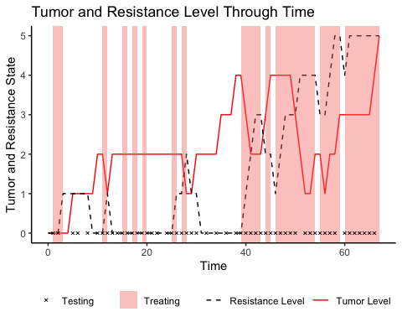

Figure 1. Figure 1. Shows a simulation run for explotary analysis.

The model seems to be somewhat sensibly applying treatment. Generally it refrains from applying treatment when the tumor state is low. Interestingly it applies treatment at the first timestep, despite the tumor state and resistance state are at their lowest possible values. Considering that the model has uniform priors about resistance state and tumor level, this means that it is maximally uninformed about both. Treating and testing would therefore immediately give information about both. Qualitively, the model also seems to prefer testing when treatment is being applied. This suggest that it first testing to be more worthwhile while also treating. Considering that testing during treatment not only provides information about the tumor state, but also the resistance state, this behavior is useful.

A plot of the models beliefs about the resistance state at each time-point (see Fig. 2) also shows that the its beliefs generally follow the development of the actual resistance level.

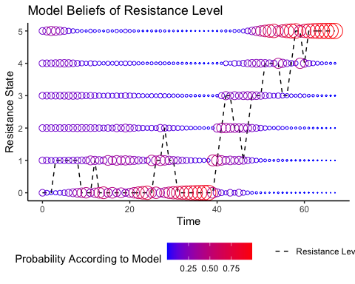

Figure 2. Plot of the models belief about the reistance level at every timepoint

All in all, the modification to POMPD structure seems to allow the model to infer an the underlying state of causally upstream state factor through a noised signal form of a downstream node.

### Expected trajectories

For each policy the model evaluates the expected trajectory of the hidden states. (See Fig. 3). These are easily accessible describe the models uncertainty, what it expects to happen under the best policy at each time point.

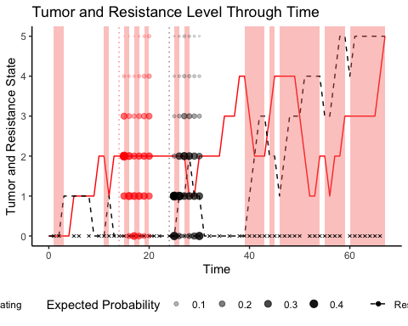

Figure 3. Shows the expected trajectories for highest evaluated policy at certain timepoints

The amount of “flip-flopping” on decisions can also be investigated, by examining what policy the model finds the most promising on each time step (see Fig. 4).

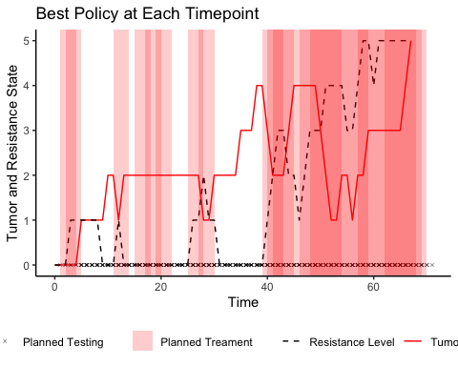

Figure 4. Best policies at each timestep are overlaied.

Curiously, there is a long stretch, approximately from timesteps 30 - 39, where the model never considers treating to be the optimal course of action, even though the resistance level is low. The model also holds accurate beliefs about the reistance level at this timepoint (see Fig. 2). However, this is likely due to a combiniation of multiple things. First of all, there is a cost to treating, which means that the model generally prefers no to treat. It too underestimates the the tumor burden at this timepoint (see Fig. 5) and gets “caught off guard” by a sudden rise in the tumor level. Since there is a cost associated with testing, it is also hesitant to applying tests during this period. Since it only considers 6 timesteps into the future, it likely doesn’t consider the consequences of being “wrong” about not needing to bring the tumor level down.

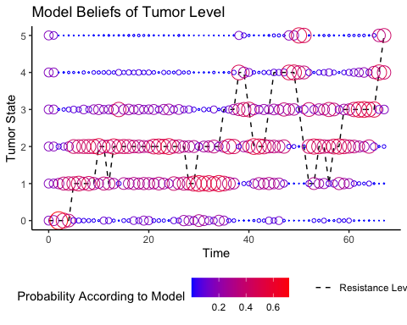

Figure 5. The panel shows the probability the model assigns to the current tumor state at each timepoint.

The excact “decision making” for each policy can be evaluated. Since each policy is evaluated for its EFE, which simply is combination of the expected utility penalized for expected uncertainty see (Fig 6.).

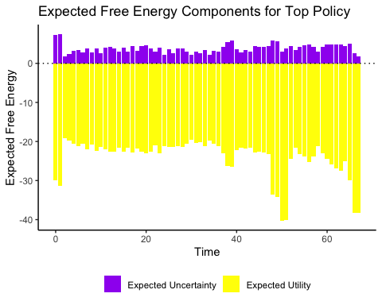

Figure 6. Free energy components. Note that policies are evaluated for the Negative Exepected Free Energy, meaning that more negative values are considered more apprioate courses of action.

The free energy components reveal a number interesting decessiion making points. At first, the model, given its uniform priors, is very unceartain about outcomes, and deacreasing unceartinty weighs heavily in its decision making. This unceartinty also means that models beliefs that it is more likely to be in a risky situtation, and bringing down this risk weighs heaviliy. At the earlier indefitied pivotal period between timesteps 30-39, there is concerning lack of increase in the weight of the utility component. This could mean that the model is too concerned with avoiding both treating and testing. It its first from timesteps 40, where the model realizes the severity of the situation, i.e. the rising tumor level. (See Fig. 5). This analysis there warrants to strategies to increasing the models ability. Changing the prior preferences, to make testing and treatment “cheaper” in terms of utilty would hopefully. However, this simply treating and testing more would translate to actual costs both financial and too patient well-being. While it would be important that the prior preferences are tuned to costs in a clinical setting, it would probably be more fruitfull to give the model longer policies to consider. This would hopefully yield models that are better tuned to the risks of not detecting and controlling tumor levels at low values.

## Performance of POMPDs against a range-bounded strategy

Several modified Active Inference POMPDs were tested against a range-bounded strategy. This was done to test to benchmark the perfomance of POMPDs against a strategy inspired by treatement protocol used in the pilot clinical trial (Zhang et al. 2017). The POMPDs were changed, so that they only could observe the tumor state, and they would recieve a noiseless signal of this on every timestep. They were also only given prior preferences for orbsevations of tumor states. These were uniform over all except the for highest tumor state, for which the probability was set to 0. Three POMPDs were tested with different lengths of policy horizons:

* A short horizon model that could consider a block of treating or not treating for the next three steps.
* A medium horizon model that could consider two blocks of treat tating or not treating for three steps. This yielded a total horizon of 6 timesteps
* A long horizon model that could consider 4 blocks of treating or treating for three steps, for a total horizon of 12 steps.

These four models, were tested on 4 bouts of different “tumor aggressivity settings”. The tested growth rates were .1, .3, 5, and .7 probability of increasing the tumor state at each timestep. Each of these 4 bouts consisted of 100 simulation runs for each model. For each single run, the environment was predetermined by generating a 200 outcomes at each combination of tumor state, resistance state and treatment state. This was done to ensure comparability at the level of each run.

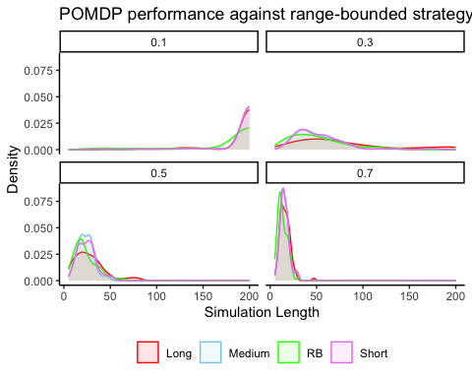

Figure. 7. The observed simulation lengths for each model type and tumor risk.

On the lowest tumor growth rate almost all the runs reach maximal length (see Fig. 7). The longest policy strategy also appear to perform slightly better than the other models. Since the difficulty of managing the tumor burden changed, contrast are computed between the long policy POMPD and the range-bounded strategy. Since each stochasticity of each run was pretedermined, the a percentage difference from switching from a RB-strategy to POMDP can be computed for each run (see Fig. 8).

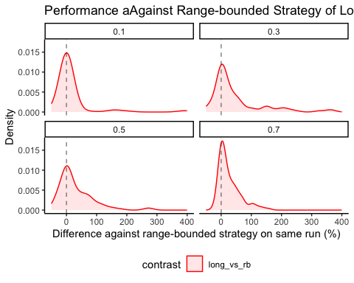

Figure 8. Shows the change in percent of between the range-bound approach and hte longest horizon POMPD for tumor aggresivity settings

On the 100 runs of .1 risk of tumor growth, the long horizon POMPD, seems to perform similar to the RB strategy. But as the tumor growth risk increases, the model POMPD increaseingly shows large percentage increases as compared to the RB strategy. This could be beacuse as the tumor dynamics speed up the need for proactive action becomes more important, thus favoring models that attempt to also control the underlying resistance state.

# Discussion

## What has this project found

The present project tested a simple modification to how POMDPs typically are implemented in Active Inference. This was done to investigate whether POMDPs could learn an control a hidden state that could only be inferred on the basis of its consequences on other states. This was done in a simulated environment designed to mimic the dynamics of adaptive therapy since resistance dynamics of cancers are not directly orbservable, but have to be inferred through treatment response. The modification was successfull, allowing the POMDP to model an underlying resistance state that controlled the efficacy of treatment, despite the underlying state not producing any observable signals itself. POMPDs were further tested against a range-bounded treatment strategy, and were found to outperfom the range-bounded strategy. The difference in performance increased as the aggresivity of tumor growth increased and the future time-horizon that the POMPDs considered at each time step. The finding underscores the prospective of using the paradigm of Active Inference in general to plan adaptive therapy, and in particular has shown that under simplifed circumstances, POMDPs could be a useful choice of model to implement Active Inference for real-time treatment decision making.

Additionally, the paper demonstrates that active inference implementation of POMPS show a number of desirable qualities for adaptive therapy POMDPs:

* The models are flexible. Computation and our ability to inform likelihood and transition dynamics, are the only limit to the combinations of hidden states, actions and outcome modalities. This present paper implemented a pomp capapble of combining multiple decisions, treating and testing, but more complex generative models could including multiple testing and treatment actions. Likewise, as (West et al. 2023) highlight desiderata of biological factors that would be important to incorporate into modelling decisions.
* A second quality is the capacity to balance expected information gain is balanced against expected utility. The certainty of the model is incorpareted directly in selecting when to apply treatments and when to test. From these considerations suggest that there is more information to be gained from testing when treatment is being applied, since it provides a view into the underlying resistance dynamics. Immediate testing seem to suggest that the models are more likely to apply testing when also applying treatment. Another interesting corrolary is that a POMPD could believe that two patients have exactly the same tumor burden but suggest treatment for one, but and not the other. This a feature, not a bug. If the model is certain about an underlying state (e.g. a resistance for the models in the present paper) there is less gain in information from treating. On the other hand, if the model is uncertain about the resistance state, it might be worthwhile to treat, simply for gain in information. This is appropriate behavior, since it allows the model better is chances of keeping the patient alive in the future.
* Another quality of models desired (West et al. 2023) is the rigorous uncertainty. Since the POMDP’s certainty about current and future states is easily extractable, this criteria is arguably met. Additionally, its “reasoning”, i.e. free energy estimates can be examined for each action.

## Future research

While the results are initially promising, the simple nature of the simulation prohibits drawing any strong conclusions about whether active inference POMPDs eventually could come to be a good model choice in a clinical setting.

To further investigate, whether POMDPs could apply to a clinical setting multiple problems will have to be solved. For example in the present study the environment featured only discrete values. Since bio-markers and dosage intensities likely will be continuous values, some combination of binning continuous values to discrete values or adapting he model structure to work with continuous data is necessary. Deep-learning have for example been used to construct likelihood mappings and transition probabilities in POMDPs Çatal et al. (2020) from the continous data. Another key issue, is determining a way to inform likelihood and transition probablities in a fashion that would be viable in a clinical setting. The present study, simply used the actual transition probabilities of the simulated enviroment, and depeding on the simulation run also used un-noised likelihood mappings. Possibly, simulations of cancer dynamics, such as (Zhang et al. 2017) could be used to inform transisition probabilities, and a clinical model could potentially readjust to patient data. The Active Inference implementation of POMDPs have a developed litterature on learning probabilities from data and even how to incorporate the information gain of learning transition and likelihood probabilities into decision-making ((Smith, Friston, and Whyte 2022) and Da Costa et al. (2020)]). Another key issue, is constructing a more rigourous benchmarking system for proposed models. In the present paper, the ranges of the compared range-bounded model, were selected fairly arbitrariliy. It produced convincing results during intial testing, and did manage to control tumor levels for substantial amount of time. However, a systematic method of comparing models is necessary, espicially considering the difficulty of real-world tests. No matter the choice of modelling framework, building a bench-marking suite must be crucial for the adaptive therapy disicpline. Considering that difficulty of real-world testing, we will have to maximize the infomration that can be extracted from simulation work. (West et al. 2023) have produced an a detailed qualitative account of needed developments in mathematical models. Translating this account to a set of simulation environments would be extremely usefull. A number of usefull simulation-script propably already exists. Zhang et al. (2017) for example released their simulations from matlab. Wrapping already existing simulations into enviroments that can easily exchange actions and orbsevations. The API used in Gymnasium (formerly OpenAI Gym) (Towers et al. 2024) could for example be used to minimize the friction for non-oncology researchers. If experts in adaptive therapy were to predetermine a set of bench marks, it would also greatly ease the burden of outsiders to first identify what even would be a usefull contribution and instead free more time for them to implement it.

If an easy to use bench-marking suite existed, POMPDs could also be “reverse-engineered” from more complex models. If a black-box model, like a neural network can be shows can be shown to succesuffly control treatment application in more complicated simulations of cancer dynamics. This would presumably not be too difficult considering that POMPDs have often been fitted to human decision-making in computational psychiatry. The same techniques could potentially allows us translate the decision making of a black-box model into the structure of a POMPD, thus combining the performance of the black-box model with the transparency of POMPD structure.

Åström, K. J. 1969. “Optimal Control of Markov Processes with Incomplete State-Information II. The Convexity of the Lossfunction.” *Journal of Mathematical Analysis and Applications* 26 (2): 403–6. <https://doi.org/10.1016/0022-247X(69)90163-2>.

Bukowski, Karol, Mateusz Kciuk, and Renata Kontek. 2020. “Mechanisms of Multidrug Resistance in Cancer Chemotherapy.” *International Journal of Molecular Sciences* 21 (9): 3233. <https://doi.org/10.3390/ijms21093233>.

Çatal, Ozan, Samuel Wauthier, Cedric De Boom, Tim Verbelen, and Bart Dhoedt. 2020. “Learning Generative State Space Models for Active Inference.” *Frontiers in Computational Neuroscience* 14 (November). <https://doi.org/10.3389/fncom.2020.574372>.

Center, H. Lee Moffitt Cancer, and Research Institute. 2024. “A Pilot Study of Adaptive Abiraterone Therapy for Metastatic Castration Resistant Prostate Cancer.” <https://clinicaltrials.gov/study/NCT02415621>.

Da Costa, Lancelot, Thomas Parr, Noor Sajid, Sebastijan Veselic, Victorita Neacsu, and Karl Friston. 2020. “Active Inference on Discrete State-Spaces: A Synthesis.” *Journal of Mathematical Psychology* 99 (December): 102447. <https://doi.org/10.1016/j.jmp.2020.102447>.

Friston, Karl J., Jean Daunizeau, and Stefan J. Kiebel. 2009. “Reinforcement Learning or Active Inference?” *PLoS ONE* 4 (7): e6421. <https://doi.org/10.1371/journal.pone.0006421>.

Gatenby, Robert A., Ariosto S. Silva, Robert J. Gillies, and B. Roy Frieden. 2009. “Adaptive Therapy.” *Cancer Research* 69 (11): 4894–4903. <https://doi.org/10.1158/0008-5472.CAN-08-3658>.

Hansen, Elsa, and Andrew F. Read. 2020. “Modifying Adaptive Therapy to Enhance Competitive Suppression.” *Cancers* 12 (12): 3556. <https://doi.org/10.3390/cancers12123556>.

Heins, Conor, Beren Millidge, Daphne Demekas, Brennan Klein, Karl Friston, Iain D. Couzin, and Alexander Tschantz. 2022a. “Pymdp: A Python Library for Active Inference Indiscrete State Spaces.” *Journal of Open Source Software* 7 (73): 4098. <https://doi.org/10.21105/joss.04098>.

Heins, Conor, Beren Millidge, Daphne Demekas, Brennan Klein, Karl Friston, Iain Couzin, and Alexander Tschantz. 2022b. “Pymdp: A Python Library for Active Inference in Discrete State Spaces.” *Journal of Open Source Software* 7 (73): 4098. <https://doi.org/10.21105/joss.04098>.

Kaelbling, Leslie Pack, Michael L. Littman, and Anthony R. Cassandra. 1998. “Planning and Acting in Partially Observable Stochastic Domains.” *Artificial Intelligence* 101 (1): 99–134. <https://doi.org/10.1016/S0004-3702(98)00023-X>.

Smith, Ryan, Karl J. Friston, and Christopher J. Whyte. 2022. “A Step-by-Step Tutorial on Active Inference and Its Application to Empirical Data.” *Journal of Mathematical Psychology* 107 (April): 102632. <https://doi.org/10.1016/j.jmp.2021.102632>.

Staňková, Kateřina, Joel S. Brown, William S. Dalton, and Robert A. Gatenby. 2019. “Optimizing Cancer Treatment Using Game Theory.” *JAMA Oncology* 5 (1): 96–103. <https://doi.org/10.1001/jamaoncol.2018.3395>.

Towers, Mark, Jordan K Terry, Ariel Kwiatkowski, John U. Balis, Gianluca Cola, Tristan Deleu, Manuel Goulão, et al. 2024. *Gymnasium*. Zenodo. <https://doi.org/10.5281/zenodo.10655021>.

West, Jeffrey, Fred Adler, Jill Gallaher, Maximilian Strobl, Renee Brady-Nicholls, Joel Brown, Mark Roberson-Tessi, et al. 2023. “A Survey of Open Questions in Adaptive Therapy: Bridging Mathematics and Clinical Translation.” Edited by Richard M White. *eLife* 12 (March): e84263. <https://doi.org/10.7554/eLife.84263>.

Zhang, Jingsong, Jessica J. Cunningham, Joel S. Brown, and Robert A. Gatenby. 2017. “Integrating Evolutionary Dynamics into Treatment of Metastatic Castrate-Resistant Prostate Cancer.” *Nature Communications* 8 (1): 1816. <https://doi.org/10.1038/s41467-017-01968-5>.