Actively Inferring Adaptive Therapy: Modifying Partially Observable Markov Decision Processes for Real-Time Treatment Decisions in Cancer

Emil Frej Brunbjerg (202105405)

2024-05-27

Abstract

Cancer remains a leading cause of death globally, with drug resistance accounting for approximately 90% of cancer fatalities. *Adaptive Therapy* (AT) which leverages intra-tumoral evolutionary dynamics to control rather than eradicate cancer, is a promosing alternative to standard care. This paper investigates if the *Active Inference* (AI) *Partially Observable Markov Decision Process* (POMDP) scheme to model and control cancer dynamics in a simulated enviroment inspired by a recent pilot clinical trial that implements AT for metastastic-Castration Resistant Prostate Cancer. The problem of inferring resistance dynamics based on signals of tumor burden motivated the use of AI, but also necesistaed modifying how transition dynamics are specified and evaluated in the POMPD scheme. Intial simulation results suggest that the modification allowed POMDPs to infer changes to resistance dynamics in real-time through observing changes in tumor burden resulting from applying treatment. The modified POMPDs were also tested against a range-bounded treatment strategy inspired by the pilot trial, and found to outperform the range-bounded strategy, particularly under conditions of aggresive tumor growth. Beyond the intially promising simulation results, POMDPs were also found to meet several criteria that have recently been identified as crucial for modelling work in AT. Consequently, this paper argues that the AI paradigm shows promise for improving real-time prediction of treatment responses, particularily when AI is applied through POMDPs. Additionally, the paper indentifies key developments needed before the POMPD scheme can be applied in clinical settings, and suggests that developing a rigorous benchmarking suite would propel modelling efforts in AT.

Table of Contents

# Introduction

## A Primer on Adaptive Therapy

Worldwide, cancer is the cause of 1 out of 6 deaths. An estimated 90% of these cancer deaths are due to the development of drug resistance (Bukowski, Kciuk, and Kontek 2020). While initial cancer treatment usually shows a positive response in tumor burden, drug resistance develops over time. To highlight the inefficiency of traditional approaches, (Staňková et al. 2019) models cancer treatment as a game-theoretic contest between a physician and a tumor. In this model, the physician’s move in each round is to apply a certain treatment to which the cancer adapts. While the game is assymetrical—one player is the leader (the physician) and another player is a follower (the tumor)—the asymmetry is rarely exploited in oncology wards. Instead of using the advantage to steer the evolutionary pressures placed on tumors, tumors can adapt not only to the current round of the game but also to future rounds under standard care. Thus, the advantage of leading the game is lost. The authors analogize the current practice to a game of rock-paper-scissors:

*” in which almost all cells within the cancer play, for example, “paper.” It is clearly advantageous for the treating physician to play “scissors.” Yet, if the physician only plays “scissors,” the cancer cells can evolve to the unbeatable resistance strategy of “rock.”“* (Staňková et al. 2019).

To exploit this asymmetry *Adaptive Therapy* (AT) controls intra-tumoral evolutionary dynamics by leveraging that cancer cells likely incur fitness costs when evolving mechanisms of drug resistance (Gatenby et al. 2009). If resistant and non-resistant cells are competing for space and resources, drug-sensitive cells should, over time, out-compete resistant cells. AT thereby utilizes Darwinian competition to make cancer suppress itself, a strategy that potentially could reduce cancer to chronic and but controllable disease.

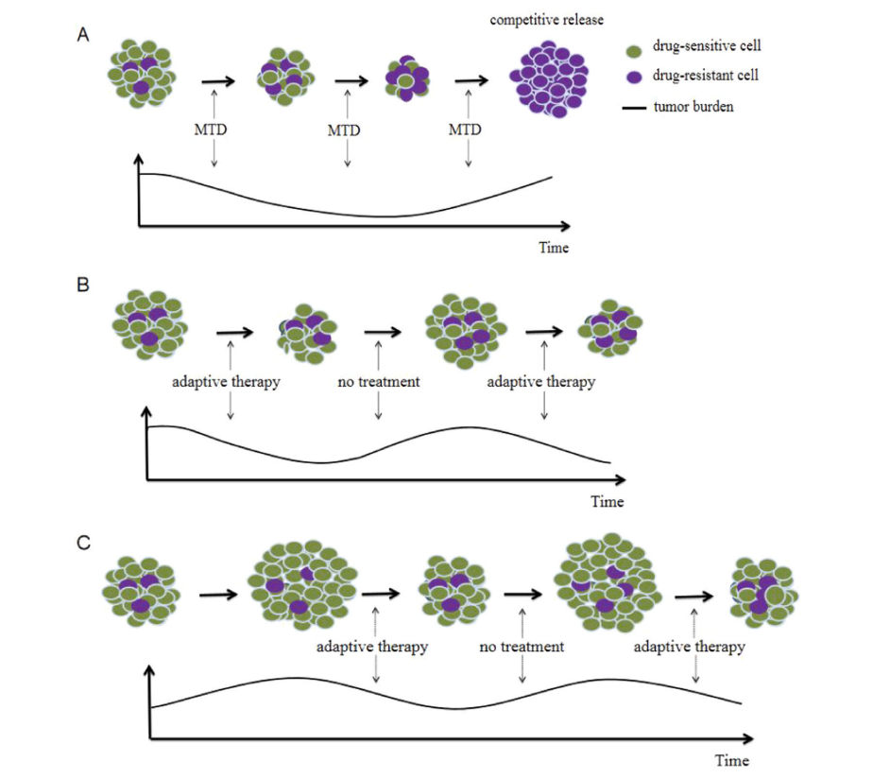

From Zhang et al. 2023. Panel A shows a typical “Maximal Tolerable Dose” treatment protocol. While the initial response in tumor burden is promising, a competitive release of resistant cells ensures. Panel B shows an AT approach with a small tumor burden. Panel C shows AT with a high tumor burden, which has been theorized to further increase the suppression of resistance cells.

Initial results from an ongoing pilot clinical trial applying AT in a group of *metastatic castrate-resistant prostate cancer* (mCRPC) patients are promising, showing both lower cumulative dosages and longer survival times compared to a similar group of patients receiving standard care. The trial utilizes a range-bounded heuristic to make treatment decisions: if the blood marker *Prostate-specific Antigen* (PSA), a proxy for tumor burden, increases back to pre-trial levels, Abiraterone treatment is applied until PSA drops to 50% of pre-trial levels (Zhang et al. 2017).

## POMPDs

*Partially Observable Markov Decision Processes* (POMDPs) is a class of controller models that model a Markov process —an environment that moves through discrete time steps and states, each step of the system only depends on states of the prior step. Partial observability refers to the fact that these models don’t directly observe the actual environment but instead observe signals emitted by the environment (Åström 1969). This allows POMPDs to differentiate an observed signal from what it “believes” about the actual configuration of states and additionally to use a single reward function to trade-off uncertainty for reaching a certain goal state (Kaelbling, Littman, and Cassandra 1998).

## Solving POMPDs with Active Inference

While POMDPs are typically difficult to solve analytically, various approximation exist. One approximation scheme is born out of the neuroscience paradigm *Active Inference* (AI) where POMPDs are typically used to model an agent’s decision-making. AI POMPDs has been used to model psychopathology (Da Costa et al. 2020) but also applied to control scenarios such as the mountain car problem (Friston, Daunizeau, and Kiebel 2009) and, albeit augmented with deep learning, robotics control (Çatal et al. 2020). The approximation finds a solution by minimizing two objective functions:

* *Variational Free Energy* (VFE). A measure of fit between a generative model and sensory input.
* *Expected Free Energy* (EFE). A score of how well a course of action is expected to bring about a set of preferences penalized for expected uncertainty.

AI implementations of the POMDP scheme have been implemented in MATLAB and recently in Python with the Python package *pymdp* Heins et al. (2022a). AI POMDPs are technically the a joint probability:

where are observations, are hidden states to be inferred, are actions that an agent can take to influence the environment, and are the hyperparameters of the model, such as normally used as ‘inverse temperature’ i.e. how strongly beliefs determines action selection. By conditioning on certain observations, the POMDP is solvable for Bayes-optimal posterior beliefs at a given time point. This yields a set of posterior beliefs about the current state of each *state factor -* the types of possible states in the environment. A posterior probability distributions over what *policies*, possible courses of actions are most likely to achieve specified preferences while keeping expected uncertainty as low as possible. As an example, a POMDP could model the joint probability of observing a noisy signal of a particular tumor burden in a patient, an actual underlying tumor burden, and the course of action that is most likely to bring the tumor burden down. By modeling, actions, states, and observations as discrete events, the joint probability is can factorized into multiple categorical probability distributions. These describe likelihood mappings between signals and specific states of the environment, transition probabilities, and a desired probability of making certain observations (see appendix A for an in-depth description of how the joint probability is factorized) (Smith, Friston, and Whyte 2022). [1]

## The aim of this paper

The treatment decisions used in the pilot trial reported by Zhang et al. (2017) were based on a well-informed heuristic about how resistance dynamics would develop as a consequence of careful timing of applying and withdrawing Abiraterone treatment. However, the actual resistance dynamics of each patient weren’t explicitly modeled in real-time, and thus not used in treatment decisions. This paper primarily investigates whether the AI implementation of POMDPs can model and control degree of treatment resistance of individual cancer patients in real-time — hoping that this strategy eventually can be applied in a clinical setting.

# Analysis

## Simulated environment

To investigate the appropriateness of the AI implementation of the POMDP scheme, multiple simulations of a clinical setting inspired by the pilot clinical trial were run. To comply with the canonical AI POMPD scheme discrete states and and time steps were used. Each simulation run simulated maximally of 200 time-steps. At each time-step, an agent had to keep a virtual cancer patient alive by deciding whether to apply a treatment based on a signal of the tumor burden. The signal could be observed at each time point, and treatment decisions were made by solving a slightly modified AI POMPD. The features of the environment were inspired by the use of PSA testing and Abiraterone treatment in the pilot trial (Zhang et al. 2017). In the simulations, the patient’s *tumor state factor* determined whether they survived to the next time-step. If the tumor state factor reached the maximal state of six possible states, the virtual patient “died” and the simulation ended. The tumor state factor was always set to the lowest at the beginning of each simulation run and could increase at a fixed risk at each time step.

Whether a round of treatment successfully reduced the tumor state depended on an underlying *resistance state factor*. This also began at state 0 out of 5. For each round of treatment application, the resistance state had a fixed risk of increasing. The only remedy to the increasing resistance states, beyond favorable bouts of stochasticity, was to withdraw treatment which would allow the resistance state factor to lower. Inspired by the work of (Hansen and Read 2020), the patient being higher tumor states increased the chance of lowering resistance.

## Modifications to the POMDP Scheme

Typically when constructing AI POMDPs, different state factors states such as resistance factorw and tumor factors are not modeled to affect each other directly. Instead, the interactions resulting from combinations of different states are modeled as leading to different observations. This means that interactions between types of states would be coded in the likelihood distribution.

This setup was deemed incompatible with the environment that the agents had to model since it wouldn’t let agents infer how changes in resistance state factor should influence the expected transition probabilities of the tumor state factor. Therefore, custom changes were made to pymdp to allow POMPDs to infer “occluded” state factors - state factors don’t produce signals themselves (e.g. the resistance state). The state of the occluded state factor need to be inferred, through its effects on downstream state factors that generate signals (e.g. the tumor state).

Specifically, modifications were made to the structure of the agents beliefs about the environment’s transition probabilities Usually, three-dimensional *tensors* describe expected transition probabilities within a state factor. This means a tensor for a type of state typically holds one dimension for the current state, one dimension for the next state, and a third dimension for every allowed action. Each cell of the tensor then contains the probability of transitioning from one state to another state conditional on a certain action. Another dimension was added to relevant tensors. This dimension corresponded to another state factor. Concretely, this means that the tensor for tumor transition probabilities had a fourth dimension corresponding to the possible resistance states. The expected transition probabilities could then be estimated by matrix multiplying the tumor transition tensor with a vector containing expected probabilities of each resistance state at a given time point. One can imagine that instead of having only one tensor for the transition probabilities between tumor states, multiple tensors of tumor transition probabilities were specified, where each tensor corresponded to a specific resistance level. This modification to the generative model necessitated taking an average of across these tensors weighted by the posterior probabilities for each resistance state at given time point. This amounts to calculating the expected transition probabilities between tumor states conditional on a set of beliefs about the resistance states. This modification strategy was repeated for the resistance level since decreases in the resistance state depended on the tumor state. It should be noted that this modification means that the order in which beliefs about states are evaluated must be specified. While these changes rendered much of the functionality of pymdp immediately unusable, the modification strategy should be able to model arbitrarily complex dependencies between states.

## Exploratory Simulation

An exploratory simulation was conducted, where for each run an agent instantiated as a modified POMPD controlled whether to treat and test. Its received the following signals:

* A noiseless signal of whether the patient was alive.
* A noiseless signal of whether it was applying tests.
* A noiseless signal of whether it was applying treatment
* A noised signal of the tumor state and it was only recieved if tests were being applied.

The agent’s prior preferences were skewed heavily against observing a dead patient, somewhat against treating, and slightly against testing. This was done to simulate the cost to both treating and testing. This means that the agent had to balance the cost of its actions while considering the potential information gain of each choice. The costs of treating and testing were introduced to investigate whether the POMPD scheme could potentially be used to strike a balance between drug toxicity, and tumor burden while optimizing real-time data collection as desired by key researches in AT (West et al. 2020). The model was further handicapped by noising the tumor signal. This means that the resistance state, which had to be inferred through the tumor signal, was doubly obfuscated.

However, the agent’s generative model did perfectly map the expected noise in the tumor signal, and its inital expected transition probabilities were identical to the actual transition probabilities of the environment. Additionally, the agent was given uniform priors over initial states, meaning it had no knowledge of the configuration of states at the beginning of each run. The same set of predetermined policies that considered the next 6 time-steps were evaluated at each step. This limited set of policies was done to ease computation by limiting the search space of possible actions. The set of policies consisted of two blocks of either testing or treating for three time-steps in a row for permuted each possible sequence of applying testing or not for the time horizon of the policies.

### Learning the Resistance State

In the following example of an exploratory simulation run, the agent managed to keep the patient alive for 68 time-steps and chose to test on 55 of these (see Fig. 2).

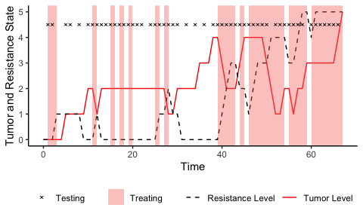

A simulation run for exploratory purposes.

The agent appears to be somewhat sensibly applying treatment, but it doesn’t apply the treatment at a pivotal period approximately between steps 30 and 39. Generally, it refrains from applying treatment when the tumor state is low and applies treatment when the tumor state is high. Interestingly, it does apply treatment at the first timestep, despite the tumor state and resistance state being at their lowest possible values. Considering that the generative model had uniform priors over both resistance state and tumor states, this behavior is more appropriate from the perspective of the agent, since treating and testing would immediately provide information about both states. Qualitatively, the model also seems to prefer testing when treatment is being applied. This suggests that it finds testing to be more worthwhile while also treating. A plot of the model’s beliefs about the resistance state at each time-point (see Fig. 3) shows that its beliefs about the resistance state generally follow the development of the actual resistance state despite the lack of direct signal.

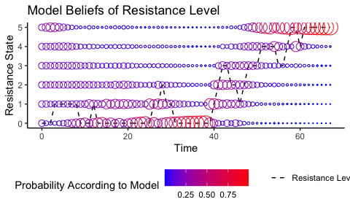

Plot of the model’s belief about the resistance level at every timepoint

In summary, the modification to POMPD structure appears to have allowed the agent to otherwise occluded resistance state by selectively applying treatment and collecting noised signals of the tumor burden. While the results are intially promising, the particular agent does make questionable choices regarding the timing of treatment. The decision-making behind these choices is dissected in-depth in the appendix.

## Performance of POMPDs against a Range-Bounded Strategy

Several agents instantiated as modified POMPDs were tested against a range-bounded strategy. This was done to benchmark the performance of POMPDs against a strategy inspired by the treatment protocol used in the pilot clinical trial (Zhang et al. 2017). The generative models used were simplified for ease of computation POMPDs and as a result, they observed a noiseless signals of the tumor state and whether treatment was being applied at every timestep. They were also only given prior preferences for observations of tumor states. The preferences were uniform over all survivable tumor states, and the probability of the highest tumor state was set to 0. The following three agents were tested:

* A short policy horizon POMPD that could consider a block of treating or not treating for the next three steps.
* A medium policy horizon POMPD that could consider two blocks of treating or not treating for three steps, yielding a total horizon of 6 timesteps.
* A long policy horizon model that could consider four blocks of treating or not treating for three steps, resulting in a total horizon of 12 steps.

The agents were benchmarked on four different “tumor aggressivity settings”. The tested tumor growth rates were 0.1, 0.3, 0.5, and 0.7 probability of increasing the tumor state at each timestep. For each setting, 100 simulation runs were done. For each run, the environment was predetermined by generating 200 outcome variables for each combination of tumor state, resistance state, and treatment state to ensure comparability between the tested agents and the RB strategy at the level of each run.

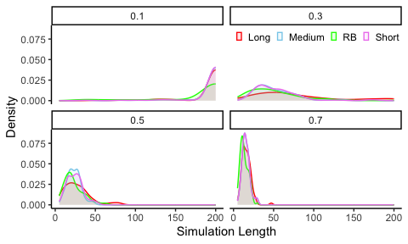

Simulated patient survival times for each agent and baseline strategy.

At the lowest tumor growth rate, nearly all the runs reached the maximal length (see Fig. 7). On the other runs, the long horizon model also appears to be slightly outperforming the others. Contrasts as the percentage difference in survival from switching from the baseline RB-strategy to the long horizon POMPD are computed for each run (see Fig 5.).coc

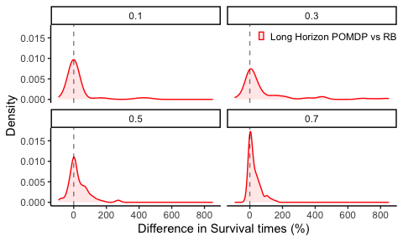

Change in percent of between the range-bound approach and the longest horizon POMPD for different tumor growth rates.

In the 100 runs with a 0.1 risk of tumor growth, the long-horizon POMPD seems to perform similarly to the RB strategy. However, as the tumor growth risk increases, the POMPD agent increasingly shows large percentage improvements compared to the RB strategy. Potentially a consequence of a greater need for proactive action when tumor dynamics accelerate, which in turn would favor models that explicitly model how treatment will effect future resistance dynamics.

# Discussion

## Findings

This project tested a simple modification to how POMDPs are typically implemented in AI to investigate whether POMDPs could learn and control an environment inferred based on their consequences on other states. In a simulated environment designed to mimic the dynamics of AT, the modification successfully allowed agents instantiated as POMDPs to model an underlying resistance state that controlled the efficacy of cancer treatment, despite the underlying state not producing observable signals itself. Additionally, costs to testing and treating implemented and crucially these could be holistically integrated using free energy minimization to trade-off utility for reductions in uncertainty. Modified POMPDs were further tested against a range-bounded treatment strategy inspired by a pilot clinical trial using AT, and were found to outperform the range-bounded strategy substantially. The gap in performance was larger in simulations of aggressive tumor growth rates and for agents with an ability to consider longer future courses of action. These findings underscore the potential of using the AI paradigm in real-time planning of treatment and testing decisions in AT, and, albeit under simplified circumstances, the modified AI POMDP is a promising model choice for improving real-time patient-specific treatment decisions in AT.

Additionally, this paper demonstrates that the AI implementation of POMPDs shows several desirable qualities for AT:

* The modified AI POMPDs show great flexibility in their ability to specify the causal structure of an environment. Computation and our ability to inform likelihood and transition dynamics are the only limits to the complexity that can be specified. This paper implemented a POMPD capable of combining multiple decisions, such as treating and testing, More complex generative models could include multiple types testing and treatment opening the door for multidrug therapies, while integrating multiple types of testing and increasingly detailed modeling of real-time tumor biology. But to avoid having to figure out how quarks and leptons might interact to produce a cancer cell, we will have to limit our desire for higher causal resolution at some point. While simulating finer-grained mechanisms of tumor biology likely will benefit clinical adaptions of AT, abstracting away physical mechanisms as random fluctuations inherent to the modeled environment will at some point be necessary. Models for real-time treatment decisions will therefore have to need the capacity to model the uncertainty of the environment and account for it in decision-making.
* Another quality is the capacity to balance expected information gain against expected utility. The certainty of the model is incorporated directly in selecting when to apply treatments and when to test. This suggests that there is more information to be gained from testing when treatment is being applied, as it provides a view into the underlying resistance dynamics. Immediate testing seems to suggest that the models are more likely to apply testing when also applying treatment. Another interesting corollary to basing therapy plans in AI is that POMPD solutions could believe that two patients have exactly the same tumor burden but suggest treatment for one patient and not the other. This is a feature, not a bug. If certain about an underlying state (e.g., resistance in the models in this paper), there will be expected information gained from treating. Yet if the model is uncertain about the resistance state of the other patient, it might be worthwhile to treat simply to gain information. This perspective slurs the line between testing and treating and drastically alters the decisions on when to collect real-time data patient data by trading uncertainty and utility in a quantitative fashion.
* Another key quality of models desired by West et al. (2023) is the ability to carefully monitor the uncertainty of outcomes. Given a pre-specified generative model, the uncertainty of both current states, and expected outcomes can easily be extracted and interrogated (See appendix C for examples).

## Future Research

While the results are initially promising, the simple nature of the simulated clinical setting prohibits drawing any strong conclusions about the promise of using AI POMPDs in a clinical setting. For example, they might simply be too computationally expensive to be practically viable for more complex generative models.

To further investigate whether POMDPs could viably be applied in a clinical setting, multiple problems will need to be solved. For example, in the present study, the environment featured only discrete values. Since biomarkers and dosage intensities will likely take continuous values, some combination of binning continuous values to discrete values or adapting the model structure to work with continuous data is necessary. Deep learning has been used to construct likelihood mappings and transition probabilities in POMDPs from continuous data (Çatal et al. 2020). Another key issue is determining a way to inform likelihood and transition probabilities in a fashion that would be viable in a clinical setting. The present study used the actual transition probabilities of the simulated environment and, depending on the simulation run, noiseless likelihood mappings. Possibly, simulations of cancer dynamics, such as those by Zhang et al. (2017), could be used to inform transition probabilities, and a clinical model could potentially readjust to patient data. The AI implementation of POMDPs has developed literature on online learning of the categorical probability distributions needed to accurately represent the environment. Even the potential information gained form learning transition and likelihood probabilities can be factored in to decision-making ((Smith, Friston, and Whyte 2022) and Da Costa et al. (2020)]).

Another key issue is constructing a more rigorous benchmarking system. In the present paper, the ranges of the baseline range-bounded strategy were selected fairly arbitrarily. It produced convincing results during initial testing and did manage to control tumor levels for a substantial amount of time. However, a systematic method for comparing models is necessary, especially considering the difficulty of real-world tests. No matter the choice of modeling framework, building a benchmarking could help propel modeling work in AT. Given the extreme barriers to real-world testing performance testing of patient-specific models, maximizing the information that can be extracted from simulation work seems crucial. The detailed qualitative account of needed developments on the needed developments mathematical modeling of AT dynamics by West et al. (2023) could be translated to a set of simulation environments used for benchmarking models. Potentially useful simulation scripts already exist. For example, Zhang et al. (2017) released their simulations on mCRCP dynamic. Wrapping existing simulations into environments that can easily facilitate actions and observations with simulated agents could be done by using an API like the one used in Gymnasium (formerly OpenAI Gym) (Towers et al. 2024). This would hopefully minimize friction for non-oncology researchers wishing to contribute to the field since it would allow them to prioritize improving model performance instead of having to spend excessive time deciphering how to construct useful metrics themselves.

POMPDs could also be “reverse-engineered” from more complex models, which could more easily be trained if a benchmarking suite existed. For example, if a black-box model, like a neural network, can be shown to successfully control treatments, fitting a POMPD to its behavior would probably be a fairly straight-forward endeavor since AI POMPDs often have been used in computational psychiatry to model human decision-making. The same techniques could potentially allow us to translate otherwise non-transparent models into the structure of a POMPD, thus combining the performance of the black-box model with the transparency of the POMPD scheme.

# References

Åström, K. J. 1969. “Optimal Control of Markov Processes with Incomplete State-Information II. The Convexity of the Lossfunction.” *Journal of Mathematical Analysis and Applications* 26 (2): 403–6. <https://doi.org/10.1016/0022-247X(69)90163-2>.

Bukowski, Karol, Mateusz Kciuk, and Renata Kontek. 2020. “Mechanisms of Multidrug Resistance in Cancer Chemotherapy.” *International Journal of Molecular Sciences* 21 (9): 3233. <https://doi.org/10.3390/ijms21093233>.

Çatal, Ozan, Samuel Wauthier, Cedric De Boom, Tim Verbelen, and Bart Dhoedt. 2020. “Learning Generative State Space Models for Active Inference.” *Frontiers in Computational Neuroscience* 14 (November). <https://doi.org/10.3389/fncom.2020.574372>.

Da Costa, Lancelot, Thomas Parr, Noor Sajid, Sebastijan Veselic, Victorita Neacsu, and Karl Friston. 2020. “Active Inference on Discrete State-Spaces: A Synthesis.” *Journal of Mathematical Psychology* 99 (December): 102447. <https://doi.org/10.1016/j.jmp.2020.102447>.

Friston, Karl J., Jean Daunizeau, and Stefan J. Kiebel. 2009. “Reinforcement Learning or Active Inference?” *PLoS ONE* 4 (7): e6421. <https://doi.org/10.1371/journal.pone.0006421>.

Gatenby, Robert A., Ariosto S. Silva, Robert J. Gillies, and B. Roy Frieden. 2009. “Adaptive Therapy.” *Cancer Research* 69 (11): 4894–4903. <https://doi.org/10.1158/0008-5472.CAN-08-3658>.

Hansen, Elsa, and Andrew F. Read. 2020. “Modifying Adaptive Therapy to Enhance Competitive Suppression.” *Cancers* 12 (12): 3556. <https://doi.org/10.3390/cancers12123556>.

Heins, Conor, Beren Millidge, Daphne Demekas, Brennan Klein, Karl Friston, Iain D. Couzin, and Alexander Tschantz. 2022a. “Pymdp: A Python Library for Active Inference Indiscrete State Spaces.” *Journal of Open Source Software* 7 (73): 4098. <https://doi.org/10.21105/joss.04098>.

Heins, Conor, Beren Millidge, Daphne Demekas, Brennan Klein, Karl Friston, Iain Couzin, and Alexander Tschantz. 2022b. “Pymdp: A Python Library for Active Inference in Discrete State Spaces.” *Journal of Open Source Software* 7 (73): 4098. <https://doi.org/10.21105/joss.04098>.

Kaelbling, Leslie Pack, Michael L. Littman, and Anthony R. Cassandra. 1998. “Planning and Acting in Partially Observable Stochastic Domains.” *Artificial Intelligence* 101 (1): 99–134. <https://doi.org/10.1016/S0004-3702(98)00023-X>.

Smith, Ryan, Karl J. Friston, and Christopher J. Whyte. 2022. “A Step-by-Step Tutorial on Active Inference and Its Application to Empirical Data.” *Journal of Mathematical Psychology* 107 (April): 102632. <https://doi.org/10.1016/j.jmp.2021.102632>.

Staňková, Kateřina, Joel S. Brown, William S. Dalton, and Robert A. Gatenby. 2019. “Optimizing Cancer Treatment Using Game Theory.” *JAMA Oncology* 5 (1): 96–103. <https://doi.org/10.1001/jamaoncol.2018.3395>.

Towers, Mark, Jordan K Terry, Ariel Kwiatkowski, John U. Balis, Gianluca Cola, Tristan Deleu, Manuel Goulão, et al. 2024. *Gymnasium*. Zenodo. <https://doi.org/10.5281/zenodo.10655021>.

West, Jeffrey, Fred Adler, Jill Gallaher, Maximilian Strobl, Renee Brady-Nicholls, Joel Brown, Mark Roberson-Tessi, et al. 2023. “A Survey of Open Questions in Adaptive Therapy: Bridging Mathematics and Clinical Translation.” Edited by Richard M White. *eLife* 12 (March): e84263. <https://doi.org/10.7554/eLife.84263>.

West, Jeffrey, Li You, Jingsong Zhang, Robert A. Gatenby, Joel S. Brown, Paul K. Newton, and Alexander R. A. Anderson. 2020. “Towards Multidrug Adaptive Therapy.” *Cancer Research* 80 (7): 1578–89. <https://doi.org/10.1158/0008-5472.CAN-19-2669>.

Zhang, Jingsong, Jessica J. Cunningham, Joel S. Brown, and Robert A. Gatenby. 2017. “Integrating Evolutionary Dynamics into Treatment of Metastatic Castrate-Resistant Prostate Cancer.” *Nature Communications* 8 (1): 1816. <https://doi.org/10.1038/s41467-017-01968-5>.

# Appendix A: In-Depth Description of the AI POMPD Scheme

The canonical implementation of POMDPs in Active Inference requires specifying the following categorical probability distributions.

**The likelihood model,** **.** is typically a set of arrays where each array corresponds to a *modality* — a category of observations. Each cell of the array describes the likelihood of making a particular observation in the modality given some configuration of states. For example, PSA readings could be considered a modality, and different test results would be the observations within the modality. The likehoods within the modality could then be modeled as a perfect signal of tumor burden, i.e., the same tumor burden always gives the same test result, or as a noisy signal.

**The transition model,** **,** describes the probability of each possible transition within a type of state between time steps. also encodes how actions are expected to influence the transition probabilities between states. For example, it could describe how a tumor is likely to evolve from one time-step to the next depending on whether treatment is being applied. The transition model is usually coded as a collection of three-dimensional arrays, a first dimension for the next state, a dimension for the current state, and a third dimension with the length of each action that would influence the transition probabilities of the state.

**A prior over preferred states** **.** A particularity of AI POMPDs is that utility is the probability for making certain observations. It can be considered the states that the system attempts to “self-organize” around. This method of modeling preferences can superficially seem odd, but its benefits will be clear later.

**A prior over initial states** **.** These are vectors of probabilities specifying initial beliefs. In continuation with the example above, could specify how probable a model believes different levels of tumor burden are before making any observations. When AI POMPDs are solved on multiple time steps, the posterior beliefs of the preceding time step replace .

# Appendix B: Simulation parameters

The transition dynamics of the simulated environments were.

Exploratory simulation:

| Outcome | Probability |
| --- | --- |
| Risk of Tumor Growth | 0.3 |
| Risk of Resistance Increase | 0.5 |
| R0 Chance of Treatment Success | 1.0 |
| R1 Chance of Treatment Success | 0.8 |
| R2 Chance of Treatment Success | 0.6 |
| R3 Chance of Treatment Success | 0.5 |
| R4 Chance of Treatment Success | 0.4 |
| R5 Chance of Treatment Success | 0.2 |
| T0 Chance of Resistance Decrease | 0.0 |
| T1 Chance of Resistance Decrease | 0.2 |
| T2 Chance of Resistance Decrease | 0.4 |
| T3 Chance of Resistance Decrease | 0.7 |
| T4 Chance of Resistance Decrease | 0.8 |
| T5 Chance of Resistance Decrease | 0.9 |

# Appendix C: A Dissection decision-making by POMPD

For each policy, the agent evaluates the expected trajectory of the hidden states (see Fig. x). These evaluations provide insights into the model’s uncertainty and what it expects to happen under the best policy at each time point.

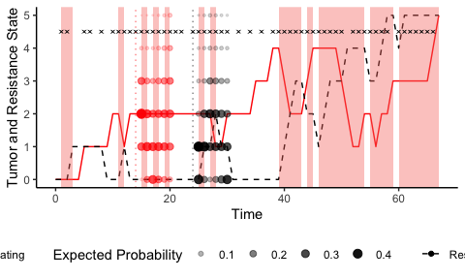

The amount of “flip-flopping” on decisions can also be investigated by examining what policy the model finds the most promising at each time step (see Fig. 4).

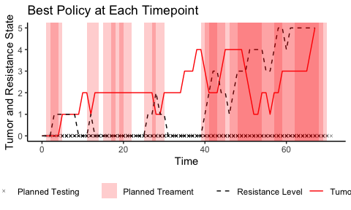

Curiously, there is a long stretch, approximately from timesteps 30 to 39, where the model never considers treating to be the optimal course of action, even though the resistance level is low. The model also holds accurate beliefs about the resistance level at this time point (see Fig. x). However, this is likely due to a combination of multiple factors. First, there is a cost to treating, which means that the model generally prefers not to treat. It also underestimates the tumor burden at this time point (see Fig. x) and gets “caught off guard” by a sudden rise in the tumor level. Since there is a cost associated with testing, it is also hesitant to apply tests during this period. Because it only considers six timesteps into the future, it likely doesn’t consider the long-term consequences of not reducing the tumor level.

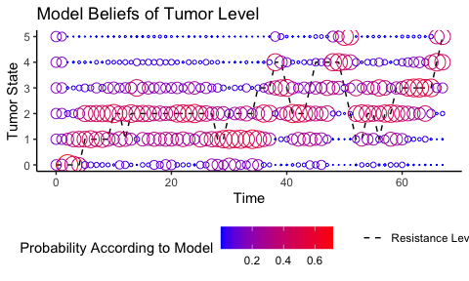

The exact “decision-making” for each policy can be evaluated. Each policy is evaluated for its EFE, which is a combination of the expected utility penalized for expected uncertainty (see Fig. 6).

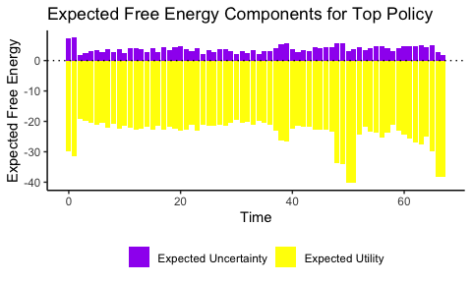

The free energy components reveal several interesting decision-making points. At first, the model, given its uniform priors, is very uncertain about outcomes, and decreasing uncertainty weighs heavily in its decision-making. This uncertainty also means that the model believes it is more likely to be in a risky situation, and reducing this risk is a priority. During the earlier identified pivotal period between timesteps 30-39, there is a concerning lack of increase in the weight of the utility component. This could mean that the model is too concerned with avoiding both treating and testing. It is only from timestep 40 onwards that the model realizes the severity of the situation, i.e., the rising tumor level (see Fig. 5). This analysis warrants strategies to increase the model’s ability. Changing the prior preferences to make testing and treatment “cheaper” in terms of utility might help. However, simply treating and testing more would translate to actual costs, both financial and to patient well-being. While it is important that the prior preferences are tuned to costs in a clinical setting, it would probably be more fruitful to give the model longer policies to consider. This would hopefully yield models that are better tuned to the risks of not detecting and controlling tumor levels at low values.

1. The Python package pymdp (Heins et al. 2022b) has numerous tutorial notebooks for implementing POMPDs in Python. Smith, Friston, and Whyte (2022) describes the process of constructing POMPDs for different scenarios in detail, albeit in MATLAB, and Da Costa et al. (2020) provides an in-depth mathematical account of POMPDs in Active inference.