Actively Inferring Treatment Resistance

Modifying Partially Observable Markov Decision Processes for Adaptive Cancer Therapy

Emil Frej Brunbjerg

2024-05-28

Table of Contents

# Introduction

## A Primer on Adaptive Therapy

Worldwide, cancer is the cause of 1 out of 6 deaths. An estimated 90% of these cancer deaths are due to the development of drug resistance (Bukowski, Kciuk, and Kontek 2020). While initial cancer treatment usually shows a positive response in tumor burden, drug resistance develops over time. To highlight the inefficiency of traditional approaches, Staňková et al. (2019) model cancer treatment as a game-theoretic contest between a physician and a tumor. In this model, the physician’s move in each round is to apply a certain treatment to which the cancer adapts. While the game is asymmetrical—one player is the leader (the physician) and another player is a follower (the tumor)—the asymmetry is rarely exploited in oncology wards. Under standard care, instead of using the advantage to steer evolutionary pressures placed on cancer cells, tumors can adapt not only to the current round of the game but also to future rounds. Thus, the advantage of leading the game is lost. The authors analogize the current practice to a game of rock-paper-scissors:

*” all cells within the cancer play, for example, “paper.” It is clearly advantageous for the treating physician to play “scissors.” Yet, if the physician only plays “scissors,” the cancer cells can evolve to the unbeatable resistance strategy of “rock.”“* (Staňková et al. 2019).

To exploit this asymmetry *Adaptive Therapy* (AT) controls intra-tumoral evolutionary dynamics by leveraging that cancer cells likely incur fitness costs when evolving mechanisms of drug resistance (Gatenby et al. 2009). Resistant and non-resistant cells are theorized to compete for space and resources, drug-sensitive cells should, over time, out-compete resistant cells. AT thereby utilizes Darwinian competition to make cancer suppress itself — a strategy that potentially could reduce cancer to a chronic but controllable disease.

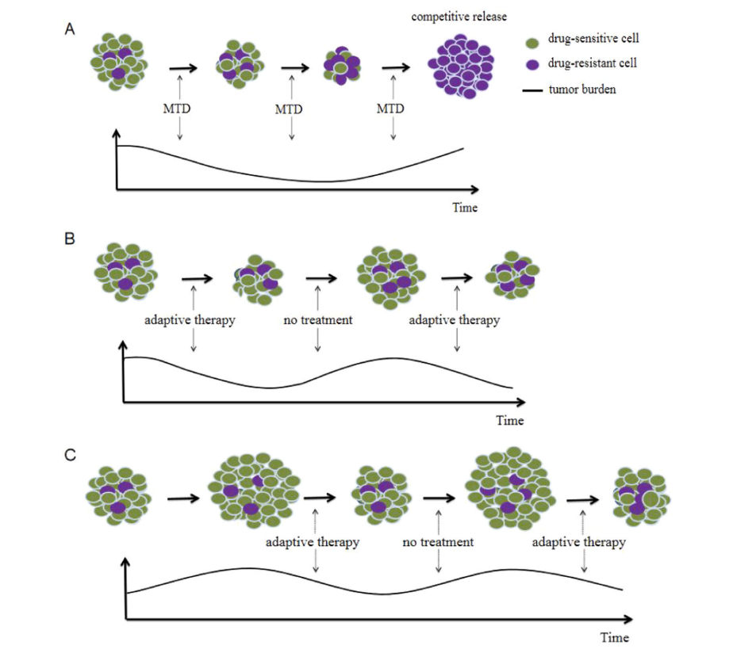

From Zhang et al. 2023. Panel A shows a typical “Maximal Tolerable Dose” treatment protocol. While the initial response in tumor burden is promising, a competitive release of resistant cells ensures. Panel B shows an AT approach with a small tumor burden. Panel C shows AT with a high tumor burden, which has been theorized to further increase the suppression of resistant cells.

Initial results from an ongoing pilot clinical trial applying AT in a group of *metastatic castrate-resistant prostate cancer* (mCRPC) patients are promising. The results reflect both lower cumulative dosages and longer survival times when the patient group is compared to a similar group of patients receiving standard care. In the trial AT has been implemented through a *range-bounded* (RB) treatment heuristic: if the blood marker *Prostate-specific Antigen* (PSA), a proxy for tumor burden increases back to pre-trial levels, Abiraterone treatment is applied until PSA drops to 50% of pre-trial levels (Zhang et al. 2017).

## POMDPs

A *Partially Observable Markov Decision Process* (POMDP) is a type of controller that models a *Markov process*. An environment that moves through discrete time steps and states, and where each step of the system only depends on the configuration of states at the prior time step. Partial observability refers to the fact that these models don’t directly observe the actual environment but instead observe signals emitted by the environment (Åström 1969). This allows POMDPs to differentiate an observed signal from what it “believes” about the actual configuration of states and crucially to use a single reward function to trade off expected uncertainty for expected utility (Kaelbling, Littman, and Cassandra 1998).

## Solving POMDPs with Active Inference

While POMDPs are typically difficult to solve analytically, various approximations exist. One approximation scheme is born out of the neuroscience paradigm *Active Inference* (AI) where POMDPs are typically used to model an agent’s decision-making. AI POMDPs have been used to model psychopathology (Da Costa et al. 2020) but also applied to control scenarios such as the mountain car problem (Friston, Daunizeau, and Kiebel 2009) and, albeit augmented with deep learning, robotics control (Çatal et al. 2020). The canonical AI approximation minimizes the following two objective functions to solve POMPDs:

* *Variational Free Energy* (VFE). A measure of fit between a *generative model —* a model of how an agent “believes” actions and an environment combine to generate observations — and sensory input.
* *Expected Free Energy* (EFE). A score of how well a course of action is expected to bring about a set of preferences penalized for expected uncertainty.

AI implementations of the POMDP scheme have been implemented in MATLAB and recently in Python with the Python package *pymdp* (Heins et al. 2022a; and Heins et al. 2022b). POMDPs are a joint probability:

$$p\left(o,s,u;ϕ\right)$$

where $o$ are observations, $s$ are hidden states to be inferred, $u$ are actions that an agent can take to influence the environment, and $ϕ$ are the hyperparameters of the mode. By conditioning on certain observations, the POMDP is solvable for Bayes-optimal posterior beliefs at a given time point given a specified generative model. This yields multiple posterior probability distributions:

* Beliefs about each *state factor —* answering what the actual state in each type of state in the environment is.
* Beliefs about what *policies* — possible courses of actions that are most likely to achieve a set of specified preferences while keeping expected uncertainty as low as possible.

As an example, a POMDP could model the joint probability of observing a noisy signal of a particular tumor burden in a patient, an actual underlying tumor burden, and the course of action that is most likely to bring the tumor burden down. By modeling, actions, states, and observations as discrete events, the joint probability can be factorized into multiple categorical probability distributions. These distributions describe likelihood mappings between signals and specific states of the environment, transition probabilities of each state factor, and preferences of certain observations. Superficially, it can seem odd to model preferences as probability distributions, but this is beneficial for balancing expected utility against expected uncertainty (Smith, Friston, and Whyte 2022). [1]

## The Aim of this Paper

The treatment decisions used in the pilot trial reported by Zhang et al. (2017) were based on a well-informed heuristic about how resistance dynamics would develop as a consequence of careful timing of Abiraterone treatment. However, the actual resistance dynamics of each patient weren’t explicitly modeled in real-time, and thus not used in treatment decisions. This paper primarily investigates whether the AI implementation of POMDPs can model and control the degree of treatment resistance of individual cancer patients in real-time. Concretely, this paper aims to show that by modifying the canonical AI POMPD, the beliefs of an agent modeled as a POMPD should converge on the actual configuration of states in the enviroment, even when entire state factors don’t emit signals. Additionaly, it will be tested whether such an ability would allow POMDPs to improve the survival times of cancer patients by improving the timing of treatment. A two-part analysis of conducted simulation work follows: One explanatory analysis of a modified POMPD in a simulated clinical setting, and a simulation experiment pitting modified POMDPs against a treatment strategy inspired by a clinical implementation of AT.

# Analysis

## Simulating Adaptive Therapy

To investigate the appropriateness of the AI implementation of the POMDP scheme, multiple simulations of a clinical setting inspired by the pilot clinical trial were run. To comply with the canonical AI POMDP scheme discrete states and and time steps were used. Each simulation run simulated maximally of 200 time steps. At each time step, an agent had to keep a virtual cancer patient alive by deciding whether to apply a treatment based on a signal of the tumor burden. The signal could be observed at each time point, and treatment decisions were made by solving a slightly modified AI POMDP. The features of the environment were inspired by the use of PSA testing and Abiraterone treatment in the pilot trial (Zhang et al. 2017). In the simulations, the simulated patient’s *tumor state factor* determined whether they survived to the next time step. If the tumor state factor reached the maximal state of six possible states, the virtual patient “died” and the simulation ended. The tumor state factor was always set to the lowest at the beginning of each simulation run and could increase at a fixed risk at each time step.

Whether a round of treatment successfully reduced the tumor state depended on an underlying *resistance state factor*. This also began at the lowest out of six possible states. For each round of treatment application, the resistance state factor had a fixed risk of increasing. The only remedy to the increasing resistance states, beyond favorable bouts of stochasticity, was to withdraw treatment which would allow the resistance state factor to lower. Inspired by the work of Hansen and Read (2020), higher tumor states increased the chance of lowering the resistance state factor (See Appendix A for all simulation parameters).

## Modifications to the POMDP Architecture

Typically when constructing the generative models of POMDPs in AI, different state factors such as the resistance state factor and tumor state factor are not modeled to affect each other directly. Instead, the interactions resulting from particular configurations of states across state types are modeled as leading to different observations. This means that interactions between types of states would be coded in the likelihood distribution.

This setup was deemed incompatible with the environment that the simulated agents had to model. It wouldn’t let agents infer how changes in resistance state factor should influence the expected transition probabilities of the tumor state factor. Therefore, custom changes were made to pymdp to allow POMDPs to infer *occluded* state factors — state factors that don’t produce signals themselves (e.g. the resistance state factor). The specific state of an occluded state factor instead needed to be inferred through its effects on downstream state factors that generate signals (e.g. the tumor state factor).

Specifically, modifications were made to the structure of the agent’s beliefs about the environment’s transition probabilities Usually, three-dimensional *tensors* describe expected transition probabilities within a state factor. This means a tensor for a type of state typically holds one dimension for the current state, one dimension for the next state, and a third dimension for every allowed action. Each cell of the tensor then contains the probability of transitioning from one state to another state conditional on a certain action. Another dimension was added to relevant tensors which corresponded to states in another state factor. Concretely, this means that the tensor for tumor transition probabilities had a fourth dimension corresponding to the possible resistance states. The expected transition probabilities could then be estimated by matrix multiplying the tumor transition tensor with a vector containing expected probabilities of each resistance state at a given time point. One can imagine that instead of having only one tensor for the transition probabilities between tumor states, multiple tensors of tumor transition probabilities were specified, where each tensor corresponded to a specific resistance level. This modification to the generative model necessitated taking an average of across these tensors weighted by the posterior probabilities for each resistance state at a given time point. This amounts to calculating the expected transition probabilities between tumor states conditional on a set of beliefs about the resistance state factor. This modification strategy was repeated for the transition probabilities assigned to the resistance state factor since decreases in the resistance state depended on the tumor state. It should be noted that this modification means that the order in which beliefs about states are evaluated must be specified. While these changes rendered much of the functionality of pymdp immediately unusable, the modification strategy should be able to model arbitrarily complex dependencies between states.[2]

## Simulations Results

### Using a POMPD to Infer Real-time Resistance Dynamics

An exploratory simulation was conducted, where for each run an agent instantiated as a modified POMDP controlled whether to treat and test a patient. The agent received the following signals:

* A noiseless signal of whether the patient was alive.
* A noiseless signal of whether it was applying tests.
* A noiseless signal of whether it was applying treatment.
* If testing was applied at the time step, the agent received a noised signal of the tumor state factor.

The agent’s prior preferences were heavily skewed against observing a dead patient, somewhat against observing treating, and slightly against observing testing. This was done to simulate the cost of both treating and testing. This means that the agent had to balance the cost of its actions while considering the potential information gain from every action. These costs were introduced to investigate whether the POMDP scheme could potentially be used to strike a balance between drug toxicity, and tumor burden while optimizing real-time data collection as desired by key researchers in AT West et al. (2023). The model was further handicapped by noising the tumor signal, meaning that the resistance state, which had to be inferred through the tumor signal, was doubly obfuscated.

The agent’s generative model did perfectly map the expected noise in the tumor signal, and its initial expected transition probabilities were identical to the actual transition probabilities of the environment. Additionally, the agent was given uniform priors over initial states, meaning it had no information on the configuration of states at the beginning of each run. The same set of predetermined policies that considered the next 6 time steps were evaluated at each step. This limited set of policies was done to ease computation by limiting the search space of possible actions. The set of policies consisted of two blocks of either testing or treating for three time steps in a row for permuted each possible sequence of applying testing or not for the time horizon of the policies.

In the following example of an exploratory simulation run, a simulated agent managed to keep the patient alive for 68 time steps (see Fig. 2).

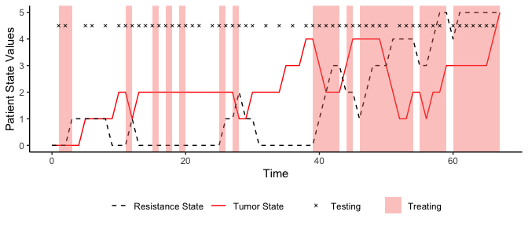

A simulation run for exploratory purposes. The simulation ended before time step 200 since the simulated patient “died” when the tumor state factor reached the state 5 at time step 68.

The agent appears to have been somewhat sensibly applying treatment, but it didn’t apply treatment at a pivotal period approximately between steps 30 and 39. Interestingly, the agent decided to apply treatment at the first time step, despite the tumor state and resistance state being at their lowest possible values. Considering that the generative model had uniform priors over both resistance state and tumor states, this behavior is appropriate from the perspective of the agent, since treating and testing would immediately provide information about both states. This suggests that the agent estimated testing to be more worthwhile while also treating. Given that by combining treatment and testing, the agent can learn about both the resistance and tumor state factors, all else being equal, the expected information gain should therefore be increased which in turn should minimize EFE. A plot of the model’s beliefs about the resistance state at each time-point (see Fig. 3) shows that the agent’s beliefs about the resistance state generally follow the development of the actual resistance state.

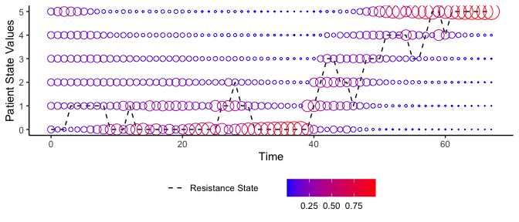

Agents beliefs about the patient’s resistance state at every timepoint. Size and color of circles indicate the probability that the agent assigns to each value of the state at a given time step.

In summary, the modification to the POMDP structure appears to have allowed the agent to infer the occluded resistance states in real-time. While the results are initially promising, the particular agent did make questionable choices regarding the timing of treatment. It’s decision-making is dissected in-depth in Appendix B.

### Testing the Performance of POMDPs against a Range-Bounded Strategy

Several agents instantiated as modified POMDPs were tested against a RB strategy. This was done to benchmark the performance of POMDPs against a strategy inspired by the treatment protocol used in the pilot clinical trial (Zhang et al. 2017). To computation the agents’ generative models were simplified — agents only observed a noiseless signal of the tumor state and whether treatment was being applied at every time step. Agents were also only given prior preferences for observations of tumor states. The preferences were uniform over all survivable observations of survivable tumor burdens, and the probability of observing the maximal burden was set to 0. The following three agents were tested:

* A short policy horizon POMDP that could consider a block of treating or not treating for the next three time steps, yielding a total horizon of 3 time steps.
* A medium policy horizon POMDP that could consider two blocks of treating or not treating for three steps, yielding a total horizon of 6 time steps.
* A long policy horizon POMDP that could consider four blocks of treating or not treating for three steps, resulting in a total horizon of 12 steps.

The agents were benchmarked on four different tumor growth rates, to investigate how a cancer’s aggressiveness would affect the agent’s ability to keep a patient alive. The tested tumor growth rates were 0.1, 0.3, 0.5, and 0.7 probability of an increase in tumor state at each time step. For each setting, 100 simulations were run. For each run, the environment was predetermined by generating 200 outcome variables for each combination of tumor state, resistance state, and treatment state to ensure comparability between the tested agents and the RB strategy at the level of each run.

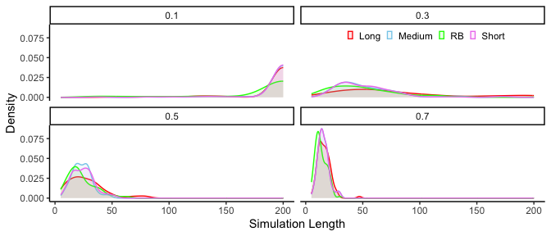

Simulated observed patient survival times for each POMDP agent and the range-bounded strategy.

At the lowest tumor growth rate, nearly all the runs reached the maximal length (see Fig. 4). On the other runs, the long horizon model appeared to be slightly outperforming the others. Contrasts, computed as the percentage difference in survival from switching from the baseline RB-strategy to the long horizon POMDP are plotted for each simulation setting in Figure 5.

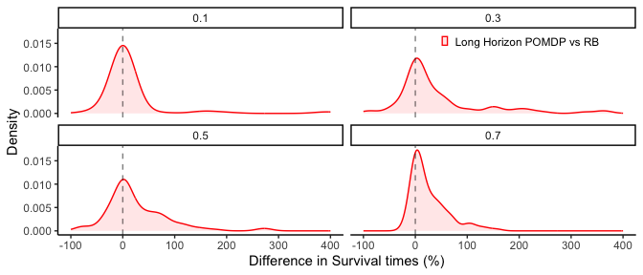

In the 100 runs with a 0.1 risk of tumor growth, the long-horizon POMDP seems to perform similarly to the RB strategy. However, as the tumor growth risk increases, the POMDP agent increasingly shows large percentage improvements compared to the RB strategy. Potentially a consequence of a greater need for proactive action when tumor dynamics accelerate, which in turn could favor models that explicitly model how treatment will effect future resistance dynamics.

# Discussion

## Findings

This project tested a modification to how POMDPs are typically implemented in AI to investigate whether POMDPs could infer and control state factors that don’t emit signals, but instead influence other state factors. This was accomplished. In a simulated environment designed to mimic the a recent clinical implementation of AT, the modification allowed agents, instantiated as POMDPs, to infer simulated resistance dynamic that modulated the efficacy of cancer treatment, despite the underlying resistance states not producing observable signals themselves.

Modified POMDPs were further tested against a RB treatment strategy inspired by a pilot clinical trial using AT, and were found to outperform the RB strategy substantially. The performance gap was largest in simulations of aggressive tumor growth rates and for agents with longer policy horizons. These results in concert with a recent review of needed developments in AT models (West et al. 2023) underscore the potential of drawing inspiration from the AI paradigm for real-time planning of treatment and testing decisions. Perhaps the modified POMDP architecture could, with refinement, come to improve real-time patient-specific therapy treatment decisions.

This paper implemented a POMDP capable of combining two actions: treating and testing. Only computation and our ability to specify likelihood and transition probabilities prohibit constructing more complicated generative models. Potentially opening the door to combining multi-drug therapies with multiple types of testing embedded in increasingly detailed real-time models of tumor biology — all of which are desiderata reported by West et al. (2023).

But to avoid having to figure out how quarks and leptons might interact to produce a cancer cell, we will have to limit our desire for higher causal resolution at some point. While simulating finer-grained mechanisms of tumor biology likely will benefit clinical adaptions of AT, abstracting away physical mechanisms as random fluctuations inherent to the modeled environment will eventually be necessary. Models for real-time treatment decisions will therefore need the capacity to model the uncertainty of the environment and account for it in decision-making.

This is a quality of the AI paradigm since it quantitatively incorporates expected utility and uncertainty in decision-making. For AT, this blurs the line between testing and treating. For example, an AI model could correctly believe that two patients have exactly the same tumor burden but suggest treatment for one patient and not the other. This is a feature, not a bug. If the model is certain in its beliefs about one patient’s resistance dynamics, the expected gain in information from treating will be small. Yet if the model is uncertain about the resistance dynamics of the other patient, it might be worthwhile to apply treatment simply for the information gain. Curiously, this could result in two patients with exactly the same tumor burden, but only one of them should receive treatment. Factoring in measures of uncertainty could drastically alter how to optimally collect real-time data patient data. While treatment responses were implicitly used as an information gathering tool in the pilot trial — Zhang et al. (2017) report only including patients who showed a substantial drop in PSA after an initial round of treating — models inspired by AI could carefully and quantitatively balance information gathering against other objectives such as drug toxicity, patient well-being, financial costs while delaying the emergence of resistance.

## Suggestions for Future Research

The results of the present work are promising, but the simple nature of the simulated environments prohibits drawing any strong conclusions about the prospect of using AI POMDPs in a clinical setting.

To further investigate whether POMDPs could viably be applied in a clinical setting, multiple problems need to be solved. For example, in the present study, the environment featured only discrete values. Since biomarkers and dosage intensities will likely take continuous values, some combination of binning continuous values to discrete values or adapting the model structure to work with continuous data is necessary. In the face of similar constraints, deep learning has been used to construct likelihood mappings and transition probabilities in POMDPs (Çatal et al. 2020). Finding better methods for searching the policy spaces will likely also be pivotal — Da Costa et al. (2020) for example suggest methods for pruning the space of possible actions to decrease search times.

Another key issue is determining how to inform likelihood and transition probabilities in a fashion that is compatible with a clinical setting. The present study used the actual transition probabilities of the simulated environment and, depending on the simulation run, noiseless likelihood mappings. Possibly, simulations of cancer dynamics, such as those by Zhang et al. (2017), could be used to inform transition probabilities, and a clinical model could potentially readjust to patient data. The AI implementation of POMDPs has a developed literature on online learning of the categorical probability distributions needed to accurately represent the environment. Even potential information gains from learning transition and likelihood probabilities can be factored into decision-making (Smith, Friston, and Whyte 2022; and Da Costa et al. 2020).

In the present paper, the ranges of the benchmark i.e., the RB strategy, were selected arbitrarily. only chosen since range seemed to manage to control tumor states for a well. A systematic benchmarking framework in AT could ease the comparison of future models. The work of West et al. (2023) could potentially be translated to a set of simulation environments used for benchmarking. Wrapping existing simulations into environments that facilitate exchaning actions and observations with simulated agents could be done by using an API like the one used in Gymnasium (formerly OpenAI Gym) (Towers et al. 2024). This would hopefully minimize friction for non-oncology researchers wishing to contribute to the field by allowing them to prioritize improving model performance over spending excessive time deciphering how to construct useful metrics themselves.

Perhaps POMDPs could even be “reverse-engineered” from more complex models, which themselves could more easily be validated if a benchmarking suite existed. For example, if a black-box model, like a neural network, can be shown to successfully control treatments, fitting a POMDP to its behavior would probably be a fairly straight-forward endeavor since AI POMDPs often have been used in computational psychiatry to model human decision-making. The same techniques might let us to translate otherwise non-transparent models into the POMDP , thus combining the performance of a black-box model with the transparency of the POMDP structure.

# References

Åström, K. J. 1969. “Optimal Control of Markov Processes with Incomplete State-Information II. The Convexity of the Lossfunction.” *Journal of Mathematical Analysis and Applications* 26 (2): 403–6. <https://doi.org/10.1016/0022-247X(69)90163-2>.

Bukowski, Karol, Mateusz Kciuk, and Renata Kontek. 2020. “Mechanisms of Multidrug Resistance in Cancer Chemotherapy.” *International Journal of Molecular Sciences* 21 (9): 3233. <https://doi.org/10.3390/ijms21093233>.

Çatal, Ozan, Samuel Wauthier, Cedric De Boom, Tim Verbelen, and Bart Dhoedt. 2020. “Learning Generative State Space Models for Active Inference.” *Frontiers in Computational Neuroscience* 14 (November). <https://doi.org/10.3389/fncom.2020.574372>.

Da Costa, Lancelot, Thomas Parr, Noor Sajid, Sebastijan Veselic, Victorita Neacsu, and Karl Friston. 2020. “Active Inference on Discrete State-Spaces: A Synthesis.” *Journal of Mathematical Psychology* 99 (December): 102447. <https://doi.org/10.1016/j.jmp.2020.102447>.

Friston, Karl J., Jean Daunizeau, and Stefan J. Kiebel. 2009. “Reinforcement Learning or Active Inference?” *PLoS ONE* 4 (7): e6421. <https://doi.org/10.1371/journal.pone.0006421>.

Gatenby, Robert A., Ariosto S. Silva, Robert J. Gillies, and B. Roy Frieden. 2009. “Adaptive Therapy.” *Cancer Research* 69 (11): 4894–4903. <https://doi.org/10.1158/0008-5472.CAN-08-3658>.

Hansen, Elsa, and Andrew F. Read. 2020. “Modifying Adaptive Therapy to Enhance Competitive Suppression.” *Cancers* 12 (12): 3556. <https://doi.org/10.3390/cancers12123556>.

Heins, Conor, Beren Millidge, Daphne Demekas, Brennan Klein, Karl Friston, Iain D. Couzin, and Alexander Tschantz. 2022a. “Pymdp: A Python Library for Active Inference Indiscrete State Spaces.” *Journal of Open Source Software* 7 (73): 4098. <https://doi.org/10.21105/joss.04098>.

Heins, Conor, Beren Millidge, Daphne Demekas, Brennan Klein, Karl Friston, Iain Couzin, and Alexander Tschantz. 2022b. “Pymdp: A Python Library for Active Inference in Discrete State Spaces.” *Journal of Open Source Software* 7 (73): 4098. <https://doi.org/10.21105/joss.04098>.

Kaelbling, Leslie Pack, Michael L. Littman, and Anthony R. Cassandra. 1998. “Planning and Acting in Partially Observable Stochastic Domains.” *Artificial Intelligence* 101 (1): 99–134. <https://doi.org/10.1016/S0004-3702(98)00023-X>.

Smith, Ryan, Karl J. Friston, and Christopher J. Whyte. 2022. “A Step-by-Step Tutorial on Active Inference and Its Application to Empirical Data.” *Journal of Mathematical Psychology* 107 (April): 102632. <https://doi.org/10.1016/j.jmp.2021.102632>.

Staňková, Kateřina, Joel S. Brown, William S. Dalton, and Robert A. Gatenby. 2019. “Optimizing Cancer Treatment Using Game Theory.” *JAMA Oncology* 5 (1): 96–103. <https://doi.org/10.1001/jamaoncol.2018.3395>.

Towers, Mark, Jordan K Terry, Ariel Kwiatkowski, John U. Balis, Gianluca Cola, Tristan Deleu, Manuel Goulão, et al. 2024. *Gymnasium*. Zenodo. <https://doi.org/10.5281/zenodo.10655021>.

West, Jeffrey, Fred Adler, Jill Gallaher, Maximilian Strobl, Renee Brady-Nicholls, Joel Brown, Mark Roberson-Tessi, et al. 2023. “A Survey of Open Questions in Adaptive Therapy: Bridging Mathematics and Clinical Translation.” Edited by Richard M White. *eLife* 12 (March): e84263. <https://doi.org/10.7554/eLife.84263>.

Zhang, Jingsong, Jessica J. Cunningham, Joel S. Brown, and Robert A. Gatenby. 2017. “Integrating Evolutionary Dynamics into Treatment of Metastatic Castrate-Resistant Prostate Cancer.” *Nature Communications* 8 (1): 1816. <https://doi.org/10.1038/s41467-017-01968-5>.

# Appendix A: Simulation parameters

| Outcome | Probability |
| --- | --- |
| Risk of Tumor Growth | 0.3 |
| Risk of Resistance Increase | 0.5 |
| R0 Chance of Treatment Success | 1.0 |
| R1 Chance of Treatment Success | 0.8 |
| R2 Chance of Treatment Success | 0.6 |
| R3 Chance of Treatment Success | 0.5 |
| R4 Chance of Treatment Success | 0.4 |
| R5 Chance of Treatment Success | 0.2 |
| T0 Chance of Resistance Decrease | 0.0 |
| T1 Chance of Resistance Decrease | 0.2 |
| T2 Chance of Resistance Decrease | 0.4 |
| T3 Chance of Resistance Decrease | 0.7 |
| T4 Chance of Resistance Decrease | 0.8 |
| T5 Chance of Resistance Decrease | 0.9 |

# Appendix B: The Decision-making of a POMDP

Examining what policy the model finds the most promising at each time step reveals an interesting pattern. From time steps 30 to 39, the model never considers treating to be the optimal course of action, even though the resistance state factor is low (see Fig. 5).

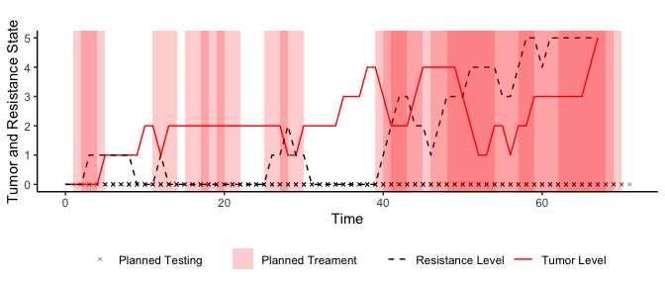

Highest rated policy at each timepoint overlaied.

The model also holds accurate beliefs about the resistance state at this time point (see Fig. 3). Multiple other reasons could account for its failure. First, there is a cost to treating, which means that the model generally prefers not to treat. It also underestimates the tumor burden at this time point (see Fig. 6) and gets “caught off guard” by a sudden rise in the tumor level. Since there is a cost associated with testing, it is also hesitant to apply tests during this period. Because it only considers six time steps into the future, it likely doesn’t consider the long-term consequences of not reducing the tumor level.

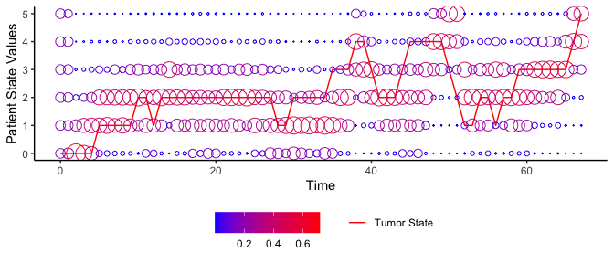

Plot of Agent’s beliefs about patients tumor state.

The exact “decision-making” for each policy can be evaluated. Each policy is evaluated for its EFE, which is a combination of the expected utility penalized for expected uncertainty (see Fig. 6). Note that minimizing EFE was actually implemented by maximizing negative EFE.

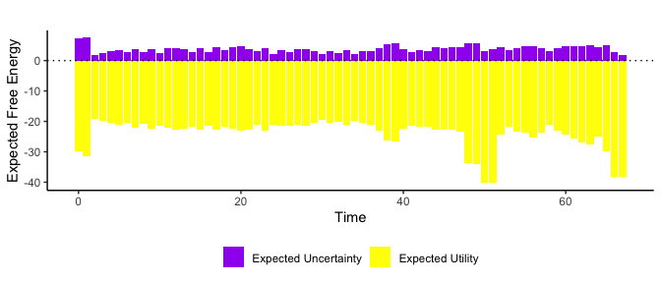

Plot of FEP Components for top policy at each timepoint.

The free energy components reveal several aspects to the agent’s decision-making. At first, the model, given its uniform priors, is very uncertain about outcomes. Decreasing uncertainty therefore weighs heavily in its decision-making. This uncertainty also means that the model believes it is more likely to be in a risky situation, and reducing this risk is a priority. During the earlier identified pivotal period between time steps 30-39, there is a concerning lack of increase in the weight of the utility component. This could mean that the model is too concerned with avoiding both treating and testing, while the utility cost of the patient dying not weighing enough in decision making. It is only from time step 40 and onwards that the model realizes the severity of the situation, i.e., the rising tumor level (see Fig. 5). This analysis warrants several changes to the model structure. Changing the prior preferences to make testing and treatment “cheaper” would be easy immediate solutions. They would also be cheating. Treating and testing more would translate to actual costs, both financial and to patient well-being. It would probably be more fruitful to give the model longer policies to consider, since it could better factor the risk of not detecting and controlling tumor levels at low values.

1. The Python package pymdp (Heins et al. 2022b) has numerous tutorial notebooks for implementing POMDPs in Python. Smith, Friston, and Whyte (2022) describes the process of constructing POMDPs for different scenarios in detail, albeit in MATLAB, and Da Costa et al. (2020) provides an in-depth mathematical account of POMDPs in Active inference.
2. Simulation scripts, the produced data and visualizations scripts are available online: <https://github.com/emilfrej/Active-Inference-Adaptive-Therapy>