**Advanced Web Technologies – Spring 2017 ORT Braude**

|  |
| --- |
| **Names:**  Emil Gelman, 310745674  Avi Bouchris, 305251118 |
| **Lecturer:** Alexander Keselman  **Download from Google Drive**  <https://drive.google.com/file/d/0B53UY51EH_q4UzA0U1V5VFJzN2c/view?usp=sharing>  **Download from AWS**  <http://ec2-35-161-129-35.us-west2.compute.amazonaws.com/website_final.zip> |
|  |

# General

The submission includes the following:

1. This README file, with explanation on the website and relevant files.
2. Source code of the entire website. Please note that passwords are hidden as this website is currently being used in Intel’s production environment.

We have attached screenshots of how the website looks in the next page. If you wish to see a live version, we can either present it in Skype or meet you in person in class.

# Background

The website was built for a group named CMCC, which is in charge of Intel’s design environment event management. The purpose of the website was to cover the group’s need for a certification progress tracking website, which includes all the related materials and subjects. The website was built following Intel’s security standards, which include SQL Injection prevention, user authentication and active directory integration.

# Objectives

The website contains the following features:

* For each member of the group, a complete feedback report of his entire certification progress, which includes: post shift feedback, exams feedback and homework feedback.
* A one-place portal which contains all of the certification materials
* Reports and information on each of the group members’ certification progress, which includes various data such as efficiency in shift, number of shifts until the next stage in the certification, etc.
* Integration with Atlassian’s JIRA system – the homework tasks given by the group members will be converted into a JIRA task using their REST API.
* The website is completely responsive – the display will resize itself according to the device.
* Integration with Intel’s SMTP server for a mailing system.

# Methodology/methods

The website was built using the following platforms:

* ASP.NET - for the server sided calculations and processing.
* HTML5
* Bootstrap and other graphical libraries (such as FancyBox and SummerNote)
* JavaScript and JQuery
* PHP (As part of the backend, used for the feedback reviewing platform)
* JIRA REST API
* MySQL
* Active Directory and LDAP

The certification portal:

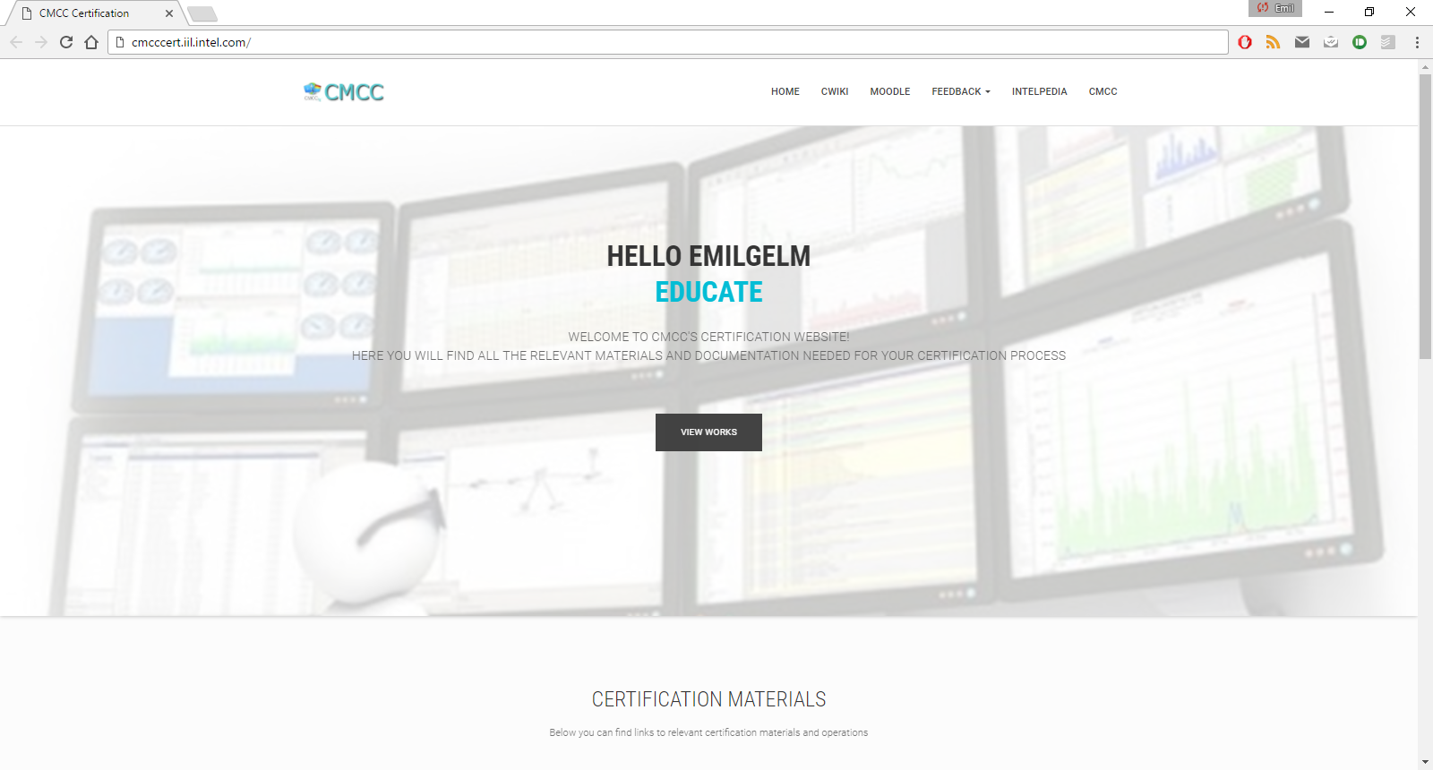

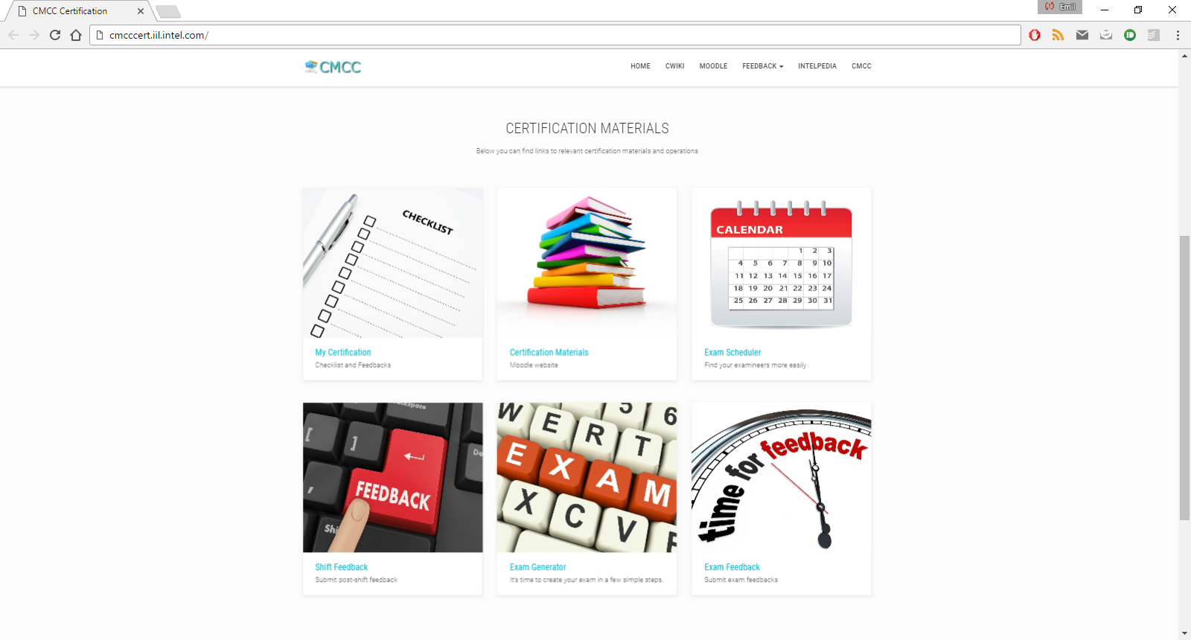

Writing feedback:

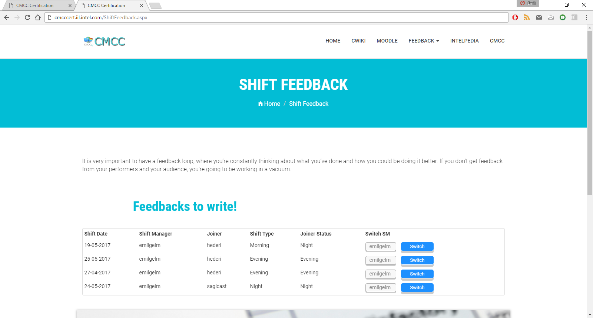

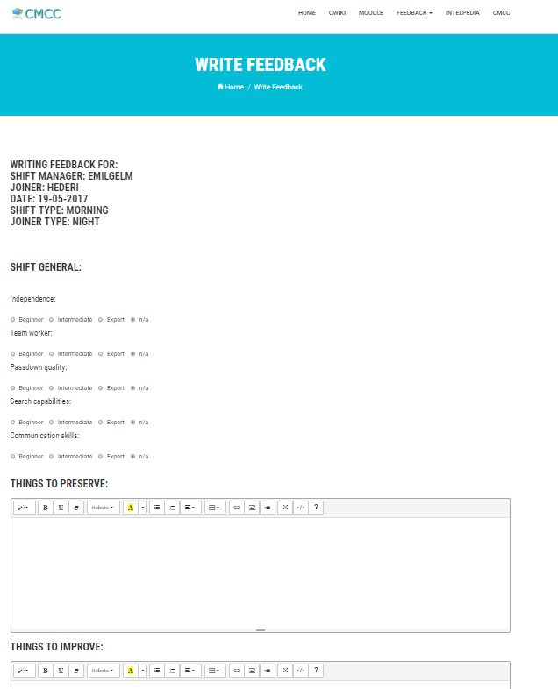

Example for one of the mails generated by the mailing system:

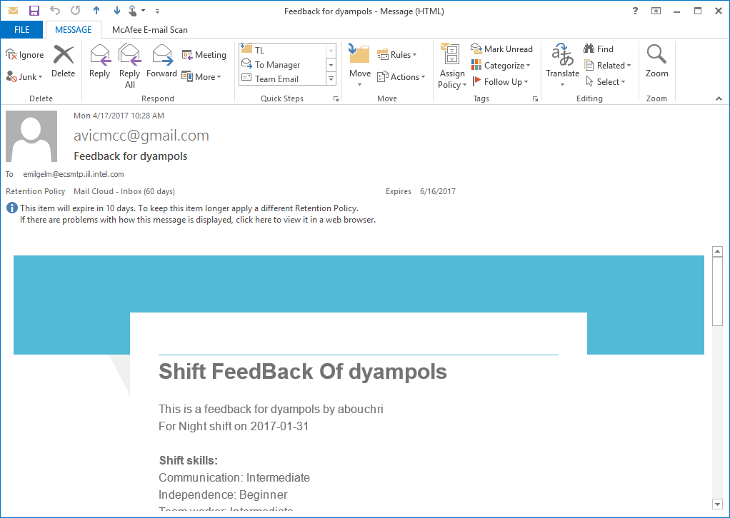

Integration with JIRA:

