
Initial Screening Report
Supplier ID: N/A
ESKO CASTING AND ELECTRONICS PRIVATE LIMITED
[Esko Casting And Electronics Private Limited]

14th September 2026

Contents

1. Company Profile 3
2. Executive Rating Summary 3
3. Detailed Findings 3
A. Entity Existence 3
B. Legal History and Open Cases 3
C. Financial Indicators 3
D. Adverse Media 3
4. Annexures 4
5. Data Sources 4

Company Profile

Uploaded Name | Esko Casting And Electronics Private Limited | Supplier ID | N/A
Name | ESKO CASTING AND ELECTRONICS PRIVATE LIMITED | Location | KOLKATA, West Bengal
Address | SAMILTON CHAMBERS181 1 A J C BOSE ROAD 2ND FLOOR PS BENIAPUKUR, KOLKATA, West Bengal - 700014 | Website | https://www.eskocast.com/
E-Filing Status | Active | Classification | Private Limited Indian Non-Government Company
Incorporation Date | 01/04/1999 | National Identifier | U27203WB1999PTC089144
Corporate Group | Shareholders: 9  Subsidiaries: 0 | Alias | ESKO DIE CASTING PRIVATE LIMITED
Revenue | 3,307,609,120 | Employee | N/A

Executive Rating Summary

Executive Summary

ESKO CASTING AND ELECTRONICS PRIVATE LIMITED, a Private Limited Indian Non-Government Company based in Kolkata, West Bengal, carries an Overall Risk Rating of Medium. The most material exposure is financial, with a Medium rating and 14 findings flagged, indicating concentrated scrutiny in this area. Legal and entity existence risks are also rated Medium, each with 2 findings, contributing to the overall risk posture. Adverse media risk is Low with 1 finding, suggesting limited negative external coverage. Cyber risk is Low with 1 finding, marking cyber and related ESG considerations as notably clean relative to other domains.

OVERALL RISK RATING | Medium

The below ratings are assigned:
Risk Areas | Risk Rating
Entity Existence | Medium
Legal | Medium
Financial | Medium
Adverse Media | Low
Cyber | Low

Detailed Findings

Entity Existence
Medium
This section shall list B2B existence, domain validation, and address validation for the entity.

Name & Relation | Google Address Validation | Rating | Medium
Findings

Factor | Value
Address | SAMILTON CHAMBERS181 1 A J C BOSE ROAD 2ND FLOOR PS BENIAPUKUR, KOLKATA, West Bengal - 700014
Zone | Mixed
Reason | The area contains a variety of establishments including offices, medical services, shops, and residential guesthouses.

Source: EY Network Alliance Databases

Name & Relation | Domain Validation | Rating | Low
Findings

Factor | Value
Domain Name | eskocast.com
Creation Date | 11-01-2002
Expiration Date | 11-01-2029
Updated Date | 18-01-2026
Registrant Org
Registrant Country
Registrar | godaddy.com, llc
Registrar Url | http://www.godaddy.com
Emails
Dnssec | unsigned
Vendor Onboarding Date (Client Database)

Source: EY Network Alliance Databases

Address Validation
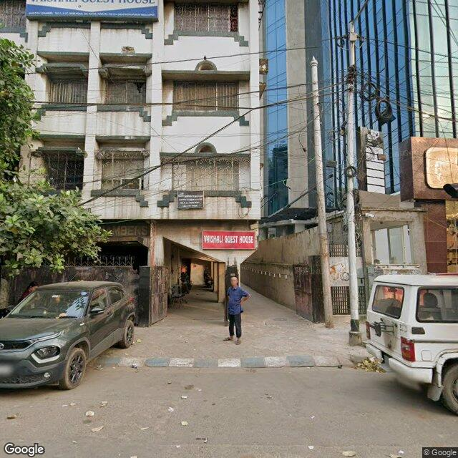 | 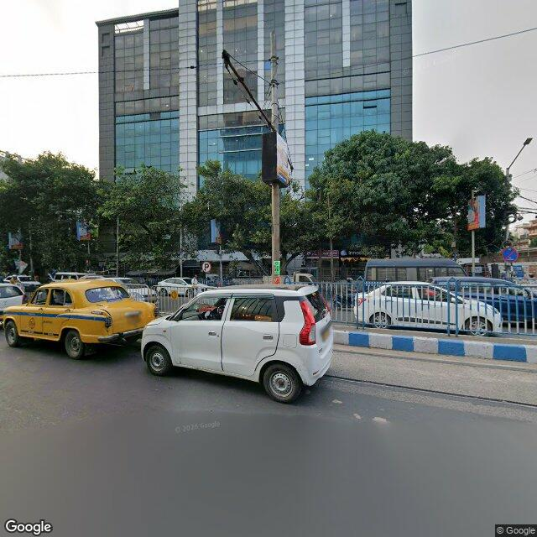 | 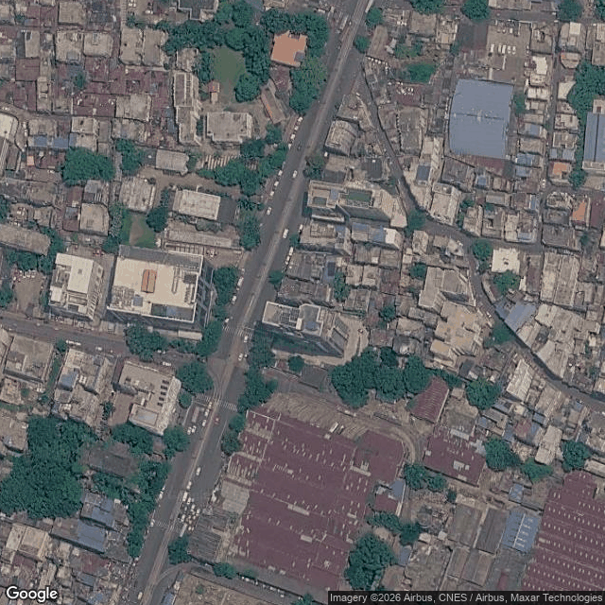

Legal History and Open Cases
Medium
This section shall list pending legal cases and open charges against the entity.

Name & Relation | Legal History | Rating | High
Findings

Sr. | Date | Case No. | Description | Category | Severity | Status
1 | 17.08.26 | COMI/153/2020 | Case No. COMI/153/2020 was filed before the Chief Judicial Magistrate, Faridabad under the category of NI Act / Company Offences. This matter pertains to Cases Filed Against This Corporate, where SUSHIL KUMAR TRIWEDI S/O SH. ARJUN TRIVEDI has initiated proceedings against ESKO CASTING AND ELECTRONICS PRIVATE LIMITED. | NI Act / Company Offences | Medium | Pending
2 | 27.07.26 | CS/6/2023 | Case No. CS/6/2023 was filed before the Civil Judge Senior Division, Faridabad under the category of Others. This matter pertains to Cases Filed Against This Corporate, where SATISH KUMAR has initiated proceedings against ESKO CASTING AND ELECTRONICS PRIVATE LIMITED. | Others | Low | Pending
3 | 07.08.25 | TRF /65913/2024 | Case No. TRF /65913/2024 was filed before the Chief Judicial Magistrate, Faridabad under the category of Others. This matter pertains to Cases Filed Against This Corporate, where STATE OF HARYANA has initiated proceedings against ESKO CASTING AND ELECTRONICS PRIVATE LIMITED. | Others | Low | Pending

Source: EY Network Alliance Databases

Name & Relation | Open Charges | Rating | High
Findings

1. Creation of Rs.1,600,000 in favour of STATE BANK OF INDIA dated 27.07.26
2. Modification of Rs.625,600,000 in favour of STATE BANK OF INDIA dated 22.05.26
3. Creation of Rs.3,600,000 in favour of STATE BANK OF INDIA dated 13.05.26
4. Creation of Rs.7,154,999 in favour of HDFC BANK LIMITED dated 31.05.24

Source: EY Network Alliance Databases

Financial Indicators
Medium
This section shall list balance sheet, profit and loss, profitability analysis, liquidity analysis, financial ratios, GST registration analysis, MSME registration validation, and related party transactions of the entity.

Name & Relation | Finance - Profit And Loss | Rating | INFO
Findings

Income Statement (₹ in Lakhs)
Particulars | 2023 | 2024 | 2025 | 2026
Net Revenue (₹ in Lakhs) | 25,056.23 | 30,175.84 | 32,055.27 | 33,076.09
Profit After Tax (₹ in Lakhs) | 993.92 | 1,056.25 | 1,378.57 | 1,238.24

Source: EY Network Alliance Databases / Annual Reports

Name & Relation | Finance - Balance Sheet | Rating | INFO
Findings

Balance Sheet (₹ in Lakhs)
Particulars | 2023 | 2024 | 2025 | 2026
Total Current Assets (₹ in Lakhs) | 7,940.21 | 8,902.87 | 9,979.63 | 13,045.8
Total Other Non Current Assets (₹ in Lakhs) | 250.46 | 150.21 | 171.85 | 177.55
Net Fixed Assets (₹ in Lakhs) | 3,306.82 | 3,595.41 | 3,826.21 | 3,864.85
Total Current Liabilities (₹ in Lakhs) | 4,788.66 | 5,638.26 | 5,968.57 | 7,903.06
Total Non Current Liabilities (₹ in Lakhs) | 1,284.48 | 529.64 | 167.26 | 267.96
Total Equity (₹ in Lakhs) | 5,424.35 | 6,480.6 | 7,859.17 | 9,097.41

Source: EY Network Alliance Databases / Annual Reports

Profitability Analysis
Name & Relation | Finance - Profitability Analysis | Rating | Medium

Revenue, EBITDA and PAT Margin
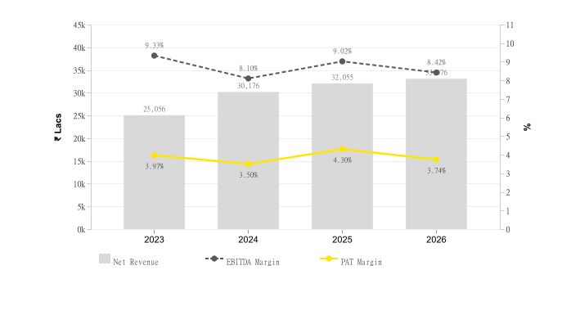
Particulars | 2023 | 2024 | 2025 | 2026
Profit Margin Ratio (%) | 3.97 | 3.5 | 4.3 | 3.74
EBITDA Margin (%) | 9.33 | 8.1 | 9.02 | 8.42

Return on Assets (ROA) & Capital Employed (ROCE)
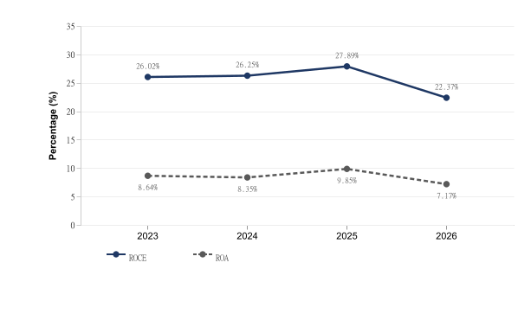
Particulars | 2023 | 2024 | 2025 | 2026
ROE (%) | 0.18 | 0.16 | 0.18 | 0.14
ROCE (%) | 26.02 | 26.25 | 27.89 | 22.37
ROA (%) | 8.64 | 8.35 | 9.85 | 7.17

Source: EY Network Alliance Databases / Annual Reports

Liquidity Analysis
Name & Relation | Finance - Liquidity Analysis | Rating | High

Liquidity Ratios
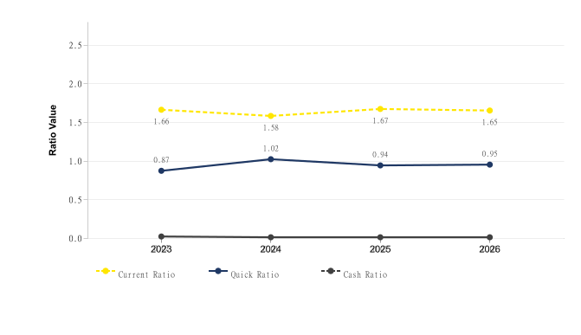
Particulars | 2023 | 2024 | 2025 | 2026
Current Ratio | 1.66 | 1.58 | 1.67 | 1.65
Quick Ratio | 0.87 | 1.02 | 0.94 | 0.95
Cash Ratio | 0.02 | 0.01 | 0.01 | 0.01

Source: EY Network Alliance Databases / Annual Reports

Operating Cycle
Name & Relation | Finance - Operating Cycle | Rating | Medium

Operating Cycle (Debtor, Creditor & Inventory Days)
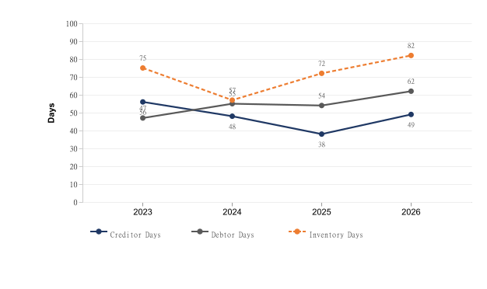
Particulars | 2023 | 2024 | 2025 | 2026
Inventory Days | 75 | 57 | 72 | 82
Debtor Days | 47 | 55 | 54 | 62
Creditor Days | 56 | 48 | 38 | 49

Asset Turnover Ratio
[Chart unavailable]
Particulars | 2023 | 2024 | 2025 | 2026
Asset Turnover Ratio | 2.18 | 2.39 | 2.29 | 1.92

Source: EY Network Alliance Databases / Annual Reports

Capital Structure
Name & Relation | Finance - Capital Structure | Rating | Medium

Debt – Equity Ratio
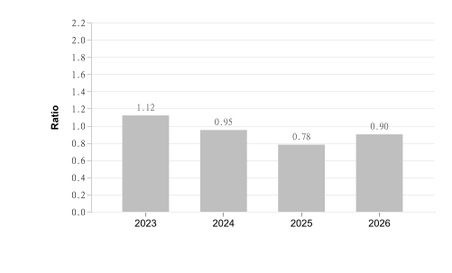
Particulars | 2023 | 2024 | 2025 | 2026
Debt Equity Ratio | 1.12 | 0.95 | 0.78 | 0.9

Interest Coverage Ratio
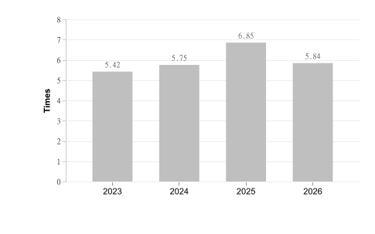
Particulars | 2023 | 2024 | 2025 | 2026
Interest Coverage Ratio | 5.42 | 5.75 | 6.85 | 5.84

Source: EY Network Alliance Databases / Annual Reports

Name & Relation | Finance - MSME Registration Status | Rating | High
Findings

Factor | Value
MSME Status (Verified) | Already Registered
MSME Status (Client Database) | Not Provided
Reason | Vendor is MSME, but client database marks vendor as not MSME

Source: EY Network Alliance Databases

Name & Relation | Finance - Credit Risk Analysis | Rating | INFO
Findings

Rating Date | Rating Agency | Rating | Type Of Loan | Amount (₹ In Lakhs)
13.08.26 | crisil | BBB (Stable/Reaffirmed) | Cash Credit | 2,500
13.08.26 | crisil | BBB (Stable/Reaffirmed) | Cash Credit | 1,800
13.08.26 | crisil | BBB (Stable/Reaffirmed) | Export Packing Credit | 500
13.08.26 | crisil | BBB (Stable/Reaffirmed) | Proposed Working Capital Facility | 1,500
29.01.26 | crisil | BBB (Stable/Assigned) | Cash Credit | 2,500
11.06.24 | india_ratings | BBB (Stable)/A3+ (Assigned) | Fund Based Working Capital Facility | 2,000
17.01.24 | care | Withdrawn (BB+/Stable/Issuer Not Cooperating) | Long Term Bank Facilities | 0
27.12.23 | care | BB+ (Stable/ Issuer Not Cooperating) | Long Term Bank Facilities | 640
26.10.22 | care | BB+ (Stable/Issuer Not Cooperaing/Revised from BBB) | Long Term Bank Facilities | 640

Source: EY Network Alliance Databases

Name & Relation | Finance - EPFO Registration | Rating | INFO
Findings

Parameter | Value
Establishment Name | M/S ESKO CASTING AND ELECTRONICS PRIVATE LIMITED
Establishment Id | HRFBD0011584000
Date Of Setup | 27-Aug-02
City | BALLABGARH
Address | PLOT NO 807 SEC 58,BALLABGARH,HARYANA,121004,India
No of Employees | 88
Last 12 Months
  May-26 | Apr-26 | Mar-26 | Feb-26 | Jan-26 | Dec-25
  On time (INR 3.0 L ; 88 Employees) | On time (INR 2.9 L ; 80 Employees) | On time (INR 2.9 L ; 85 Employees) | On time (INR 2.9 L ; 85 Employees) | On time (INR 2.8 L ; 82 Employees) | On time (INR 2.7 L ; 81 Employees)
  Nov-25 | Oct-25 | Sep-25 | Aug-25 | Jul-25 | Jun-25
  On time (INR 2.8 L ; 78 Employees) | On time (INR 2.8 L ; 83 Employees) | On time (INR 2.8 L ; 78 Employees) | On time (INR 2.8 L ; 77 Employees) | On time (INR 2.8 L ; 82 Employees) | On time (INR 2.7 L ; 80 Employees)

Parameter | Value
Establishment Name | ESKO DIE CASTING P LTD
Establishment Id | HRFBD0011955000
Date Of Setup | 07-Feb-05
City | BALLABGARH
Address | PLOT NO 30 SEC 4 FARIDABAD HR ,BALLABGARH,HARYANA,121006,India
No of Employees | 94
Last 12 Months
  May-26 | Apr-26 | Mar-26 | Feb-26 | Jan-26 | Dec-25
  On time (INR 3.4 L ; 94 Employees) | On time (INR 3.4 L ; 94 Employees) | On time (INR 3.4 L ; 94 Employees) | On time (INR 3.4 L ; 92 Employees) | On time (INR 3.4 L ; 93 Employees) | On time (INR 3.4 L ; 95 Employees)
  Nov-25 | Oct-25 | Sep-25 | Aug-25 | Jul-25 | Jun-25
  On time (INR 3.4 L ; 94 Employees) | On time (INR 3.4 L ; 93 Employees) | On time (INR 3.4 L ; 94 Employees) | On time (INR 3.5 L ; 98 Employees) | On time (INR 3.5 L ; 98 Employees) | On time (INR 3.4 L ; 95 Employees)

Parameter | Value
Establishment Name | ESKO CASTING AND ELECTRONICS PRIVATE LIMITED
Establishment Id | WBTLO0024233000
Date Of Setup | 01-Aug-84
City | KOLKATA
Address | 48, DUM DUM ROAD, ,KOLKATA,WEST BENGAL,700074,India
No of Employees | 76
Last 12 Months
  May-26 | Apr-26 | Mar-26 | Feb-26 | Jan-26 | Dec-25
  On time (INR 3.2 L ; 76 Employees) | On time (INR 3.2 L ; 77 Employees) | On time (INR 3.1 L ; 78 Employees) | On time (INR 3.1 L ; 71 Employees) | On time (INR 3.1 L ; 71 Employees) | On time (INR 3.0 L ; 69 Employees)
  Nov-25 | Oct-25 | Sep-25 | Aug-25 | Jul-25 | Jun-25
  On time (INR 3.0 L ; 69 Employees) | On time (INR 3.0 L ; 69 Employees) | On time (INR 2.2 K ; 1 Employees) | On time (INR 2.9 L ; 69 Employees) | On time (INR 3.0 L ; 70 Employees) | On time (INR 2.8 L ; 70 Employees)

Source: EY Network Alliance Databases

Name & Relation | Finance - MSME Payment Analysis | Rating | INFO
Findings

Period | Amount (₹ In Lakhs)
October 2023 to March 2024 | 4.37
April 2024 to September 2024 | 8.96
October 2024 to March 2025 | 5.42
April 2025 to September 2025 | 7.37
October 2025 to March 2026 | 7.56

Source: EY Network Alliance Databases

Name & Relation | Finance - Auditor Comments | Rating | Low
Findings

Parameter | Value
Adverse Filing | False

Source: EY Network Alliance Databases

Name & Relation | Finance - Related Party Transaction | Rating | INFO
Findings

Name | Relationship | Type Of Transaction | Amount (₹ In Lakhs)
Unity Merchandise Pvt Ltd | Companies KMP or Their Relatives have Significant Influence | Expense | 587.01
Progressive Corrugated Fiberboard Pvt Ltd | Companies KMP or Their Relatives have Significant Influence | Expense | 311.2
Unity Merchandise Pvt Ltd | Companies KMP or Their Relatives have Significant Influence | Revenue | 179.84
ONS Engineering Pvt Ltd | Companies KMP or Their Relatives have Significant Influence | Expense | 78
Progressive Corrugated Fiberboard Pvt Ltd | Companies KMP or Their Relatives have Significant Influence | Revenue | 27.73

Source: EY Network Alliance Databases

Name & Relation | Finance - GST Registration Analysis | Rating | Low
Findings

Date Of Registration | State Of Registration | Gst In | Filing Timeliness
01.07.17 | Haryana | 06AAACE7249Q1Z4 | Filed on Time
13.09.21 | Haryana | 06AAACE7249Q2Z3 | Filed on Time
01.07.17 | West Bengal | 19AAACE7249Q1ZX | Filed on Time
05.11.24 | West Bengal | 19AAACE7249Q1D6 | Filed on Time

Source: EY Network Alliance Databases

Name & Relation | Finance - Z Altman Score Analysis | Rating | Low
Findings

Parameter | Calculation
Altman Z Score (manufacturing) | 3.81

Source: EY Network Alliance Databases

Adverse Media
Low
This section shall list adverse media coverage and Google ratings for the entity.

Name & Relation | Google Rating Validation | Rating | Low
Findings

Name: ESKO CASTING AND ELECTRONICS PRIVATE LIMITED
Rating: 4
Number of Reviews: 2
Reviews:
1. Name: RAHUL RAJ | Rating: 3
2. Name: Sk Imtiyaaz | Rating: 5

Source: EY Network Alliance Databases

Cyber
Low
This section shall list cyber security ratings for the entity.

Name & Relation | Cyber Risk Validation | Rating | Low
Findings

Factor | Value
Resolved IP | 65.1.139.83
Botnet Threat | NO
Malware Hosting Threat | NO
Command & Control Threat | NO
Spam Server Threat | NO
Overall Compromised | NO
Vendor / 3rd-Party Risk | PASS
Fraud / Compliance Flag | NO

Source: EY Network Alliance Databases

Annexures

Full List of Shareholders
Significant Shareholders
1. ASHOK KUMAR PODDAR 17.29%
2. UNITY MERCHANDISE PRIVATE LIMITED 17.2%
3. L K PODDAR 13.4%
4. ARUN PODDAR 10.89%
5. AMITA PODDAR 9.72%
6. LAKSHMI KANT PODDAR 6.78%
7. A PODDAR 6.49%
8. LAXMI PODDAR 5.87%
9. A K PODDAR 5.06%

Key Management Personnel
Key Management
1. ASHOK KUMAR PODDAR - Whole-time director
2. ARUN PODDAR - Director
3. LAKSHMI KANT PODDAR - Director

Full List of Legal History

Sr. | Date | Case No. | Description | Category | Severity | Status
1 | 08.09.26 | COMI/280/2020 | Case No. COMI/280/2020 was filed before the Chief Judicial Magistrate, Faridabad under the category of NI Act / Company Offences. This matter pertains to Cases Filed Against This Corporate, where NARENDER S/O RAM CHANDER has initiated proceedings against ESKO CASTING AND ELECTRONICS PRIVATE LIMITED. | NI Act / Company Offences | Medium | Disposed
2 | 17.08.26 | COMI/153/2020 | Case No. COMI/153/2020 was filed before the Chief Judicial Magistrate, Faridabad under the category of NI Act / Company Offences. This matter pertains to Cases Filed Against This Corporate, where SUSHIL KUMAR TRIWEDI S/O SH. ARJUN TRIVEDI has initiated proceedings against ESKO CASTING AND ELECTRONICS PRIVATE LIMITED. | NI Act / Company Offences | Medium | Pending
3 | 01.05.24 | SUMM/94/2024 | Case No. SUMM/94/2024 was filed before the Chief Judicial Magistrate, Palwal under the category of Civil Cases. This matter pertains to Cases Filed Against This Corporate, where State of Haryana has initiated proceedings against ESKO CASTING AND ELECTRONICS PRIVATE LIMITED. | Civil Cases | Medium | Disposed
4 | 01.05.24 | SUMM/95/2024 | Case No. SUMM/95/2024 was filed before the Chief Judicial Magistrate, Palwal under the category of Civil Cases. This matter pertains to Cases Filed Against This Corporate, where State of Haryana has initiated proceedings against ESKO CASTING AND ELECTRONICS PRIVATE LIMITED. | Civil Cases | Medium | Disposed
5 | 10.11.22 | CS/723/2018 | Case No. CS/723/2018 was filed before the District and Session Court, Palwal under the category of Civil Cases. This matter pertains to Cases Filed Against This Corporate, where Rakesh has initiated proceedings against ESKO CASTING AND ELECTRONICS PRIVATE LIMITED. | Civil Cases | Medium | Disposed
6 | 17.05.22 | SUMM /108/2021 | Case No. SUMM /108/2021 was filed before the Chief Judicial Magistrate, Faridabad under the category of Civil Cases. This matter pertains to Cases Filed Against This Corporate, where STATE OF HARYANA has initiated proceedings against ESKO CASTING AND ELECTRONICS PRIVATE LIMITED. | Civil Cases | Medium | Disposed
7 | 17.05.22 | SUMM/107/2021 | Case No. SUMM/107/2021 was filed before the Chief Judicial Magistrate, Faridabad under the category of Civil Cases. This matter pertains to Cases Filed Against This Corporate, where STATE OF HARYANA has initiated proceedings against ESKO CASTING AND ELECTRONICS PRIVATE LIMITED. | Civil Cases | Medium | Disposed
8 | 17.05.22 | SUMM/106/2021 | Case No. SUMM/106/2021 was filed before the Chief Judicial Magistrate, Faridabad under the category of Civil Cases. This matter pertains to Cases Filed Against This Corporate, where STATE OF HARYANA has initiated proceedings against ESKO CASTING AND ELECTRONICS PRIVATE LIMITED. | Civil Cases | Medium | Disposed
9 | 17.05.22 | SUMM /105/2021 | Case No. SUMM /105/2021 was filed before the Chief Judicial Magistrate, Faridabad under the category of Civil Cases. This matter pertains to Cases Filed Against This Corporate, where STATE OF HARYANA has initiated proceedings against ESKO CASTING AND ELECTRONICS PRIVATE LIMITED. | Civil Cases | Medium | Disposed
10 | 08.12.18 | SUMM/477/2018 | Case No. SUMM/477/2018 was filed before the Chief Judicial Magistrate, Palwal under the category of Civil Cases. This matter pertains to Cases Filed Against This Corporate, where State of Haryana has initiated proceedings against ESKO CASTING AND ELECTRONICS PRIVATE LIMITED. | Civil Cases | Medium | Disposed
11 | 08.12.18 | SUMM/481/2018 | Case No. SUMM/481/2018 was filed before the Chief Judicial Magistrate, Palwal under the category of Civil Cases. This matter pertains to Cases Filed Against This Corporate, where State of Haryana has initiated proceedings against ESKO CASTING AND ELECTRONICS PRIVATE LIMITED. | Civil Cases | Medium | Disposed
12 | 08.12.18 | SUMM/483/2018 | Case No. SUMM/483/2018 was filed before the Chief Judicial Magistrate, Palwal under the category of Civil Cases. This matter pertains to Cases Filed Against This Corporate, where State of Haryana has initiated proceedings against ESKO CASTING AND ELECTRONICS PRIVATE LIMITED. | Civil Cases | Medium | Disposed
13 | 08.12.18 | SUMM/486/2018 | Case No. SUMM/486/2018 was filed before the Chief Judicial Magistrate, Palwal under the category of Civil Cases. This matter pertains to Cases Filed Against This Corporate, where State of Haryana has initiated proceedings against ESKO CASTING AND ELECTRONICS PRIVATE LIMITED. | Civil Cases | Medium | Disposed
14 | 08.12.18 | SUMM/482/2018 | Case No. SUMM/482/2018 was filed before the Chief Judicial Magistrate, Palwal under the category of Civil Cases. This matter pertains to Cases Filed Against This Corporate, where State of Haryana has initiated proceedings against ESKO CASTING AND ELECTRONICS PRIVATE LIMITED. | Civil Cases | Medium | Disposed
15 | 08.12.18 | SUMM/484/2018 | Case No. SUMM/484/2018 was filed before the Chief Judicial Magistrate, Palwal under the category of Civil Cases. This matter pertains to Cases Filed Against This Corporate, where State of Haryana has initiated proceedings against ESKO CASTING AND ELECTRONICS PRIVATE LIMITED. | Civil Cases | Medium | Disposed
16 | 08.12.18 | SUMM /478/2018 | Case No. SUMM /478/2018 was filed before the Chief Judicial Magistrate, Palwal under the category of Civil Cases. This matter pertains to Cases Filed Against This Corporate, where State of Haryana has initiated proceedings against ESKO CASTING AND ELECTRONICS PRIVATE LIMITED. | Civil Cases | Medium | Disposed
17 | 08.12.18 | SUMM/488/2018 | Case No. SUMM/488/2018 was filed before the Chief Judicial Magistrate, Palwal under the category of Civil Cases. This matter pertains to Cases Filed Against This Corporate, where State of Haryana has initiated proceedings against ESKO CASTING AND ELECTRONICS PRIVATE LIMITED. | Civil Cases | Medium | Disposed
18 | 08.12.18 | SUMM/479/2018 | Case No. SUMM/479/2018 was filed before the Chief Judicial Magistrate, Palwal under the category of Civil Cases. This matter pertains to Cases Filed Against This Corporate, where State of Haryana has initiated proceedings against ESKO CASTING AND ELECTRONICS PRIVATE LIMITED. | Civil Cases | Medium | Disposed
19 | 08.12.18 | SUMM/480/2018 | Case No. SUMM/480/2018 was filed before the Chief Judicial Magistrate, Palwal under the category of Civil Cases. This matter pertains to Cases Filed Against This Corporate, where State of Haryana has initiated proceedings against ESKO CASTING AND ELECTRONICS PRIVATE LIMITED. | Civil Cases | Medium | Disposed
20 | 08.12.18 | SUMM/485/2018 | Case No. SUMM/485/2018 was filed before the Chief Judicial Magistrate, Palwal under the category of Civil Cases. This matter pertains to Cases Filed Against This Corporate, where State of Haryana has initiated proceedings against ESKO CASTING AND ELECTRONICS PRIVATE LIMITED. | Civil Cases | Medium | Disposed
21 | 08.12.18 | SUMM/487/2018 | Case No. SUMM/487/2018 was filed before the Chief Judicial Magistrate, Palwal under the category of Civil Cases. This matter pertains to Cases Filed Against This Corporate, where State of Haryana has initiated proceedings against ESKO CASTING AND ELECTRONICS PRIVATE LIMITED. | Civil Cases | Medium | Disposed
22 | 11.07.18 | E/2216/2011 | Case No. E/2216/2011 was filed before the Customs, Excise and Service Tax Appellate Tribunal under the category of Excise Duty. This matter pertains to Cases Filed Against This Corporate, where C.C.E. DELHI IV has initiated proceedings against ESKO DIE CASTINGS PVT. LTD. (UNIT-III). | Excise Duty | Medium | Disposed
23 | 09.01.17 | SUMM/2136/2016 | Case No. SUMM/2136/2016 was filed before the Chief Judicial Magistrate, Faridabad under the category of Civil Cases. This matter pertains to Cases Filed Against This Corporate, where State has initiated proceedings against ESKO CASTING AND ELECTRONICS PRIVATE LIMITED. | Civil Cases | Medium | Disposed
24 | 24.08.11 | CP/565/2010 | Case No. CP/565/2010 was filed before the High Court of Calcutta under the category of Corporate Disputes. This matter pertains to Cases for Consolidation of Corporate affairs, where Self has initiated proceedings against None. | Corporate Disputes | Medium | Disposed
25 | 25.11.10 | CA/858/2010 | Case No. CA/858/2010 was filed before the High Court of Calcutta under the category of Corporate Disputes. This matter pertains to Cases for Consolidation of Corporate affairs, where Self has initiated proceedings against None. | Corporate Disputes | Medium | Disposed
26 | 27.07.26 | CS/6/2023 | Case No. CS/6/2023 was filed before the Civil Judge Senior Division, Faridabad under the category of Others. This matter pertains to Cases Filed Against This Corporate, where SATISH KUMAR has initiated proceedings against ESKO CASTING AND ELECTRONICS PRIVATE LIMITED. | Others | Low | Pending
27 | 07.08.25 | TRF /65913/2024 | Case No. TRF /65913/2024 was filed before the Chief Judicial Magistrate, Faridabad under the category of Others. This matter pertains to Cases Filed Against This Corporate, where STATE OF HARYANA has initiated proceedings against ESKO CASTING AND ELECTRONICS PRIVATE LIMITED. | Others | Low | Pending
28 | 20.06.19 | WP/135/2015 | Case No. WP/135/2015 was filed before the High Court of Calcutta under the category of Writs and Regulatory Matters. This matter pertains to Cases Filed By This Corporate, where ESKO DIE CASTING PRIVATE LIMITED has initiated proceedings against STATE OF WEST BENGAL & ORS.. | Writs and Regulatory Matters | Low | Disposed
29 | 20.06.19 | WPO/135/2015 | Case No. WPO/135/2015 was filed before the High Court of Calcutta under the category of Writs and Regulatory Matters. This matter pertains to Cases Filed By This Corporate, where ESKO DIE CASTING PRIVATE LIMITED has initiated proceedings against STATE OF WEST BENGAL & ORS.. | Writs and Regulatory Matters | Low | Disposed
30 | 13.01.16 | WP/474W/2016 | Case No. WP/474W/2016 was filed before the High Court of Calcutta - Appellate Side under the category of Writs and Regulatory Matters. This matter pertains to Cases Filed By This Corporate, where ESKO DIE CASTING PRIVATE LIMITED has initiated proceedings against DEPUTY COMMISSIONER, COMMERCIAL TAXES,DUBURDIH CHECK POST &. | Writs and Regulatory Matters | Low | Disposed
31 | 13.01.16 | WPA/474/2016 | Case No. WPA/474/2016 was filed before the High Court of Calcutta - Appellate Side under the category of Writs and Regulatory Matters. This matter pertains to Cases Filed By This Corporate, where ESKO DIE CASTING PRIVATE LIMITED has initiated proceedings against DEPUTY COMMISSIONER, COMMERCIAL TAXES,DUBURDIH CHECK POST &. | Writs and Regulatory Matters | Low | Disposed

Source: EY Network Alliance Databases

Full List of Director Network

Sr. | Director Name | DIN | Network
1 | ASHOK KUMAR PODDAR | 00538388 | • TWENTY FIRST CENTURY AUTO LOCKS PVT LTD — Director (1987-04-27 – 2016-03-30) [AMALGAMATED]  • KANISHKA MARKETING PVT. LTD. — Additional Director (2020-08-29 – 2020-10-06)  • ESKO CASTING AND ELECTRONICS PRIVATE LIMITED — Whole-time director (1999-04-01 – Present)
2 | ARUN PODDAR | 00574732 | • ONS ENGINEERING PRIVATE LIMITED — Director (2017-11-24 – Present)  • ESKO CASTING AND ELECTRONICS PRIVATE LIMITED — Director (1999-04-01 – Present)
3 | LAKSHMI KANT PODDAR | 00574787 | • KANISHKA MARKETING PVT. LTD. — Additional Director (2020-08-29 – 2020-10-06)  • UNITY MERCHANDISE PRIVATE LIMITED — Director (2024-03-11 – Present)  • ESKO CASTING AND ELECTRONICS PRIVATE LIMITED — Director (2011-10-29 – Present)

Source: EY Network Alliance Databases

Disclaimer:
The information included in this report has been primarily collected from databases or public sources, thus it is difficult to verify all aspects of the information obtained. EY makes no representation or warranties with respect to the contents or use of this report, and specifically disclaims any express or implied warranties or usefulness for any particular purpose of this report. EY takes no responsibility for the consequences resulting from decisions based on information included in this report. EY reserves the right to change or revise this report at any time.

Copyright:
All rights reserved. No part of this screening report may be reproduced, photocopied, stored on a retrieval system, or transmitted without the express prior consent of EY.

