
Initial Screening Report
Supplier ID: N/A
UNICAST AUTOTECH PRIVATE LIMITED
[Unicast Autotech Private Limited]

14th September 2026

Contents

1. Company Profile 3
2. Executive Rating Summary 3
3. Detailed Findings 3
A. Entity Existence 3
B. Legal History and Open Cases 3
C. Financial Indicators 3
D. Adverse Media 3
4. Annexures 4
5. Data Sources 4

Company Profile

Uploaded Name | Unicast Autotech Private Limited | Supplier ID | N/A
Name | UNICAST AUTOTECH PRIVATE LIMITED | Location | NEW DELHI, Delhi
Address | 27-B/7, NEW ROHTAK ROAD, NEW DELHI, Delhi - 110005 | Website | N/A
E-Filing Status | Active | Classification | Private Limited Indian Non-Government Company
Incorporation Date | 23/08/2012 | National Identifier | U34102DL2012PTC240620
Corporate Group | Shareholders: 1  Subsidiaries: 0 | Alias
Revenue | 16,844,171 | Employee | N/A

Executive Rating Summary

Executive Summary

UNICAST AUTOTECH PRIVATE LIMITED is a Private Limited Indian Non-Government Company based in New Delhi, Delhi. The overall risk rating is Medium. The most material risk area is Financial, rated Medium with 13 findings flagged. Legal risk is also Medium with 2 findings, and Entity Existence shows a Medium posture with 1 flagged finding. Adverse Media risk is Low, suggesting limited negative coverage identified. Cyber risk is Low, indicating no notable cyber-related concerns identified in this review.

OVERALL RISK RATING | Medium

The below ratings are assigned:
Risk Areas | Risk Rating
Entity Existence | Medium
Legal | Medium
Financial | Medium
Adverse Media | Low
Cyber | Low

Detailed Findings

Entity Existence
Medium
This section shall list B2B existence, domain validation, and address validation for the entity.

Name & Relation | Google Address Validation | Rating | Medium
Findings

Factor | Value
Address | 27-B/7, NEW ROHTAK ROAD, NEW DELHI, Delhi - 110005
Zone | Mixed
Reason | The presence of residences, various commercial establishments, hospitals, and places of worship indicates a mixture of residential and commercial activities.

Source: EY Network Alliance Databases

Address Validation
 | 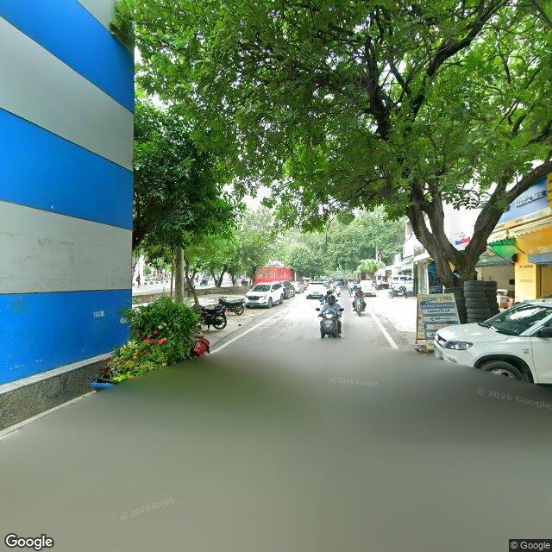 | 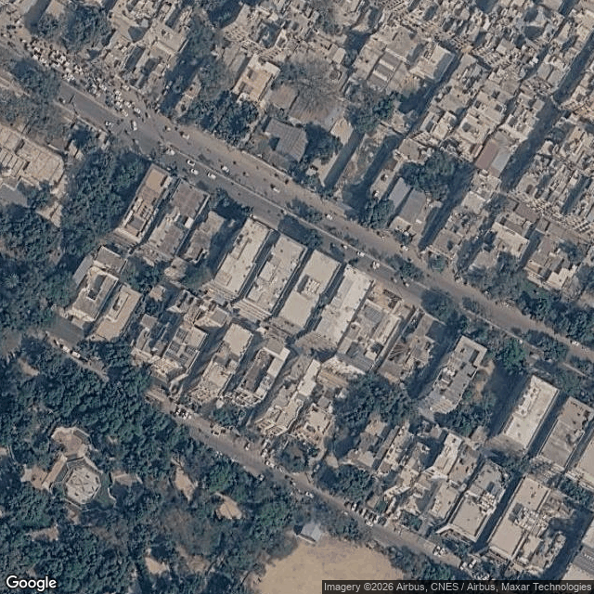

Legal History and Open Cases
Medium
This section shall list pending legal cases and open charges against the entity.

Name & Relation | Legal History | Rating | High
Findings

Sr. | Date | Case No. | Description | Category | Severity | Status
1 | 06.05.24 | IA(I.B.C) | Case No. IA(I.B.C) - 5376/2023 was filed before the National Company Law Tribunal under the category of Insolvency. This matter pertains to Cases Filed Against This Corporate, where Tata Capital Financial Services Limited has initiated proceedings against UNICAST AUTOTECH PRIVATE LIMITED. | Insolvency | High | Pending
2 | 31.10.23 | IA(I.B.C) | Case No. IA(I.B.C) - 2017/2023 was filed before the National Company Law Tribunal under the category of Insolvency. This matter pertains to Cases Filed Against This Corporate, where MINDA INDUSTRIES LIMITED has initiated proceedings against UNICAST AUTOTECH PRIVATE LIMITED. | Insolvency | High | Pending
3 | 16.09.22 | C.P. | Case No. C.P. (IB) - 763/2021 was filed before the National Company Law Tribunal under the category of Insolvency. This matter pertains to Cases Filed Against This Corporate, where MINDA INDUSTRIES LIMITED has initiated proceedings against UNICAST AUTOTECH PRIVATE LIMITED. | Insolvency | High | Pending
4 | 22.06.26 | CS /47566/2021 | Case No. CS /47566/2021 was filed before the Metropolitan Magistrate Court, Calcutta under the category of NI Act / Company Offences. This matter pertains to Cases Filed Against This Corporate, where INCRED FINANCIAL SERVICES LTD has initiated proceedings against UNICAST AUTOTECH PRIVATE LIMITED. | NI Act / Company Offences | Medium | Pending
5 | 16.06.26 | S.C.C. /23282/2021 | Case No. S.C.C. /23282/2021 was filed before the Chief Judicial Magistrate, Pune under the category of NI Act / Company Offences. This matter pertains to Cases Filed Against This Corporate, where Bajaj Finance Ltd - Bhushan Ashok Jiwade has initiated proceedings against UNICAST AUTOTECH PRIVATE LIMITED. | NI Act / Company Offences | Medium | Pending
6 | 16.04.26 | S.C.C. /23291/2021 | Case No. S.C.C. /23291/2021 was filed before the Chief Judicial Magistrate, Pune under the category of NI Act / Company Offences. This matter pertains to Cases Filed Against This Corporate, where Bajaj Finance Limited Through Bhushan Ashok Jiwade has initiated proceedings against UNICAST AUTOTECH PRIVATE LIMITED. | NI Act / Company Offences | Medium | Pending
7 | 16.04.26 | S.C.C. /23302/2021 | Case No. S.C.C. /23302/2021 was filed before the Chief Judicial Magistrate, Pune under the category of NI Act / Company Offences. This matter pertains to Cases Filed Against This Corporate, where Bajaj Finance Limited Thr Bhushan Ashok Jiwade has initiated proceedings against UNICAST AUTOTECH PRIVATE LIMITED. | NI Act / Company Offences | Medium | Pending
8 | 12.04.26 | CS /9370/2021 | Case No. CS /9370/2021 was filed before the Metropolitan Magistrate Court, Calcutta under the category of NI Act / Company Offences. This matter pertains to Cases Filed Against This Corporate, where INCRED FINANCIAL SERVICES LTD has initiated proceedings against UNICAST AUTOTECH PRIVATE LIMITED. | NI Act / Company Offences | Medium | Pending
9 | Unavailable | CARBPL/17614/2021 | Case No. CARBPL/17614/2021 was filed before the High Court of Bombay under the category of Arbitration Matters. This matter pertains to Cases Filed Against This Corporate, where TATA CAPITAL FINANCIAL SERVICES LTD has initiated proceedings against UNICAST AUTOTECH PVT LTD AND 7 ORS. | Arbitration Matters | Medium | Pending
10 | Unavailable | CARBP/84/2022 | Case No. CARBP/84/2022 was filed before the High Court of Bombay under the category of Arbitration Matters. This matter pertains to Cases Filed Against This Corporate, where TATA CAPITAL FINANCIAL SERVICES LTD - has initiated proceedings against UNICAST AUTOTECH PRIVATE LIMITED and Others.. | Arbitration Matters | Medium | Pending

Source: EY Network Alliance Databases

Name & Relation | Open Charges | Rating | High
Findings

1. Creation of Rs.250,000,000 in favour of YES BANK LIMITED dated 01.08.26
2. Creation of Rs.30,000,000 in favour of MAHINDRA AND MAHINDRA FINANCIAL SERVICES LIMITED dated 31.07.17
3. Creation of Rs.8,192,202 in favour of SIEMENS FINANCIAL SERVICES PRIVATE LIMITED dated 14.08.14
4. Creation of Rs.22,396,249 in favour of SIEMENS FINANCIAL SERVICES PRIVATE LIMITED dated 17.06.14
5. Creation of Rs.12,900,000 in favour of SIEMENS FINANCIAL SERVICES PRIVATE LIMITED dated 23.09.13

Source: EY Network Alliance Databases

Financial Indicators
Medium
This section shall list balance sheet, profit and loss, profitability analysis, liquidity analysis, financial ratios, GST registration analysis, MSME registration validation, and related party transactions of the entity.

Name & Relation | Finance - Profit And Loss | Rating | INFO
Findings

Income Statement (₹ in Lakhs)
Particulars | 2024 | 2025
Net Revenue (₹ in Lakhs) | 0 | 168.44
Profit After Tax (₹ in Lakhs) | 1,187.89 | -1,871.54

Source: EY Network Alliance Databases / Annual Reports

Name & Relation | Finance - Balance Sheet | Rating | INFO
Findings

Balance Sheet (₹ in Lakhs)
Particulars | 2024 | 2025
Total Current Assets (₹ in Lakhs) | 420.79 | 469.92
Total Other Non Current Assets (₹ in Lakhs) | 151.76 | 82.83
Net Fixed Assets (₹ in Lakhs) | 3,928.85 | 3,727.85
Total Current Liabilities (₹ in Lakhs) | 11.54 | 920.3
Total Non Current Liabilities (₹ in Lakhs) | 2,834.12 | 3,576.1
Total Equity (₹ in Lakhs) | 1,655.74 | -215.8

Source: EY Network Alliance Databases / Annual Reports

Profitability Analysis
Name & Relation | Finance - Profitability Analysis | Rating | Medium

Revenue, EBITDA and PAT Margin
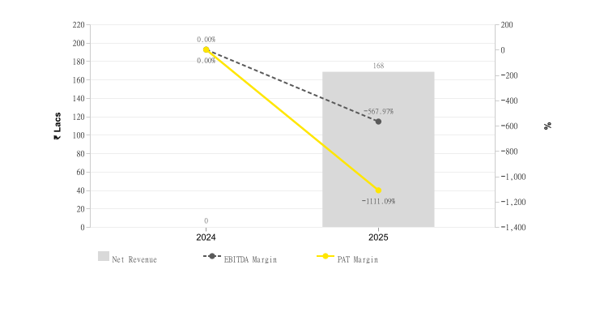
Particulars | 2024 | 2025
Profit Margin Ratio (%) | null | -1,111.09
EBITDA Margin (%) | null | -567.97

Return on Assets (ROA) & Capital Employed (ROCE)
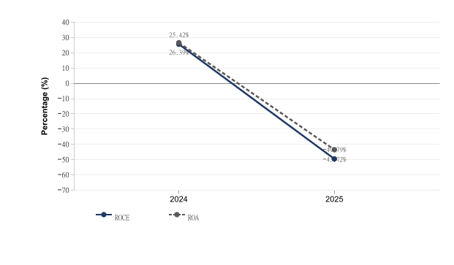
Particulars | 2024 | 2025
ROE (%) | 0.72 | 8.67
ROCE (%) | 25.42 | -49.79
ROA (%) | 26.39 | -43.72

Source: EY Network Alliance Databases / Annual Reports

Liquidity Analysis
Name & Relation | Finance - Liquidity Analysis | Rating | High

Liquidity Ratios
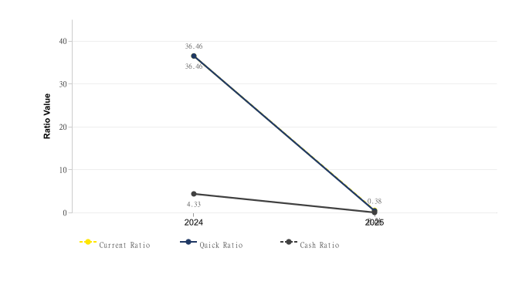
Particulars | 2024 | 2025
Current Ratio | 36.46 | 0.51
Quick Ratio | 36.46 | 0.38
Cash Ratio | 4.33 | 0

Source: EY Network Alliance Databases / Annual Reports

Operating Cycle
Name & Relation | Finance - Operating Cycle | Rating | Medium

Operating Cycle (Debtor, Creditor & Inventory Days)
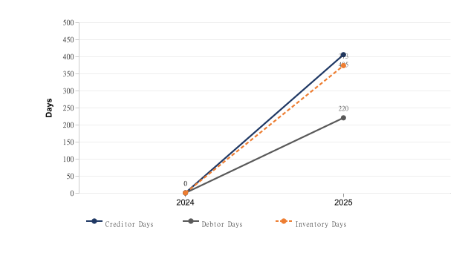
Particulars | 2024 | 2025
Inventory Days | null | 373
Debtor Days | null | 220
Creditor Days | null | 405

Asset Turnover Ratio
[Chart unavailable]
Particulars | 2024 | 2025
Asset Turnover Ratio | 0 | 0.04

Source: EY Network Alliance Databases / Annual Reports

Capital Structure
Name & Relation | Finance - Capital Structure | Rating | High

Debt – Equity Ratio
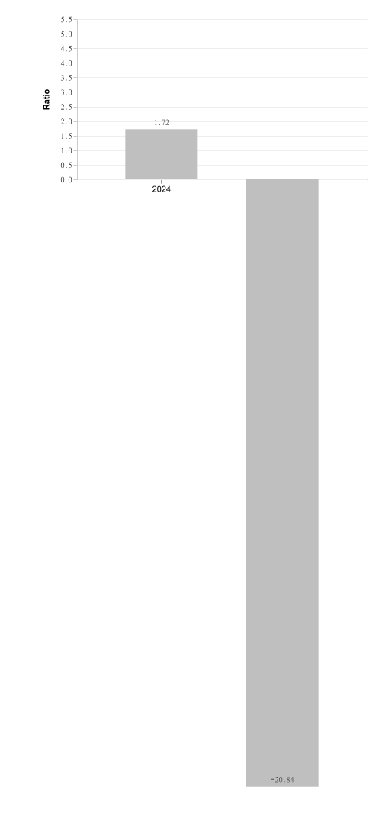
Particulars | 2024 | 2025
Debt Equity Ratio | 1.72 | -20.84

Interest Coverage Ratio
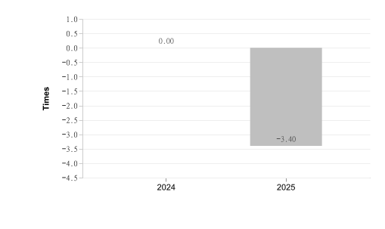
Particulars | 2024 | 2025
Interest Coverage Ratio | null | -3.4

Source: EY Network Alliance Databases / Annual Reports

Name & Relation | Finance - MSME Registration Status | Rating | Medium
Findings

Factor | Value
MSME Status (Verified) | Unknown
MSME Status (Client Database) | Not Provided
Reason | MSME status unavailable or could not be confidently matched

Source: EY Network Alliance Databases

Name & Relation | Finance - GST Registration Analysis | Rating | Medium
Findings

Date Of Registration | State Of Registration | Gst In | Filing Timeliness
10.11.22 | Karnataka | 29AABCU4886A2Z6 | Filed After Due Date in last 12 Months,

Source: EY Network Alliance Databases

Name & Relation | Finance - Auditor Comments | Rating | Low
Findings

Parameter | Value
Adverse Filing | False

Source: EY Network Alliance Databases

Name & Relation | Finance - EPFO Registration | Rating | INFO
Findings

Parameter | Value
Establishment Name | UNICAST AUTOTECH PVT LTD
Establishment Id | PYKRP0053353000
Date Of Setup | 01-Dec-13
City | NARASAPURA
Address | PLOT NO 223-226 NARASPURA INDL AREA ,NARASAPURA,KARNATAKA,563133,India
No of Employees | 59
Last 12 Months
  May-26 | Apr-26 | Mar-26 | Feb-26 | Jan-26 | Dec-25
  On time (INR 1.9 L ; 59 Employees) | On time (INR 15.2 K ; 5 Employees) | Delay (INR 1.6 L ; 48 Employees) | On time (INR 1.4 L ; 41 Employees) | On time (INR 1.5 L ; 40 Employees) | On time (INR 1.4 L ; 39 Employees)
  Nov-25 | Oct-25 | Sep-25 | Aug-25 | Jul-25 | Jun-25
  On time (INR 1.3 L ; 37 Employees) | On time (INR 1.2 L ; 35 Employees) | On time (INR 1.1 L ; 33 Employees) | On time (INR 1.1 L ; 31 Employees) | Delay (INR 1.1 L ; 32 Employees) | On time (INR 1.1 L ; 31 Employees)

Source: EY Network Alliance Databases

Name & Relation | Finance - Related Party Transaction | Rating | INFO
Findings

Name | Relationship | Type Of Transaction | Amount (₹ In Lakhs)
SAHUWALA CYLINDERS PRIVATE LIMITED | Holding Company | Expense | 482.36
ARETE 22 LIMITED | Companies KMP or Their Relatives have Significant Influence | Expense | 14.46

Source: EY Network Alliance Databases

Name & Relation | Finance - Credit Risk Analysis | Rating | INFO
Findings

Rating Date | Rating Agency | Rating | Type Of Loan | Amount (₹ In Lakhs)
20.08.26 | brickwork | Withdrawn (D/Issuer Not Cooperating) | Long Term Fund Based Facility | 8,198
20.08.26 | brickwork | Withdrawn (D/Issuer Not Cooperating) | Short Term Non Fund Based Facility | 500
13.08.25 | brickwork | D (Issuer Not Cooperating/Reaffimed) | Long Term Fund Based Facility | 8,198
13.08.25 | brickwork | D (Issuer Not Cooperating/Reaffimed) | Short Term Non Fund Based Facility | 500
29.07.24 | brickwork | D (Issuer Not Cooperating/Reaffirmed) | Long Term Fund Based Facility | 8,198
29.07.24 | brickwork | D (Issuer Not Cooperating/Reaffirmed) | Short Term Non Fund Based Facility | 500
10.07.23 | brickwork | D (Issuer Not Cooperating/Reaffirmed) | Long Term Fund Based Facility | 8,198
10.07.23 | brickwork | D (Issuer Not Cooperating/Reaffirmed) | Short Term Non Fund Based Facility | 500
13.07.22 | brickwork | D (Issuer Not Cooperating/Reaffirmed) | Long Term Fund Based Facility | 8,198
13.07.22 | brickwork | D (Issuer Not Cooperating/Reaffirmed) | Short Term Non Fund Based Facility | 500

Source: EY Network Alliance Databases

Name & Relation | Finance - Z Altman Score Analysis | Rating | High
Findings

Parameter | Calculation
Altman Z Score (manufacturing) | -1.55

Source: EY Network Alliance Databases

Adverse Media
Low
This section shall list adverse media coverage and Google ratings for the entity.

ADVERSE MEDIA – NO TRUE HITS IDENTIFIED

Cyber
Low
This section shall list cyber security ratings for the entity.

CYBER – NO TRUE HITS IDENTIFIED

Annexures

Full List of Shareholders
Significant Shareholders
1. SAHUWALA CYLINDERS PRIVATE LIMITED 99.99%

Key Management Personnel
Key Management
1. VIVEK KUMAR JAIN - Director
2. RAJIV KUMAR JAIN - Director
3. ABHISHEK GUPTA - Director
4. GUPTA ADITYA - Director
5. PRADEEP KUMAR JAIN - Director
6. ARVIND KUMAR JAIN - Director
7. SANJAY KUMAR JAIN - Director
8. DEEPALI AGARWAL - Director
9. PANKAJ AGARWAL - Director
10. ANAND KUMAR SHARMA - Director
11. VIPUL VAIBHAV - Director
12. ATUL VAIBHAV - Director
13. GEETANJALI SHARMA - Company Secretary
14. ANANDA BABU CHEPURI - Director
15. RUCHIKA DHIMAN - Company Secretary
16. NAMRATA NAIR - Company Secretary
17. SIDDHI JAIN - Company Secretary

Full List of Legal History

Sr. | Date | Case No. | Description | Category | Severity | Status
1 | 29.05.24 | 2815(ND)2024 | Case No. 2815(ND)2024 was filed before the National Company Law Tribunal under the category of Insolvency. This matter pertains to Cases Filed Against This Corporate, where TATA CAPITAL LIMITED has initiated proceedings against UNICAST AUTOTECH PRIVATE LIMITED. | Insolvency | High | Disposed
2 | 29.05.24 | 2815(ND)2024 | Case No. 2815(ND)2024 was filed before the National Company Law Tribunal under the category of Insolvency. This matter pertains to Cases Filed Against This Corporate, where TATA CAPITAL LIMITED has initiated proceedings against UNICAST AUTOTECH PRIVATE LIMITED. | Insolvency | High | Disposed
3 | 06.05.24 | IA(I.B.C) - 5376/2023 | Case No. IA(I.B.C) - 5376/2023 was filed before the National Company Law Tribunal under the category of Insolvency. This matter pertains to Cases Filed Against This Corporate, where Tata Capital Financial Services Limited has initiated proceedings against UNICAST AUTOTECH PRIVATE LIMITED. | Insolvency | High | Pending
4 | 31.10.23 | IA(I.B.C) - 2017/2023 | Case No. IA(I.B.C) - 2017/2023 was filed before the National Company Law Tribunal under the category of Insolvency. This matter pertains to Cases Filed Against This Corporate, where MINDA INDUSTRIES LIMITED has initiated proceedings against UNICAST AUTOTECH PRIVATE LIMITED. | Insolvency | High | Pending
5 | 14.09.23 | IA(I.B.C) - 2032/2023 | Case No. IA(I.B.C) - 2032/2023 was filed before the National Company Law Tribunal under the category of Insolvency. This matter pertains to Cases Filed Against This Corporate, where MINDA INDUSTRIES LIMITED has initiated proceedings against UNICAST AUTOTECH PRIVATE LIMITED. | Insolvency | High | Disposed
6 | 14.09.23 | IA(I.B.C) - 657/2023 | Case No. IA(I.B.C) - 657/2023 was filed before the National Company Law Tribunal under the category of Insolvency. This matter pertains to Cases Filed Against This Corporate, where BERGER PAINTS INDIA LIMITED has initiated proceedings against UNICAST AUTOTECH PRIVATE LIMITED. | Insolvency | High | Disposed
7 | 14.09.23 | IA(I.B.C) - 807/2023 | Case No. IA(I.B.C) - 807/2023 was filed before the National Company Law Tribunal under the category of Insolvency. This matter pertains to Cases Filed Against This Corporate, where M/S AAR CEE Auto Components Pvt. Ltd. has initiated proceedings against UNICAST AUTOTECH PRIVATE LIMITED. | Insolvency | High | Disposed
8 | 14.09.23 | 807(ND)2023 | Case No. 807(ND)2023 was filed before the National Company Law Tribunal under the category of Insolvency. This matter pertains to Cases Filed Against This Corporate, where M/S AAR CEE AUTO COMPONENTS PVT. LTD. has initiated proceedings against UNICAST AUTOTECH PRIVATE LIMITED. | Insolvency | High | Disposed
9 | 14.09.23 | 2032(ND)2023 | Case No. 2032(ND)2023 was filed before the National Company Law Tribunal under the category of Insolvency. This matter pertains to Cases Filed Against This Corporate, where MINDA INDUSTRIES LIMITED has initiated proceedings against UNICAST AUTOTECH PRIVATE LIMITED. | Insolvency | High | Disposed
10 | 14.09.23 | 657(ND)2023 | Case No. 657(ND)2023 was filed before the National Company Law Tribunal under the category of Insolvency. This matter pertains to Cases Filed Against This Corporate, where BERGER PAINTS INDIA LIMITED has initiated proceedings against UNICAST AUTOTECH PRIVATE LIMITED. | Insolvency | High | Disposed
11 | 25.08.23 | IA(I.B.C) - 2684/2023 | Case No. IA(I.B.C) - 2684/2023 was filed before the National Company Law Tribunal under the category of Insolvency. This matter pertains to Cases Filed Against This Corporate, where Mr.Himanshu Jain has initiated proceedings against UNICAST AUTOTECH PRIVATE LIMITED. | Insolvency | High | Disposed
12 | 25.08.23 | 2684(ND)2023 | Case No. 2684(ND)2023 was filed before the National Company Law Tribunal under the category of Insolvency. This matter pertains to Cases Filed Against This Corporate, where MR.HIMANSHU JAIN has initiated proceedings against UNICAST AUTOTECH PRIVATE LIMITED. | Insolvency | High | Disposed
13 | 24.04.23 | IA(I.B.C) - 383/2023 | Case No. IA(I.B.C) - 383/2023 was filed before the National Company Law Tribunal under the category of Insolvency. This matter pertains to Cases Filed Against This Corporate, where MINDA INDUSTRIES LIMITED has initiated proceedings against UNICAST AUTOTECH PRIVATE LIMITED. | Insolvency | High | Disposed
14 | 24.04.23 | 383(ND)2023 | Case No. 383(ND)2023 was filed before the National Company Law Tribunal under the category of Insolvency. This matter pertains to Cases Filed Against This Corporate, where MINDA INDUSTRIES LIMITED has initiated proceedings against UNICAST AUTOTECH PRIVATE LIMITED. | Insolvency | High | Disposed
15 | 13.12.22 | IA(I.B.C) - 5994/2022 | Case No. IA(I.B.C) - 5994/2022 was filed before the National Company Law Tribunal under the category of Insolvency. This matter pertains to Cases Filed Against This Corporate, where KANTI MOHAN RUSTAGI has initiated proceedings against UNICAST AUTOTECH PRIVATE LIMITED. | Insolvency | High | Disposed
16 | 13.12.22 | 5994(ND)2022 | Case No. 5994(ND)2022 was filed before the National Company Law Tribunal under the category of Insolvency. This matter pertains to Cases Filed Against This Corporate, where KANTI MOHAN RUSTAGI has initiated proceedings against UNICAST AUTOTECH PRIVATE LIMITED. | Insolvency | High | Disposed
17 | 13.12.22 | 5993(ND)2022 | Case No. 5993(ND)2022 was filed before the National Company Law Tribunal under the category of Insolvency. This matter pertains to Cases Filed Against This Corporate, where KANTI MOHAN RUSTAGI has initiated proceedings against UNICAST AUTOTECH PRIVATE LIMITED. | Insolvency | High | Disposed
18 | 16.09.22 | C.P. (IB) - 763/2021 | Case No. C.P. (IB) - 763/2021 was filed before the National Company Law Tribunal under the category of Insolvency. This matter pertains to Cases Filed Against This Corporate, where MINDA INDUSTRIES LIMITED has initiated proceedings against UNICAST AUTOTECH PRIVATE LIMITED. | Insolvency | High | Pending
19 | 16.09.22 | IA(I.B.C) - 4344/2022 | Case No. IA(I.B.C) - 4344/2022 was filed before the National Company Law Tribunal under the category of Insolvency. This matter pertains to Cases Filed Against This Corporate, where Kanti Mohan Rustagi has initiated proceedings against UNICAST AUTOTECH PRIVATE LIMITED. | Insolvency | High | Disposed
20 | 16.09.22 | 4344(ND)2022 | Case No. 4344(ND)2022 was filed before the National Company Law Tribunal under the category of Insolvency. This matter pertains to Cases Filed Against This Corporate, where KANTI MOHAN RUSTAGI has initiated proceedings against UNICAST AUTOTECH PRIVATE LIMITED. | Insolvency | High | Disposed
21 | 29.08.22 | IA(I.B.C) - 4041/2022 | Case No. IA(I.B.C) - 4041/2022 was filed before the National Company Law Tribunal under the category of Insolvency. This matter pertains to Cases Filed Against This Corporate, where MINDA INDUSTRIES LIMITED has initiated proceedings against UNICAST AUTOTECH PRIVATE LIMITED. | Insolvency | High | Disposed
22 | 29.08.22 | IA(I.B.C) - 4090/2022 | Case No. IA(I.B.C) - 4090/2022 was filed before the National Company Law Tribunal under the category of Insolvency. This matter pertains to Cases Filed Against This Corporate, where MINDA INDUSTRIES LIMITED has initiated proceedings against UNICAST AUTOTECH PRIVATE LIMITED. | Insolvency | High | Disposed
23 | 29.08.22 | IA(I.B.C) - 4039/2022 | Case No. IA(I.B.C) - 4039/2022 was filed before the National Company Law Tribunal under the category of Insolvency. This matter pertains to Cases Filed Against This Corporate, where MINDA INDUSTRIES LIMITED has initiated proceedings against UNICAST AUTOTECH PRIVATE LIMITED. | Insolvency | High | Disposed
24 | 29.08.22 | 4041(ND)2022 | Case No. 4041(ND)2022 was filed before the National Company Law Tribunal under the category of Insolvency. This matter pertains to Cases Filed Against This Corporate, where MINDA INDUSTRIES LIMITED has initiated proceedings against UNICAST AUTOTECH PRIVATE LIMITED. | Insolvency | High | Disposed
25 | 29.08.22 | 4090(ND)2022 | Case No. 4090(ND)2022 was filed before the National Company Law Tribunal under the category of Insolvency. This matter pertains to Cases Filed Against This Corporate, where MINDA INDUSTRIES LIMITED has initiated proceedings against UNICAST AUTOTECH PRIVATE LIMITED. | Insolvency | High | Disposed
26 | 29.08.22 | 4039(ND)2022 | Case No. 4039(ND)2022 was filed before the National Company Law Tribunal under the category of Insolvency. This matter pertains to Cases Filed Against This Corporate, where MINDA INDUSTRIES LIMITED has initiated proceedings against UNICAST AUTOTECH PRIVATE LIMITED. | Insolvency | High | Disposed
27 | Unavailable | Case Not Registered | Case No. Case Not Registered was filed before the Debts Recovery Tribunal under the category of Loan Recovery. This matter pertains to Cases Filed Against This Corporate, where ICICI BANK LIMITED has initiated proceedings against UNICAST AUTOTECH PRIVATE LIMITED and Others.. | Loan Recovery | High | Disposed
28 | 22.06.26 | CS /47566/2021 | Case No. CS /47566/2021 was filed before the Metropolitan Magistrate Court, Calcutta under the category of NI Act / Company Offences. This matter pertains to Cases Filed Against This Corporate, where INCRED FINANCIAL SERVICES LTD has initiated proceedings against UNICAST AUTOTECH PRIVATE LIMITED. | NI Act / Company Offences | Medium | Pending
29 | 16.06.26 | S.C.C. /23282/2021 | Case No. S.C.C. /23282/2021 was filed before the Chief Judicial Magistrate, Pune under the category of NI Act / Company Offences. This matter pertains to Cases Filed Against This Corporate, where Bajaj Finance Ltd - Bhushan Ashok Jiwade has initiated proceedings against UNICAST AUTOTECH PRIVATE LIMITED. | NI Act / Company Offences | Medium | Pending
30 | 16.04.26 | S.C.C. /23291/2021 | Case No. S.C.C. /23291/2021 was filed before the Chief Judicial Magistrate, Pune under the category of NI Act / Company Offences. This matter pertains to Cases Filed Against This Corporate, where Bajaj Finance Limited Through Bhushan Ashok Jiwade has initiated proceedings against UNICAST AUTOTECH PRIVATE LIMITED. | NI Act / Company Offences | Medium | Pending
31 | 16.04.26 | S.C.C. /23302/2021 | Case No. S.C.C. /23302/2021 was filed before the Chief Judicial Magistrate, Pune under the category of NI Act / Company Offences. This matter pertains to Cases Filed Against This Corporate, where Bajaj Finance Limited Thr Bhushan Ashok Jiwade has initiated proceedings against UNICAST AUTOTECH PRIVATE LIMITED. | NI Act / Company Offences | Medium | Pending
32 | 12.04.26 | CS /9370/2021 | Case No. CS /9370/2021 was filed before the Metropolitan Magistrate Court, Calcutta under the category of NI Act / Company Offences. This matter pertains to Cases Filed Against This Corporate, where INCRED FINANCIAL SERVICES LTD has initiated proceedings against UNICAST AUTOTECH PRIVATE LIMITED. | NI Act / Company Offences | Medium | Pending
33 | 29.03.23 | OS/546/2022 | Case No. OS/546/2022 was filed before the Principal District Court, Chengalpet, Kancheepuram under the category of Civil Cases. This matter pertains to Cases Filed Against This Corporate, where M/s CMR Toyotsu Aluminium India Pvt., Ltd., has initiated proceedings against UNICAST AUTOTECH PRIVATE LIMITED. | Civil Cases | Medium | Disposed
34 | 11.01.22 | OMP (I) (COMM.)/2383/2021 | Case No. OMP (I) (COMM.)/2383/2021 was filed before the District and Sessions Judge, South , Saket under the category of Arbitration Matters. This matter pertains to Cases Filed Against This Corporate, where TOYOTA FINANCIAL SERVICES INDIA LTD. has initiated proceedings against UNICAST AUTOTECH PRIVATE LIMITED. | Arbitration Matters | Medium | Disposed
35 | 11.01.22 | OMP (I) (COMM.)/2384/2021 | Case No. OMP (I) (COMM.)/2384/2021 was filed before the District and Sessions Judge, South , Saket under the category of Arbitration Matters. This matter pertains to Cases Filed Against This Corporate, where TOYOTA FINANCIAL SERVICES INDIA LTD. has initiated proceedings against UNICAST AUTOTECH PRIVATE LIMITED. | Arbitration Matters | Medium | Disposed
36 | 09.08.21 | OMP (I) (COMM.)/144/2021 | Case No. OMP (I) (COMM.)/144/2021 was filed before the District and Sessions Judge,New Delhi, PHC under the category of Arbitration Matters. This matter pertains to Cases Filed Against This Corporate, where INCRED FINANCIAL SERVICES LTD has initiated proceedings against UNICAST AUTOTECH PRIVATE LIMITED. | Arbitration Matters | Medium | Disposed
37 | 20.04.21 | O.M.P.(I) (COMM.) 141/2021 | Case No. O.M.P.(I) (COMM.) 141/2021 was filed before the High Court of Delhi under the category of Arbitration Matters. This matter pertains to Cases Filed Against This Corporate, where SANDHAR TECHNOLOGIES LIMITED has initiated proceedings against UNICAST AUTOTECH PRIVATE LIMITED & ORS.. | Arbitration Matters | Medium | Disposed
38 | 10.03.15 | O.S./8078/2014 | Case No. O.S./8078/2014 was filed before the CCH1 PRL. CITY CIVIL and SESSIONS JUDGE under the category of Civil Cases. This matter pertains to Cases Filed Against This Corporate, where M/S BLUE TECH E OFFICE SOLUTIONS, M S BLUE TECH E OFFICE SOLUTIONS has initiated proceedings against UNICAST AUTOTECH PRIVATE LIMITED. | Civil Cases | Medium | Disposed
39 | Unavailable | CARBPL/17614/2021 | Case No. CARBPL/17614/2021 was filed before the High Court of Bombay under the category of Arbitration Matters. This matter pertains to Cases Filed Against This Corporate, where TATA CAPITAL FINANCIAL SERVICES LTD has initiated proceedings against UNICAST AUTOTECH PVT LTD AND 7 ORS. | Arbitration Matters | Medium | Pending
40 | Unavailable | CARBP/84/2022 | Case No. CARBP/84/2022 was filed before the High Court of Bombay under the category of Arbitration Matters. This matter pertains to Cases Filed Against This Corporate, where TATA CAPITAL FINANCIAL SERVICES LTD - has initiated proceedings against UNICAST AUTOTECH PRIVATE LIMITED and Others.. | Arbitration Matters | Medium | Pending
41 | 09.04.26 | TA/2859/2022 | Case No. TA/2859/2022 was filed before the Debts Recovery Tribunal under the category of Applications. This matter pertains to Cases Filed Against This Corporate, where ICICI BANK LIMITED has initiated proceedings against UNICAST AUTOTECH PRIVATE LIMITED and Others.. | Applications | Low | Pending
42 | 04.06.24 | CS (COMM) /2164/2022 | Case No. CS (COMM) /2164/2022 was filed before the District and Sessions Judge, Central, THC under the category of Others. This matter pertains to Cases Filed Against This Corporate, where AEROAIDS CORPORATION THROUGH ITS PARTNER has initiated proceedings against UNICAST AUTOTECH PRIVATE LIMITED. | Others | Low | Disposed
43 | 21.08.23 | TRAFFIC CHALLAN/21938/2022 | Case No. TRAFFIC CHALLAN/21938/2022 was filed before the Chief Metropolitan Magistrate, New Delhi, PHC under the category of Others. This matter pertains to Cases Filed Against This Corporate, where STATE has initiated proceedings against UNICAST AUTOTECH PRIVATE LIMITED. | Others | Low | Disposed
44 | 07.09.22 | OMP (I) (COMM.) /143/2021 | Case No. OMP (I) (COMM.) /143/2021 was filed before the District and Sessions Judge,New Delhi, PHC under the category of Others. This matter pertains to Cases Filed Against This Corporate, where INCRED FINANCIAL SERVICES LTD has initiated proceedings against UNICAST AUTOTECH PRIVATE LIMITED. | Others | Low | Disposed
45 | 28.04.22 | S.C.S. /64/2021 | Case No. S.C.S. /64/2021 was filed before the District and Sessions Court, DNH, Silvassa under the category of Others. This matter pertains to Cases Filed Against This Corporate, where Lubrikote Specialties Private Limited has initiated proceedings against UNICAST AUTOTECH PRIVATE LIMITED. | Others | Low | Disposed
46 | 16.01.20 | WP/738/2020 | Case No. WP/738/2020 was filed before the High Court of Karnataka under the category of Writs and Regulatory Matters. This matter pertains to Cases Filed Against This Corporate, where RASHMI G K has initiated proceedings against UNICAST AUTOTECH PVT LTD. | Writs and Regulatory Matters | Low | Pending
47 | 30.07.19 | IDact of S10/44/2017 | Case No. IDact of S10/44/2017 was filed before the PRL. DISTRICT AND SESSIONS JUDGE, KOLAR under the category of Writs and Regulatory Matters. This matter pertains to Cases Filed Against This Corporate, where Rashmi G K has initiated proceedings against UNICAST AUTOTECH PRIVATE LIMITED. | Writs and Regulatory Matters | Low | Disposed

Source: EY Network Alliance Databases

Full List of Director Network

Sr. | Director Name | DIN | Network
1 | SANJAY KUMAR JAIN | 00234791 | • MURTI UDYOG LIMITED — Director (2009-05-01 – 2012-02-09)  • KIRAN UDYOG PRIVATE LIMITED — Whole-time director (2000-01-10 – 2020-03-09) [UNDER CIRP]  • K U DIE CASTINGS PRIVATE LIMITED — Director (1990-12-26 – 2020-03-09)  • UNICAST AUTOTECH PRIVATE LIMITED — Director (2012-08-23 – 2020-03-09)
2 | RAJIV KUMAR JAIN | 00234872 | • K U DIE CASTINGS PRIVATE LIMITED — Director (1990-12-26 – Present)  • UNICAST AUTOTECH PRIVATE LIMITED — Director (2015-12-29 – 2025-03-06)  • KIRAN UDYOG PRIVATE LIMITED — Whole-time director (2007-04-01 – Present) [UNDER CIRP]
3 | ARVIND KUMAR JAIN | 00234939 | • K U DIE CASTINGS PRIVATE LIMITED — Director (1990-12-26 – 2021-06-21)  • UNICAST AUTOTECH PRIVATE LIMITED — Director (2012-08-23 – 2025-03-06)  • KIRAN UDYOG PRIVATE LIMITED — Managing Director (2000-01-10 – Present) [UNDER CIRP]
4 | VIVEK KUMAR JAIN | 00234981 | • K U DIE CASTINGS PRIVATE LIMITED — Director (1990-12-26 – Present)  • UNICAST AUTOTECH PRIVATE LIMITED — Director (2015-12-29 – 2025-03-06)  • SAVI CAKES N RIBBONS PRIVATE LIMITED — Director (2019-11-21 – Present) [STRIKE OFF]  • KIRAN UDYOG PRIVATE LIMITED — Whole-time director (2007-04-01 – Present) [UNDER CIRP]
5 | PRADEEP KUMAR JAIN | 00303976 | • STARTRITE FINANCIAL SERVICES PRIVATE LIMITED — Director (2001-03-12 – Present)  • A R J METAL PRIVATE LIMITED — Director (2013-11-11 – 2015-12-30)  • EVERGROWING INVESTMENTS AND CONSULTANTS PRIVATE LIMITED — Director (2004-09-15 – 2013-11-11)  • LEAD FINANCIAL SERVICES LIMITED — Director (2007-03-10 – 2024-09-25)  • KARNI MATA AUTO PRIVATE LIMITED — Director (2013-11-11 – 2015-12-21)  • UNICAST AUTOTECH PRIVATE LIMITED — Director (2013-11-15 – 2014-05-21)  • SLS STOCK AND SHARE BROKERS PRIVATE LIMITED — Director (2004-12-10 – 2008-08-12)
6 | ABHISHEK GUPTA | 00671043 | • SAHUWALA HIGH PRESSURE CYLINDERS PRIVATE LIMITED — Director (2006-12-01 – 2009-06-22) [AMALGAMATED]  • SAHUWALA CYLINDERS PRIVATE LIMITED — Director (2016-12-31 – Present)  • ANG AGRO FOODS PRIVATE LIMITED — Director (2010-08-09 – 2023-08-01)  • ANJANEYA ROLLER FLOUR MILLS PRIVATE LIMITED — Director (2018-08-23 – Present)  • GODAVARI ROLLER FLOUR MILLS PRIVATE LIMITED — Director (2019-09-03 – Present)  • UNICAST AUTOTECH PRIVATE LIMITED — Director (2024-04-11 – Present)  • ECON TOMASETTO INDIA PRIVATE LIMITED — Director (2012-12-17 – Present) [STRIKE OFF]  • DOLPHIN FINANCE AND INVESTMENT COMPANY LIMITED — Additional Director (2009-08-31 – 2021-10-21)  • COROMANDEL ROLLER FLOUR MILLS PVT LTD — Director (2009-06-22 – 2023-08-01)  • TIRUMALA BALAJI SLEEPERS PRIVATE LIMITED — Additional Director (2021-10-07 – 2021-12-17)  • SAHUWALA CYLINDERS UNIT-3 PRIVATE LIMITED — Director (2022-07-26 – 2023-08-09)  • SAHUWALA CYLINDERS UNIT-2 PRIVATE LIMITED — Director (2022-08-01 – 2023-08-09)  • RAJAMAHENDRI FOOD PRODUCTS PRIVATE LIMITED — Director (2022-09-28 – Present)  • ALL INDIA HIGH PRESSURE CYLINDER MANUFACTURERS' ASOCIATION — Director (2023-01-10 – Present)  • ARETE 22 LIMITED — Managing Director (2021-02-09 – Present)  • GLOBAL GOURMET (I) FOODS LLP (LLP) — Designated Partner (None – Present) [STRIKE OFF]
7 | GUPTA ADITYA | 00671864 | • SAHUWALA CYLINDERS PRIVATE LIMITED — Director (2004-07-16 – 2023-03-15)  • NITHYA ESTATES AND DEVELOPERS INDIA PRIVATE LIMITED — Managing Director (2007-10-31 – Present)  • MINOLTA SECURITIES LTD. — Director (2020-02-03 – 2025-11-25)  • ANJANEYA ROLLER FLOUR MILLS PRIVATE LIMITED — Director (2003-02-01 – 2016-11-14)  • GODAVARI ROLLER FLOUR MILLS PRIVATE LIMITED — Director (2002-07-08 – 2019-07-20)  • UNICAST AUTOTECH PRIVATE LIMITED — Director (2024-08-20 – 2026-03-03)  • BERYLL DESIGN ONE LLP (LLP) — Designated Partner (None – Present)
8 | DEEPALI AGARWAL | 03156261 | • A R J METAL PRIVATE LIMITED — Director (2010-08-20 – 2013-10-01)  • KARNI MATA AUTO PRIVATE LIMITED — Director (2012-06-04 – 2013-08-06)  • UNICAST AUTOTECH PRIVATE LIMITED — Director (2012-08-23 – 2013-11-15)
9 | PANKAJ AGARWAL | 03381413 | • A R J METAL PRIVATE LIMITED — Director (2011-02-08 – 2013-11-11)  • KARNI MATA AUTO PRIVATE LIMITED — Director (2012-06-04 – 2013-11-11)  • UNICAST AUTOTECH PRIVATE LIMITED — Director (2012-08-23 – 2013-11-15)
10 | ANAND KUMAR SHARMA | 06738295 | • A R J METAL PRIVATE LIMITED — Director (2013-11-11 – 2015-12-30)  • KARNI MATA AUTO PRIVATE LIMITED — Director (2013-11-11 – 2015-12-21)  • UNICAST AUTOTECH PRIVATE LIMITED — Director (2013-11-15 – 2014-05-21)
11 | ATUL VAIBHAV | 06932645 | • UNICAST AUTOTECH PRIVATE LIMITED — Director (2015-04-17 – 2015-12-29)  • SHREE BALAJI TECHMAC PRIVATE LIMITED — Director (2014-08-01 – 2015-12-21) [CONVERTED TO LLP]  • OKINAWA SKILL NEXT INDIA PRIVATE LIMITED — Director (2016-01-08 – 2020-03-14)
12 | VIPUL VAIBHAV | 06938597 | • UNICAST AUTOTECH PRIVATE LIMITED — Director (2015-04-17 – 2015-12-29)  • SHREE BALAJI TECHMAC PRIVATE LIMITED — Director (2014-08-01 – 2015-12-21) [CONVERTED TO LLP]
13 | ANANDA BABU CHEPURI | 10270908 | • SAHUWALA CYLINDERS PRIVATE LIMITED — Director (2023-08-09 – Present)  • UNICAST AUTOTECH PRIVATE LIMITED — Director (2024-09-09 – Present)

Source: EY Network Alliance Databases

Disclaimer:
The information included in this report has been primarily collected from databases or public sources, thus it is difficult to verify all aspects of the information obtained. EY makes no representation or warranties with respect to the contents or use of this report, and specifically disclaims any express or implied warranties or usefulness for any particular purpose of this report. EY takes no responsibility for the consequences resulting from decisions based on information included in this report. EY reserves the right to change or revise this report at any time.

Copyright:
All rights reserved. No part of this screening report may be reproduced, photocopied, stored on a retrieval system, or transmitted without the express prior consent of EY.

