
Initial Screening Report
Supplier ID: N/A
TERRA REX PRIVATE LIMITED
[TERRA REX PRIVATE LIMITED]

9th September 2026

Contents

1. Company Profile 3
2. Executive Rating Summary 3
3. Detailed Findings 3
A. Entity Existence 3
B. Legal History and Open Cases 3
C. Financial Indicators 3
D. Adverse Media 3
4. Annexures 4
5. Data Sources 4

Company Profile

Uploaded Name | TERRA REX PRIVATE LIMITED | Supplier ID | N/A
Name | TERRA REX PRIVATE LIMITED | Location | Faridabad, Haryana
Address | Flat No. 702, Tower-B Tulip Heights, Sector-11E, Faridabad, Faridabad, Haryana - 121006 | Website | N/A
E-Filing Status | Active | Classification | Private Limited Indian Non-Government Company
Incorporation Date | 11/01/2022 | National Identifier | U68100HR2022PTC100453
Corporate Group | Shareholders: 2  Subsidiaries: 0 | Alias
Revenue | 0 | Employee | N/A

Executive Rating Summary

Executive Summary

TERRA REX PRIVATE LIMITED, a private limited Indian non-government company based in Faridabad, Haryana, presents an overall Low risk rating. The most material risk area is Financial, rated Medium, with 11 financial findings flagged that warrant focused review. Legal, Cyber, and Entity Existence risks are each rated Low, with only one entity existence finding noted. Adverse Media risk is also Low, with just a single flagged item indicating minimal negative coverage. Overall, the risk posture is favorable, with financial controls and disclosures representing the primary area for enhanced diligence while other domains show low-risk profiles.

OVERALL RISK RATING | Low

The below ratings are assigned:
Risk Areas | Risk Rating
Entity Existence | Low
Legal | Low
Financial | Medium
Adverse Media | Low
Cyber | Low

Detailed Findings

Entity Existence
Low
This section shall list B2B existence, domain validation, and address validation for the entity.

Name & Relation | Google Address Validation | Rating | Low
Findings

Factor | Value
Address | Flat No. 702, Tower-B Tulip Heights, Sector-11E, Faridabad, Faridabad, Haryana - 121006
Zone | Commercial
Reason | Rule-based pre-score: commercial places account for 99% of weighted evidence. Incidental amenities (shops, clinics, ATMs) in an otherwise commercial area were discounted per Indian urban norms.

Source: EY Network Alliance Databases

Address Validation
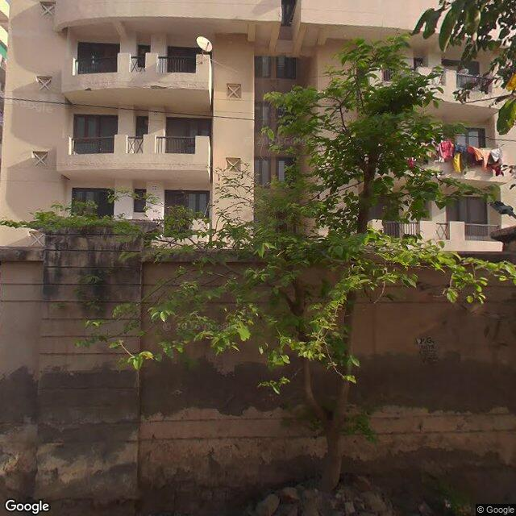 | 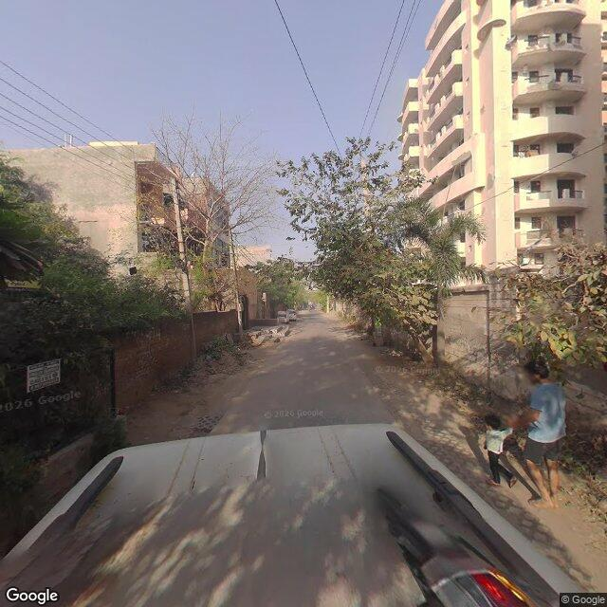 | 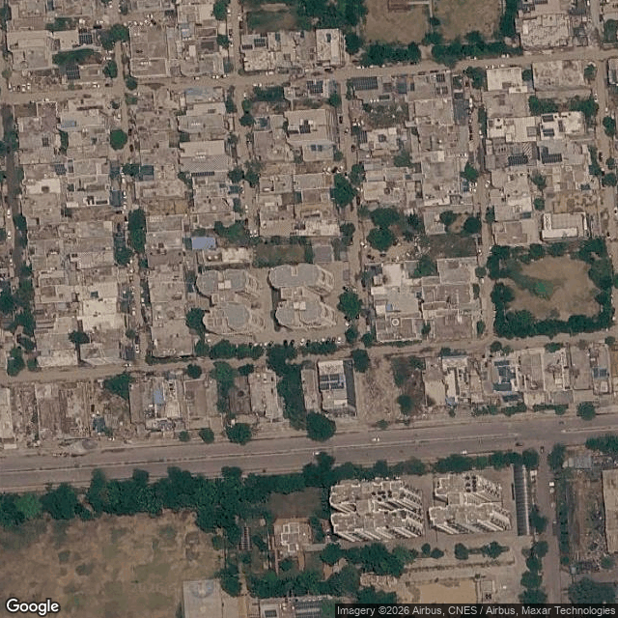

Legal History and Open Cases
Low
This section shall list pending legal cases and open charges against the entity.

LEGAL – NO TRUE HITS IDENTIFIED

Financial Indicators
Medium
This section shall list balance sheet, profit and loss, profitability analysis, liquidity analysis, financial ratios, GST registration analysis, MSME registration validation, and related party transactions of the entity.

Name & Relation | Finance - Profit And Loss | Rating | INFO
Findings

Income Statement (₹ in Lakhs)
Particulars | 2023 | 2024
Net Revenue (₹ in Lakhs) | 0 | 0
Profit After Tax (₹ in Lakhs) | -0.31 | -0.17

Source: EY Network Alliance Databases / Annual Reports

Name & Relation | Finance - Balance Sheet | Rating | INFO
Findings

Balance Sheet (₹ in Lakhs)
Particulars | 2023 | 2024
Total Current Assets (₹ in Lakhs) | 5.8 | 51
Total Other Non Current Assets (₹ in Lakhs) | 0 | 0
Net Fixed Assets (₹ in Lakhs) | 0 | 0
Total Current Liabilities (₹ in Lakhs) | 5.11 | 50.48
Total Non Current Liabilities (₹ in Lakhs) | 0 | 0
Total Equity (₹ in Lakhs) | 0.69 | 0.52

Source: EY Network Alliance Databases / Annual Reports

Profitability Analysis
Name & Relation | Finance - Profitability Analysis | Rating | Low

Revenue, EBITDA and PAT Margin
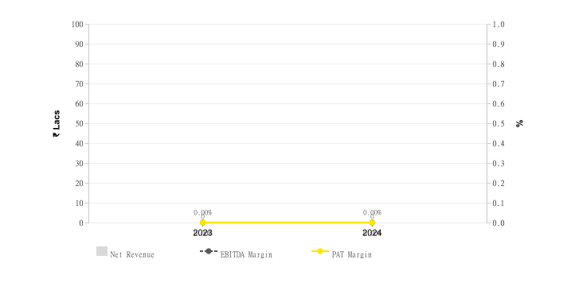

Return on Assets (ROA) & Capital Employed (ROCE)
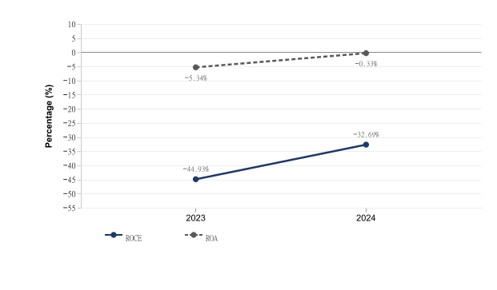
Particulars | 2023 | 2024
ROE (%) | -0.45 | -0.33
ROCE (%) | -44.93 | -32.69
ROA (%) | -5.34 | -0.33

Source: EY Network Alliance Databases / Annual Reports

Liquidity Analysis
Name & Relation | Finance - Liquidity Analysis | Rating | High

Liquidity Ratios
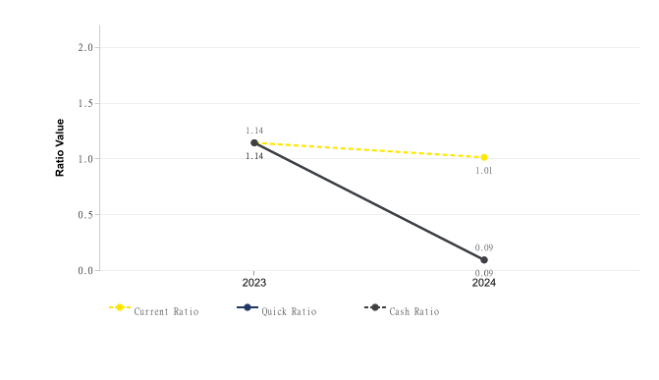
Particulars | 2023 | 2024
Current Ratio | 1.14 | 1.01
Quick Ratio | 1.14 | 0.09
Cash Ratio | 1.14 | 0.09

Source: EY Network Alliance Databases / Annual Reports

Operating Cycle
Name & Relation | Finance - Operating Cycle | Rating | Medium

Operating Cycle (Debtor, Creditor & Inventory Days)
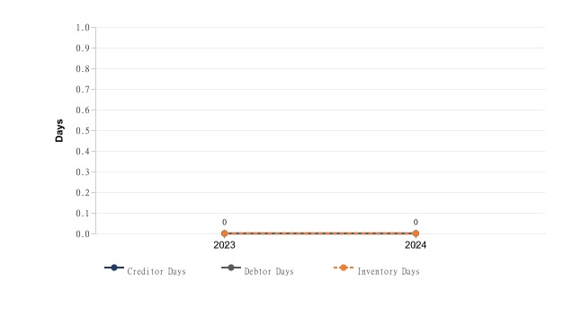

Asset Turnover Ratio
[Chart unavailable]
Particulars | 2023 | 2024
Asset Turnover Ratio | 0 | 0

Source: EY Network Alliance Databases / Annual Reports

Capital Structure
Name & Relation | Finance - Capital Structure | Rating | High

Debt – Equity Ratio
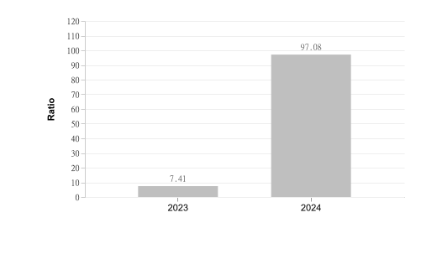
Particulars | 2023 | 2024
Debt Equity Ratio | 7.41 | 97.08

Interest Coverage Ratio
[Chart unavailable]

Source: EY Network Alliance Databases / Annual Reports

Name & Relation | Finance - MSME Registration Status | Rating | High
Findings

Factor | Value
MSME Status (Verified) | Already Registered
MSME Status (Client Database) | Not Provided
Reason | Vendor is MSME, but client database marks vendor as not MSME

Source: EY Network Alliance Databases

Name & Relation | Finance - EPFO Registration | Rating | INFO
Findings

Parameter | Value
Establishment Name | TERRA REX PRIVATE LIMITED
Establishment Id | HRFBD2556952000
Date Of Setup | 11-Jan-22
City | Faridabad
Address | Flat No. 702, TowerB Tulip Heights, Sector11E,Faridabad,HARYANA,121006,India
No of Employees | —
Last 12 Months | —

Source: EY Network Alliance Databases

Name & Relation | Finance - Auditor Comments | Rating | Low
Findings

Parameter | Value
Adverse Filing | False

Source: EY Network Alliance Databases

Name & Relation | Finance - GST Registration Analysis | Rating | Medium
Findings

Date Of Registration | State Of Registration | Gst In | Filing Timeliness
09.09.24 | Uttar Pradesh | 09AAJCT1125D1ZM | Filed After Due Date in last 12 Months,

Source: EY Network Alliance Databases

Name & Relation | Finance - Z Altman Score Analysis | Rating | High
Findings

Parameter | Calculation
Altman Z Score (trading) | 0.02
Altman Z Score (manufacturing) | -0.01

Source: EY Network Alliance Databases

Adverse Media
Low
This section shall list adverse media coverage and Google ratings for the entity.

Name & Relation | Google Rating Validation | Rating | Low
Findings

Name: TERRA REX PRIVATE LIMITED
Rating: 4
Number of Reviews: 1
Reviews:
1. Name: Abhishek Arora | Rating: 4
Great location
Peaceful Society

Source: EY Network Alliance Databases

Cyber
Low
This section shall list cyber security ratings for the entity.

CYBER – NO TRUE HITS IDENTIFIED

Annexures

Full List of Shareholders
Significant Shareholders
1. ENTRANCED TECHNOLOGIES PRIVATE LIMITED 50%
2. JANESHWAR . 50%

Key Management Personnel
Key Management
1. KRIPA SHANKER SINGH - Director
2. RITIJ VIKRAM SINGH - Director
3. JANESHWAR . - Director
4. SHASHI SHEKHAR MISHRA - Additional Director

Full List of Director Network

Sr. | Director Name | DIN | Network
1 | SHASHI SHEKHAR MISHRA | 06880735 | • PAARTH INFRABUILD PRIVATE LIMITED. — Director (2023-06-19 – 2023-10-20)  • CLARION TOWNSHIPS PRIVATE LIMITED — Director (2024-07-21 – Present)  • ASTHA INFRAPROJECTS PRIVATE LIMITED — Director (2022-10-20 – 2023-09-13)  • MAA DATIA AGRO PRIVATE LIMITED — Director (2014-08-11 – 2017-05-13)  • BAGLAMUKHI INFRASTRUCTURE PRIVATE LIMITED — Director (2014-06-27 – 2015-11-18)  • MERIPRO INFRAVENTURE AND DEVELOPERS PRIVATE LIMITED — Director (2015-01-09 – 2016-02-12) [STRIKE OFF, ACTIVE Non-Compliant]  • LALA JUGAL KISHORE INFRASTRUCTURE PRIVATE LIMITED — Director (2022-11-25 – 2026-08-03)  • LJK CONSTRUCTION INDIA PRIVATE LIMITED — Director (2021-12-31 – 2026-04-30)  • ENFINITYWORLD DEVELOPERS PRIVATE LIMITED — Director (2015-11-18 – Present) [STRIKE OFF, ACTIVE Non-Compliant]  • DAINIKNANDINI PRINTERS PRIVATE LIMITED — Director (2016-09-14 – 2021-06-18) [ACTIVE Non-Compliant]  • SAND & STONE INFRATECH PRIVATE LIMITED — Director (2017-05-16 – 2019-04-06)  • SUBHDHAN DEALER PRIVATE LIMITED — Additional Director (2017-07-27 – 2019-04-25)  • LALA JUGAL KISHORE SARRAFF PRIVATE LIMITED — Director (2022-02-22 – Present)  • LALA JUGAL KISHORE BUILDTECH INDIA PRIVATE LIMITED — Director (2022-03-03 – Present)  • LJK HOTELS & RESORTS PRIVATE LIMITED — Director (2022-03-03 – Present)  • LJK ENTERTAINMENT PRIVATE LIMITED — Director (2022-03-23 – Present)  • EVANKA REALTORS PRIVATE LIMITED — Director (2022-07-15 – Present)  • SPARSH AND LALA JUGAL KISHORE BUILDERS PRIVATE LIMITED — Director (2023-06-15 – Present)  • SPARSH CITY DEVELOPERS PRIVATE LIMITED — Director (2023-09-06 – Present)  • SHAVI INFRABUILD PRIVATE LIMITED — Director (2024-06-12 – Present)  • LJK & EVANKA BUILDCON PRIVATE LIMITED — Director (2024-06-28 – Present)  • SHAVI MEDICINE PRIVATE LIMITED — Director (2024-06-28 – Present)  • SHAVI CONSTRUCTION AND CONSULTANTS PRIVATE LIMITED — Director (2024-06-29 – Present)  • EVANKA CONSTRUCTION INDIA PRIVATE LIMITED — Director (2024-08-07 – Present)  • EVANKA FOUNDATION — Director (2025-06-05 – Present)  • PRANSHI & EVANKA REAL ESTATES PRIVATE LIMITED — Director (2025-06-24 – Present)  • LINAKS MICRO ELECTRONICS LIMITED — Managing Director (2024-07-18 – Present)  • TERRA REX PRIVATE LIMITED — Additional Director (2022-11-04 – 2022-11-05)  • LALA JUGAL KISHORE & SV BUILDERS LLP (LLP) — Designated Partner (None – Present)  • EVANKA INFRAESTATES LLP (LLP) — Designated Partner (None – Present)
2 | JANESHWAR . | 07427822 | • PARATUS HOSPITALITY PRIVATE LIMITED — Director (2016-02-11 – 2019-12-10)  • GAIASYS PRIVATE LIMITED — Director (2018-12-18 – Present)  • K.R.C. INFRAPROJECTS PRIVATE LIMITED — Director (2018-07-30 – Present)  • K.R.C. A2A HIGHWAY PRIVATE LIMITED — Director (2025-04-15 – Present)  • TERRA REX PRIVATE LIMITED — Director (2022-01-11 – 2022-11-05)  • MERRY MAKING EVENTS & WEDDINGS LLP (LLP) — Designated Partner (2017-03-10 – 2020-05-28)
3 | KRIPA SHANKER SINGH | 08946334 | • NEXTBIG THING VENTURES PRIVATE LIMITED — Additional Director (2022-07-07 – 2022-08-16)  • FORCE OF TALENT PRIVATE LIMITED — Director (2020-11-07 – Present)  • ENTRANCED TECHNOLOGIES PRIVATE LIMITED — Director (2020-11-03 – Present)  • TERRA REX PRIVATE LIMITED — Director (2022-01-11 – Present)  • UNITED ACHIEVERS INFRA PRIVATE LIMITED — Director (2020-11-28 – Present)  • TERRA REX ENERGY PRIVATE LIMITED — Director (2025-12-17 – Present)  • SSL REALTY LLP (LLP) — Designated Partner (None – Present)
4 | RITIJ VIKRAM SINGH | 08946335 | • FORCE OF TALENT PRIVATE LIMITED — Director (2020-11-07 – Present)  • ENTRANCED TECHNOLOGIES PRIVATE LIMITED — Director (2020-11-03 – Present)  • TERRA REX PRIVATE LIMITED — Director (2022-11-05 – Present)  • UNITED ACHIEVERS INFRA PRIVATE LIMITED — Director (2020-11-28 – 2024-12-19)  • TERRA REX ENERGY PRIVATE LIMITED — Director (2025-12-17 – Present)

Source: EY Network Alliance Databases

Disclaimer:
The information included in this report has been primarily collected from databases or public sources, thus it is difficult to verify all aspects of the information obtained. EY makes no representation or warranties with respect to the contents or use of this report, and specifically disclaims any express or implied warranties or usefulness for any particular purpose of this report. EY takes no responsibility for the consequences resulting from decisions based on information included in this report. EY reserves the right to change or revise this report at any time.

Copyright:
All rights reserved. No part of this screening report may be reproduced, photocopied, stored on a retrieval system, or transmitted without the express prior consent of EY.

