
Initial Screening Report
Supplier ID: N/A
ANTELEC PRIVATE LIMITED
[ANTELEC PRIVATE LIMITED]

9th September 2026

Contents

1. Company Profile 3
2. Executive Rating Summary 3
3. Detailed Findings 3
A. Entity Existence 3
B. Legal History and Open Cases 3
C. Financial Indicators 3
D. Adverse Media 3
4. Annexures 4
5. Data Sources 4

Company Profile

Uploaded Name | ANTELEC PRIVATE LIMITED | Supplier ID | N/A
Name | ANTELEC PRIVATE LIMITED | Location | Mumbai, Maharashtra
Address | Office No. 210, B Wing, 215, Atrium, Chakala, Mumbai, Mumbai City, Maharashtra - 400059 | Website | https://antelecltd.com/
E-Filing Status | Active | Classification | Private Limited Indian Non-Government Company
Incorporation Date | 11/09/1981 | National Identifier | U31200MH1981PTC025198
Corporate Group | Shareholders: 1  Subsidiaries: 0 | Alias | ANTELEC LIMITED
Revenue | 1,714,905,000 | Employee | N/A

Executive Rating Summary

Executive Summary

ANTELEC PRIVATE LIMITED, a private limited Indian non-government company based in Mumbai, Maharashtra, demonstrates an overall Low risk rating. The most material area identified is Legal, rated Medium, with one legal finding flagged. Financial risk is rated Low, though there are 14 financial findings flagged, suggesting a need for continued monitoring despite the low rating. Cyber/ESG risk remains Low with only one finding. Adverse media risk is also Low with a single flagged item. Entity existence risk is Low with two findings, and these do not alter the company’s overall low-risk posture.

OVERALL RISK RATING | Low

The below ratings are assigned:
Risk Areas | Risk Rating
Entity Existence | Low
Legal | Medium
Financial | Low
Adverse Media | Low
Cyber | Low

Detailed Findings

Entity Existence
Low
This section shall list B2B existence, domain validation, and address validation for the entity.

Name & Relation | Google Address Validation | Rating | Low
Findings

Factor | Value
Address | Office No. 210, B Wing, 215, Atrium, Chakala, Mumbai, Mumbai City, Maharashtra - 400059
Zone | Commercial
Reason | Rule-based pre-score: commercial places account for 97% of weighted evidence. Incidental amenities (shops, clinics, ATMs) in an otherwise commercial area were discounted per Indian urban norms.

Source: EY Network Alliance Databases

Name & Relation | Domain Validation | Rating | Low
Findings

Factor | Value
Domain Name | antelecltd.com
Creation Date | 17-05-2004
Expiration Date | 17-05-2027
Updated Date | 09-05-2026
Registrant Org | redacted for privacy
Registrant Country | in
Registrar | pdr ltd. d/b/a publicdomainregistry.com
Registrar Url | www.publicdomainregistry.com  www.publicdomainregistry.com
Emails | abuse-contact@publicdomainregistry.com, suresh.jaykumar@gmail.com
Dnssec | unsigned
Vendor Onboarding Date (Client Database)

Source: EY Network Alliance Databases

Address Validation
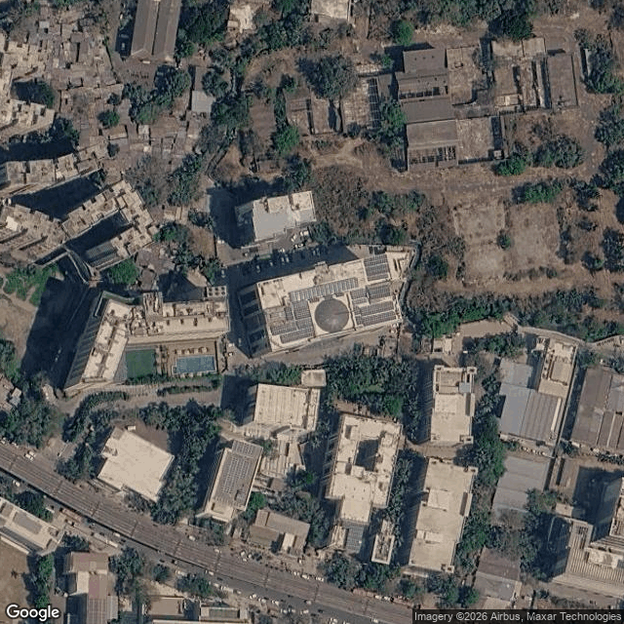

Legal History and Open Cases
Medium
This section shall list pending legal cases and open charges against the entity.

Name & Relation | Legal History | Rating | High
Findings

Sr. | Date | Case No. | Description | Category | Severity | Status
1 | 28.04.21 | IA(I.B.C) | Case No. IA(I.B.C) - 90/2021 was filed before the National Company Law Tribunal under the category of Insolvency. This matter pertains to Cases Filed By This Corporate, where ANTELEC LIMITED has initiated proceedings against VATIKA LIMITED. | Insolvency | High | Pending
2 | 13.02.20 | CP(IB)No.666/Chd/Hry/2019 | Case No. CP(IB)No.666/Chd/Hry/2019 was filed before the National Company Law Tribunal under the category of Insolvency. This matter pertains to Cases Filed By This Corporate, where Antelec Limited has initiated proceedings against Vatika Limited. | Insolvency | High | Pending
3 | 19.12.19 | cpib666/chd/hry/2019 | Case No. cpib666/chd/hry/2019 was filed before the National Company Law Tribunal under the category of Insolvency. This matter pertains to Cases Filed By This Corporate, where antelec Ltd. has initiated proceedings against vatika ltd.. | Insolvency | High | Pending
4 | Unavailable | CA-64-2014 | Case No. CA-64-2014 was filed before the High Court of Punjab and Haryana under the category of Civil Cases. This matter pertains to Cases Filed By This Corporate, where ANTELEC LTD. has initiated proceedings against CINEPOLIS INDIA PVT. LTD.. | Civil Cases | Medium | Pending
5 | 30.04.19 | WP/3072/2005 | Case No. WP/3072/2005 was filed before the High Court of Bombay under the category of Writs and Regulatory Matters. This matter pertains to Cases Filed By This Corporate, where ANTELEC LTD. AND ANR. has initiated proceedings against STATE OF MAHARASHTRA AND 3 ORS.. | Writs and Regulatory Matters | Low | Pending
6 | 06.03.19 | CHSW/60/2019 | Case No. CHSW/60/2019 was filed before the High Court of Bombay under the category of Writs and Regulatory Matters. This matter pertains to Cases Filed By This Corporate, where ANTELEC LIMITED AND ANR has initiated proceedings against STATE OF MAHARASHTRA AND 3 ORS.. | Writs and Regulatory Matters | Low | Pending

Source: EY Network Alliance Databases

Financial Indicators
Low
This section shall list balance sheet, profit and loss, profitability analysis, liquidity analysis, financial ratios, GST registration analysis, MSME registration validation, and related party transactions of the entity.

Name & Relation | Finance - Profit And Loss | Rating | INFO
Findings

Income Statement (₹ in Lakhs)
Particulars | 2023 | 2024 | 2025 | 2026
Net Revenue (₹ in Lakhs) | 11,701.63 | 22,320.26 | 26,298.82 | 17,149.05
Profit After Tax (₹ in Lakhs) | 305.94 | 1,009.77 | 2,062.08 | 787.68

Source: EY Network Alliance Databases / Annual Reports

Name & Relation | Finance - Balance Sheet | Rating | INFO
Findings

Balance Sheet (₹ in Lakhs)
Particulars | 2023 | 2024 | 2025 | 2026
Total Current Assets (₹ in Lakhs) | 9,984.14 | 25,189.46 | 19,214.71 | 15,572.06
Total Other Non Current Assets (₹ in Lakhs) | 177.78 | 166.02 | 149.89 | 182.47
Net Fixed Assets (₹ in Lakhs) | 540.74 | 547.07 | 500.34 | 440.13
Total Current Liabilities (₹ in Lakhs) | 2,787.99 | 16,978.11 | 8,810.37 | 4,317.69
Total Non Current Liabilities (₹ in Lakhs) | 0 | 0 | 62.13 | 96.89
Total Equity (₹ in Lakhs) | 7,914.67 | 8,924.44 | 10,992.44 | 11,780.08

Source: EY Network Alliance Databases / Annual Reports

Profitability Analysis
Name & Relation | Finance - Profitability Analysis | Rating | Medium

Revenue, EBITDA and PAT Margin
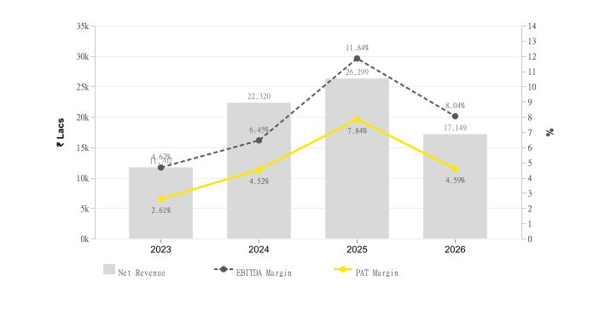
Particulars | 2023 | 2024 | 2025 | 2026
Profit Margin Ratio (%) | 2.61 | 4.52 | 7.84 | 4.59
EBITDA Margin (%) | 4.67 | 6.45 | 11.84 | 8.04

Return on Assets (ROA) & Capital Employed (ROCE)
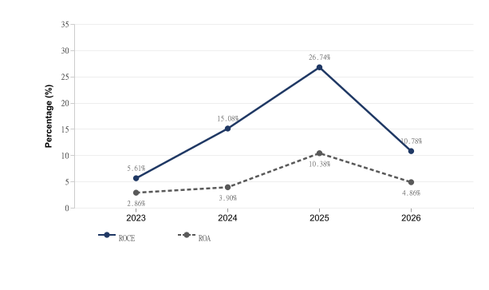
Particulars | 2023 | 2024 | 2025 | 2026
ROE (%) | 0.04 | 0.11 | 0.19 | 0.07
ROCE (%) | 5.61 | 15.08 | 26.74 | 10.78
ROA (%) | 2.86 | 3.9 | 10.38 | 4.86

Source: EY Network Alliance Databases / Annual Reports

Liquidity Analysis
Name & Relation | Finance - Liquidity Analysis | Rating | Low

Liquidity Ratios
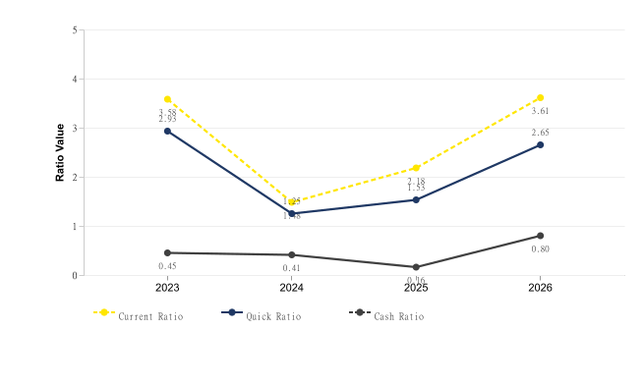
Particulars | 2023 | 2024 | 2025 | 2026
Current Ratio | 3.58 | 1.48 | 2.18 | 3.61
Quick Ratio | 2.93 | 1.25 | 1.53 | 2.65
Cash Ratio | 0.45 | 0.41 | 0.16 | 0.8

Source: EY Network Alliance Databases / Annual Reports

Operating Cycle
Name & Relation | Finance - Operating Cycle | Rating | Medium

Operating Cycle (Debtor, Creditor & Inventory Days)
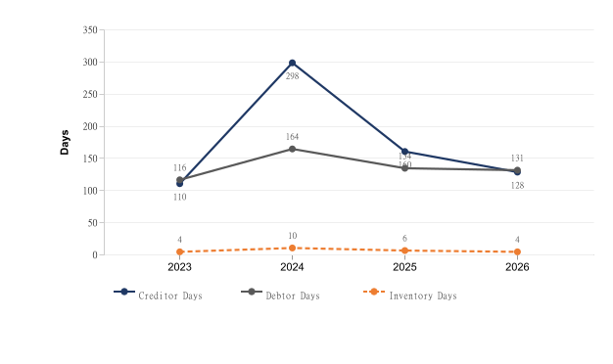
Particulars | 2023 | 2024 | 2025 | 2026
Inventory Days | 4 | 10 | 6 | 4
Debtor Days | 116 | 164 | 134 | 131
Creditor Days | 110 | 298 | 160 | 128

Asset Turnover Ratio
[Chart unavailable]
Particulars | 2023 | 2024 | 2025 | 2026
Asset Turnover Ratio | 1.09 | 0.86 | 1.32 | 1.06

Source: EY Network Alliance Databases / Annual Reports

Capital Structure
Name & Relation | Finance - Capital Structure | Rating | Low

Debt – Equity Ratio
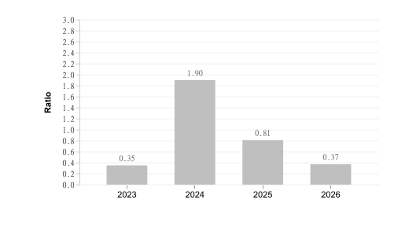
Particulars | 2023 | 2024 | 2025 | 2026
Debt Equity Ratio | 0.35 | 1.9 | 0.81 | 0.37

Interest Coverage Ratio
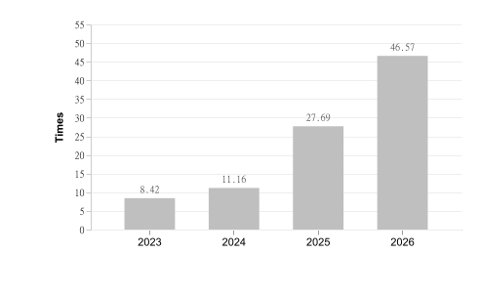
Particulars | 2023 | 2024 | 2025 | 2026
Interest Coverage Ratio | 8.42 | 11.16 | 27.69 | 46.57

Source: EY Network Alliance Databases / Annual Reports

Name & Relation | Finance - MSME Registration Status | Rating | High
Findings

Factor | Value
MSME Status (Verified) | Already Registered
MSME Status (Client Database) | Not Provided
Reason | Vendor is MSME, but client database marks vendor as not MSME

Source: EY Network Alliance Databases

Name & Relation | Finance - Related Party Transaction | Rating | INFO
Findings

Name | Relationship | Type Of Transaction | Amount (₹ In Lakhs)
Kinden Corporation | Holding Company | Expense | 143.82
Kinden Charitable Trust | We could not Identify the Relationship Category | Expense | 20

Source: EY Network Alliance Databases

Name & Relation | Finance - Auditor Comments | Rating | Low
Findings

Parameter | Value
Adverse Filing | False

Source: EY Network Alliance Databases

Name & Relation | Finance - EPFO Registration | Rating | INFO
Findings

Parameter | Value
Establishment Name | ANTELEC LTD
Establishment Id | MHBAN0015232000
Date Of Setup | 11-Sep-81
City | MUMBAI
Address | NARIMAN POINT ,MUMBAI,MAHARASHTRA,400021,India
No of Employees | 559
Last 12 Months | May-26 Apr-26 Mar-26 Feb-26 Jan-26 Dec-25  On time (INR 26.2 L ; 559 Employees) On time (INR 28.6 L ; 558 Employees) On time (INR 29.4 L ; 557 Employees) On time (INR 26.9 L ; 558 Employees) On time (INR 27.9 L ; 514 Employees) On time (INR 28.3 L ; 503 Employees)  Nov-25 Oct-25 Sep-25 Aug-25 Jul-25 Jun-25  On time (INR 26.0 L ; 510 Employees) On time (INR 27.6 L ; 474 Employees) On time (INR 27.0 L ; 499 Employees) On time (INR 8.6 L ; 186 Employees) On time (INR 2.0 L ; 39 Employees) On time (INR 1.1 L ; 23 Employees)

Source: EY Network Alliance Databases

Name & Relation | Finance - GST Registration Analysis | Rating | Low
Findings

Date Of Registration | State Of Registration | Gst In | Filing Timeliness
25.08.20 | Andhra Pradesh | 37AAACA3287A1Z2 | Filed on Time
23.10.25 | Chhattisgarh | 22AAACA3287A1ZD | Filed on Time
01.07.17 | Delhi | 07AAACA3287A1Z5 | Filed on Time
23.05.20 | Goa | 30AAACA3287A1ZG | Filed on Time
01.07.17 | Gujarat | 24AAACA3287A1Z9 | Filed on Time
01.07.17 | Haryana | 06AAACA3287A1Z7 | Filed on Time
18.11.24 | Jharkhand | 20AAACA3287A3ZF | Filed on Time
01.07.17 | Karnataka | 29AAACA3287A1ZZ | Filed on Time
01.07.17 | Maharashtra | 27AAACA3287A1Z3 | Filed on Time
01.07.17 | Punjab | 03AAACA3287A1ZD | Filed on Time
01.07.17 | Rajasthan | 08AAACA3287A1Z3 | Filed on Time
12.07.18 | Tamil Nadu | 33AAACA3287A1ZA | Filed on Time
01.07.17 | Telangana | 36AAACA3287A1Z4 | Filed on Time
01.07.17 | Uttar Pradesh | 09AAACA3287A1Z1 | Filed on Time

Source: EY Network Alliance Databases

Name & Relation | Finance - Credit Risk Analysis | Rating | INFO
Findings

Rating Date | Rating Agency | Rating | Type Of Loan | Amount (₹ In Lakhs)
31.12.24 | india_ratings | BBB (Stable/Upgraded from BBB-) | Fund Based Working Capital Facility | 55
31.12.24 | india_ratings | A3+ (Upgraded from A3) | Non Fund Based Working Capital Facility | 2,300
10.11.23 | india_ratings | BBB- (Stable/Affirmed) | Fund Based Working Capital limit | 55
10.11.23 | india_ratings | A3 (Affirmed) | Non Fund Based Working Capital Facility | 2,300
26.07.23 | india_ratings | BBB- (Issuer Not Cooperating) | Fund Based Working Capital limit | 55
26.07.23 | india_ratings | BBB- (Issuer Not Cooperating) | Long Term Issuer Rating | 0
26.07.23 | india_ratings | A3 (Issuer Not Cooperating) | Non Fund Based Working Capital Facility | 2,300
13.06.22 | india_ratings | BBB- (Negative/Affirmed) | Fund Based Working Capital limit | 55
13.06.22 | india_ratings | BBB- (Negative/Affirmed) | Long Term Issuer Rating | 0
13.06.22 | india_ratings | A3 (Affirmed) | Non Fund Based Bank Limit | 2,300

Source: EY Network Alliance Databases

Name & Relation | Finance - MSME Payment Analysis | Rating | INFO
Findings

Period | Amount (₹ In Lakhs)
October 2023 to March 2024 | 57.23
April 2024 to September 2024 | 28.86
October 2024 to March 2025 | 228.03
April 2025 to September 2025 | 242.12
October 2025 to March 2026 | 399.04

Source: EY Network Alliance Databases

Name & Relation | Finance - Z Altman Score Analysis | Rating | Low
Findings

Parameter | Calculation
Altman Z Score (trading) | 10.25
Altman Z Score (manufacturing) | 4.77

Source: EY Network Alliance Databases

Adverse Media
Low
This section shall list adverse media coverage and Google ratings for the entity.

Name & Relation | Google Rating Validation | Rating | High
Findings

Name: ANTELEC PRIVATE LIMITED
Rating: 1
Number of Reviews: 1
Reviews:
1. Name: Shaikh Israil | Rating: 1

Source: EY Network Alliance Databases

Cyber
Low
This section shall list cyber security ratings for the entity.

Name & Relation | Cyber Risk Validation | Rating | Low
Findings

Factor | Value
Resolved IP | 94.136.191.240
Botnet Threat | NO
Malware Hosting Threat | NO
Command & Control Threat | NO
Spam Server Threat | NO
Overall Compromised | NO
Vendor / 3rd-Party Risk | PASS
Fraud / Compliance Flag | NO

Source: EY Network Alliance Databases

Annexures

Full List of Shareholders
Significant Shareholders
1. KINDEN CORPORATION 100%

Key Management Personnel
Key Management
1. AKIHIKO SHIMIZU - Director
2. TAKAYUKI NAKAMOTO - Director
3. YASUYUKI INOUE - Director
4. VEERENDRA SINGH - Director
5. RAKESH KUMAR GUPTA - Director
6. MADHAVAN NAGARETHINAM - Managing Director
7. HANOZ PHIROZE PATEL - Director
8. NARIOSANG HORMASJI ANTIA - Director
9. SURENDRA GIRDHARLAL SHETH - Director
10. SHERNAZ NARIOSANG ANTIA - Director
11. SANJIV BANGA - Managing Director
12. KAINAZ NARIOSANG ANTIA - Director
13. SANJIV BANGA - CEO(KMP)
14. MASASHI TOKUMOTO - Director
15. MASARU HIKITA - Director
16. KENJI YAMANISHI - Director

Full List of Legal History

Sr. | Date | Case No. | Description | Category | Severity | Status
1 | 08.07.22 | C.P. (IB) - 389/2021 | Case No. C.P. (IB) - 389/2021 was filed before the National Company Law Tribunal under the category of Insolvency. This matter pertains to Cases Filed By This Corporate, where Antelec Limited has initiated proceedings against Rajesh Business and Leisure Hotels Private Limited. | Insolvency | High | Disposed
2 | 19.04.22 | C.P. (IB) - 666/2019 | Case No. C.P. (IB) - 666/2019 was filed before the National Company Law Tribunal under the category of Insolvency. This matter pertains to Cases Filed By This Corporate, where ANTELEC LIMITED has initiated proceedings against VATIKA LIMITED. | Insolvency | High | Disposed
3 | 28.04.21 | IA(I.B.C) - 90/2021 | Case No. IA(I.B.C) - 90/2021 was filed before the National Company Law Tribunal under the category of Insolvency. This matter pertains to Cases Filed By This Corporate, where ANTELEC LIMITED has initiated proceedings against VATIKA LIMITED. | Insolvency | High | Pending
4 | 13.02.20 | CP(IB)No.666/Chd/Hry/2019 | Case No. CP(IB)No.666/Chd/Hry/2019 was filed before the National Company Law Tribunal under the category of Insolvency. This matter pertains to Cases Filed By This Corporate, where Antelec Limited has initiated proceedings against Vatika Limited. | Insolvency | High | Pending
5 | 19.12.19 | cpib666/chd/hry/2019 | Case No. cpib666/chd/hry/2019 was filed before the National Company Law Tribunal under the category of Insolvency. This matter pertains to Cases Filed By This Corporate, where antelec Ltd. has initiated proceedings against vatika ltd.. | Insolvency | High | Pending
6 | 30.07.26 | Arb O.P(COM.DIV.)/308/2026 | Case No. Arb O.P(COM.DIV.)/308/2026 was filed before the High Court of Madras under the category of Arbitration Matters. This matter pertains to Cases Filed Against This Corporate, where Larsen and Toubro Limited has initiated proceedings against ANTELEC PRIVATE LIMITED. | Arbitration Matters | Medium | Disposed
7 | 16.12.22 | CRLMP/5763/2018 | Case No. CRLMP/5763/2018 was filed before the High Court of Rajasthan - Jaipur under the category of Criminal Appeals. This matter pertains to Cases Filed By This Corporate, where ANTELEC PRIVATE LIMITED and Others. has initiated proceedings against STATE OF RAJASTHAN. | Criminal Appeals | Medium | Disposed
8 | 20.12.21 | TC/50/2021 | Case No. TC/50/2021 was filed before the High Court of Madras under the category of Taxation Matters. This matter pertains to Cases Filed Against This Corporate, where THE STATE OF TAMIL NADU, has initiated proceedings against TVL. ANTLEC LTD.,. | Taxation Matters | Medium | Disposed
9 | 31.01.19 | ARBP/238/2015 | Case No. ARBP/238/2015 was filed before the High Court of Bombay under the category of Arbitration Matters. This matter pertains to Cases Filed Against This Corporate, where M/S. ELPRO ESTATES LIMITED has initiated proceedings against M/S. ANTELEC LIMITED. | Arbitration Matters | Medium | Disposed
10 | 05.09.18 | CCP(CO.) 23/2017 | Case No. CCP(CO.) 23/2017 was filed before the High Court of Delhi under the category of Civil Cases. This matter pertains to Cases Filed By This Corporate, where M/S ANTELEC LIMITED has initiated proceedings against THREE C UNIVERSAL DEVELOPERS LTD. & ORS.. | Civil Cases | Medium | Disposed
11 | 08.12.16 | CO.PET. 282/2016 | Case No. CO.PET. 282/2016 was filed before the High Court of Delhi under the category of Corporate Disputes. This matter pertains to Cases Filed By This Corporate, where M/S ANTELEC LIMITED has initiated proceedings against THREE C UNIVERSAL DEVELOPERS PVT. LTD.. | Corporate Disputes | Medium | Disposed
12 | 22.07.16 | ARP/34/2016 | Case No. ARP/34/2016 was filed before the High Court of Bombay under the category of Arbitration Matters. This matter pertains to Cases Filed By This Corporate, where ANTELEC LIMITED has initiated proceedings against M/S. GRANT MEDICAL FOUNDATION RUBY HALL CLININC AND ORS. | Arbitration Matters | Medium | Disposed
13 | 30.10.15 | ARP/60/2015 | Case No. ARP/60/2015 was filed before the High Court of Bombay under the category of Arbitration Matters. This matter pertains to Cases Filed By This Corporate, where ANTELEC LIMITED has initiated proceedings against M/S.GRANT MEDICAL FOUNDATION. | Arbitration Matters | Medium | Disposed
14 | 05.05.15 | CP/268/2015 | Case No. CP/268/2015 was filed before the High Court of Bombay under the category of Corporate Disputes. This matter pertains to Cases Filed By This Corporate, where ANTELEC LIMITED has initiated proceedings against RUBY MILLS LTD CIN L17120MH1917PLC000447. | Corporate Disputes | Medium | Disposed
15 | 06.04.15 | CHS/799/2015 | Case No. CHS/799/2015 was filed before the High Court of Bombay under the category of Civil Cases. This matter pertains to Cases Filed Against This Corporate, where M/S. ELPRO ESTATES LIMITED has initiated proceedings against M/S. ANTELEC LIMITED. | Civil Cases | Medium | Disposed
16 | 28.11.14 | MCA/488/2014 | Case No. MCA/488/2014 was filed before the High Court of Bombay at Goa under the category of Civil Cases. This matter pertains to Cases Filed Against This Corporate, where 1.AVERINA INTERNATIONAL RESORTS LTD., has initiated proceedings against 1.ANTELEC PVT. LTD.,. | Civil Cases | Medium | Disposed
17 | 07.02.14 | CA-65-2014 | Case No. CA-65-2014 was filed before the High Court of Punjab and Haryana under the category of Civil Cases. This matter pertains to Cases Filed By This Corporate, where ANTELEC LTD. has initiated proceedings against CINEPOLIS INDIA PVT. LTD.. | Civil Cases | Medium | Disposed
18 | 11.12.13 | CS/289/2010 | Case No. CS/289/2010 was filed before the High Court of Calcutta under the category of Civil Cases. This matter pertains to Cases Filed By This Corporate, where ANTELEC LIMITED has initiated proceedings against DEVBHOOMI AWAS LIMITED. | Civil Cases | Medium | Disposed
19 | 08.11.13 | CA-571-2013 | Case No. CA-571-2013 was filed before the High Court of Punjab and Haryana under the category of Civil Cases. This matter pertains to Cases Filed By This Corporate, where ANTELEC LTD. has initiated proceedings against CINEPOLIS INDIA PVT. LTD.. | Civil Cases | Medium | Disposed
20 | 08.11.13 | CP-82-2012 | Case No. CP-82-2012 was filed before the High Court of Punjab and Haryana under the category of Corporate Disputes. This matter pertains to Cases Filed By This Corporate, where ANTELEC LTD. has initiated proceedings against CINEPOLIS INDIA PVT. LTD.. | Corporate Disputes | Medium | Disposed
21 | 17.09.13 | RCA/265/2010 | Case No. RCA/265/2010 was filed before the District and Sessions Court Margao under the category of Civil Cases. This matter pertains to Cases Filed Against This Corporate, where Averina International Resorts has initiated proceedings against ANTELEC PRIVATE LIMITED. | Civil Cases | Medium | Disposed
22 | 17.06.11 | ARBAP/50/2011 | Case No. ARBAP/50/2011 was filed before the High Court of Bombay under the category of Arbitration Matters. This matter pertains to Cases Filed By This Corporate, where ANTELEC LTD. has initiated proceedings against ELPRO ESTATES LTD.. | Arbitration Matters | Medium | Disposed
23 | 15.07.10 | APO/327/2010 | Case No. APO/327/2010 was filed before the High Court of Calcutta under the category of Civil Cases. This matter pertains to Cases Filed Against This Corporate, where DEVBHOOMI AWAS LTD. has initiated proceedings against ANTELEC LTD.. | Civil Cases | Medium | Disposed
24 | 16.06.10 | CP/292/2009 | Case No. CP/292/2009 was filed before the High Court of Calcutta under the category of Corporate Disputes. This matter pertains to Cases Filed Against This Corporate, where IN THE MATTER OF DEVBHOOMI AWAS LIMITED has initiated proceedings against ANTELEC LTD.. | Corporate Disputes | Medium | Disposed
25 | 07.12.09 | FA/176/2002 | Case No. FA/176/2002 was filed before the High Court of Bombay at Goa under the category of Civil Cases. This matter pertains to Cases Filed Against This Corporate, where 1.AVERINA INTERNATIONAL RESORTS LTD., has initiated proceedings against 1.ANTELEC PVT. LTD.,. | Civil Cases | Medium | Disposed
26 | 10.11.09 | S.C.C./1500315/2008 | Case No. S.C.C./1500315/2008 was filed before the Civil Judge, J.D.and J.M.F.C., Uran under the category of NI Act / Company Offences. This matter pertains to Cases Filed Against This Corporate, where The State -L.E.O. has initiated proceedings against ANTELEC PRIVATE LIMITED. | NI Act / Company Offences | Medium | Disposed
27 | 30.11.06 | MCA/656/2006 | Case No. MCA/656/2006 was filed before the High Court of Bombay at Goa under the category of Civil Cases. This matter pertains to Cases Filed Against This Corporate, where 1.AVERINA INTERNATIONAL RESORTS LTD., has initiated proceedings against 1.ANTELEC PVT. LTD.,. | Civil Cases | Medium | Disposed
28 | 10.05.05 | COMP/11/2005 | Case No. COMP/11/2005 was filed before the High Court of Gujarat under the category of Corporate Disputes. This matter pertains to Cases Filed By This Corporate, where ANTELEC LIMITED has initiated proceedings against JMC PROJECTS (INDIA) LIMITED. | Corporate Disputes | Medium | Disposed
29 | 14.08.03 | MCA/440/2003 | Case No. MCA/440/2003 was filed before the High Court of Bombay at Goa under the category of Civil Cases. This matter pertains to Cases Filed Against This Corporate, where 1.AVERINA INTERNATIONAL RESORTS LTD., has initiated proceedings against 1.ANTELEC PVT.LTD.,. | Civil Cases | Medium | Disposed
30 | 04.10.02 | MCA/558/2002 | Case No. MCA/558/2002 was filed before the High Court of Bombay at Goa under the category of Civil Cases. This matter pertains to Cases Filed Against This Corporate, where 1.AVERINA INTERNATIONAL RESORTS LTD.,MARGAO-GOA. has initiated proceedings against 1.ANTELEC PVT. LTD., BOMBAY-400 021.. | Civil Cases | Medium | Disposed
31 | 22.08.02 | CA/225/2002 | Case No. CA/225/2002 was filed before the High Court of Bombay at Goa under the category of Civil Cases. This matter pertains to Cases Filed Against This Corporate, where 1.AVERINA INTERNATIONAL RESORTS LTD., has initiated proceedings against 1.ANTELEC PVT. LTD.,. | Civil Cases | Medium | Disposed
32 | 04.10.99 | ARB.P. 356/1999 | Case No. ARB.P. 356/1999 was filed before the High Court of Delhi under the category of Arbitration Matters. This matter pertains to Cases Filed By This Corporate, where ANTELEC P LTD. has initiated proceedings against PHOENIX INTERNTIONAL. | Arbitration Matters | Medium | Disposed
33 | Unavailable | CA-64-2014 | Case No. CA-64-2014 was filed before the High Court of Punjab and Haryana under the category of Civil Cases. This matter pertains to Cases Filed By This Corporate, where ANTELEC LTD. has initiated proceedings against CINEPOLIS INDIA PVT. LTD.. | Civil Cases | Medium | Pending
34 | Unavailable | CA-418-2012 | Case No. CA-418-2012 was filed before the High Court of Punjab and Haryana under the category of Civil Cases. This matter pertains to Cases Filed By This Corporate, where ANTELEC LTD. has initiated proceedings against CINEPOLIS INDIA PVT. LTD.. | Civil Cases | Medium | Pending
35 | Unavailable | CA-417-2012 | Case No. CA-417-2012 was filed before the High Court of Punjab and Haryana under the category of Civil Cases. This matter pertains to Cases Filed By This Corporate, where ANTELEC LTD. has initiated proceedings against CINEPOLIS INDIA PVT. LTD.. | Civil Cases | Medium | Disposed
36 | 30.04.19 | WP/3072/2005 | Case No. WP/3072/2005 was filed before the High Court of Bombay under the category of Writs and Regulatory Matters. This matter pertains to Cases Filed By This Corporate, where ANTELEC LTD. AND ANR. has initiated proceedings against STATE OF MAHARASHTRA AND 3 ORS.. | Writs and Regulatory Matters | Low | Pending
37 | 06.03.19 | CHSW/60/2019 | Case No. CHSW/60/2019 was filed before the High Court of Bombay under the category of Writs and Regulatory Matters. This matter pertains to Cases Filed By This Corporate, where ANTELEC LIMITED AND ANR has initiated proceedings against STATE OF MAHARASHTRA AND 3 ORS.. | Writs and Regulatory Matters | Low | Pending
38 | 03.07.12 | Appln.IDA/5100143/2010 | Case No. Appln.IDA/5100143/2010 was filed before the Labour, Mumbai under the category of Others. This matter pertains to Cases Filed Against This Corporate, where JitendraKumar Y. Parmar has initiated proceedings against ANTELEC PRIVATE LIMITED. | Others | Low | Disposed

Source: EY Network Alliance Databases

Full List of Director Network

Sr. | Director Name | DIN | Network
1 | SHERNAZ NARIOSANG ANTIA | 00030058 | • ANTIA HOLDINGS PRIVATE LIMITED — Director (1981-09-11 – Present)  • ANTIA ELECTRICALS PRIVATE LIMITED — Director (1975-01-04 – Present)  • KINDEN INDIA PRIVATE LIMITED — Director (2018-04-01 – 2018-11-01) [STRIKE OFF]  • ANTELEC PRIVATE LIMITED — Director (1981-09-11 – 2021-12-15)
2 | SURENDRA GIRDHARLAL SHETH | 00089981 | • ANTRON INDIA PRIVATE LIMITED — Director (1990-01-01 – Present) [STRIKE OFF]  • ANTIA HOLDINGS PRIVATE LIMITED — Director (2017-03-21 – Present)  • ANTIA ELECTRICALS PRIVATE LIMITED — Director (2022-07-29 – Present)  • BLUE DART EXPRESS LIMITED — Director (1992-09-16 – 2016-05-12)  • BLUE DART AVIATION LIMITED — Alternate Director (2017-03-15 – 2020-11-03)  • ANTELEC PRIVATE LIMITED — Director (2002-01-02 – 2021-12-16)
3 | NARIOSANG HORMASJI ANTIA | 00239849 | • ANTRON INDIA PRIVATE LIMITED — Director (1990-01-01 – Present) [STRIKE OFF]  • ANTIA HOLDINGS PRIVATE LIMITED — Director (1981-09-11 – Present)  • ANTIA ELECTRICALS PRIVATE LIMITED — Director (1975-01-04 – Present)  • ANTELEC PRIVATE LIMITED — Director (1981-09-11 – 2021-12-15)
4 | HANOZ PHIROZE PATEL | 00360673 | • SYNCHRO INVESTMENTS PRIVATE LIMITED — Director (2011-10-06 – Present)  • AURUM LOGISTICS PRIVATE LIMITED — Director (2019-02-11 – Present)  • BOMBAY METAL AND ALLOYS MFG COMPANY PRIVATE LIMITED — Director (2011-10-06 – Present)  • PARIA FINANCIAL SERVICES PRIVATE LIMITED — Director (2008-09-08 – Present)  • POWERPUSHER FINANCIAL SERVICES PRIVATE LIMITED — Director (1995-08-22 – Present) [CONVERTED TO LLP]  • IORN & METAL TRADERS PRIVATE LIMITED — Director (2011-10-06 – Present)  • H AND Z FINANCE PRIVATE LIMITED — Director (1995-09-27 – Present)  • ANTELEC PRIVATE LIMITED — Director (2015-03-26 – 2021-12-16)  • USHTAVAITI FOUNDATION — Director (2025-12-08 – Present)  • POWERPUSHER FINANCIAL SERVICES LLP (LLP) — Designated Partner (None – Present)  • PPS FINANCIAL SERVICES LLP (LLP) — Designated Partner (None – Present)  • POWERPUSHER SUPREME PEST CONTROL LLP (LLP) — Designated Partner (None – Present) [STRIKE OFF]
5 | KAINAZ NARIOSANG ANTIA | 00648384 | • ANTELEC PRIVATE LIMITED — Director (2006-08-08 – 2016-05-30)
6 | MADHAVAN NAGARETHINAM | 05217685 | • SINE WAVE ENGINEERING CONTRACTING & TRADING PRIVATE LIMITED — Director (2012-08-29 – Present) [STRIKE OFF, ACTIVE Non-Compliant]  • ANTELEC PRIVATE LIMITED — Managing Director (2023-08-02 – Present)
7 | YASUYUKI INOUE | 05357113 | • KINDEN INDIA PRIVATE LIMITED — Director (2012-10-12 – 2018-09-05) [STRIKE OFF]  • ANTELEC PRIVATE LIMITED — Director (2021-12-23 – 2024-12-31)
8 | AKIHIKO SHIMIZU | 05357208 | • KINDEN INDIA PRIVATE LIMITED — Director (2012-10-12 – Present) [STRIKE OFF]  • ANTELEC PRIVATE LIMITED — Director (2016-05-30 – 2024-12-31)
9 | SANJIV BANGA | 08198637 | • KINDEN INDIA PRIVATE LIMITED — Director (2018-11-01 – Present) [STRIKE OFF]  • ANTELEC PRIVATE LIMITED — Managing Director (2018-08-29 – 2023-08-09)
10 | VEERENDRA SINGH | 10182789 | • ANTELEC PRIVATE LIMITED — Director (2023-08-02 – Present)
11 | RAKESH KUMAR GUPTA | 10183438 | • ANTELEC PRIVATE LIMITED — Director (2023-08-02 – Present)
12 | TAKAYUKI NAKAMOTO | 10229605 | • ANTELEC PRIVATE LIMITED — Director (2023-08-02 – Present)
13 | MASASHI TOKUMOTO | 10864827 | • ANTELEC PRIVATE LIMITED — Director (2024-12-19 – Present)
14 | MASARU HIKITA | 10864830 | • ANTELEC PRIVATE LIMITED — Director (2024-12-19 – Present)
15 | KENJI YAMANISHI | 10864832 | • ANTELEC PRIVATE LIMITED — Director (2024-12-19 – Present)

Source: EY Network Alliance Databases

Disclaimer:
The information included in this report has been primarily collected from databases or public sources, thus it is difficult to verify all aspects of the information obtained. EY makes no representation or warranties with respect to the contents or use of this report, and specifically disclaims any express or implied warranties or usefulness for any particular purpose of this report. EY takes no responsibility for the consequences resulting from decisions based on information included in this report. EY reserves the right to change or revise this report at any time.

Copyright:
All rights reserved. No part of this screening report may be reproduced, photocopied, stored on a retrieval system, or transmitted without the express prior consent of EY.

