
Initial Screening Report
Supplier ID: N/A
SPEED MOTORS PRIVATE LIMITED
[Speed Motors Private Limited]

14th July 2026

Contents

1. Company Profile 3
2. Executive Rating Summary 3
3. Detailed Findings 3
A. Entity Existence 3
B. Legal History and Open Cases 3
C. Financial Indicators 3
D. Adverse Media 3
4. Annexures 4
5. Data Sources 4

Company Profile

Uploaded Name | Speed Motors Private Limited | Supplier ID | N/A
Name | SPEED MOTORS PRIVATE LIMITED | Location | UTTAR PRADESH, Uttar Pradesh
Address | 3SHAH NAJAF ROAD LUCKNOW, UTTAR PRADESH, Uttar Pradesh - 226001 | Website | N/A
E-Filing Status | Active | Classification | Private Limited Indian Non-Government Company
Incorporation Date | 05/11/1947 | National Identifier | U34102UP1947PTC001835
Corporate Group | Shareholders: 5  Subsidiaries: 1 | Alias | SPEED MOTORS LIMITED
Revenue | 2,606,635,237 | Employee | N/A

Executive Rating Summary

OVERALL RISK RATING | Low

The below ratings are assigned:
Risk Areas | Risk Rating
Entity Existence | Low
Legal | Medium
Financial | Medium
Adverse Media | Low
Cyber | Low

Detailed Findings

Entity Existence
Low
This section shall list B2B existence, domain validation, and address validation for the entity.

Name & Relation | Google Address Validation | Rating | Low
Findings

Factor | Value
Address | 3SHAH NAJAF ROAD LUCKNOW, UTTAR PRADESH, Uttar Pradesh - 226001
Zone | Commercial
Reason | Rule-based pre-score: commercial places account for 92% of weighted evidence. Incidental amenities (shops, clinics, ATMs) in an otherwise commercial area were discounted per Indian urban norms.

Source: EY Network Alliance Databases

Address Validation
 | 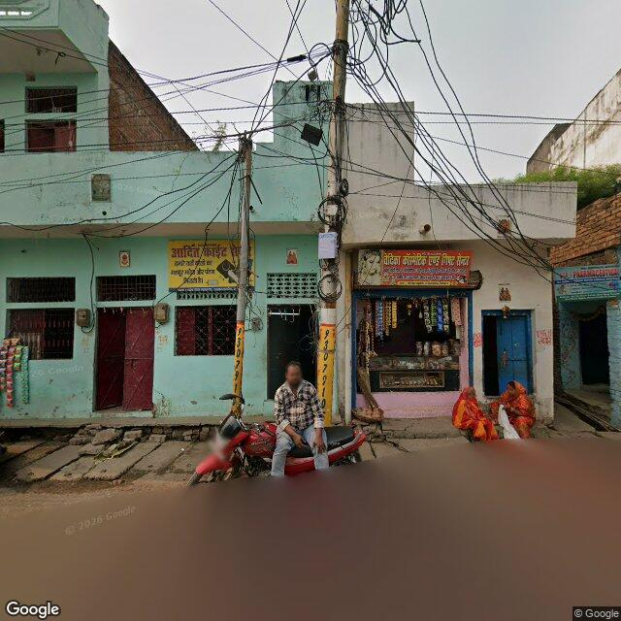 | 

Legal History and Open Cases
Medium
This section shall list pending legal cases and open charges against the entity.

Name & Relation | Legal History | Rating | High
Findings

Sr. | Date | Case No. | Description | Category | Severity | Status
1 | 24.09.24 | IA/4151/2019 | Case No. IA/4151/2019 was filed before the National Consumer Disputes Redressal Commission under the category of Applications. This matter pertains to Cases Filed By This Corporate, where M/S. SPEED MOTORS PVT. LTD. has initiated proceedings against UPPER MUKHYA ADHIKARI & ANR.. | Applications | Low | Pending
2 | Unavailable | CV/541/2018 | Case No. CV/541/2018 was filed before the National Consumer Disputes Redressal Commission under the category of Others. This matter pertains to Cases Filed Against This Corporate, where UPPER MUKHYA ADHIKARI, ZILA PANCHAYAT JHANSI has initiated proceedings against SPEED MOTORS PRIVATE LIMITED. | Others | Low | Pending

Source: EY Network Alliance Databases

Name & Relation | Open Charges | Rating | High
Findings

1. Creation of Rs.33,621,000 in favour of HDFC BANK LIMITED dated 08.06.26
2. Modification of Rs.161,000,000 in favour of BMW INDIA PRIVATE LIMITED dated 08.04.26
3. Modification of Rs.311,400,000 in favour of BMW INDIA FINANCIAL SERVICES PRIVATE LIMITED dated 08.04.26
4. Modification of Rs.39,500,000 in favour of BMW INDIA FINANCIAL SERVICES PRIVATE LIMITED dated 08.04.26
5. Modification of Rs.20,000,000 in favour of BMW INDIA FINANCIAL SERVICES PRIVATE LIMITED dated 08.04.26

Source: EY Network Alliance Databases

Financial Indicators
Medium
This section shall list balance sheet, profit and loss, profitability analysis, liquidity analysis, financial ratios, GST registration analysis, MSME registration validation, and related party transactions of the entity.

Name & Relation | Finance - Profit And Loss | Rating | INFO
Findings

Income Statement (₹ in Lakhs)
Particulars | 2023 | 2024 | 2025
Net Revenue (₹ in Lakhs) | 18,225.36 | 24,979.64 | 26,826.53
Profit After Tax (₹ in Lakhs) | 646.11 | 687.2 | 853.04

Source: EY Network Alliance Databases / Annual Reports

Name & Relation | Finance - Balance Sheet | Rating | INFO
Findings

Balance Sheet (₹ in Lakhs)
Particulars | 2023 | 2024 | 2025
Total Current Assets (₹ in Lakhs) | 3,806.37 | 6,180.44 | 9,167.59
Total Other Non Current Assets (₹ in Lakhs) | 79.9 | 77.83 | 72.54
Net Fixed Assets (₹ in Lakhs) | 904.74 | 1,048.29 | 1,054
Total Current Liabilities (₹ in Lakhs) | 3,195.88 | 5,102.84 | 7,295.89
Total Non Current Liabilities (₹ in Lakhs) | 163.57 | 84.96 | 26.44
Total Equity (₹ in Lakhs) | 1,431.56 | 2,118.75 | 2,971.79

Source: EY Network Alliance Databases / Annual Reports

Profitability Analysis
Name & Relation | Finance - Profitability Analysis | Rating | Medium

Revenue, EBITDA and PAT Margin
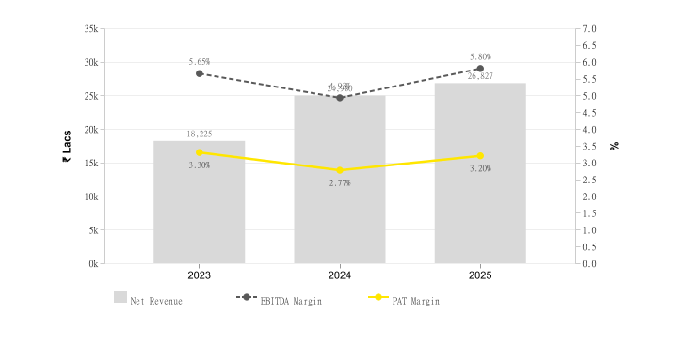
Particulars | 2023 | 2024 | 2025
Profit Margin Ratio (%) | 3.3 | 2.77 | 3.2
EBITDA Margin (%) | 5.65 | 4.93 | 5.8

Return on Assets (ROA) & Capital Employed (ROCE)
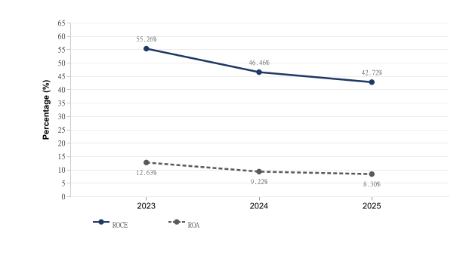
Particulars | 2023 | 2024 | 2025
ROE (%) | 0.38 | 0.31 | 0.28
ROCE (%) | 55.26 | 46.46 | 42.72
ROA (%) | 12.63 | 9.22 | 8.3

Source: EY Network Alliance Databases / Annual Reports

Liquidity Analysis
Name & Relation | Finance - Liquidity Analysis | Rating | High

Liquidity Ratios
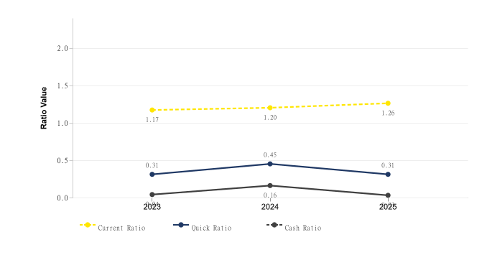
Particulars | 2023 | 2024 | 2025
Current Ratio | 1.17 | 1.2 | 1.26
Quick Ratio | 0.31 | 0.45 | 0.31
Cash Ratio | 0.04 | 0.16 | 0.03

Source: EY Network Alliance Databases / Annual Reports

Operating Cycle
Name & Relation | Finance - Operating Cycle | Rating | Medium

Operating Cycle (Debtor, Creditor & Inventory Days)
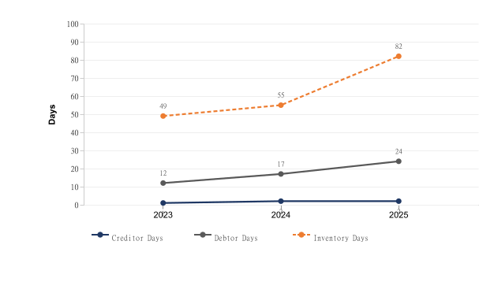
Particulars | 2023 | 2024 | 2025
Inventory Days | 49 | 55 | 82
Debtor Days | 12 | 17 | 24
Creditor Days | 1 | 2 | 2

Asset Turnover Ratio
[Chart unavailable]
Particulars | 2023 | 2024 | 2025
Asset Turnover Ratio | 3.83 | 3.34 | 2.59

Source: EY Network Alliance Databases / Annual Reports

Capital Structure
Name & Relation | Finance - Capital Structure | Rating | High

Debt – Equity Ratio
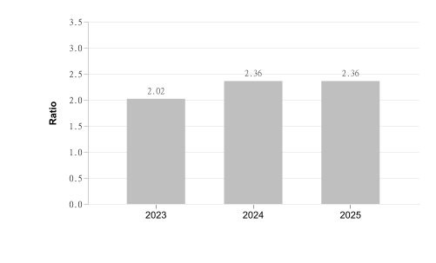
Particulars | 2023 | 2024 | 2025
Debt Equity Ratio | 2.02 | 2.36 | 2.36

Interest Coverage Ratio
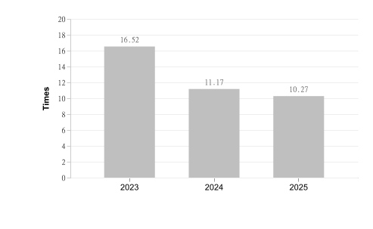
Particulars | 2023 | 2024 | 2025
Interest Coverage Ratio | 16.52 | 11.17 | 10.27

Source: EY Network Alliance Databases / Annual Reports

Name & Relation | Finance - GST Registration Analysis | Rating | Medium
Findings

Date Of Registration | State Of Registration | Gst In | Filing Timeliness
01.07.17 | Uttar Pradesh | 09AAGCS6205A2ZO | Filed After Due Date in last 12 Months,

Source: EY Network Alliance Databases

Name & Relation | Finance - EPFO Registration | Rating | INFO
Findings

Parameter | Value
City | LUCKNOW
Amount | 1,85,776
Address | 3, SHAHNAJAF ROAD ,LUCKNOW,UTTAR PRADESH,226001,India
Date Of Setup | 1947-11-05
Working Status | LIVE ESTABLISHMENT
No Of Employees | 60
Establishment Id | UPLKO0001471000
Latest Wage Month | MAR-26
Establishment Name | SPEED MOTORS PRIVATE LIMITED
Payment Timeliness | Payment After Due Date in last 12 Months.
Exemption Status Pf | UNEXEMPTED
Exemption Status Edli | UNEXEMPTED
Latest Date Of Credit | —
Exemption Status Pension | UNEXEMPTED
Principal Business Activities | AUTOMIBILE SERVICING
City | GORAKHPUR
Amount | —
Address | GOLGHAR GOLGHAR,GORAKHPUR,UTTAR PRADESH,273001,India
Date Of Setup | —
Working Status | CLOSED/ALL MEMBER EXCLUDED
No Of Employees | —
Establishment Id | UPGKP0001472000
Latest Wage Month | —
Establishment Name | SPEED MOTORS PVT. LTD.
Payment Timeliness | —
Exemption Status Pf | UNEXEMPTED
Exemption Status Edli | UNEXEMPTED
Latest Date Of Credit | —
Exemption Status Pension | UNEXEMPTED
Principal Business Activities | AUTOMIBILE SERVICING

Source: EY Network Alliance Databases

Name & Relation | Finance - Auditor Comments | Rating | Low
Findings

Parameter | Value
Adverse Filing | False

Source: EY Network Alliance Databases

Name & Relation | Finance - Related Party Transaction | Rating | INFO
Findings

Name | Relationship | Type Of Transaction | Amount (₹ In Lakhs)
RAJESH NARAIN - HUF | Companies KMP or Their Relatives have Significant Influence | Expense | 48
SPEED MOTORCORP PRIVATE LIMITED | Companies KMP or Their Relatives have Significant Influence | Revenue | 18.85
SPEED WORKS AUTO PVT. LTD. | Companies KMP or Their Relatives have Significant Influence | Revenue | 2.54
SPEED MOTOR COMPANY | Companies KMP or Their Relatives have Significant Influence | Revenue | 1.71
SPEED SAFE AUTO PVT. LTD. | Companies KMP or Their Relatives have Significant Influence | Revenue | 1.12
SPEED MOTORCORP PRIVATE LIMITED | Companies KMP or Their Relatives have Significant Influence | Expense | 0.36

Source: EY Network Alliance Databases

Name & Relation | Finance - Z Altman Score Analysis | Rating | Low
Findings

Parameter | Calculation
Altman Z Score (trading) | 3.28

Source: EY Network Alliance Databases

Adverse Media
Low
This section shall list adverse media coverage and Google ratings for the entity.

Name & Relation | Google Rating Validation | Rating | Low
Findings

Name: SPEED MOTORS PRIVATE LIMITED
Rating: 4.4
Number of Reviews: 1108
Reviews:
1. Name: Mohd Arshad | Rating: 1
I bought new bmw 310 rr a week ago ...I am constantly experiencing clutch issues. The bike is not picking up and producing a lot of sound. I went to service centre, they assured me that they fixed the bike but next day the same issue again came up. The bike is still at bmw service centre and I have no clue as to why my new bike is experiencing this issue. I need urgent help from the bmw India team as my trust is broken and I don't know If I have new or refurbished bike
2. Name: siddhartha mishra | Rating: 5
I had an exceptional experience at BMW Speed Motors! I want to make a specific mention of Mr. Mukul Tripathi, the Sales Consultant who assisted me. I walked in with a lot of questions, and the way he handled every single query was impressive.
What stood out most was how he completely changed my perspective on the BMW X1. His deep product knowledge and genuine advice helped me see value in the car that I hadn't noticed before. If you are looking for a BMW, I highly recommend asking for Mr. Mukul—his professionalism and expertise are top-notch.
3. Name: Shashank Tiwari | Rating: 5
It was really amazing and memorable experience of delivering of the car. Thanks to Anas & Parampreet to make this experience memorable for our family
4. Name: Fd Kd | Rating: 1
Disappointing service experience
For a premium brand, the service experience here was extremely disappointing. My car remained unusable for weeks due to delays, poor communication, and lack of urgency from the service team. Multiple follow-ups were required with no clear timelines. Ghanshyam keeps changing dates every single time without providing prior communication.
When you invest in a luxury vehicle, you expect efficiency and accountability—sadly, that was missing. This experience seriously takes away from the premium ownership promise.
5. Name: Arun Sinha | Rating: 1
Worst service experience.
I had to get my vehicle fixed, but Ghanshyam at BMW was extremely uncooperative. He did not pick up calls despite repeated follow-ups and showed very bad behaviour when contacted. On top of that, he kept giving vague and misleading information, which only delayed the repair and created unnecessary confusion. This is unacceptable from a brand like BMW. Strongly disappointed with the professionalism.

Source: EY Network Alliance Databases

Cyber
Low
This section shall list cyber security ratings for the entity.

CYBER – NO TRUE HITS IDENTIFIED

Annexures

Full List of Shareholders
Significant Shareholders
1. SANDEEP NARAIN 36.3%
2. DIVIJ NARAIN 29.88%
3. VIDIT NARAIN 13.7%
4. RAJESH NARAIN 13.69%
5. RAJESH NARAIN H.U.F 6.43%

Key Management Personnel
Key Management
1. DIVIJ NARAIN - Director
2. RAJESH NARAIN - Director
3. SANDEEP NARAIN - Director
4. VIDIT NARAIN - Director
5. ANITA NARAIN - Director
6. RATI NARAIN - Director
7. SHANTI NARAIN - Director

Full List of Subsidiary
Subsidiary
1. SPEED MOTOCORP PRIVATE LIMITED - 99.99%

Full List of Legal History

Sr. | Date | Case No. | Description | Category | Severity | Status
1 | 08.02.23 | A482/23842/2022 | Case No. A482/23842/2022 was filed before the High Court of Allahabad under the category of Criminal Appeals. This matter pertains to Cases Filed By This Corporate, where SPEED MOTORS PRIVATE LIMITED and Others. has initiated proceedings against State of U.P. AND ANOTHER. | Criminal Appeals | Medium | Disposed
2 | 19.10.21 | Original Suit/4581/2017 | Case No. Original Suit/4581/2017 was filed before the Civil Judge Junior Division under the category of Civil Cases. This matter pertains to Cases Filed Against This Corporate, where Yogeshver Prasad has initiated proceedings against SPEED MOTORS PRIVATE LIMITED. | Civil Cases | Medium | Disposed
3 | 11.09.21 | CS CJ/1629/2016 | Case No. CS CJ/1629/2016 was filed before the Civil Judge Senior Division, Chandigarh under the category of Civil Cases. This matter pertains to Cases Filed Against This Corporate, where M/S AMIT PAINTS has initiated proceedings against SPEED MOTORS PRIVATE LIMITED. | Civil Cases | Medium | Disposed
4 | 14.02.13 | 17 | Case No. 17 was filed before the High Court of Allahabad under the category of Taxation Matters. This matter pertains to Cases Filed Against This Corporate, where C I T has initiated proceedings against Speed Motor P Ltd. | Taxation Matters | Medium | Disposed
5 | 31.03.10 | 486 | Case No. 486 was filed before the High Court of Allahabad under the category of Civil Cases. This matter pertains to Cases Filed Against This Corporate, where Jyoti Rani has initiated proceedings against M/S Speed Motors Pvt. Ltd. & Others. | Civil Cases | Medium | Disposed
6 | 31.03.10 | 486 | Case No. 486 was filed before the High Court of Allahabad under the category of Civil Cases. This matter pertains to Cases Filed Against This Corporate, where Jyoti Rani has initiated proceedings against SPEED MOTORS PRIVATE LIMITED and Others.. | Civil Cases | Medium | Disposed
7 | 12.05.06 | ARBT/19/2005 | Case No. ARBT/19/2005 was filed before the High Court of Allahabad under the category of Arbitration Matters. This matter pertains to Cases Filed Against This Corporate, where SAHU INVESTMENT MUTUAL BENEFIT CO. LTD. THRU S.K.SAHU has initiated proceedings against SPEED MOTORS PRIVATE LIMITED. | Arbitration Matters | Medium | Disposed
8 | 24.09.24 | IA/4151/2019 | Case No. IA/4151/2019 was filed before the National Consumer Disputes Redressal Commission under the category of Applications. This matter pertains to Cases Filed By This Corporate, where M/S. SPEED MOTORS PVT. LTD. has initiated proceedings against UPPER MUKHYA ADHIKARI & ANR.. | Applications | Low | Pending
9 | 30.08.19 | EXE /1161/2016 | Case No. EXE /1161/2016 was filed before the Civil Judge Senior Division, Chandigarh under the category of Others. This matter pertains to Cases Filed Against This Corporate, where M/S PARAM ENTERPRISES has initiated proceedings against SPEED MOTORS PRIVATE LIMITED. | Others | Low | Disposed
10 | 26.05.16 | CS CJ /341/2015 | Case No. CS CJ /341/2015 was filed before the Civil Judge Senior Division, Chandigarh under the category of Others. This matter pertains to Cases Filed Against This Corporate, where MS PARAM ENTERPRISES has initiated proceedings against SPEED MOTORS PRIVATE LIMITED. | Others | Low | Disposed
11 | Unavailable | CV/541/2018 | Case No. CV/541/2018 was filed before the National Consumer Disputes Redressal Commission under the category of Others. This matter pertains to Cases Filed Against This Corporate, where UPPER MUKHYA ADHIKARI, ZILA PANCHAYAT JHANSI has initiated proceedings against SPEED MOTORS PRIVATE LIMITED. | Others | Low | Pending

Source: EY Network Alliance Databases

Full List of Director Network

Sr. | Director Name | DIN | Network
1 | SHANTI NARAIN | 00748628 | • SPEED MOTORS PRIVATE LIMITED — Director (1985-09-02 – 2012-04-18)
2 | RAJESH NARAIN | 00752726 | • SPEED MOTORS PRIVATE LIMITED — Director (1993-01-01 – Present)  • BEVENTUS AGRO VENTURES PRIVATE LIMITED — Director (2010-07-06 – Present) [STRIKE OFF]  • SPEED MOTOCORP PRIVATE LIMITED — Director (2014-12-29 – Present)  • SPEEDSAFE AUTO PRIVATE LIMITED — Director (2016-05-26 – Present)
3 | RATI NARAIN | 00753046 | • SPEED MOTORS PRIVATE LIMITED — Director (1995-10-01 – 2022-05-23)
4 | SANDEEP NARAIN | 00753108 | • SPEED MOTORS PRIVATE LIMITED — Director (1985-09-02 – Present)  • SPEED MOTOCORP PRIVATE LIMITED — Director (2014-12-29 – Present)
5 | ANITA NARAIN | 00753175 | • SPEED MOTORS PRIVATE LIMITED — Director (1995-10-01 – 2012-01-19)  • BEVENTUS AGRO VENTURES PRIVATE LIMITED — Director (2010-07-06 – Present) [STRIKE OFF]
6 | DIVIJ NARAIN | 03030319 | • SPEED MOTORS PRIVATE LIMITED — Director (2012-01-23 – Present)  • BEVENTUS AGRO VENTURES PRIVATE LIMITED — Director (2010-07-06 – Present) [STRIKE OFF]  • SPEED MOTOCORP PRIVATE LIMITED — Additional Director (2015-01-15 – Present)  • SPEEDWORKS AUTO PRIVATE LIMITED — Director (2021-06-04 – Present)
7 | VIDIT NARAIN | 07056540 | • SPEED MOTORS PRIVATE LIMITED — Director (2022-05-23 – Present)  • SPEED MOTOCORP PRIVATE LIMITED — Additional Director (2015-01-15 – Present)  • SPEEDSAFE AUTO PRIVATE LIMITED — Director (2016-05-26 – Present)  • SPEEDWORKS AUTO PRIVATE LIMITED — Director (2021-06-04 – Present)

Source: EY Network Alliance Databases

Disclaimer:
The information included in this report has been primarily collected from databases or public sources, thus it is difficult to verify all aspects of the information obtained. EY makes no representation or warranties with respect to the contents or use of this report, and specifically disclaims any express or implied warranties or usefulness for any particular purpose of this report. EY takes no responsibility for the consequences resulting from decisions based on information included in this report. EY reserves the right to change or revise this report at any time.

Copyright:
All rights reserved. No part of this screening report may be reproduced, photocopied, stored on a retrieval system, or transmitted without the express prior consent of EY.

