
Initial Screening Report
Supplier ID: N/A
INSTANT PROCUREMENT SERVICES PRIVATE LIMITED
[Instant Procurement Services Pvt Ltd]

16th July 2026

Contents

1. Company Profile 3
2. Executive Rating Summary 3
3. Detailed Findings 3
A. Entity Existence 3
B. Legal History and Open Cases 3
C. Financial Indicators 3
D. Adverse Media 3
4. Annexures 4
5. Data Sources 4

Company Profile

Uploaded Name | Instant Procurement Services Pvt Ltd | Supplier ID | N/A
Name | INSTANT PROCUREMENT SERVICES PRIVATE LIMITED | Location | Noida, Uttar Pradesh
Address | KS Corporate Towers, 6th Floor, 24B, Film City, Sector-16A, Noida , Noida Sector 16, Noida, Gautam Buddha Nagar, Uttar Pradesh - 201301 | Website | https://www.procmart.com/
E-Filing Status | Active | Classification | Private Limited Indian Non-Government Company
Incorporation Date | 01/12/2015 | National Identifier | U74120UP2015PTC074758
Corporate Group | Shareholders: 2  Subsidiaries: 5 | Alias
Revenue | 5,185,120,000 | Employee | N/A

Executive Rating Summary

OVERALL RISK RATING | Low

The below ratings are assigned:
Risk Areas | Risk Rating
Entity Existence | Low
Legal | Low
Financial | Low
Adverse Media | Low
Cyber | Low

Detailed Findings

Entity Existence
Low
This section shall list B2B existence, domain validation, and address validation for the entity.

Name & Relation | Domain Validation | Rating | Medium
Findings

Factor | Value
Domain Name | procmart.com
Creation Date | 23-12-2015
Expiration Date | 23-12-2026
Updated Date | 04-05-2024
Registrant Org | redacted for privacy
Registrant Country | in
Registrar | bigrock solutions ltd.
Registrar Url | www.bigrock.com, http://www.bigrock.com
Emails | anish_popli@yahoo.co.in, abuse@bigrock.com
Dnssec | unsigned
Vendor Onboarding Date (Client Database)

Source: EY Network Alliance Databases

Address Validation
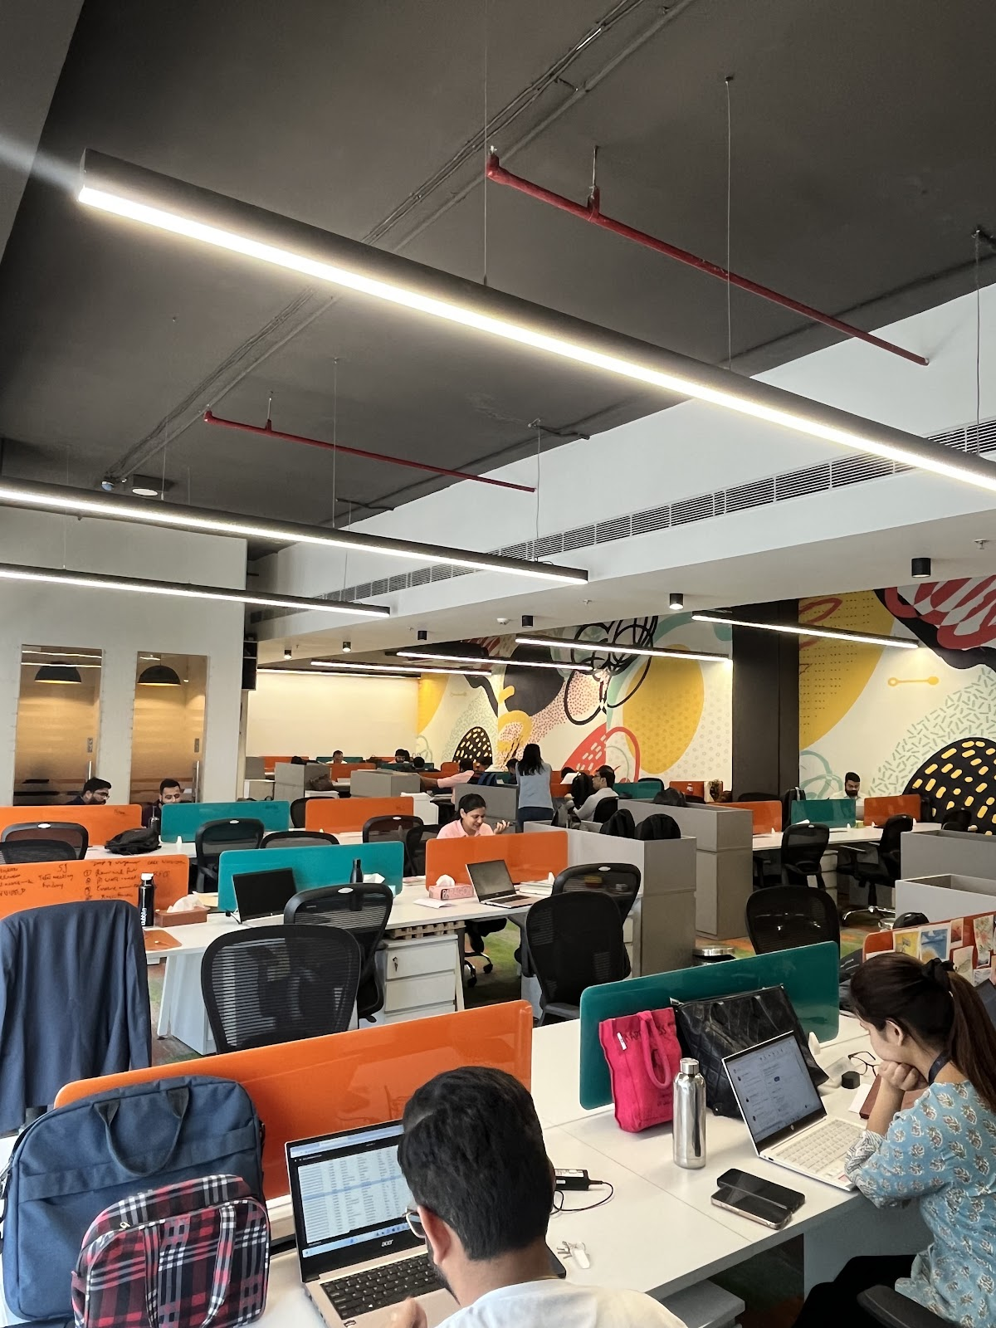 | 

Legal History and Open Cases
Low
This section shall list pending legal cases and open charges against the entity.

Name & Relation | Open Charges | Rating | High
Findings

1. Modification of Rs.143,200,000 in favour of CITIBANK N.A dated 22.05.26
2. Modification of Rs.200,000,000 in favour of ICICI BANK LIMITED dated 18.03.26
3. Creation of Rs.400,000,000 in favour of STANDARD CHARTERED BANK dated 16.02.26
4. Modification of Rs.50,000,000 in favour of TATA CAPITAL LIMITED dated 24.12.25
5. Creation of Rs.250,000,000 in favour of FEDERAL BANK LIMITED dated 15.11.25

Source: EY Network Alliance Databases

Financial Indicators
Low
This section shall list balance sheet, profit and loss, profitability analysis, liquidity analysis, financial ratios, GST registration analysis, MSME registration validation, and related party transactions of the entity.

Name & Relation | Finance - Profit And Loss | Rating | INFO
Findings

Income Statement (₹ in Lakhs)
Particulars | 2023 | 2024 | 2025
Net Revenue (₹ in Lakhs) | 20,607.3 | 62,148.99 | 52,226.69
Profit After Tax (₹ in Lakhs) | 168.57 | 72.74 | 1.92

Source: EY Network Alliance Databases / Annual Reports

Name & Relation | Finance - Balance Sheet | Rating | INFO
Findings

Balance Sheet (₹ in Lakhs)
Particulars | 2023 | 2024 | 2025
Total Current Assets (₹ in Lakhs) | 12,799.83 | 22,145.12 | 42,664.8
Total Other Non Current Assets (₹ in Lakhs) | 949.31 | 889.82 | 811.59
Net Fixed Assets (₹ in Lakhs) | 168.36 | 563.71 | 1,177.95
Total Current Liabilities (₹ in Lakhs) | 7,956.72 | 9,352.13 | 11,580.54
Total Non Current Liabilities (₹ in Lakhs) | 123.95 | 335.68 | 175.93
Total Equity (₹ in Lakhs) | 5,836.83 | 13,910.84 | 32,897.87

Source: EY Network Alliance Databases / Annual Reports

Profitability Analysis
Name & Relation | Finance - Profitability Analysis | Rating | Medium

Revenue, EBITDA and PAT Margin
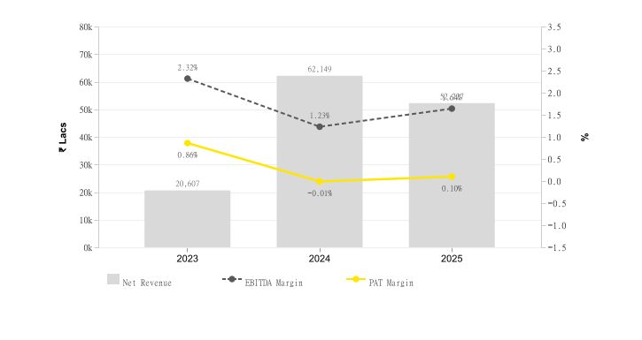
Particulars | 2023 | 2024 | 2025
Profit Margin Ratio (%) | 0.86 | -0.01 | 0.1
EBITDA Margin (%) | 2.32 | 1.23 | 1.64

Return on Assets (ROA) & Capital Employed (ROCE)
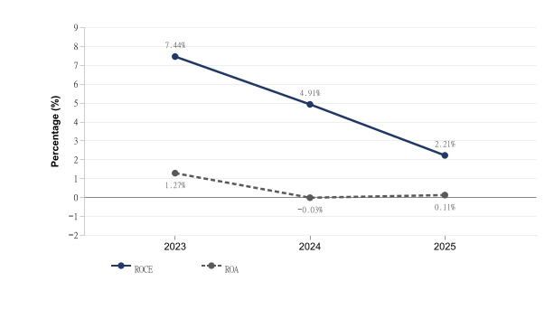
Particulars | 2023 | 2024 | 2025
ROE (%) | 0.03 | -0 | 0
ROCE (%) | 7.44 | 4.91 | 2.21
ROA (%) | 1.27 | -0.03 | 0.11

Source: EY Network Alliance Databases / Annual Reports

Liquidity Analysis
Name & Relation | Finance - Liquidity Analysis | Rating | Low

Liquidity Ratios
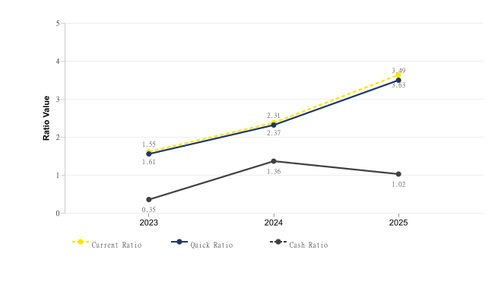
Particulars | 2023 | 2024 | 2025
Current Ratio | 1.61 | 2.37 | 3.63
Quick Ratio | 1.55 | 2.31 | 3.49
Cash Ratio | 0.35 | 1.36 | 1.02

Source: EY Network Alliance Databases / Annual Reports

Operating Cycle
Name & Relation | Finance - Operating Cycle | Rating | Medium

Operating Cycle (Debtor, Creditor & Inventory Days)
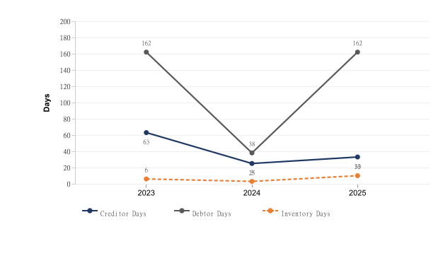
Particulars | 2023 | 2024 | 2025
Inventory Days | 6 | 3 | 10
Debtor Days | 162 | 38 | 162
Creditor Days | 63 | 25 | 33

Asset Turnover Ratio
[Chart unavailable]
Particulars | 2023 | 2024 | 2025
Asset Turnover Ratio | 1.48 | 2.62 | 1.16

Source: EY Network Alliance Databases / Annual Reports

Capital Structure
Name & Relation | Finance - Capital Structure | Rating | High

Debt – Equity Ratio
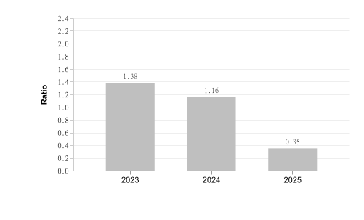
Particulars | 2023 | 2024 | 2025
Debt Equity Ratio | 1.38 | 1.16 | 0.35

Interest Coverage Ratio
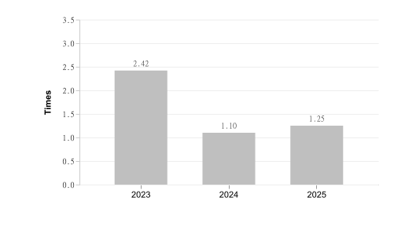
Particulars | 2023 | 2024 | 2025
Interest Coverage Ratio | 2.42 | 1.1 | 1.25

Source: EY Network Alliance Databases / Annual Reports

Name & Relation | Finance - Auditor Comments | Rating | Low
Findings

Parameter | Value
Adverse Filing | False

Source: EY Network Alliance Databases

Name & Relation | Finance - Related Party Transaction | Rating | INFO
Findings

Name | Relationship | Type Of Transaction | Amount (₹ In Lakhs)
Procmart SDN. BHD., Malaysia | Subsidiary | Revenue | 30.99

Source: EY Network Alliance Databases

Name & Relation | Finance - MSME Payment Analysis | Rating | INFO
Findings

Period | Amount (₹ In Lakhs)
October 2023 to March 2024 | 5.72
April 2024 to September 2024 | 39.99
October 2024 to March 2025 | 90.84
April 2025 to September 2025 | 65.65
October 2025 to March 2026 | 133.73

Source: EY Network Alliance Databases

Name & Relation | Finance - EPFO Registration | Rating | INFO
Findings

Parameter | Value
City | Noida
Amount | 30,50,985
Address | Flat No.1401, Tower 7 Lotus Boulevard Sector 100,Noida,UTTAR PRADESH,201304,India
Date Of Setup | 2015-12-01
Working Status | LIVE ESTABLISHMENT
No Of Employees | 650
Establishment Id | MRNOI1805895000
Latest Wage Month | APR-26
Establishment Name | Instant Procurement Services Private Limited
Payment Timeliness | Payment After Due Date in last 12 Months.
Exemption Status Pf | UNEXEMPTED
Exemption Status Edli | UNEXEMPTED
Latest Date Of Credit | —
Exemption Status Pension | UNEXEMPTED
Principal Business Activities | TRADING - COMMERCIAL ESTABLISHMENTS

Source: EY Network Alliance Databases

Name & Relation | Finance - GST Registration Analysis | Rating | Low
Findings

Date Of Registration | State Of Registration | Gst In | Filing Timeliness
18.01.25 | Assam | 18AADCI9794D1Z5 | Filed on Time
01.01.25 | Bihar | 10AADCI9794D1ZL | Filed on Time
07.01.25 | Chhattisgarh | 22AADCI9794D2ZF | Filed on Time
01.07.17 | Delhi | 07AADCI9794D1Z8 | Filed on Time
15.07.20 | Goa | 30AADCI9794D1ZJ | Filed on Time
01.09.19 | Gujarat | 24AADCI9794D1ZC | Filed on Time
01.08.19 | Haryana | 06AADCI9794D1ZA | Filed on Time
21.08.24 | Himachal Pradesh | 02AADCI9794D1ZI | Filed on Time
01.07.17 | Karnataka | 29AADCI9794D1Z2 | Filed on Time
19.04.22 | Kerala | 32AADCI9794D1ZF | Filed on Time
22.01.24 | Madhya Pradesh | 23AADCI9794D1ZE | Filed on Time
01.02.25 | Maharashtra | 27AADCI9794D2Z5 | Filed on Time
01.07.17 | Maharashtra | 27AADCI9794D1Z6 | Filed on Time
18.12.24 | Maharashtra | 27AADCI9794D1DF | Filed on Time
29.04.22 | Odisha | 21AADCI9794D1ZI | Filed on Time
01.08.24 | Rajasthan | 08AADCI9794D1Z6 | Filed on Time
08.06.19 | Tamil Nadu | 33AADCI9794D1ZD | Filed on Time
06.09.22 | Telangana | 36AADCI9794D1Z7 | Filed on Time
17.12.25 | Tripura | 16AADCI9794D1Z9 | Filed on Time
01.07.17 | Uttar Pradesh | 09AADCI9794D1Z4 | Filed on Time
27.02.24 | Uttarakhand | 05AADCI9794D1ZC | Filed on Time
01.11.21 | West Bengal | 19AADCI9794D1Z3 | Filed on Time

Source: EY Network Alliance Databases

Name & Relation | Finance - Z Altman Score Analysis | Rating | Low
Findings

Parameter | Calculation
Altman Z Score (trading) | 8.83

Source: EY Network Alliance Databases

Adverse Media
Low
This section shall list adverse media coverage and Google ratings for the entity.

Name & Relation | Google Rating Validation | Rating | Medium
Findings

Name: INSTANT PROCUREMENT SERVICES PRIVATE LIMITED
Rating: 3.2
Number of Reviews: 9
Reviews:
1. Name: Satva international | Rating: 1
Our experience with this company has been disappointing due to delayed payments. Despite completing the work and multiple follow-ups, the payment has still not been cleared. Timely payment is very important in business, and we hope the company improves its financial commitment and communication with vendors. -AXCELL INDUSTRIES
2. Name: Axcell Industries | Rating: 1
Avoid ProcMart! They have failed to provide payment for services rendered months ago. Multiple follow-ups have been ignored. Highly unprofessional and lacks integrity. #ProcMart #PaymentIssue #VendorBeware
3. Name: Nikesh Axcell Industries | Rating: 1
Payment terms are not proper, don't go for verbal confirmations.
4. Name: CA Lalit Patel | Rating: 5
5. Name: Srinivasan | Rating: 5

Source: EY Network Alliance Databases

Cyber
Low
This section shall list cyber security ratings for the entity.

Name & Relation | Cyber Risk Validation | Rating | Low
Findings

Factor | Value
Resolved IP | 13.207.248.103
Botnet Threat | NO
Malware Hosting Threat | NO
Command & Control Threat | NO
Spam Server Threat | NO
Overall Compromised | NO
Vendor / 3rd-Party Risk | PASS
Fraud / Compliance Flag | NO

Source: EY Network Alliance Databases

Annexures

Full List of Shareholders
Significant Shareholders
1. ANISH POPLI 70.18%
2. SIXTH SENSE INDIA OPPORTUNITIES III 24.35%

Key Management Personnel
Key Management
1. ANISH POPLI - Director
2. NIKHIL KISHORCHANDRA VORA - Director
3. ASHOK KUMAR POPLI - Director
4. PRATEEK KUMAR JAIN - Nominee Director
5. ASHISH AGARWAL - Nominee Director
6. CHUNSOO KIM - Nominee Director
7. KETKI BAPAT - Director
8. PRATIK KISHOR POTNIS - Additional Director
9. JOSHI SAHEEL UDAY - Additional Director

Full List of Subsidiary
Subsidiary
1. PROCMART PACKAGING PRIVATE LIMITED - 100%
2. PROCMART SDN BHD - 100%
3. PT PROCMART TECHNOLOGIES - 100%
4. PT Procmart Technologies, Indonesia - 100%
5. Procmart SDN BHD - 100%

Full List of Legal History

Sr. | Date | Case No. | Description | Category | Severity | Status
1 | 23.10.23 | SCA/563/2023 | Case No. SCA/563/2023 was filed before the High Court of Gujarat under the category of Civil Cases. This matter pertains to Cases Filed Against This Corporate, where FOXBASE TECHNOLOGIES PRIVATE LIMITED has initiated proceedings against INSTANT PROCUREMENT SERVICES PRIVATE LIMITED and Others.. | Civil Cases | Medium | Disposed
2 | 27.04.22 | CS DJ/740/2021 | Case No. CS DJ/740/2021 was filed before the District and Sessions Judge, Central, THC under the category of Civil Cases. This matter pertains to Cases Filed Against This Corporate, where M/S TRANSJOVAN CAPITAL ADVISORS LLP has initiated proceedings against INSTANT PROCUREMENT SERVICES PRIVATE LIMITED. | Civil Cases | Medium | Disposed
3 | 13.09.23 | CS (COMM.) /873/2022 | Case No. CS (COMM.) /873/2022 was filed before the District and Sessions Judge,New Delhi, PHC under the category of Others. This matter pertains to Cases Filed Against This Corporate, where KUEHNE NAGEL PVT LTD has initiated proceedings against INSTANT PROCUREMENT SERVICES PRIVATE LIMITED. | Others | Low | Disposed

Source: EY Network Alliance Databases

Full List of Director Network

Sr. | Director Name | DIN | Network
1 | ASHISH AGARWAL | 02421421 | • RELAITECH ENGINEERS PRIVATE LIMITED — Director (2011-06-29 – 2014-09-15) [STRIKE OFF]  • AMBROSIA CORNER HOUSE PRIVATE LIMITED — Director (2011-05-13 – 2012-07-19)  • PROSALES FINANCIAL SERVICES PRIVATE LIMITED — Director (2011-02-21 – 2012-07-11)  • ITM EDUTECH (INDIA) LIMITED — Director (2009-04-15 – 2022-04-11)  • AFFILIATES MANAGEMENT RESOURCES PRIVATE LIMITED — Director (2011-02-21 – 2012-07-11)  • ATHENA BPO PRIVATE LIMITED — Additional Director (2012-08-08 – 2013-03-20)  • ATHENA CALL CENTRE SERVICES PRIVATE LIMITED — Director (2011-02-21 – 2013-03-20)  • ANDROMEDA SALES AND DISTRIBUTION PRIVATE LIMITED — Additional Director (2012-06-14 – 2012-07-11) [AMALGAMATED]  • CLASSIC STRIPES PRIVATE LIMITED — Director (2011-03-29 – 2014-05-19) [AMALGAMATED]  • HILL & ASSOCIATES RISK CONSULTANCY PRIVATE LIMITED — Director (2007-03-15 – 2010-03-31) [STRIKE OFF]  • INSTITUTE FOR TECHNOLOGY AND MANAGEMENT — Director (2009-04-15 – 2022-04-11)  • ITM EDUTECH TRAINING PRIVATE LIMITED — Director (2013-07-04 – 2022-04-11)  • GP PETROLEUMS LIMITED — Director (2013-03-28 – 2014-07-31)  • NIRVADHYA CAPITAL INDIA PRIVATE LIMITED — Director (2014-06-30 – 2020-06-01) [STRIKE OFF]  • RANKSURGE LEARNING PRIVATE LIMITED — Nominee Director (2015-07-15 – 2019-02-07)  • SEKHMET TECHNOLOGIES PRIVATE LIMITED — Nominee Director (2023-03-24 – Present)  • INSTANT PROCUREMENT SERVICES PRIVATE LIMITED — Nominee Director (2024-04-19 – Present)  • RESIDEO INTERNATIONAL (INDIA) PRIVATE LIMITED — Director (2011-02-12 – 2011-12-16)  • RENEE COSMETICS PRIVATE LIMITED — Nominee Director (2024-07-04 – Present)  • SIAASH FOODS PRIVATE LIMITED — Director (2020-01-03 – Present)  • RENTOMOJO LIMITED — Nominee Director (2024-02-21 – 2026-03-09)
2 | PRATEEK KUMAR JAIN | 03127489 | • CANOPUS WASTE WATER TREATMENT PRIVATE LIMITED — Director (2011-02-07 – Present) [STRIKE OFF]  • GLOW PRIME TECHNOLOGIES PRIVATE LIMITED — Director (2015-05-06 – 2017-02-28) [AMALGAMATED]  • INSTANT PROCUREMENT SERVICES PRIVATE LIMITED — Nominee Director (2024-04-19 – Present)  • PLUS HEALTH TECH VENTURES PRIVATE LIMITED — Nominee Director (2022-06-01 – 2025-03-31)  • FUNDAMENTUM VC ADVISORS LLP (LLP) — Designated Partner (None – Present)  • FUNDAMENTUM SPONSORS III LLP (LLP) — Designated Partner (None – Present)
3 | NIKHIL KISHORCHANDRA VORA | 05014606 | • WONDERCHEF HOME APPLIANCES PRIVATE LIMITED — Director (2021-11-17 – Present)  • CROSS ROADS INDIA ASSISTANCE PRIVATE LIMITED — Nominee Director (2015-01-08 – 2017-07-27)  • FULLIFE HEALTHCARE PRIVATE LIMITED — Nominee Director (2018-06-14 – 2025-03-27)  • SOOTHE HEALTHCARE PRIVATE LIMITED — Director (2016-06-06 – 2025-06-24)  • G S E-COMMERCE PRIVATE LIMITED — Nominee Director (2021-09-15 – 2022-09-06)  • ALTIGREEN PROPULSION LABS PRIVATE LIMITED — Nominee Director (2022-02-18 – 2024-11-13)  • SMAAASH ENTERTAINMENT PRIVATE LIMITED — Director (2017-12-05 – 2019-08-15)  • PROZO INTEGRATED LOGISTICS PRIVATE LIMITED — Director (2022-03-07 – Present)  • VAHDAM TEAS PRIVATE LIMITED — Director (2019-10-03 – Present)  • SHOP KIRANA E TRADING PRIVATE LIMITED — Nominee Director (2022-09-13 – 2023-03-15)  • L-FAST BRANDS PRIVATE LIMITED — Nominee Director (2016-02-24 – 2019-03-06)  • SAFFRON STUDIOS PRIVATE LIMITED — Nominee Director (2018-08-16 – 2022-01-18)  • KHANAL FOODS PRIVATE LIMITED — Nominee Director (2022-01-25 – 2023-11-02)  • INSTANT PROCUREMENT SERVICES PRIVATE LIMITED — Director (2023-04-19 – Present)  • GOODDOT ENTERPRISES PRIVATE LIMITED — Director (2021-07-28 – 2026-02-05)  • KANPUR FLOWERCYCLING PRIVATE LIMITED — Nominee Director (2022-09-15 – Present)  • MYHEALTHCARE TECHNOLOGIES PRIVATE LIMITED — Nominee Director (2024-10-04 – Present)  • VNF IDEAS PRIVATE LIMITED — Nominee Director (2021-08-09 – 2022-07-22)  • SWMABHAN COMMERCE PRIVATE LIMITED — Director (2021-09-03 – 2022-08-09)  • STORIA FOODS & BEVERAGES PRIVATE LIMITED — Director (2021-10-12 – 2022-01-21)  • IMMACULATEBITES PRIVATE LIMITED — Director (2021-07-16 – 2023-09-29)  • LIFEX SCIENCES PRIVATE LIMITED — Director (2023-10-10 – 2024-06-11)  • JHS SVENDGAARD LABORATORIES LIMITED — Nominee Director (2016-02-11 – 2022-02-28)  • JHS SVENDGAARD BRANDS LIMITED — Nominee Director (2019-03-01 – 2022-01-14) [AMALGAMATED]  • ACEFOUR ACCESSORIES PRIVATE LIMITED — Nominee Director (2022-08-01 – Present)  • PROFICIENCY LEARNING SOLUTIONS PRIVATE LIMITED — Director (2018-03-12 – 2022-06-20)  • FITTERNITY HEALTH E-SOLUTION PRIVATE LIMITED — Nominee Director (2019-09-19 – 2021-03-15) [AMALGAMATED]  • GRAB A GRUB SERVICES LIMITED — Nominee Director (2015-12-02 – 2019-03-07)  • SAUCERY FOODS PRIVATE LIMITED — Director (2018-05-29 – 2021-11-20)  • VISAGE LINES PERSONAL CARE PRIVATE LIMITED — Nominee Director (2020-05-25 – Present)  • PARAG MILK FOODS LIMITED — Director (2021-08-20 – Present)  • HINDUSTAN FOODS LIMITED — Director (2017-05-22 – Present)  • BIKAJI FOODS INTERNATIONAL LIMITED — Director (2021-12-08 – Present)  • LEAP INDIA LIMITED — Director (2016-12-22 – 2021-08-06)  • INSTITUTE INCUBATION & INNOVATION COUNCIL (I3C)-IIT JAMMU — Director (2021-10-14 – Present)  • ENLEARNING SKILL DEVELOPMENT LIMITED — Director (2025-09-19 – Present)  • NEEMANS PRIVATE LIMITED — Nominee Director (2021-07-29 – Present)  • IN-FIELDSPORTS TECHNOLOGY INDIA PRIVATE LIMITED — Additional Director (2026-06-22 – Present)  • NOBEL HYGIENE LIMITED — Nominee Director (2022-09-07 – 2026-06-25)  • SIXTH SENSE KNOWLEDGE INDIA - LLP (LLP) — Designated Partner (None – Present)  • SIXTH SENSE VENTURES ADVISORS LLP (LLP) — Designated Partner (None – Present)  • BAMBOO VENTURES ADVISORS LLP (LLP) — Designated Partner (None – Present)
4 | PRATIK KISHOR POTNIS | 06455250 | • INSTANT PROCUREMENT SERVICES PRIVATE LIMITED — Additional Director (2015-12-31 – 2017-09-16)  • TRIOS COWORKING PRIVATE LIMITED — Director (2017-01-23 – Present)  • FIXSTREAM INDIA PRIVATE LIMITED — Director (2013-01-14 – 2016-01-01)  • THOUGHT RIVER EDUTECH PRIVATE LIMITED — Director (2022-05-14 – Present)  • MODULARTEK FURNITURE PRIVATE LIMITED — Director (2024-07-23 – Present)
5 | KETKI BAPAT | 06501326 | • VEDIC COSMECEUTICALS PRIVATE LIMITED — Director (2022-03-30 – 2024-09-30)  • IMPRESARIO ENTERTAINMENT AND HOSPITALITY PRIVATE LIMITED — Director (2017-11-30 – 2021-09-15)  • LCATTERTON MUMBAI ADVISORY SERVICES PRIVATE LIMITED — Managing Director (2017-03-20 – 2021-09-16)  • FUTURE LIFESTYLE FASHIONS LIMITED — Alternate Director (2020-07-31 – 2021-08-13) [UNDER CIRP]  • INSTANT PROCUREMENT SERVICES PRIVATE LIMITED — Director (2023-01-31 – 2023-04-19)  • MYHEALTHCARE TECHNOLOGIES PRIVATE LIMITED — Nominee Director (2023-01-13 – 2024-09-30)  • GLF LIFESTYLE BRANDS PRIVATE LIMITED — Director (2013-03-11 – 2013-11-25) [AMALGAMATED]  • RELIANCE BRANDS LUXURY FASHION PRIVATE LIMITED — Director (2013-02-16 – 2014-03-03) [AMALGAMATED]  • RAS BEAUTY PRIVATE LIMITED — Nominee Director (2022-05-13 – 2025-01-10)  • ROKETRISE LLP (LLP) — Designated Partner (None – Present)
6 | ANISH POPLI | 06904348 | • INTERROBANG SOLUTIONS PRIVATE LIMITED — Director (2014-11-20 – Present) [STRIKE OFF, ACTIVE Non-Compliant]  • INSTANT PROCUREMENT SERVICES PRIVATE LIMITED — Director (2015-12-01 – Present)  • PROCMART PACKAGING PRIVATE LIMITED — Director (2025-02-04 – Present)
7 | ASHOK KUMAR POPLI | 07348432 | • INSTANT PROCUREMENT SERVICES PRIVATE LIMITED — Director (2017-09-15 – Present)
8 | JOSHI SAHEEL UDAY | 07389623 | • INSTANT PROCUREMENT SERVICES PRIVATE LIMITED — Additional Director (2015-12-31 – 2017-09-16)
9 | CHUNSOO KIM | 09749619 | • INSTANT PROCUREMENT SERVICES PRIVATE LIMITED — Nominee Director (2024-04-19 – Present)  • MANAK WASTE MANAGEMENT PRIVATE LIMITED — Nominee Director (2022-09-27 – Present)

Source: EY Network Alliance Databases

Disclaimer:
The information included in this report has been primarily collected from databases or public sources, thus it is difficult to verify all aspects of the information obtained. EY makes no representation or warranties with respect to the contents or use of this report, and specifically disclaims any express or implied warranties or usefulness for any particular purpose of this report. EY takes no responsibility for the consequences resulting from decisions based on information included in this report. EY reserves the right to change or revise this report at any time.

Copyright:
All rights reserved. No part of this screening report may be reproduced, photocopied, stored on a retrieval system, or transmitted without the express prior consent of EY.

