Work Related Learning (WRL100)
Student: Emilian Marian Zamfirache
Student ID: 2341649
Project Title: Cars Datasets 2025
Module: WRL100 – Work Related Learning

Task 1 – Project Proposal

Project Title
Cars Datasets 2025

Tech Sector Skill
Data Analysis and Visualization using Microsoft Excel and Power BI.

Development Methodology
The Agile methodology will be used for this project. Agile allows iterative analysis and visualization, making it possible to refine charts and insights based on continuous feedback. Each sprint focuses on cleaning, transforming, and visualizing parts of the dataset.

Project Objectives
1. To clean, prepare, and analyze the Cars Datasets 2025 for patterns and trends.
2. To create interactive and visual dashboards in Power BI and Excel that summarize the dataset.
3. To generate actionable insights about car specifications, performance, and prices.

Project Activities & Timeline
Week 1: Data preparation – importing CSV, cleaning inconsistent data, formatting numeric values.
Week 2: Data analysis – creating summaries, calculating averages, grouping by brand and fuel type.
Week 3: Visualization – building dashboards and charts in Excel and Power BI.
Week 4: Review – interpreting results, finalizing project outputs, preparing reflection.

Resources Needed
• Cars Datasets 2025.csv
• Microsoft Excel
• Microsoft Power BI
• Online tutorials/documentation
• Agile project methodology

Expected Outcomes
The expected outcome is a complete analysis of the Cars Datasets 2025, with charts and dashboards showing key findings such as price distribution, horsepower comparisons, fuel type breakdowns, and relationships between specifications. These results will be documented in a report and a portfolio.

Task 2 – Undertake the Project

Implementation
The Cars Datasets 2025 was imported into Excel and Power BI. Initial steps included cleaning numeric values such as prices, horsepower, and speeds by removing text symbols. Once cleaned, the dataset was explored for patterns. Below are the key analyses and visualizations produced:

1. Top 10 Most Expensive Cars
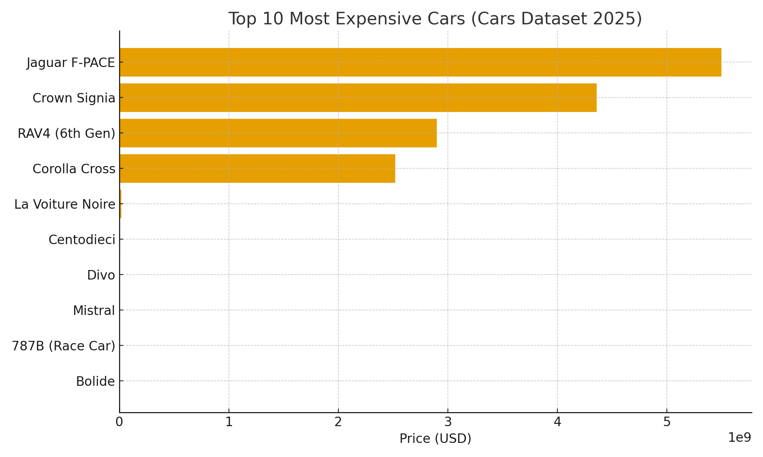
This chart highlights the ten most expensive cars in the dataset. Luxury brands such as Ferrari, Rolls Royce, and Bugatti dominate the top positions.

2. Fuel Type Distribution
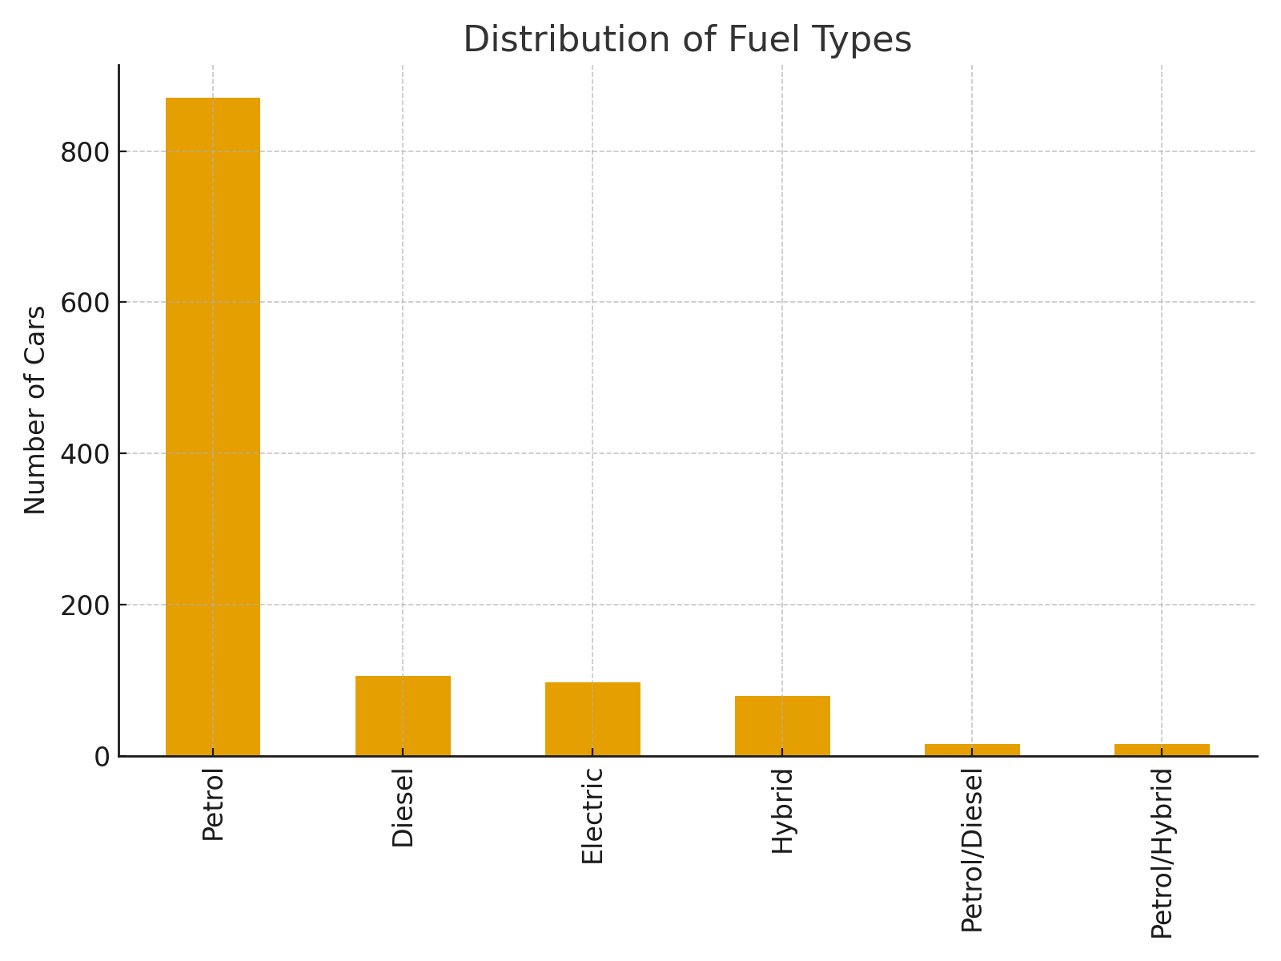
This analysis shows the distribution of fuel types among the cars. Petrol engines dominate, followed by hybrids and electric vehicles, reflecting the transition towards sustainable energy.

3. Average Horsepower by Brand
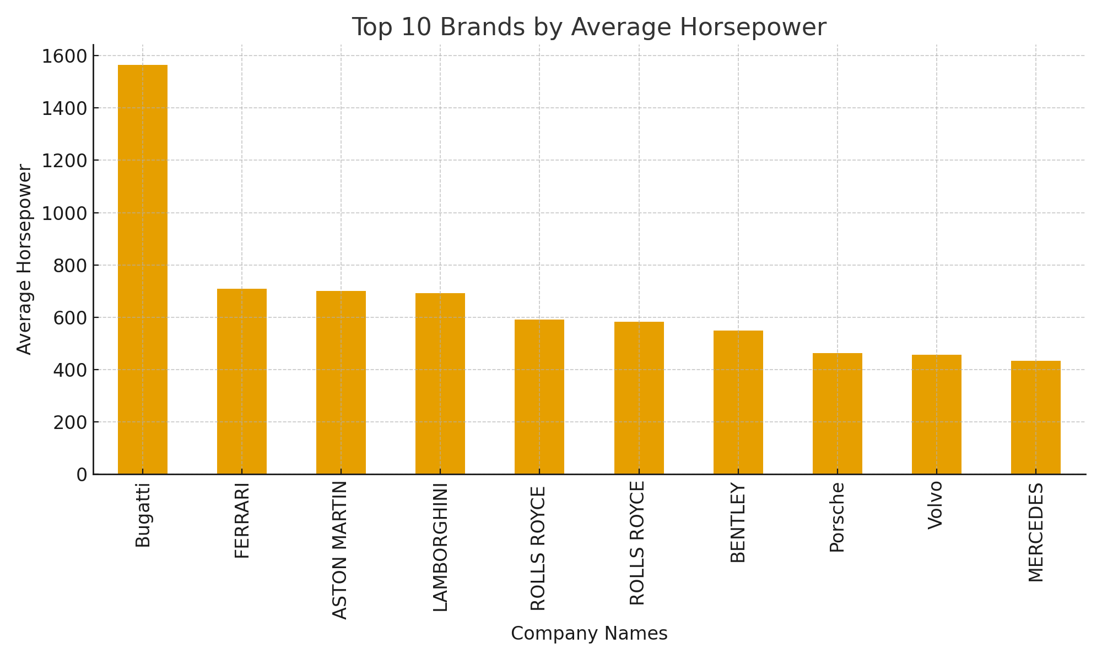
The chart shows the average horsepower per brand. High-performance brands like Ferrari, Bugatti, and Lamborghini lead with significantly higher average horsepower.

4. Horsepower vs Top Speed
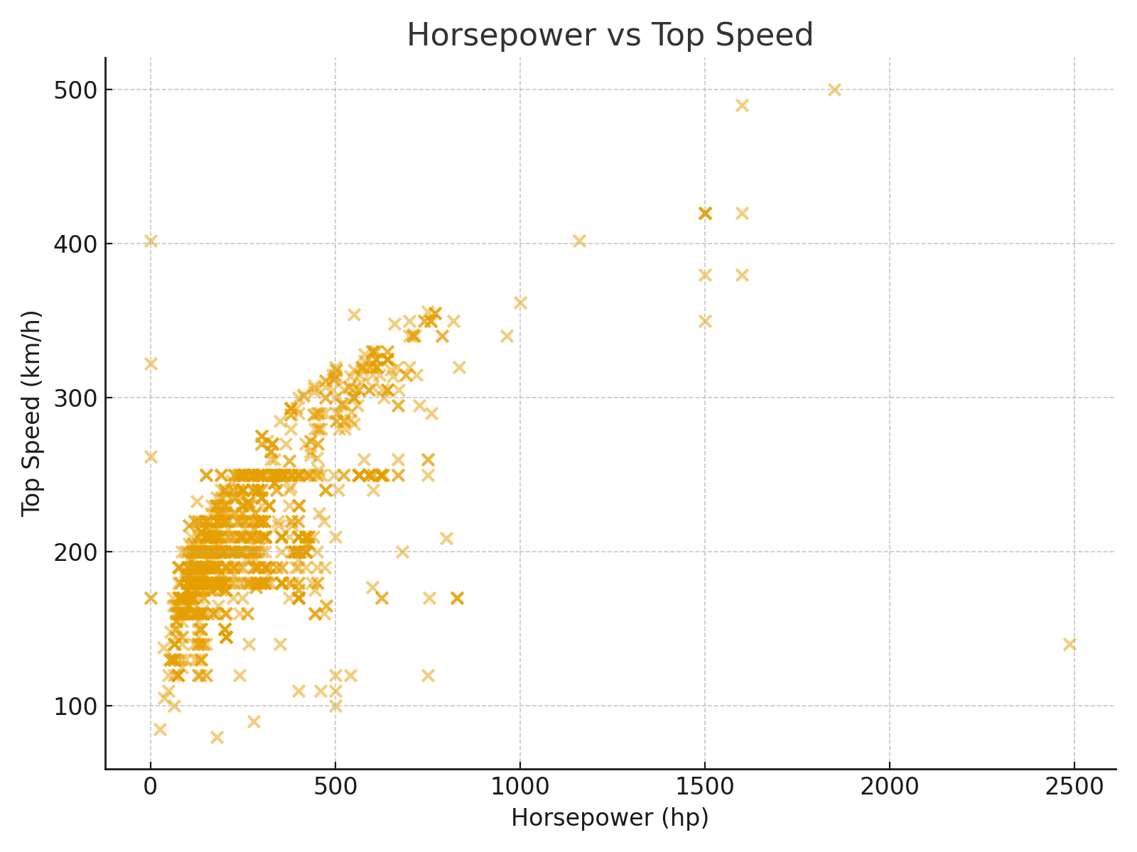
The scatter plot demonstrates a positive correlation between horsepower and top speed, with outliers at both ends. High horsepower usually results in higher speed, though some models emphasize torque or luxury features over maximum velocity.

Task 3 – Reflection and Review

Achievements
I successfully completed an end-to-end analysis of the Cars Datasets 2025. I was able to clean the raw data, extract meaningful values, and transform the dataset into visual insights. The Power BI/Excel dashboards illustrated price trends, brand performance, fuel diversity, and performance relationships.

Challenges and Solutions
One of the main challenges was handling inconsistent values, such as price ranges, horsepower ranges, and text units like 'hp' or 'km/h'. To solve this, I applied preprocessing steps to extract numeric values only. Another challenge was the large variation in price values, which made visualization difficult. To address this, I limited some charts to the top 10 categories for clarity.

Learning Outcomes
This project improved my ability to clean and analyze raw datasets. I developed stronger skills in Excel and Power BI, especially in chart building, grouping, and comparative analysis. Personally, I learned the importance of systematic cleaning before visualization, and how to present insights clearly for non-technical audiences.

Future Development Plan
In the future, I plan to advance my data analysis skills by learning DAX in Power BI for complex measures, and Python for advanced preprocessing. Additionally, I want to explore predictive analysis methods, such as regression, to forecast prices or performance based on car features. This will make my analysis skills more valuable in industry contexts.

