# BD-4873 UAT- BBR- "0 null in list “ message is displayed when clearing industry type field and user is able to move to next page without Industry Class

Steps to reproduce:

1. Re-call a existing quote with Industry type and Industry class completed
2. Clear Industry type field
3. Click on Continue- “0 null in list “ message is displayed
4. Close the error
5. Click on next

Actual result: “0 null in list “ message is displayed and user is able to proceed

Expected result: Industry class field should be required

Testing Results:

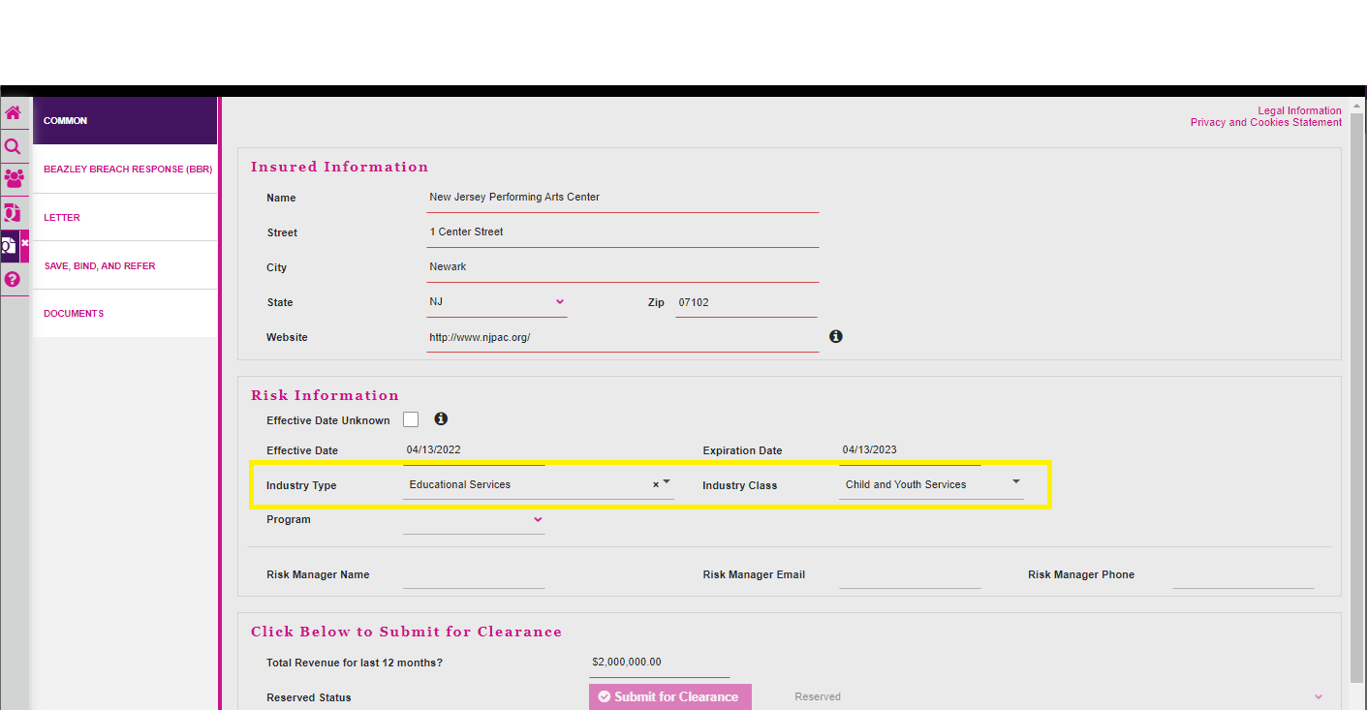

After the Industry Type value was removed, automatically the Industry Class value went empty.

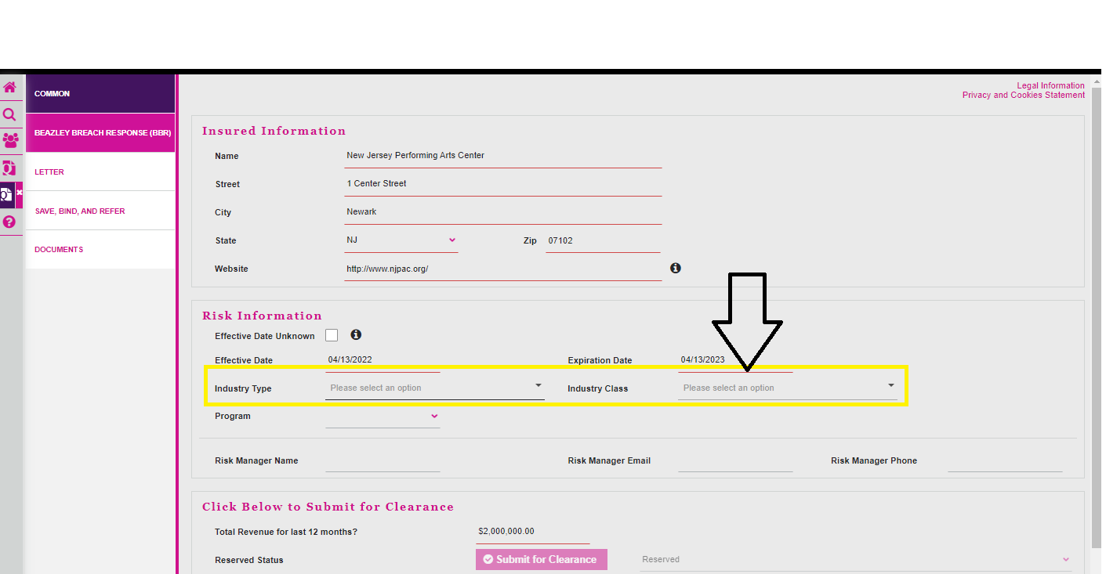

Then I clicked continue, and a message appeared in the Industry Class as shown in the next capture, which is the expected result.

