# BD-4246 Base Merge & RSX Upgrade - April 2022

**Test Case BD-6556**

At the moment we saved the quote, the name “UAT-June3-WV-Surplus” was done.

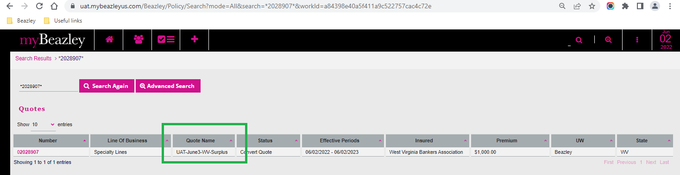

Test case BD-6557

