# Ghsdfgsdfgsdfg

The status changed

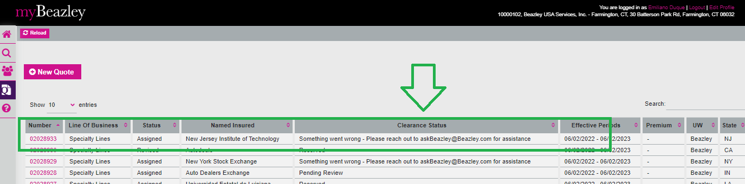

Changed the Clearance status to “Reserved”

After click on Save and Exit, the banner disappears and the loading bar appears, so there is no way to double click it.

