# BD-5341

Test Case BD-6987

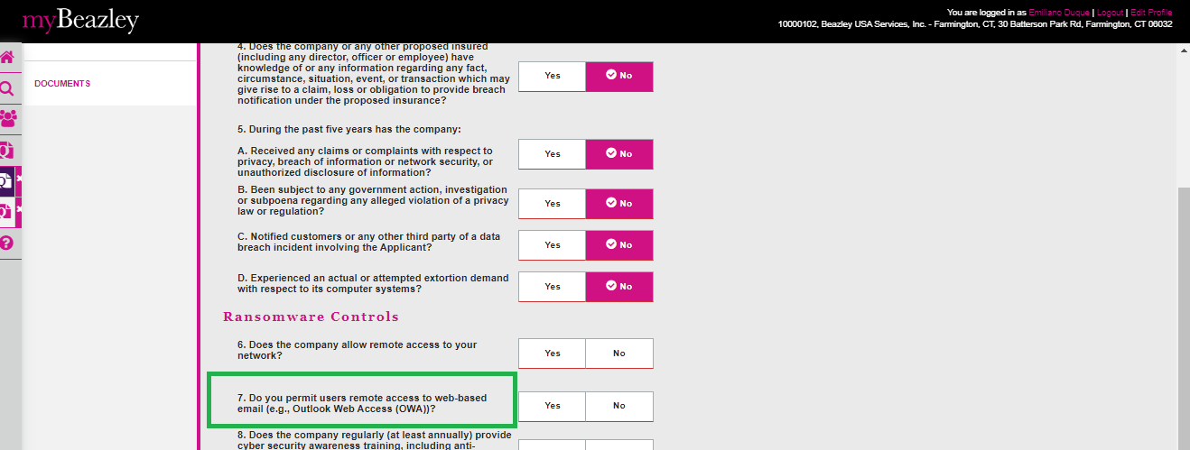

Test Case BD-6988

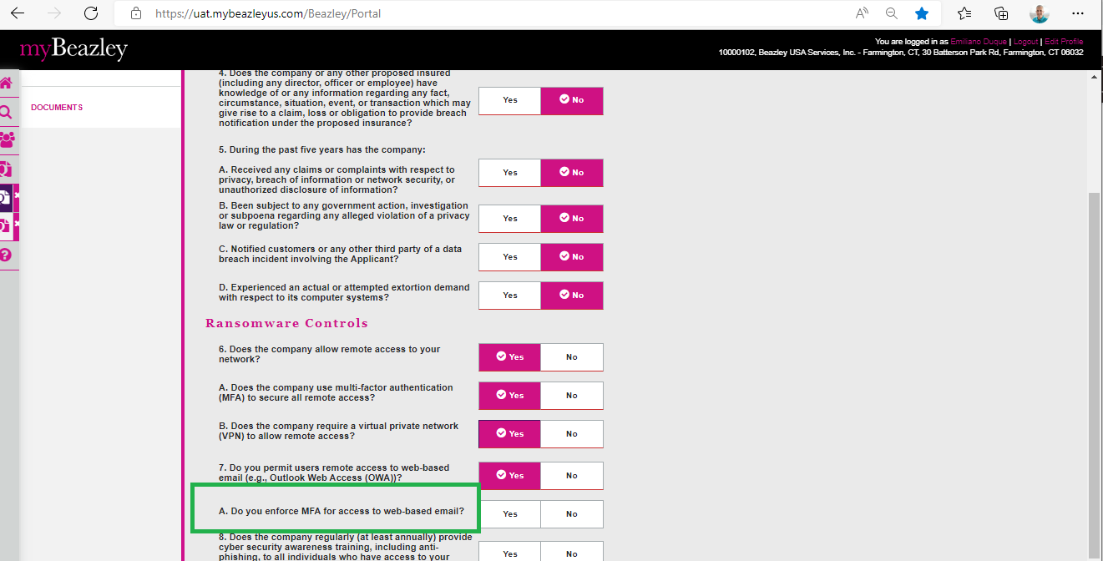

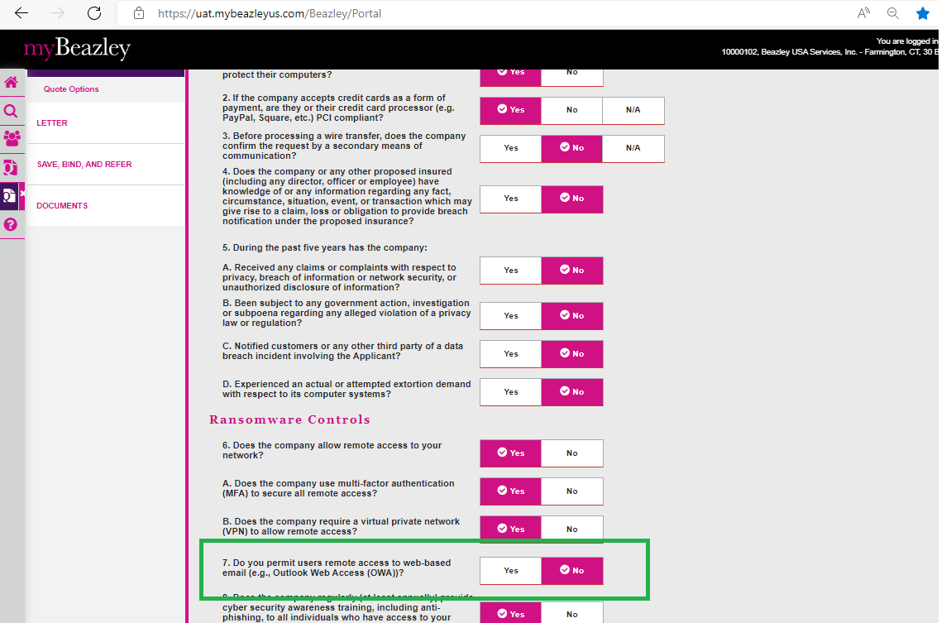

BD-5568

