# BD-7205-TC BD-8091 BMT

Created a new Quote from insight (Q# 2029302) and it is not defaulted to Lloyd’s America, Inc. when it is opened in GC.

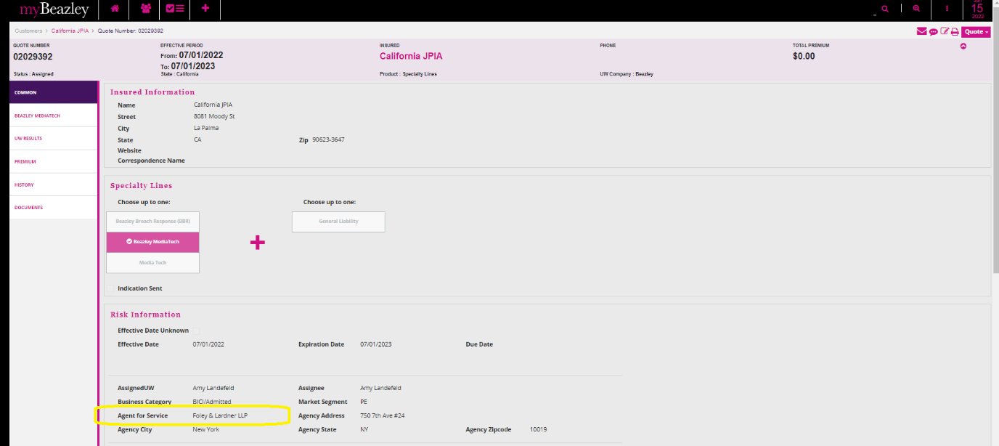

Also noticed that in the case of Copy a previous quote, during the copy process it still gives you the option to choose between “Lloyd’s America, Inc” and “Foley & Lardner LLP”

If “Foley & Lardner LLP” is selected, there are no messages to prevent you to save the quote.

And then I did the Bind, but still the same Agent for Service.

