# BD-7614

**TC BD-8610**

BBR Q#2029600

State: CT

Rater: Base No Range

Line: Admitted

With the happy path…

With 2 negative answers

**TC BD-8611**

BBR Q#2029603

State: LA

Rater: Surplus

Line: Non-Admitted/Surplus

The question 12C=NO and changed the 10% in the Privacy and Security Control Procedures in the Surplus rater, and as it was expected this change did not match the final Total Premium in the UI.

Then removed the 10%

On top of the 1.8 SLDF factor, added the 0.1 = 1.9

The result matched the value of the option chose in the options.

**TC BD-8612**

BBR Q#2029610

State: NE

Rater: SEPs

Line: Admitted

Selected the happy path, making sure not triggered any of the RSA questions.

Now, we are going to trigger one RSA Question…

There was no change in the Total Premium

**TC BD-8613**

BBR Q#2029611

State: VA

Rater: Base No Range

Line: Admitted

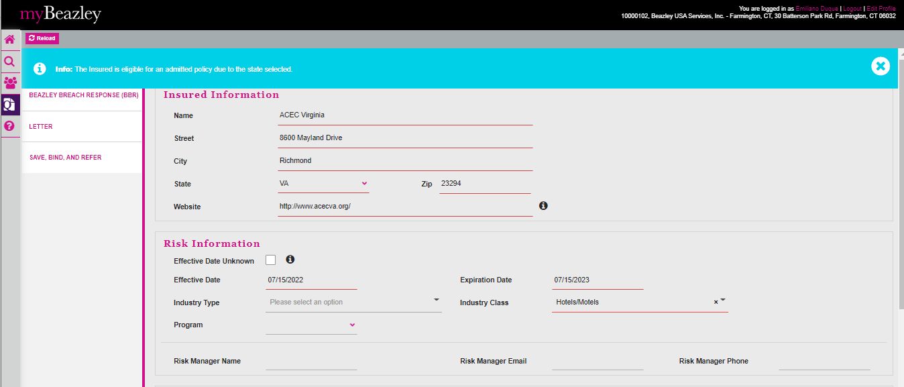

Happy path…

Now, one or more questions will be triggered. In this case questions 8 and 9 were answered as NO.

**TC BD-8614**

BBR Q#2029612

State: NH

Rater: Base No Range

Line: Admitted

BBR Q#2029615

State: DE

Rater: Base

Line: Admitted

Tested all the possible negative answers and the Raters matched with the UI values in AP and UWP.