# BD-8172

1. **New business from Insight.**

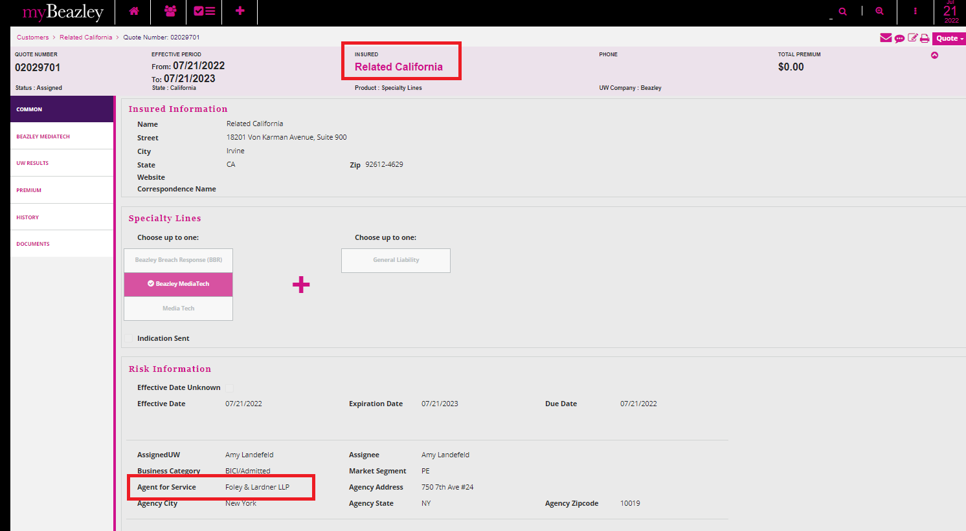

After amend the quote and complete it, the result was that it did not change the Agent for service automatically to Lloyds America, Inc. For this step the user needs to do it manually.

Did not Pass. It is defaulted to Foley & Lardener LLP.

1. **Copy a previous quote and continues with the creation of the new one**

