# BD-7856 TC-10447

Creating the Quote

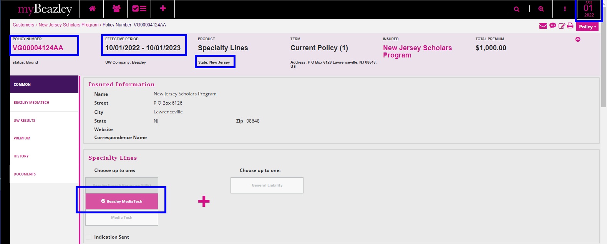

Quote Letter

Binder Letter

Invoice

Policy Declaration

