# BD-7856-TC-10453

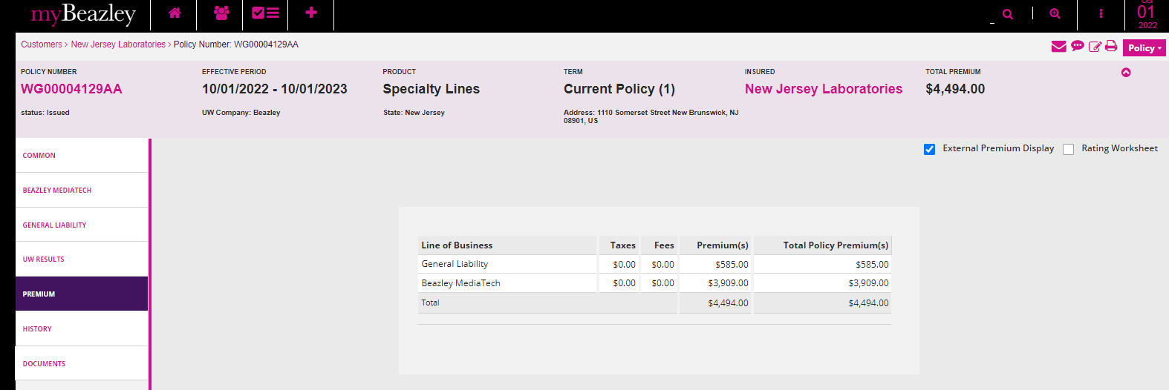

Invoice

