# Verify AP - Broker is getting an error message when using "Investment Advise" as Industry Class - Hazard group selection is not valid

Quote number [02030377](https://uat.mybeazleyus.com/Beazley/PolicyFrame/Quote/Recall/70809) PA

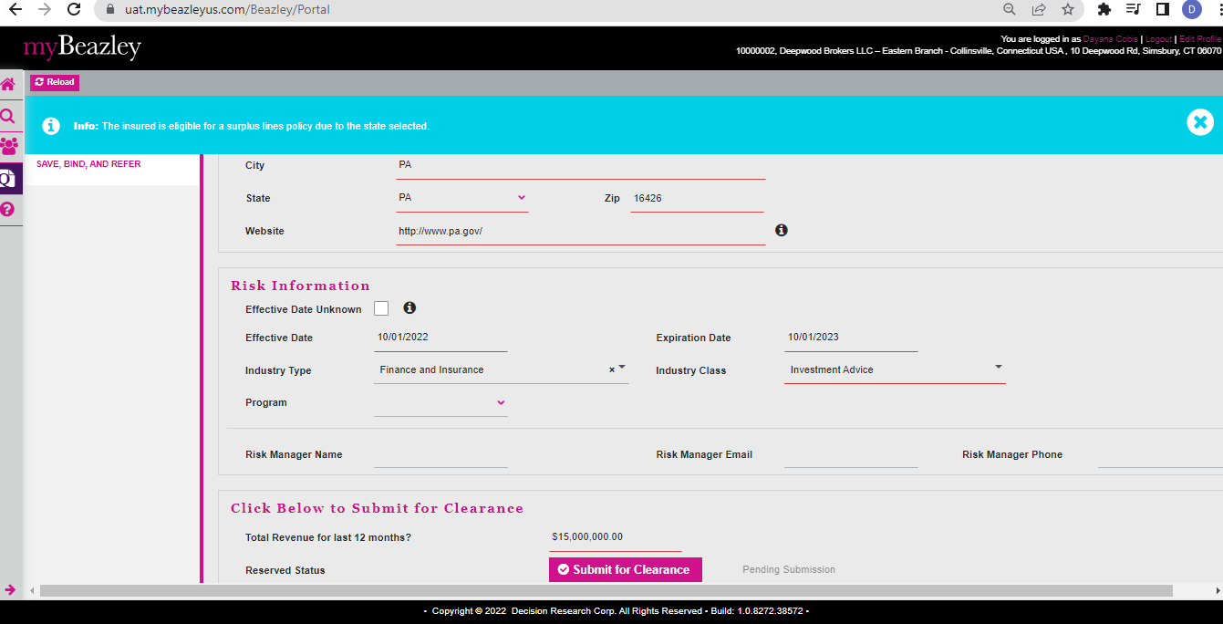

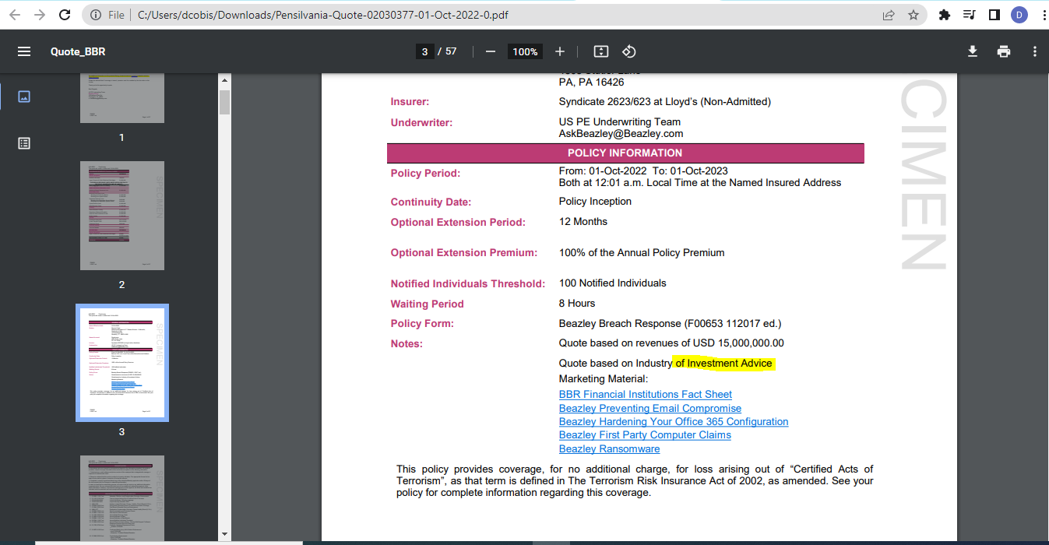

BBR quote [02030379](https://uat.mybeazleyus.com/Beazley/PolicyFrame/Quote/Recall/70819) (GA)

# Verify AP - Broker is getting an error message when using "Real Estate Lessors" as Industry Class - Hazard group selection is not valid

BBRQ quote [02030378](javascript:void(0);) (NY)



