UAT TESTING

BD-9466 Verify the industry class “Elementary/High Schools is rated for a BBR Surplus quote

Quote number: [02030353](javascript:void(0);) ( FL)

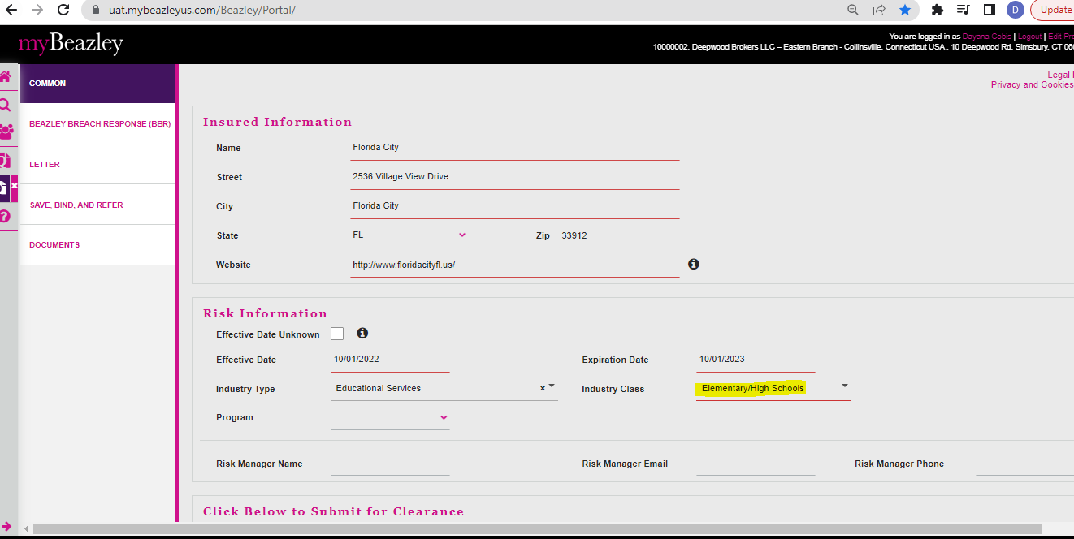

Quote number [02030360](javascript:void(0);) (MA)

Quote number 0230370 (AK)

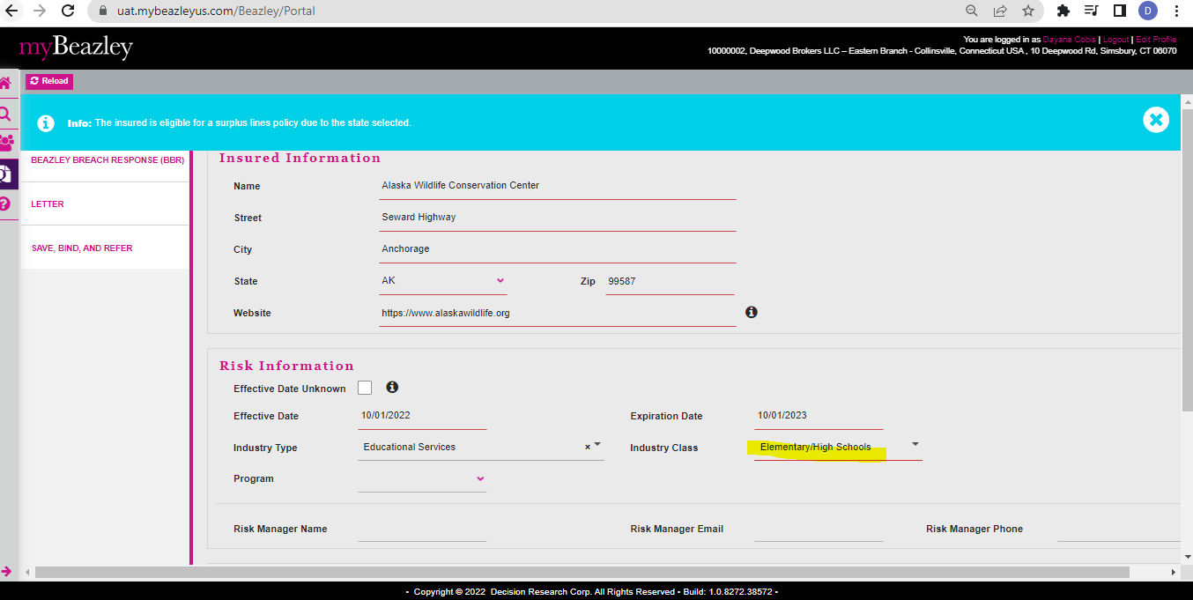

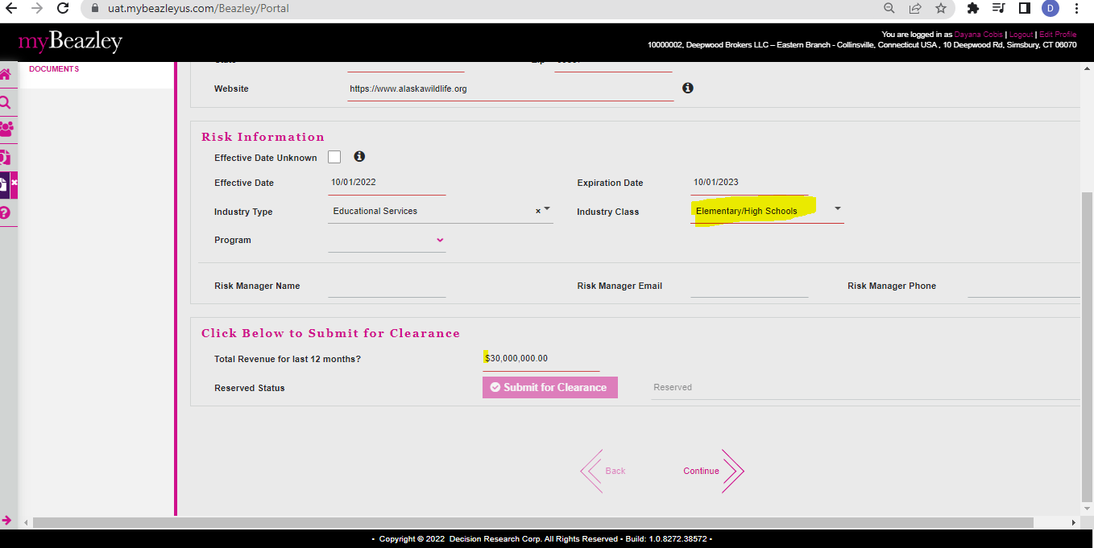

Quote number 02030371 (CA)

Quote number 02030373 (NY)

Quote number **02030374** (GE)

BD-9466 Verify the industry class “Elementary/High Schools appears on the Quote Letter doc for a surplus BBR quote.

Quote number 0230370(AK)

Quote number: [02030353](javascript:void(0);) ( FL)

Quote number 0230371 (CA)

Quote number 0230360 (MA)

Quote number 02030373 (NY)

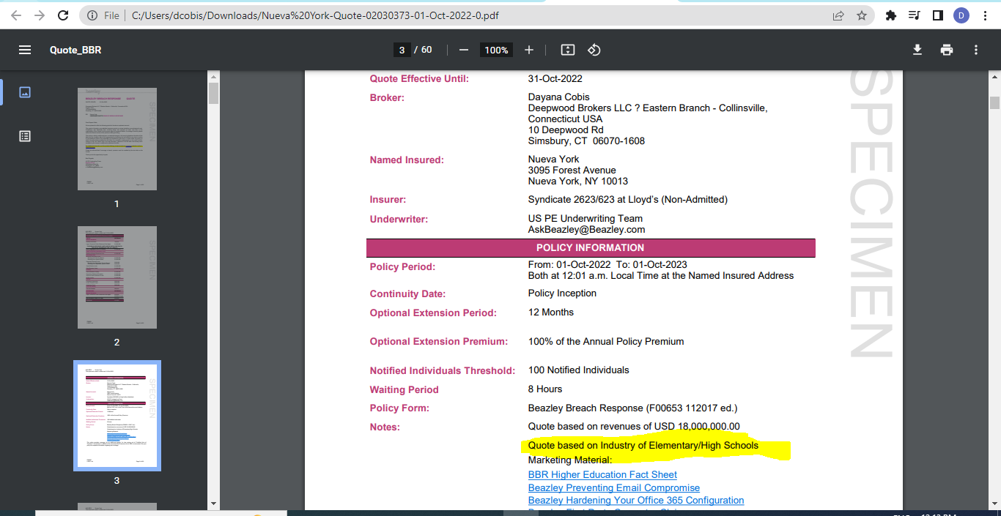

Quote number **02030374** (GE)

BD-9466 Verify the industry class “ Elementary/High Schools appears on the Application doc for a surplus BBR quote.

Quote number 0230370 (AK)

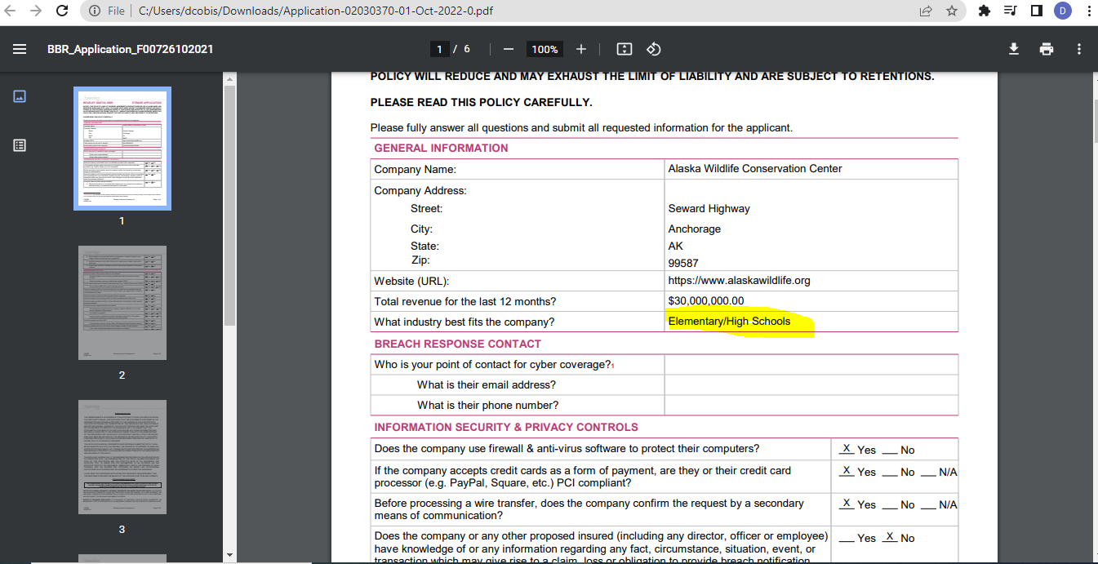

Quote number: [02030353](javascript:void(0);) ( FL)

Quote number: [02030](javascript:void(0);)371 ( CA)

Quote number 0230360 (MA)

Quote number 02030373 (NY)

Quote number **02030374** (GE)

