UAT testing

BD-10572-Verify BBR quote industry class :"Environment, Conservation and Wildlife Organizations"

BBR quote: 02030395 (GE)

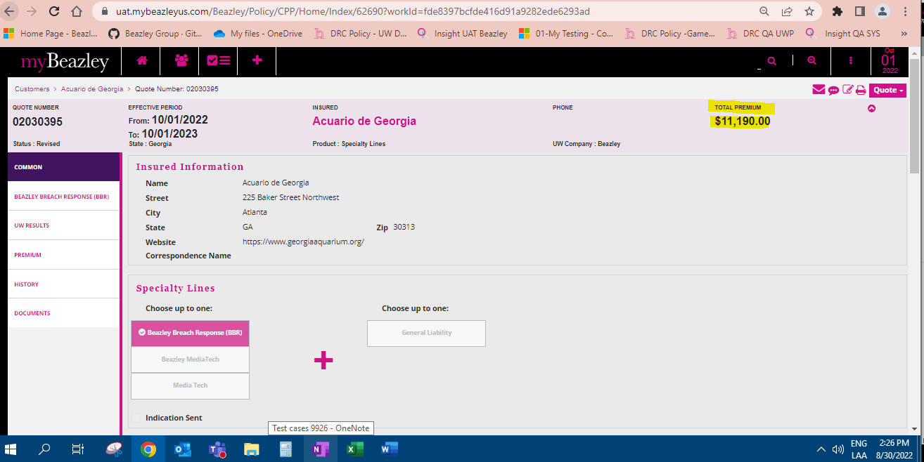

BBR Quote letter

BBRquote Application

# BD-10573-Verify BBR quote industry class :"Pathologist"

BBR quote: 02030388

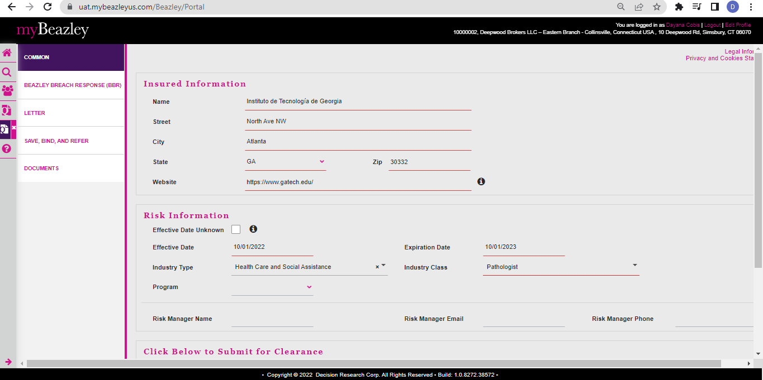

BBR quote letter

BBR Quote Application

# BD-10574 Verify BBR quote industry class :"Police Protection"

BBRquote:02030401

BBR Quote Letter

BBR Quote Application

# BD-10575 Verify BBR quote industry class :"Retail Business"

BRR quote: 02030409

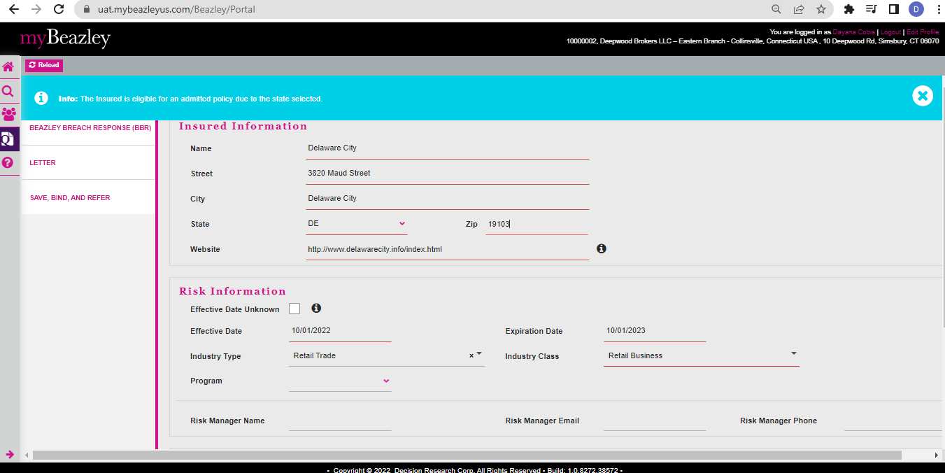

# 

BBR Quote Letter

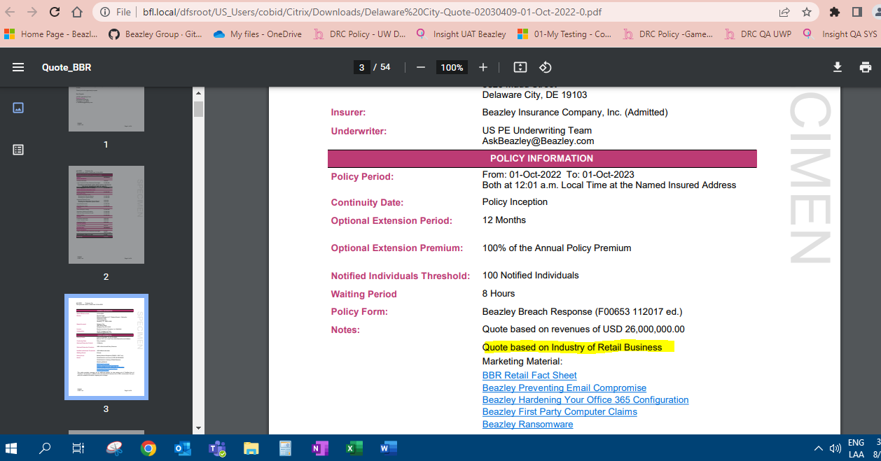

BBR quote Application

