# BD-9763_TC-11007

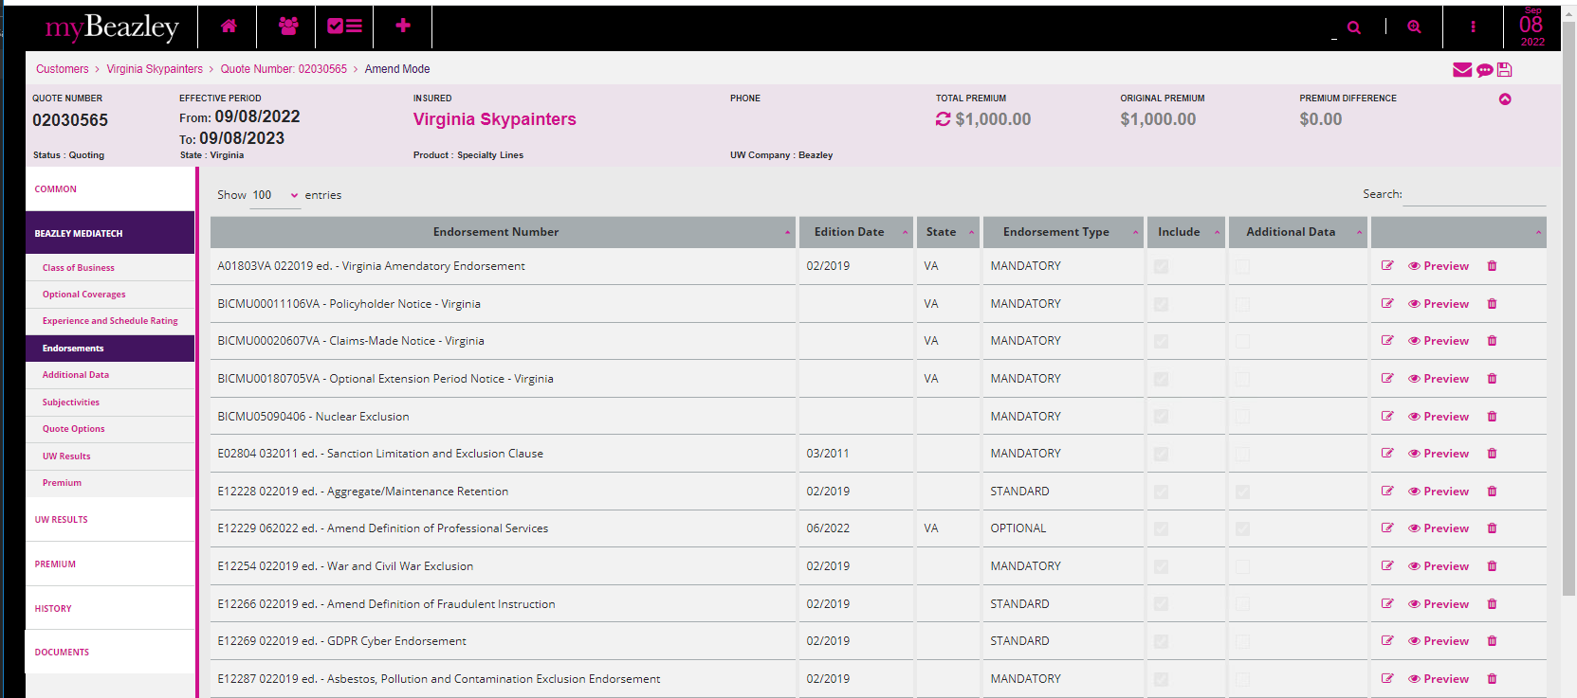

Binder Letter

Policy DEC

