# BD-9763_TC-11008

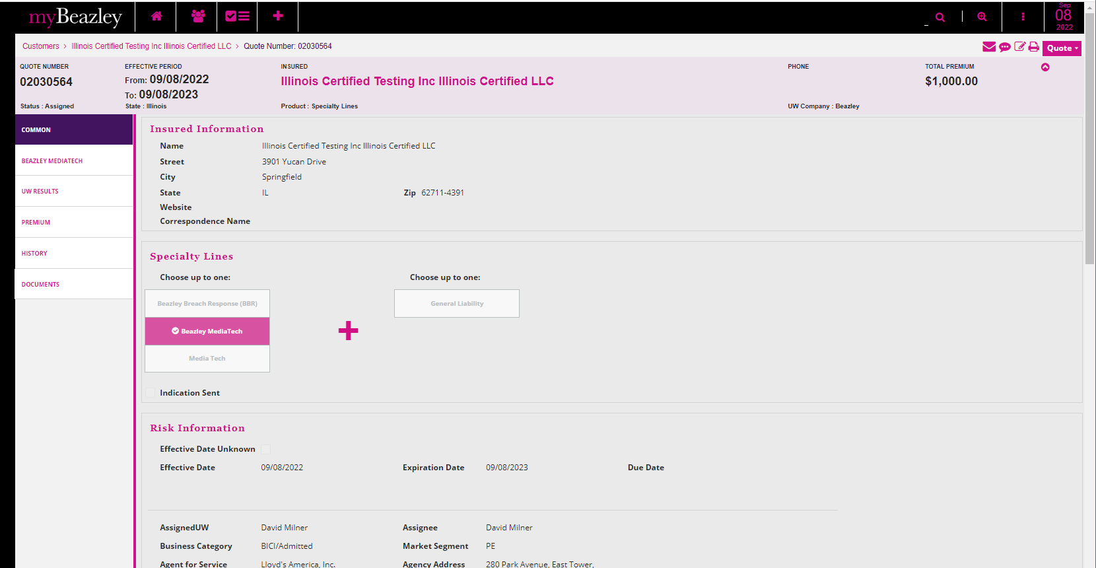

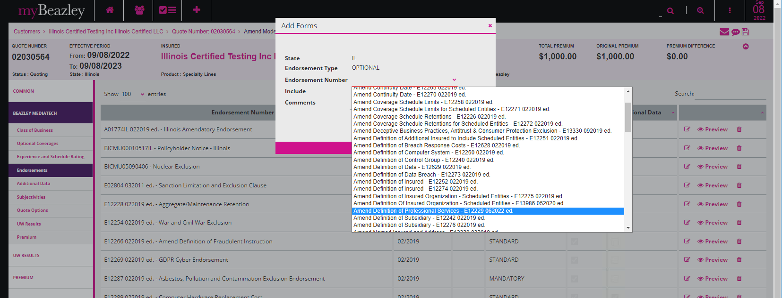

Binder Letter

Policy Dec.

