# BD-9763_TC-11009

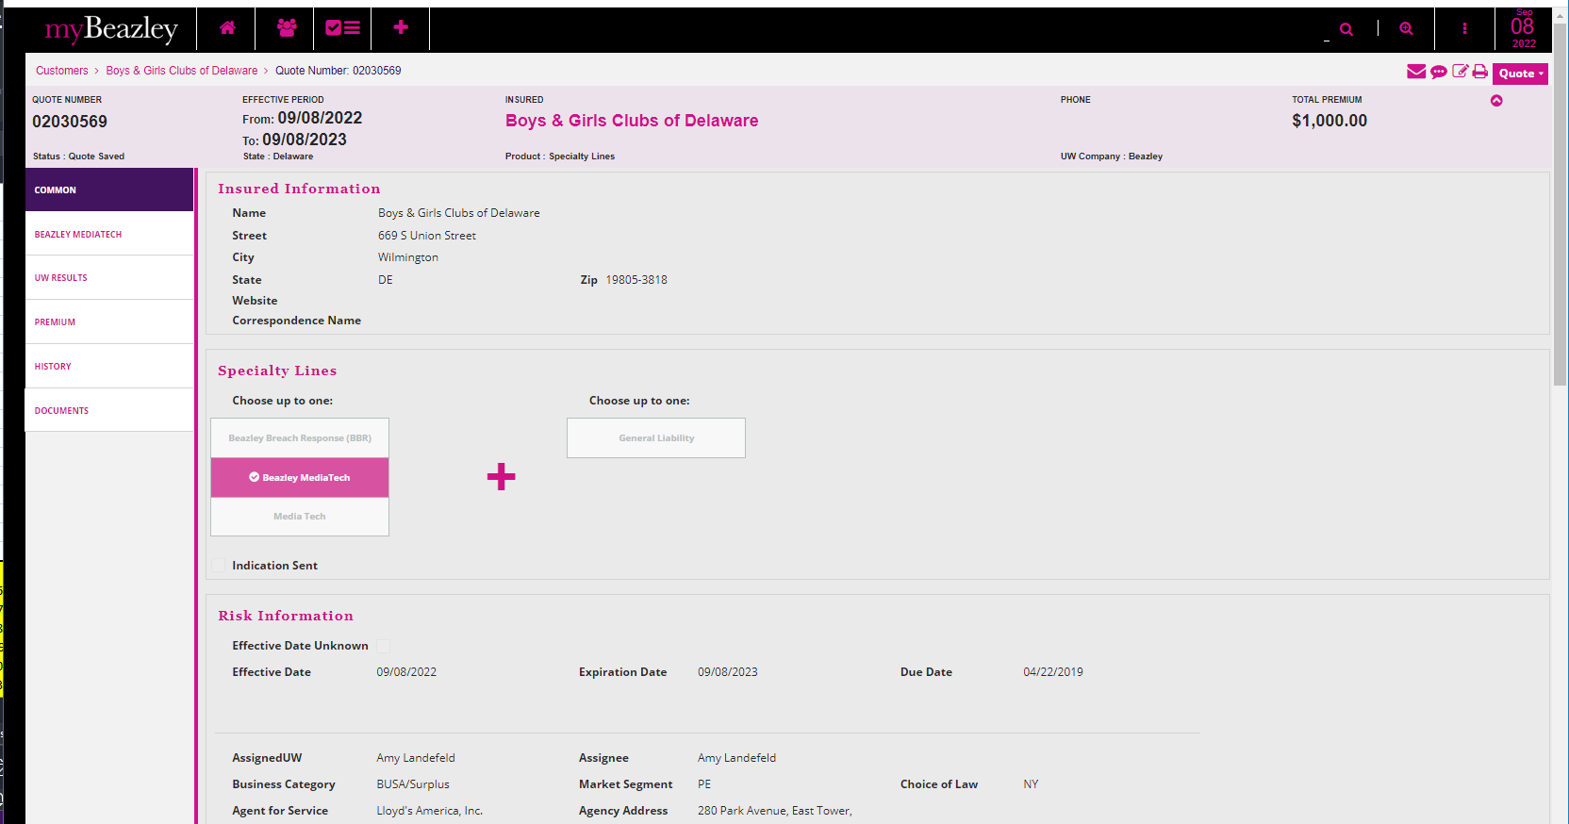

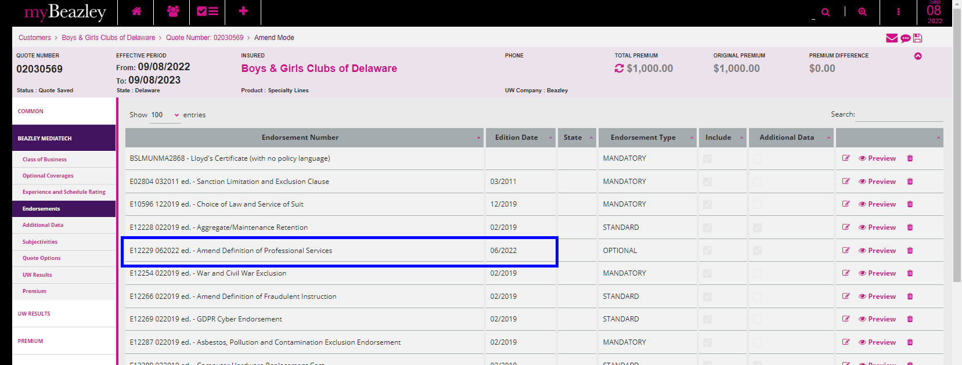

Quote Letter

Binder Letter

Policy Dec

