# BD-9765_TC-11015

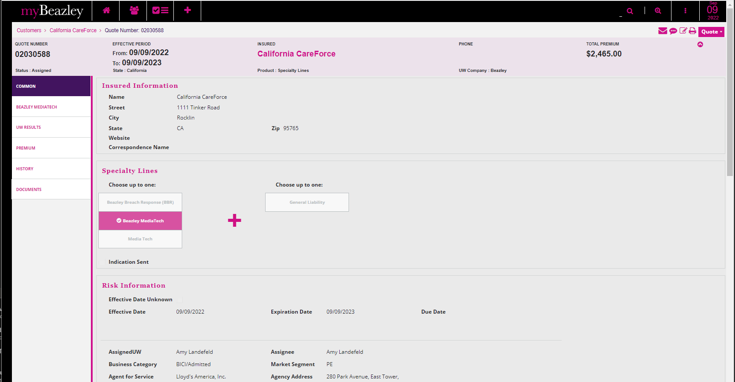

Quote Letter

Binder Letter

Policy DEC

