# BD-9765_TC-11020

Surplus-TX

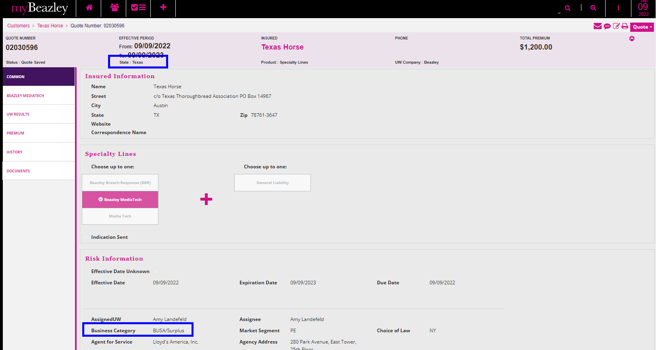

The previous version is available to other states different from CA.

